Brassica yellows virus’ movement protein upregulates anthocyanin accumulation, leading to the development of purple leaf symptoms on Arabidopsis thaliana
Xiang-Ru Chen¹, Ying Wang¹, Hang-Hai Zhao¹, Xiao-Yan Zhang¹, Xian-Bing Wang², Da-Wei Li², Jia-Lin Yu², Cheng-Gui Han¹*
¹State Key Laboratory for Agro-biotechnology and Ministry of Agriculture Key Laboratory of Pest Monitoring and Green Management, College of Plant Protection, China Agricultural University, Beijing 100193, P. R. China
²State Key Laboratory of Agro-Biotechnology and Ministry of Agriculture Key Laboratory of Soil Microbiology, College of Biological Sciences, China Agricultural University, Beijing 100193, P. R., China
*Correspondence to Cheng-Gui Han Email address：hanchenggui@cau.edu.cn

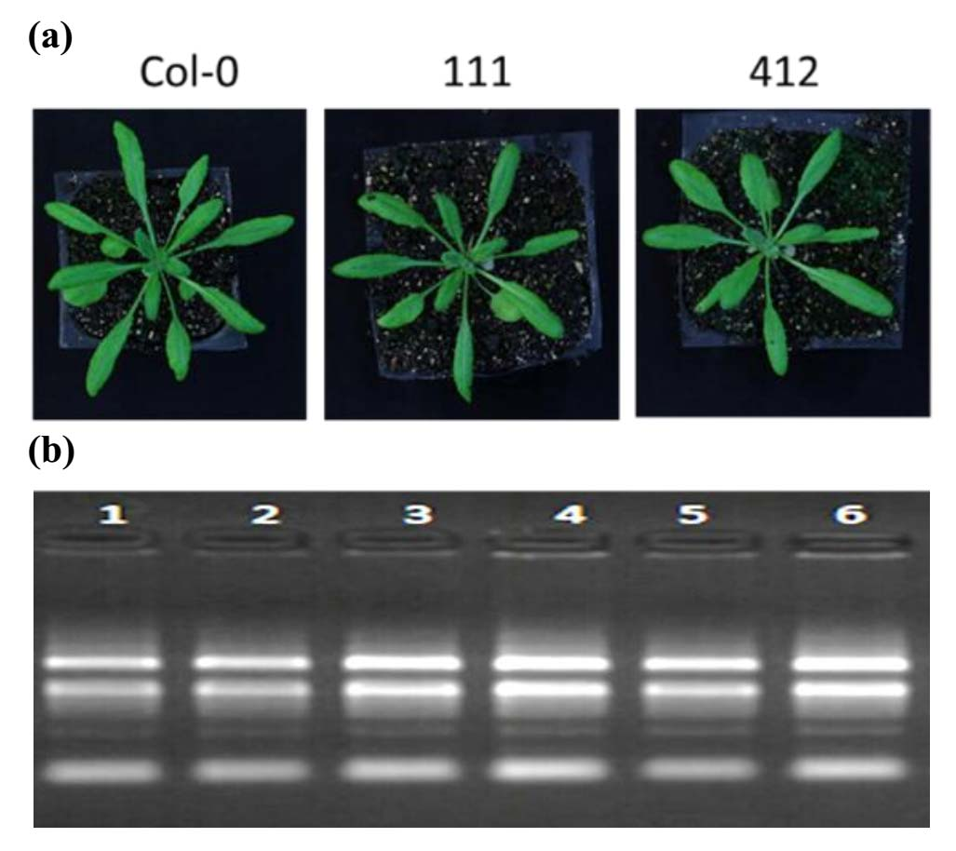

Figure S1. Samples prepared for next generation sequencing.

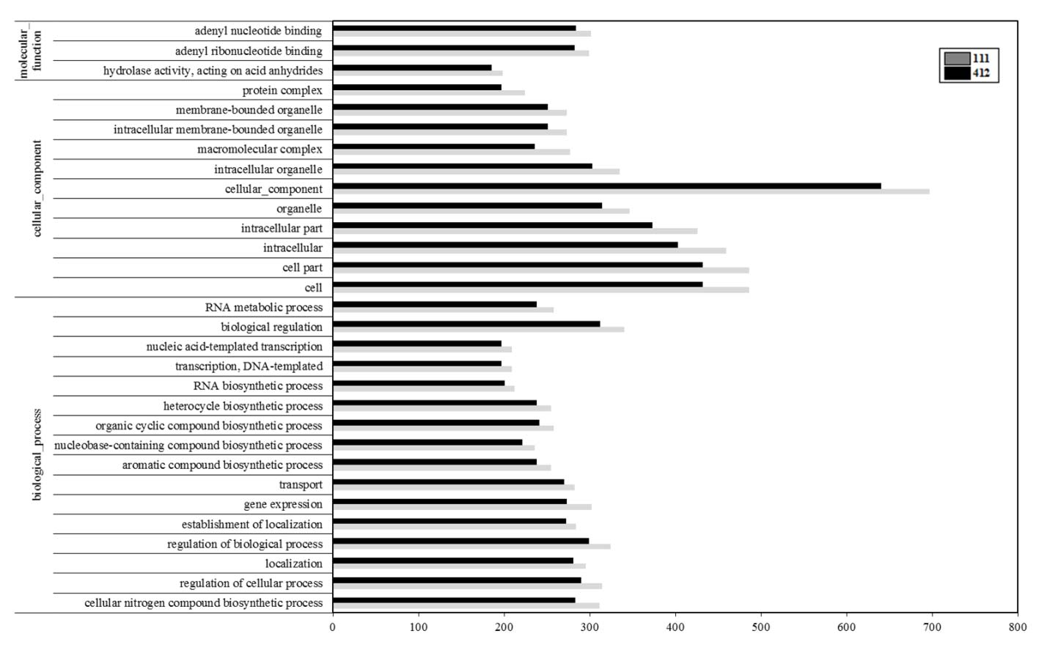

Figure S2. Top 30 GO terms enriched in the BrYV amplicon-transformed Arabidopsis lines (111 and 412) compared with Col-0.

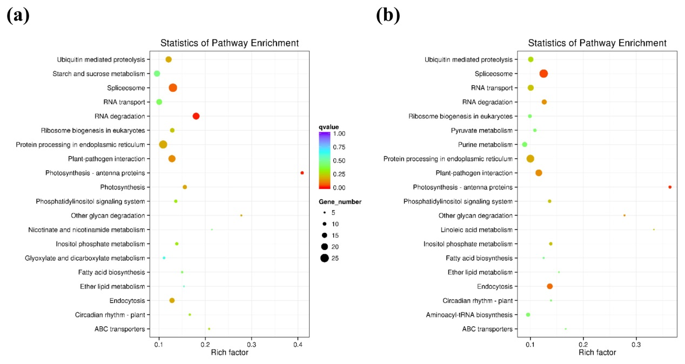

Figure S3. Scatter plot of top 20 enriched KEGG pathways in lines 111 and 412.

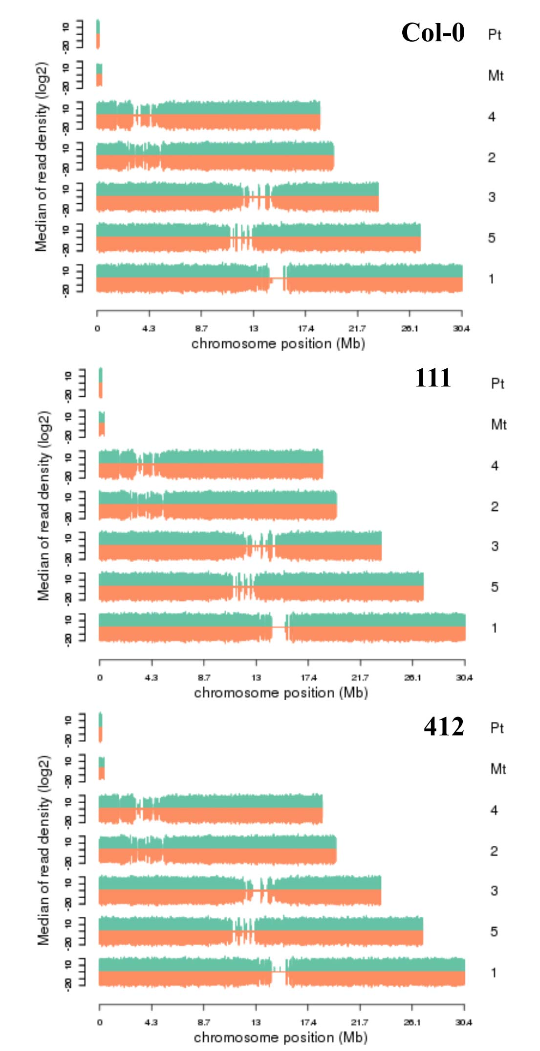

Figure S4. Reads density of transcripts on chromosomes.

