Supplemental material

Association of short-term exposure to fine particulate air pollution and mortality: effect modification by oxidant gases

Eric Lavigne^{1,2}, Richard T Burnett³, Scott Weichenthal^{1,4}

¹Air Health Science Division, Health Canada, Ottawa, ON, Canada
² School of Epidemiology & Public Health, University of Ottawa, Ottawa, Ontario, Canada
³Population Studies Division, Health Canada, Ottawa, ON, Canada
⁴ Department of Epidemiology, Biostatistics, and Occupational Health, McGill University, Montreal, QC, Canada

Table S1. Pearson correlation coefficients of mean concentrations of ambient air pollutants and weather variables in 24 cities across Canada (1998 - 2011).
 | PM_{2.5} (µg/m³) | NO₂ (ppb) | O₃ (ppb) | O_{x} (ppb) | Temperature (ºC) | Relative Humidity (%)
PM_{2.5} (µg/m³) | 1 | 0.53 | 0.03 | 0.28 | 0.08 | 0.04
NO₂ (ppb) |  | 1 | -0.33 | 0.10 | -0.24 | -0.07
O₃ (ppb) |  |  | 1 | 0.90 | 0.32 | -0.39
O_{x} (ppb) |  |  |  | 1 | 0.23 | -0.44
Temperature (ºC) |  |  |  |  | 1 | -0.12
Relative Humidity (%) |  |  |  |  |  | 1

Table S2. Odds ratios (ORs) and 95% CIs for nonaccidental, cardiovascular, and respiratory mortality associated with acute exposure to ambient air pollutants in 24 cities across Canada (1998 - 2011).
Cause of death | Lag | Exposure
Cause of death | Lag | PM_{2.5} | NO₂ | O₃ | O_{x}
Cause of death | Lag | OR (95% CI) | OR (95% CI) | OR (95% CI) | OR (95% CI)
Nonaccidental | 0 | 1.005 (1.002 – 1.008) | 1.003 (1.000 – 1.006) | 1.013 (1.009 – 1.019) | 1.019 (1.014 – 1.025)
 | 1 | 1.006 (1.004 – 1.009) | 1.012 (1.009 – 1.016) | 0.997 (0.992 – 1.002) | 1.006 (1.001 – 1.011)
 | 2 | 0.997 (0.994 – 0.999) | 1.004 (1.001 – 1.007) | 0.994 (0.990 – 0.999) | 0.996 (0.991 – 1.001)
 | 3-day average | 1.005 (1.001 – 1.008) | 1.011 (1.007 – 1.016) | 1.003 (0.997 – 1.009) | 1.013 (1.006 – 1.020)
Cardiovascular | 0 | 1.004 (0.999 – 1.008) | 0.999 (0.993 – 1.005) | 1.022 (1.014 – 1.030) | 1.026 (1.017 – 1.035)
 | 1 | 1.008 (1.003 – 1.012) | 1.013 (1.007 – 1.019) | 1.001 (0.993 – 1.009) | 1.012 (1.003 – 1.020)
 | 2 | 0.997 (0.993 – 1.002) | 1.004 (0.998 – 1.009) | 0.996 (0.989 – 1.004) | 0.998 (0.989 – 1.007)
 | 3-day average | 1.005 (0.999 – 1.011) | 1.009 (1.001 – 1.017) | 1.012 (1.001 – 1.023) | 1.022 (1.009 – 1.034)
Respiratory | 0 | 0.997 (0.989 – 1.006) | 0.993 (0.982 – 1.004) | 1.019 (1.003 – 1.034) | 1.018 (0.999 – 1.036)
 | 1 | 1.000 (0.991 – 1.009) | 1.009 (0.998 – 1.020) | 1.000 (0.985 – 1.015) | 1.007 (0.990 – 1.025)
 | 2 | 0.999 (0.990 – 1.007) | 1.002 (0.991 – 1.013) | 1.003 (0.989 – 1.018) | 1.006 (0.989 – 1.023)
 | 3-day average | 0.997 (0.986 – 1.009) | 1.002 (0.988 – 1.017) | 1.013 (0.992 – 1.035) | 1.018 (0.994 – 1.042)
ORs reflect a 6.63 µg/m³ change in PM_{2.5}, a 10.91 ppb change in NO₂, a 13.61 ppb change in O₃, and a 8.13 ppb change in O_{x}. All models are adjusted for 3-day mean ambient temperature (cubic splines) and relative humidity and daily counts of hospitalization for influenza (in respiratory mortality models only).

Table S3. Potentiation of the relationship between lag 0 exposure to ambient PM_{2.5} and mortality (nonaccidental, cardiovascular and respiratory mortality) by 3-day mean O_{x} in 24 cities across Canada (1998 - 2011).
Cause of Death | AIC | Pollutant
Cause of Death | AIC | PM_{2.5} |  | O_{x} |  | PM_{2.5}*O_{x}
Cause of Death | AIC | OR | 95% CI | OR | 95% CI | OR | 95% CI
PM_{2.5}
Nonaccidental | 3459084 | 1.005 | 1.002 – 1.008
Cardiovascular | 1177947 | 1.004 | 0.999 – 1.009
Respiratory | 310592 | 0.997 | 0.989 – 1.009
PM_{2.5} + O_{x}
Nonaccidental | 3459078 | 1.005 | 1.002 – 1.007 | 1.010 | 1.003 – 1.017
Cardiovascular | 1177939 | 1.002 | 0.998 – 1.007 | 1.020 | 1.008 – 1.033
Respiratory | 310592 | 0.996 | 0.988 – 1.005 | 1.020 | 0.995 – 1.044
PM_{2.5 +} O_{x +} PM_{2.5}*O_{x}
Nonaccidental | 3459080 | 1.002 | 0.995 – 1.009 | 1.008 | 0.999 – 1.017 | 1.002 | 0.997 – 1.006
Cardiovascular | 1177940 | 1.000 | 0.988 – 1.012 | 1.018 | 1.002 – 1.034 | 1.002 | 0.994 – 1.010
Respiratory | 310593 | 1.001 | 0.977 – 1.026 | 1.024 | 0.993 – 1.056 | 0.997 | 0.981 – 1.012
ORs reflect a 6.63 µg/m³ change in PM_{2.5}, a 8.13 ppb change in O_{x} and 100 ppb*µg/m³ change in PM_{2.5}*O_{x.} All models are adjusted for 3-day mean ambient temperature (cubic splines) and relative humidity and daily counts of hospitalization for influenza (in respiratory mortality models only).

Table S4. Potentiation of the relationship between 3-day mean ambient PM_{2.5} and mortality (nonaccidental, cardiovascular and respiratory mortality) by 3-day mean O_{x} in 24 cities across Canada (1998 - 2011).
Cause of Death | AIC | Pollutant
Cause of Death | AIC | PM_{2.5} |  | O_{x} |  | PM_{2.5}*O_{x}
Cause of Death | AIC | OR | 95% CI | OR | 95% CI | OR | 95% CI
PM_{2.5}
Nonaccidental | 3459094 | 1.005 | 1.001 – 1.008
Cardiovascular | 1177947 | 1.005 | 0.999 – 1.011
Respiratory | 310592 | 0.997 | 0.986 – 1.009
PM_{2.5} + O_{x}
Nonaccidental | 3459087 | 1.004 | 1.000 – 1.007 | 1.011 | 1.004 – 1.018
Cardiovascular | 1177939 | 1.003 | 0.997 – 1.009 | 1.020 | 1.008 – 1.033
Respiratory | 310592 | 0.996 | 0.984 – 1.007 | 1.019 | 0.995 – 1.044
PM_{2.5 +} O_{x +} PM_{2.5}*O_{x}
Nonaccidental | 3459088 | 1.008 | 1.000 – 1.017 | 1.015 | 1.005 – 1.025 | 0.997 | 0.992 – 1.002
Cardiovascular | 1177938 | 1.014 | 0.999 – 1.029 | 1.030 | 1.013 – 1.048 | 0.992 | 0.983 – 1.002
Respiratory | 310593 | 1.008 | 0.979 – 1.037 | 1.030 | 0.996 – 1.066 | 0.992 | 0.973 – 1.010
ORs reflect a 6.63 µg/m³ change in PM_{2.5}, a 8.13 ppb change in O_{x} and 100 ppb*µg/m³ change in PM_{2.5}*O_{x.} All models are adjusted for 3-day mean ambient temperature (cubic splines) and relative humidity and daily counts of hospitalization for influenza (in respiratory mortality models only).

Table S5. Odds ratios (ORs)¹ and 95% CIs for nonaccidental, cardiovascular, and respiratory mortality across tertiles (I, II, III) of same day, 3-day mean, and 5-day mean O_{x} in 24 cities across Canada (1998 - 2011).
Cause of death | PM_{2.5} Lag | Time-Period of O_{x} Exposure
Cause of death | PM_{2.5} Lag | Lag0 |  |  |  | 3 Day Mean |  |  |  | 5 Day Mean
Cause of death | PM_{2.5} Lag | I | II | III | p value | I | II | III | p value | I | II | III | P value
Nonaccidental | 0 | 0.998  (0.992 – 1.004) | 1.001  (0.995 –  1.007) | 1.008  (1.003 – 1.012) | 0.05 | 0.999  (0.994 – 1.005) | 1.004  (0.998 – 1.010) | 1.009  (1.005 – 1.013) | 0.04 | 0.998  (0.992 – 1.003) | 1.006  (1.000 – 1.011) | 1.010  (1.006 – 1.013) | 0.01
 | 3-day | 1.002  (0.994 – 1.010) | 1.002  (0.993 –  1.010) | 1.006  (1.000 – 1.013) | 0.35 | 1.002  (0.994 – 1.010) | 1.003  (0.995 – 1.012) | 1.010  (1.004 – 1.017) | 0.59 | 1.002  (0.994 – 1.010) | 1.003  (0.995 – 1.011) | 1.011  (1.005 – 1.017) | 0.36
Cardiovascular | 0 | 0.996  (0.986 – 1.007) | 1.002  (0.991 –  1.013) | 1.010  (1.003 – 1.018) | 0.12 | 0.999  (0.989 – 1.009) | 0.996  (0.986 – 1.006) | 1.009  (1.002 – 1.016) | 0.19 | 0.999  (0.990 – 1.009) | 0.999  (0.990 – 1.009) | 1.009  (1.002 – 1.016) | 0.29
 | 3-day | 1.009  (0.996 – 1.023) | 1.003  (0.988 –  1.017) | 1.006  (0.995 – 1.017) | 0.72 | 1.009  (0.995 – 1.022) | 1.003  (0.989 – 1.017) | 1.006  (0.996 – 1.017) | 0.38 | 1.002  (0.994 – 1.010) | 1.003  (0.995 – 1.011) | 1.011  (1.005 – 1.017) | 0.32
Respiratory | 0 | 0.978  (0.958 – 0.998) | 0.987  (0.966 –  1.008) | 0.982  (0.966 – 1.011) | 0.35 | 0.994  (0.975 – 1.014) | 0.999  (0.980 – 1.019) | 1.001  (0.988 – 1.015) | 0.73 | 0.996  (0.978 – 1.016) | 0.998  (0.980 – 1.016) | 0.997  (0.984 – 1.011) | 0.66
 | 3-day | 0.975  (0.950 – 1.001) | 0.995  (0.968 –  1.022) | 0.993  (0.972 – 1.015) | 0.73 | 0.987  (0.961 – 1.013) | 0.995  (0.968 – 1.022) | 1.005  (0.985 – 1.026) | 0.40 | 0.990  (0.965 – 1.015) | 0.996  (0.971 – 1.022) | 0.998  (0.978 – 1.019) | 0.88
ORs reflect a 6.63 µg/m³ change in PM_{2.5}. All models are adjusted for 3-day mean ambient temperature (cubic splines) and relative humidity and
daily counts of hospitalization for influenza (in respiratory mortality models only).

Figure S1. Concentration-response curves using natural cubic splines with 3 degrees of freedom for the associations between exposure to 3-day mean PM_{2.5} and nonaccidental, cardiovascular and respiratory mortality in 24 cities across Canada (1998 – 2011). Solid lines reflect odds ratios and dashed lines reflect 95% confidence intervals.
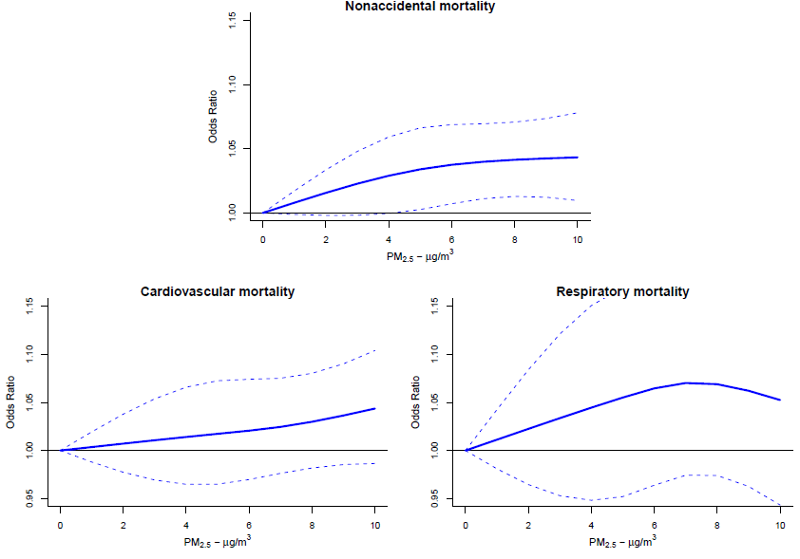
All models are adjusted for 3-day mean ambient temperature (cubic splines) and relative humidity and daily counts of hospitalization for influenza (in respiratory mortality models only).

Figure S2. Concentration-response curves using natural cubic splines with 3 degrees of freedom for the association between exposure to 3-day mean O_{x} and nonaccidental, cardiovascular and respiratory mortality in 24 cities across Canada (1998 – 2011). Solid blue line reflects odds ratios and gray area reflect 95% confidence intervals.
All models are adjusted for 3-day mean ambient temperature (cubic splines) and relative humidity and daily counts of hospitalization for influenza (in respiratory mortality models only).

