Machine Learning Reveals Protein Signatures in CSF and Plasma Fluids of Clinical Value for ALS

Michael S. Bereman*,¹⁻³ Joshua Beri¹, Jeffrey R. Enders³, and Tara Nash³

¹Department of Biological Sciences, North Carolina State University, Raleigh, NC 27695
²Department of Chemistry, North Carolina State University, Raleigh, NC 27695
³Center for Human Health and the Environment, North Carolina State University, Raleigh, NC 27695

Submitted to: Scientific Reports

Supplemental Information
Keywords: Amyotrophic Lateral Sclerosis, Biomarkers, csf, proteomics

*Author for Correspondence
Michael S. Bereman, Ph.D.
Department of Biological Sciences
Center for Human Health and the Environment
North Carolina State University
Raleigh, NC
Phone: 919.515.8520
Email: michaelbereman@ncsu.edu

Supplemental Figure 1 Plots of the abundances of complement protein 7 and retinol binding protein 4 in plasma versus cerebral spinal fluid in ALS patients (first row) and controls (second row)

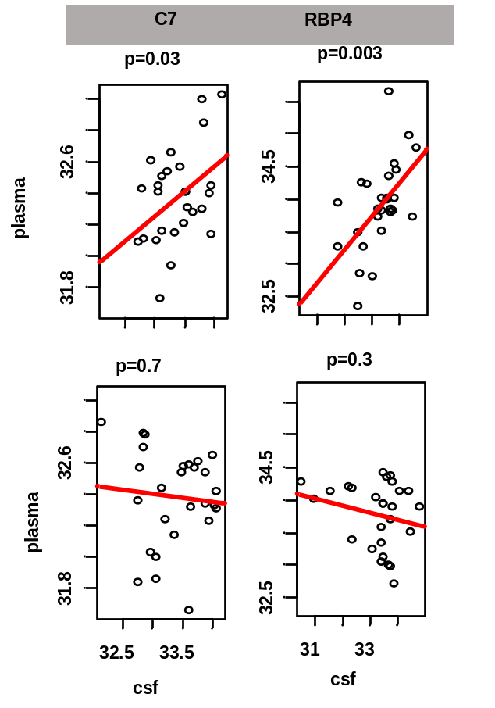

Supplemental Figure 2 A dot plot comparing the performance of the different models. Below is a table with the mean differences in area under the curve and significance of the models

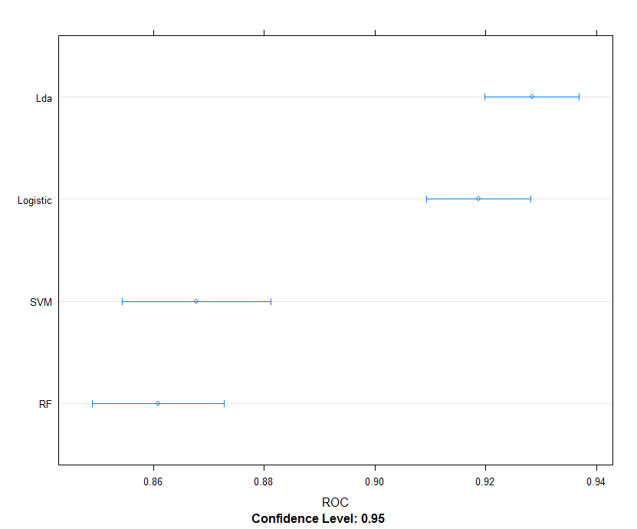

Supplemental Table 1: Pairwise comparison of the performance of each model using the CSF data

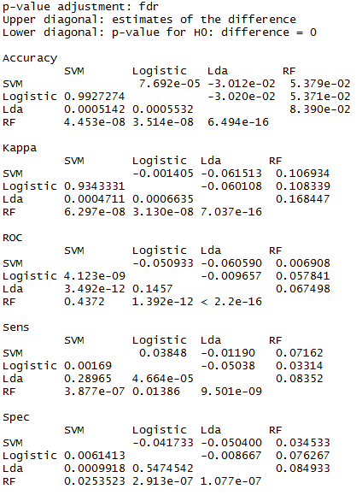

Supplemental Figure 3 A plot of Pearson correlation coefficients amongst proteins found to be significant in CSF. Proteins labeled in red were removed from model building process

Supplemental Figure 4 Residual versus fitted and QQ plot of residuals of the mlr model

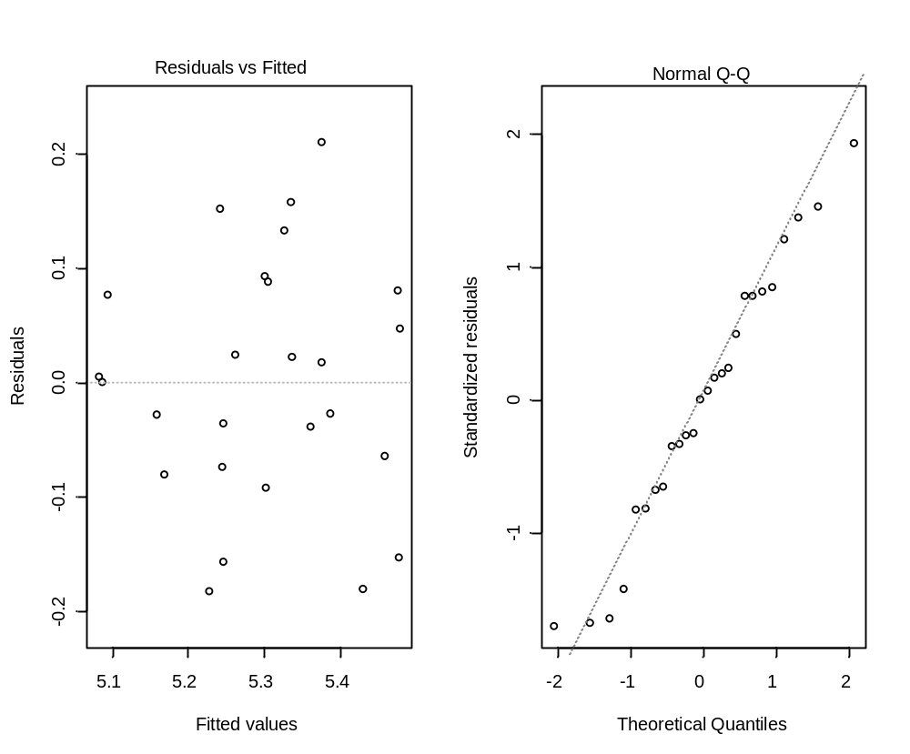

Supplemental Table 2 list of the plasma proteins used in the nonlinear support vector classifier

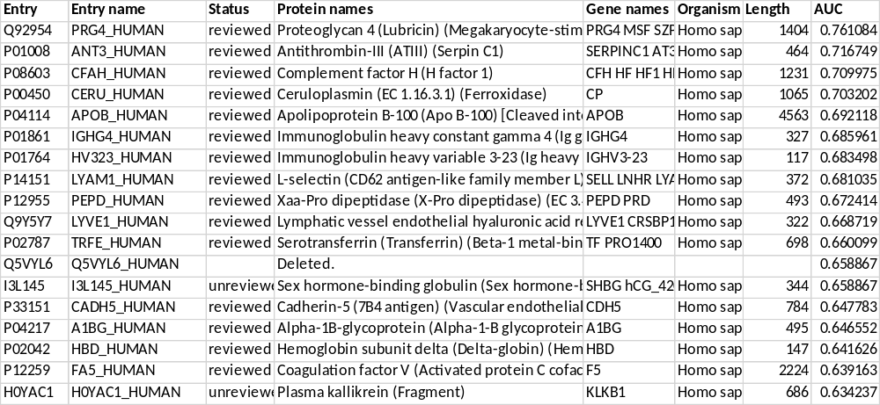

Supplemental Figure 5 Evaluation of A) peptide stability B) digestion time and C) the need for protein depletion on abundance and precision.

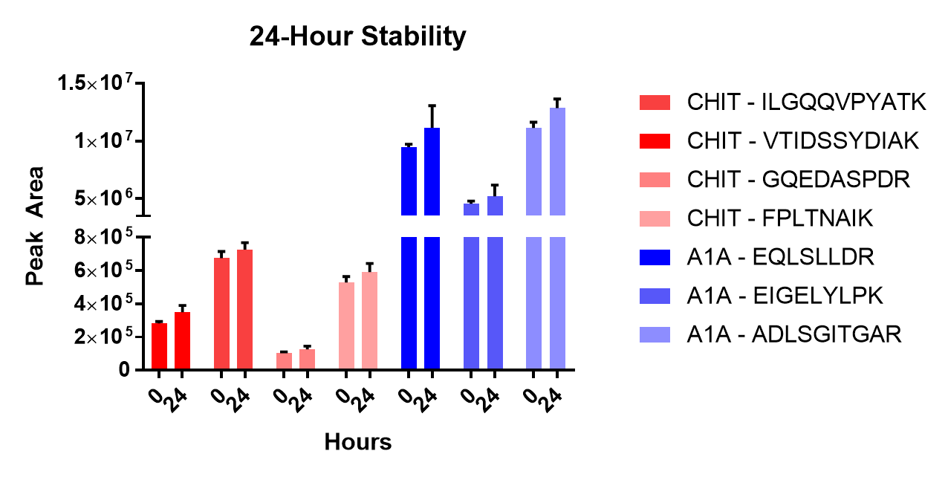
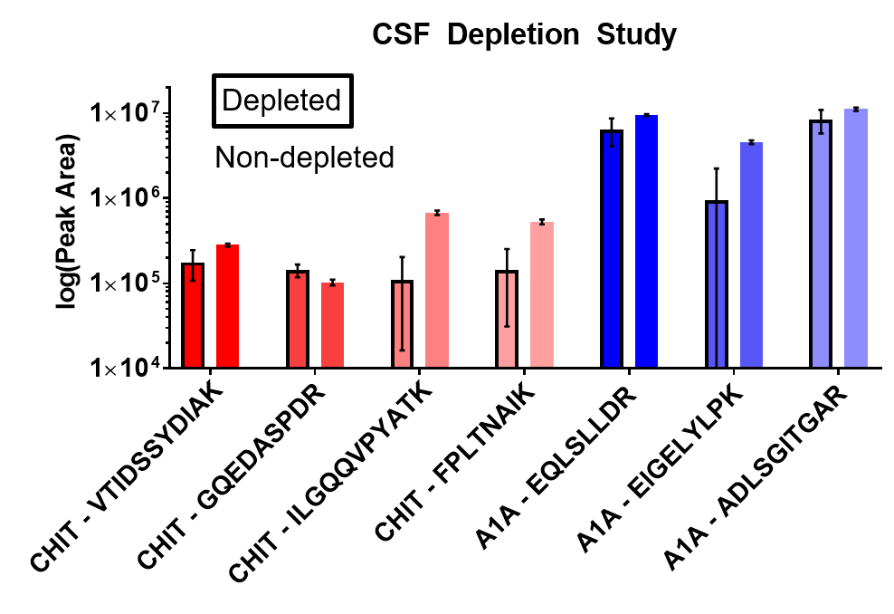
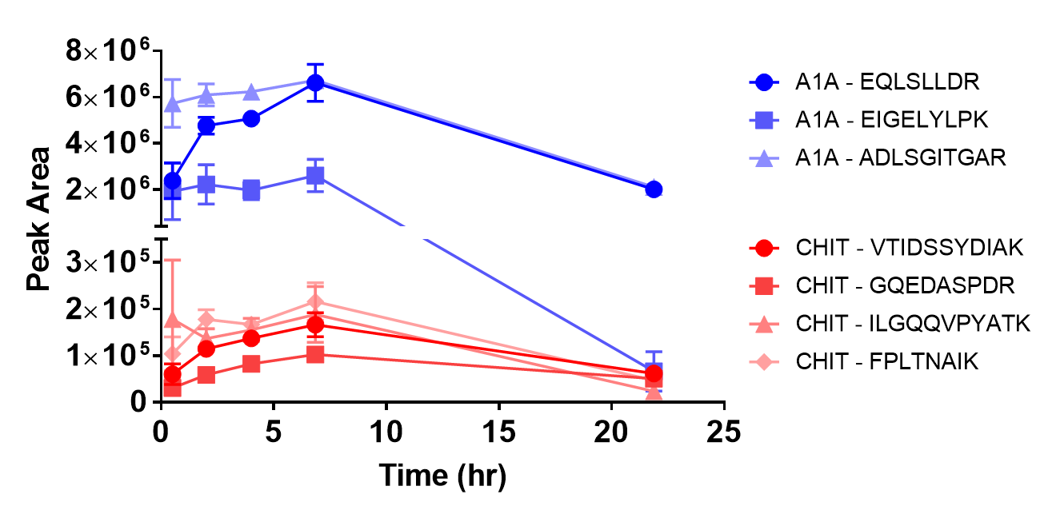
A
C
B

