Supplementary information to: Evidence for ‘critical slowing down’ in seagrass: a stress gradient experiment at the southern limit of its range

El-Hacen M. El-Hacen^{1, 2,*}, Tjeerd J. Bouma^{1, 3}, Gregory S. Fivash^{1, 3}, Amadou Abderahmane Sall⁴, Theunis Piersma^{1, 5}, Han Olff¹ and Laura L. Govers^{1, 6}

¹ Conservation Ecology Group, Groningen Institute for Evolutionary Life Sciences (GELIFES), University of Groningen, P.O. Box 11103, 9700 CC Groningen, The Netherlands
² Parc National du Banc d’Arguin (PNBA), Rue Gleiguime Ould Habiboullah, B Nord No 100, B.P. 5355, Nouakchott, R.I. de Mauritanie
³ NIOZ Royal Netherlands Institute for Sea Research, Department of Estuarine and Delta Systems and Utrecht University, P.O. Box 140, 4400 AC Yerseke, The Netherlands
⁴ Institut Mauritanien de Recherches Océanographiques et des Pêches (IMROP), BP 22, Nouadhibou, R.I. de Mauritanie
⁵ NIOZ Royal Netherlands Institute for Sea Research, Department of Coastal Systems and Utrecht University, P.O. Box 59, 1790 AB Den Burg, Texel, The Netherlands
⁶ Department of Aquatic Ecology and Environmental Biology, Institute for Water and Wetland Research (IWWR), Radboud University, Heyendaalseweg 135, 6525 AJ, Nijmegen, the Netherlands

*Corresponding author: Hacen El-Hacen (e.h.m.el.hacen@rug.nl)
Postal address: P.O. Box 11103, 9700 CC Groningen, The Netherlands
Telephone/Fax: [+31] 50 363 5205

Supplementary 1: Witnessed seagrass die-off events in Banc d’Arguin

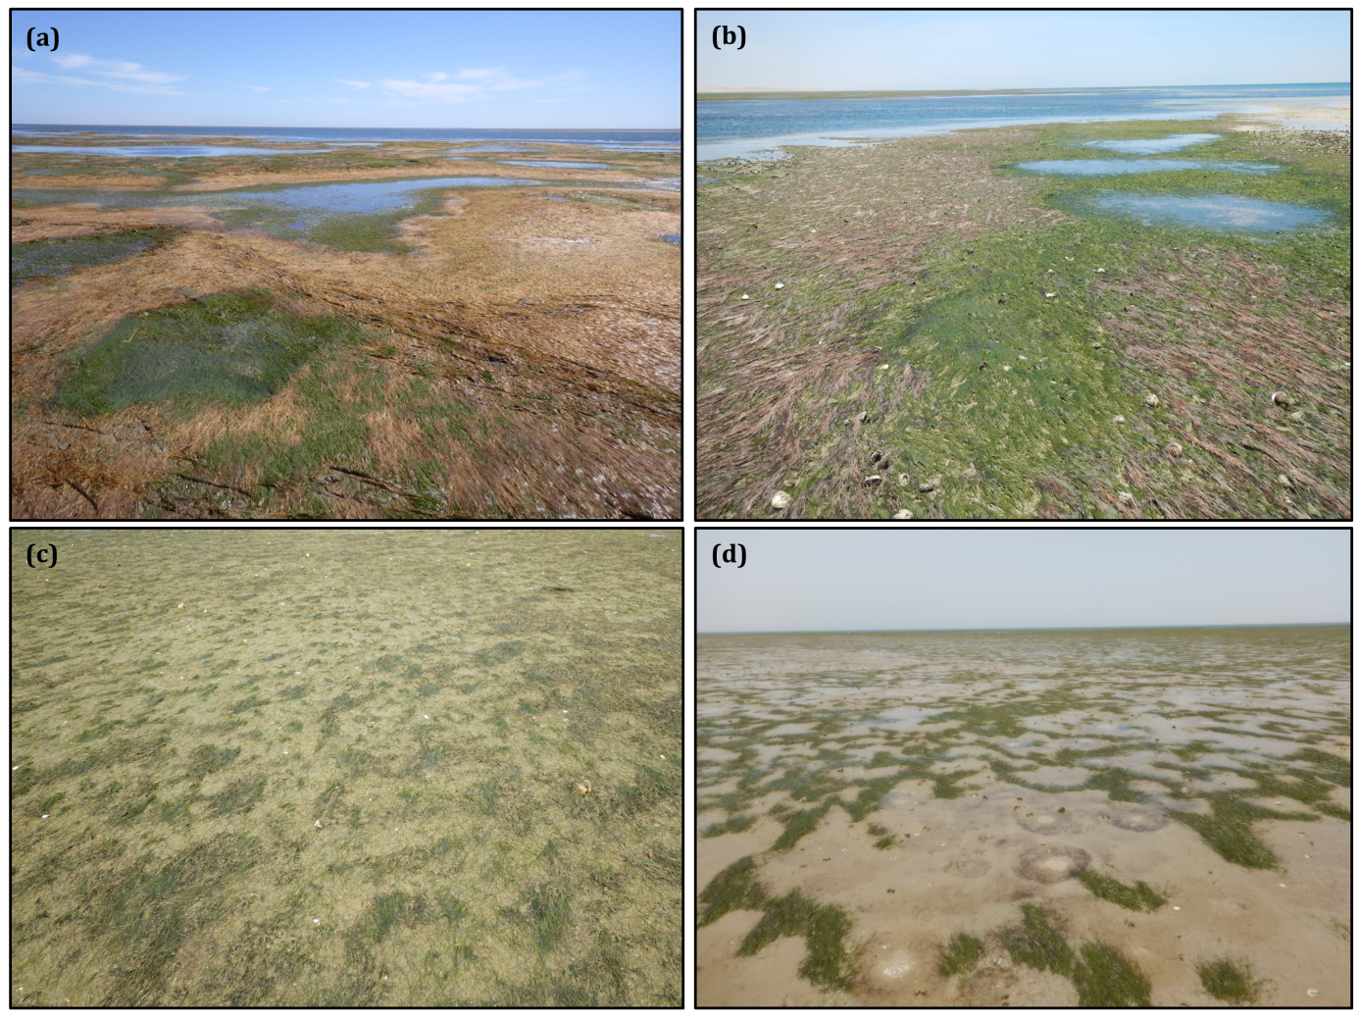
Figure S1. Landscape-scale seagrass die-off related events in Parc National du Banc d’Arguin, Mauritania (see Fig. 2) observed during the study period. Upper panels (a, b) show sudden die-off low on the elevational gradient due to unknown physiological damage to the tissues. Lower panels (c, d) demonstrate degrading seagrass higher on the elevational gradient du to massive deposition of mud-packages. Left photos (a, c) were taken in May 2015 and the right ones (b, d) on May 2016.

Supplementary 2: Structural equation modelling procedures
The process of conducting structural equation models typically involves model specification, identification, parameter estimates, evaluation of model fit, and model re-specification (Grace 2006, Grace et al. 2010). In the present study, a prior meta-model was developed, based upon our knowledge on the functioning of Zostera noltii, including important interactions that might affect its recovery (Fig. S2). This meta-model included eight observed exogenous variables and was improved by removing the non-significant paths from the meta-model^{1,2}, and compared these models using Akaike’s information criterion (AICc)^{3–7}. Our prior model depicted that elevation and die-off treatments would have direct effects on recovery rate as well as on abiotic and biotic variables that might affect the recovery rate of seagrass after die-off. Variables were checked for parametric assumptions and were transformed when necessary to meet the assumptions.

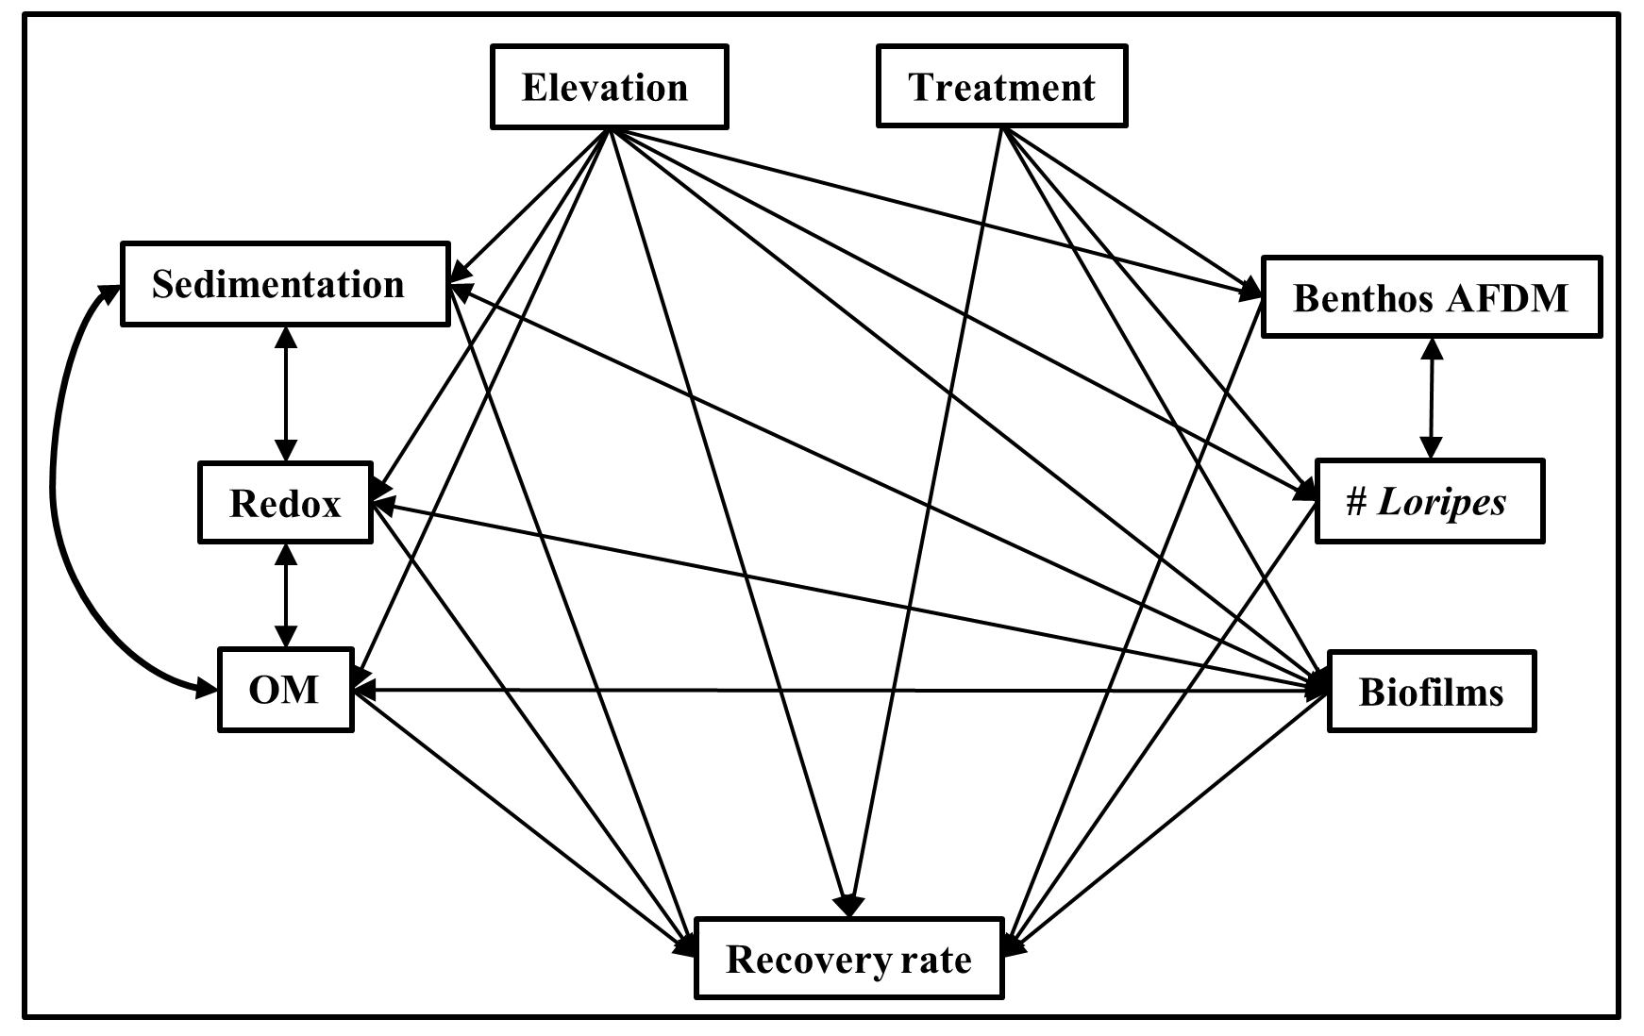
Figure S2. A priori meta-model of possible links of the predicted effects of elevation, treatment, and various abiotic and biotic factors on the recovery rate of seagrass after experimental die-off events at Zira, Banc d’Arguin.

Table S1. Complete outcomes of the fitted model tested in the Piecewise SEM showing standardized coefficients of the effects of elevation, die-off treatments, and various abiotic and biotic factors on the seagrass recovery after experimental die-off events at Banc d’Arguin, Mauritania. Significant paths (P < 0.05) are denoted in bold.
Response | Predictor | Estimate | SE | P-value | Std Estimate
Redox | Elevation | 0.004 | 0.007 | 0.556 | 0.152
Redox | Die-off size | 0 | 0.001 | 0.95 | -0.002
Sedimentation | Elevation | 0.385 | 0.044 | 0.001 | 0.625
Sedimentation | Die-off size | 0.158 | 0.059 | 0.008 | 0.154
Organic matter | Elevation | 0.836 | 0.054 | <0.001 | 0.903
Organic matter | Die-off size | -0.029 | 0.048 | 0.554 | -0.019
# Loripes | Elevation | -0.04 | 0.11 | 0.733 | -0.039
# Loripes | Die-off size | 0.306 | 0.118 | 0.011 | 0.176
Benthos AFDM | Elevation | 0.111 | 0.208 | 0.623 | 0.095
Benthos AFDM | Die-off size | 0.067 | 0.135 | 0.619 | 0.035
Benthos AFDM | Organic matter | 0.057 | 0.19 | 0.765 | 0.045
Biofilm | Elevation | 0.032 | 0.335 | 0.929 | 0.023
Biofilm | Die-off size | -0.015 | 0.055 | 0.787 | -0.006
Biofilm | Sedimentation | -0.151 | 0.065 | 0.022 | -0.106
Biofilm | Organic matter | -0.189 | 0.076 | 0.014 | -0.125
Recovery rate | Redox | 0.082 | 2.283 | 0.972 | 0.002
Recovery rate | Sedimentation | -0.075 | 0.049 | 0.128 | -0.034
Recovery rate | Organic matter | 0.005 | 0.06 | 0.938 | 0.003
Recovery rate | # Loripes | 0.009 | 0.027 | 0.732 | 0.007
Recovery rate | Benthos AFDM | -0.039 | 0.024 | 0.116 | -0.034
Recovery rate | Biofilm | -0.118 | 0.055 | 0.032 | -0.128
Recovery rate | Elevation | -0.409 | 0.294 | <0.001 | -0.306
Recovery rate | Die-off size | -0.218 | 0.041 | 0.236 | -0.098
Sedimentation | Organic matter | -0.114 | NA | 0.935 | -0.114
Sedimentation | Redox | -0.018 | NA | 0.597 | -0.018
Redox | Organic matter | 0.086 | NA | 0.125 | 0.086
# Loripes | Benthos AFDM | 0.313 | NA | <0.001 | 0.313
# Loripes | Redox | 0.096 | NA | 0.1 | 0.096
Notes: Estimate = standardized path coefficient; SE = standard error;
Std Estimate = conditional R²; Model Fisher's C statistic = 14.65; P = 0.56.

Supplementary 3: Macrofaunal recolonization
Figure S3. Seasonal change in benthos density (m⁻²) of the most common species (94%) found in the experimental plots (C = control, L = large, S = small) along an elevation gradient, (a) high zone and (b) low zone.

Figure S4. MDS plots showing differences in macrobenthic community assemblages between disturbed plots (large, small) and controls in two elevational zones (high, low) represented by 95% confidence interval ellipses. (a) six months, (b) 12 months, (c) 18 months, and (d) 24 months after defaunation.

References
1. Grace, J. B. Structural equation modeling and natural systems. (Cambridge University Press, Cambridge, 2006).
2. Grace, J. B., Anderson, T. M., Olff, H. & Scheiner, S. M. On the specification of structural equation models for ecological systems. Ecological Monographs 80, 67–87 (2010).
3. Edgar, G. J. et al. Abundance and local-scale processes contribute to multi-phyla gradients in global marine diversity. Science Advances 3, e1700419 (2017).
4. Lefcheck, J. S. piecewiseSEM : Piecewise structural equation modelling in r for ecology, evolution, and systematics. Methods in Ecology and Evolution 7, 573–579 (2016).
5. Lefcheck, J. S. & Duffy, J. E. Multitrophic functional diversity predicts ecosystem functioning in experimental assemblages of estuarine consumers. Ecology (2015).
6. Lefcheck, J. S. et al. Long-term nutrient reductions lead to the unprecedented recovery of a temperate coastal region. Proceedings of the National Academy of Sciences (2018).
7. Rosseel, Y. lavaan : An R Package for Structural Equation Modeling. Journal of Statistical Software 48, 1–36 (2012).

