Supporting Information
Rapid and selective recovery of palladium from platinum group metals and base metals using a thioamide-modified calix[4]arene extractant in environmentally friendly hydrocarbon fluids

Manabu Yamada ^{1†}, Muniyappan Rajiv Gandhi ^{2†§} & Atsushi Shibayama ²

¹ Research Center of Advanced Materials for Breakthrough Technology, Graduate School of Engineering Science, Akita University, Akita 010-8502, Japan.
² Graduate School of International Resource Sciences, Akita University, Akita 010-8502, Japan.

†These authors contributed equally to this work. §Current address: Quality Control Department, Panipat Refinery & Petrochemical Complex, Indian Oil Corporation Limited, Haryana 132140, India. Correspondence and requests for materials should be addressed to M.Y. (email: myamada@gipc.akita-u.ac.jp)

Contents
Preliminary data of X-ray crystallography measurement of crystals 1

Supporting Tables
Table S1. The concentrations of metal ions in the leached liquors of automotive catalysts after 5 times dilution.
Table S2. Stripping of Pd(II) from the automotive leached solution extracted in kerosene + 20% n-octanol phase of 1 by 1 M HCl, 1 M HNO₃, 10% (v/v) NH₃ aqueous solution and 0.5 M thiourea + 1.0 M HCl solution.

Supporting figures

Figure S1. Extraction of Pd(II) by 1 in kerosene, kerosene + 20% n-octanol and extraction
of Pd(II) by 2 in kerosene.

Figure S2. The FT-IR spectra of native 1 and acid treated 1.

Figure S3. Metal ions E% of 1 in ExxalTM 10 from catalyst leach liquors.
Conditions: shaking time = 30 min; [1] = 1.0 mM in ExxalTM 10; pH = 1.22
(~0.06 M HCl); O/A = 1; shaking speed = 300 rpm.

Figure S4. (a) Stripping of Pd(II) using 0.1 M thiourea/HCl (TU), (b) stripping of Pd(II)
using 10% (v/v) NH₃.

Figure S5. Stick diagram of 1. S = yellow, O = red, N = pale purple, C = dark grey (The H
atoms have been omitted for clarity).

Preliminary data of X-ray crystallography measurement of crystals 1
Single crystals of 1 for X-ray diffraction studies were grown from CHCl₃ by slow evaporation at room temperature. The crystals in mother liquid were picked up with a pipette, and dropped in Paratone-N oil. The single crystals coated with oil were isolated on MicroMountsTM, and the crystals were placed in a cold nitrogen steam at 93 K. X-ray diffraction data were collected a Rigaku Saturn 724 CCD diffractometer with Mo-Kα radiation (λ = 0.71073 Å). The structures were solved by direct methods using SHELXT-2014,¹ and refined using the full-matrix least-squares method on F² using SHELXL-2014.² All materials for publication were prepared by Yadokari-XG 2009 software.^{3,4}
Crystal data. C_{85.5}H_{132.5}Cl_{1.50}N₄O₅S₄, M =1477.95, colorless, crystal dimensions 0.35 × 0.35 × 0.10 mm³, triclinic, space group P -1, crystal description block, a = 13.4706(4), b = 18.5354(5), c = 19.9039(6) Å, α = 112.967(3)°, β = 91.894(2)º, γ = 97.076(2)°, V = 4522.9(2) Å³, Z = 1, Mo Kα radiation (λ = 0.71075 Å), ρ_{calcd} = 1.082 g/cm³, T = 93 K, µ(Mo Kα) = 0.197 mm⁻¹, 60181 measured reflections, 20511 unique reflections (R_{int} = 0.0373), 15535 observed reflections (I > 2σ(I)), 966 parameters, R = 0.1402, wR = 0.4487, refined against |F|, GOF = 1.884.
References
(1) Sheldrick, G. SHLEXT ‒ Integrated space-group and crystal-structure determination. Acta Crystallogr. Sect. A Found. Adv. 2015, 71, 3-8.
(2) Sheldrick, G. Crystal structure refinement with SHELXL. Acta Crystallogr. Sect. C Struct. Chem. 2015, 71, 3-8.
(3) Wakita, K. Yadokari-XG, software for crystal structure analyses. 2001.
(4) Kabuto, C.; Akine, S.; Nemoto, T.; Kwon, E. Release of software (Yadokari-XG 2009) for crystal structure analyses. Nippon Kessho Gakkaishi 2009, 51, 218-224.
Supporting Table
Table S1. The concentrations of metal ions in the leached liquors of automotive catalysts
after 5 times dilution.
Metal ions | [M]_{aq,init} (mg/L)
Pd  Pt  Rh  La  Ce  Y  Zr  Ba  Al | 92.8  54.2  37.2  86.7  608.8  3.8  25.6  289.3  320.9

Table S2. Stripping of Pd(II) from the automotive leached solution extracted in kerosene + 20% n-octanol phase of 1 by 1 M HCl, 1 M HNO₃, 10% (v/v) NH₃ aqueous solution and 0.5 M thiourea + 1.0 M HCl solution.
Stripping reagent | Pd(II) S%
0.1 M thiourea + 1.0 M HCl solution | 99.9
10% (v/v) NH₃ aqueous solution | 20.1
1 M HNO₃ | 16.4
1 M HCl | 15.3

Shaking time = 30 min; shaking speeds = 300 rpm; O/A= 1; temperature = 20 ± 1 °C.
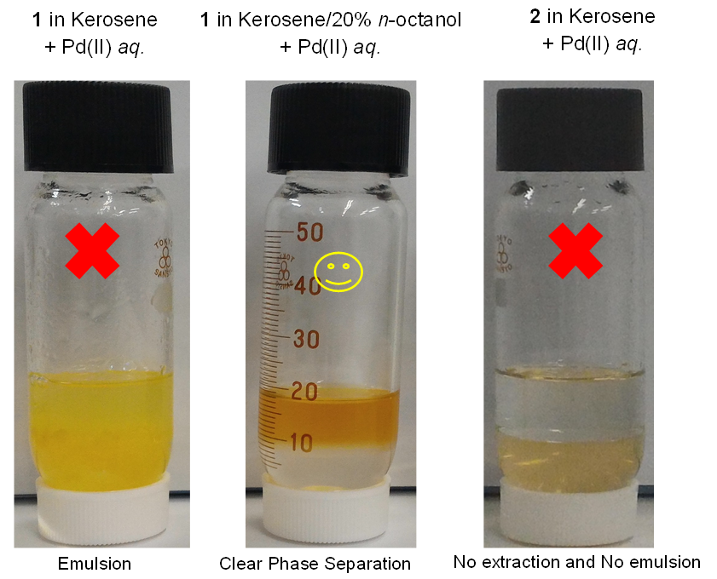
Figure S1. Extraction of Pd(II) by 1 in kerosene, kerosene + 20% n-octanol and extraction of Pd(II) by 2 in kerosene.

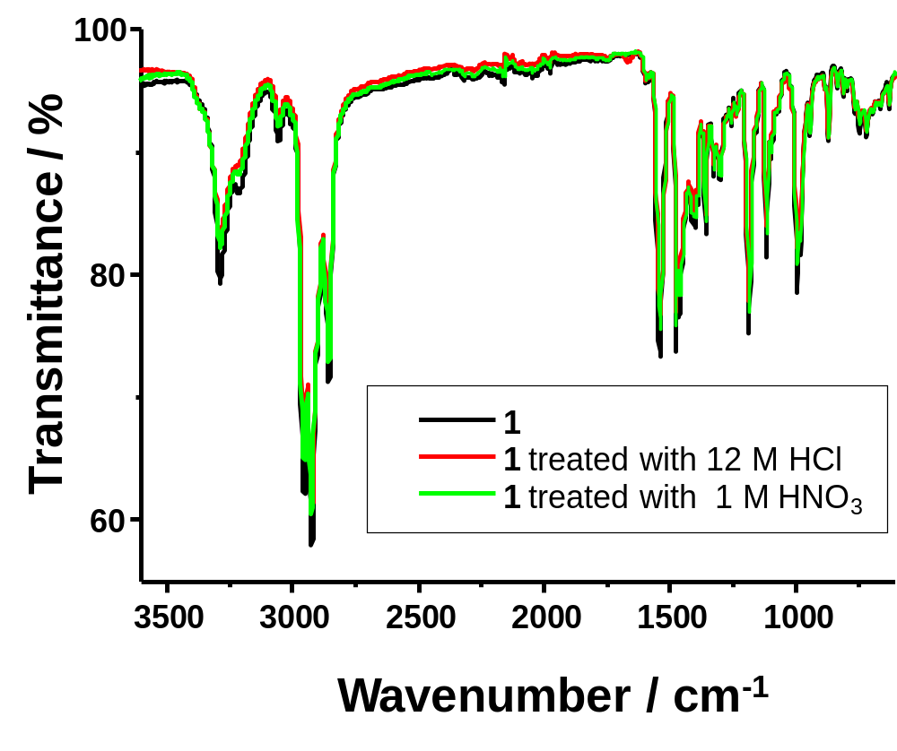
Figure S2. The FT-IR spectra of native 1 and acid treated 1.

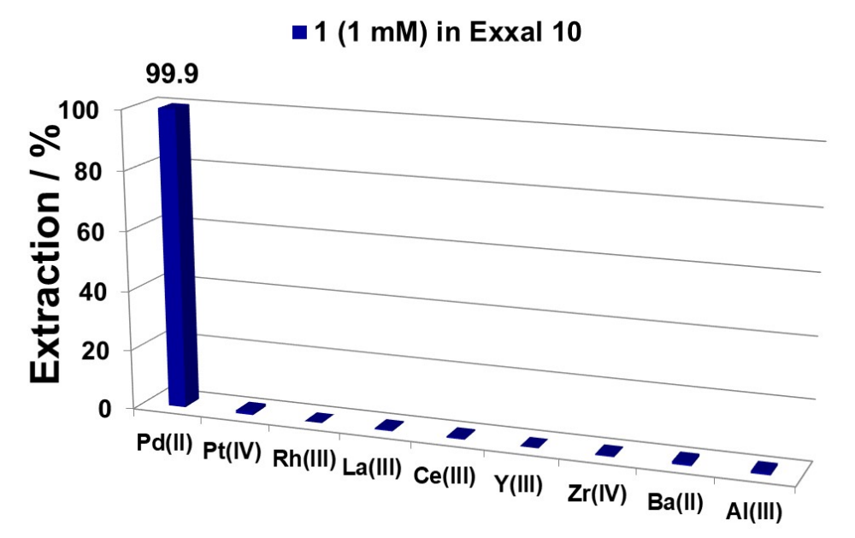
Figure S3. Metal ions E% of 1 in ExxalTM 10 from catalyst leach liquors. Conditions: shaking time = 30 min; [1] = 1.0 mM in ExxalTM 10; pH = 1.22 (~0.06 HCl); O/A = 1; shaking speed = 300 rpm.
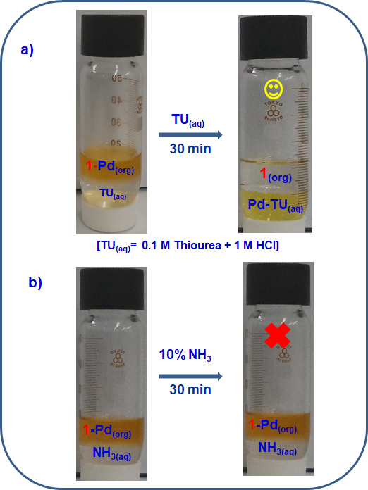

Figure S4. (a) Stripping of Pd(II) ion using 0.1 M thiourea/HCl (TU), (b) Stripping of Pd(II) ion using 10% (v/v) NH₃.
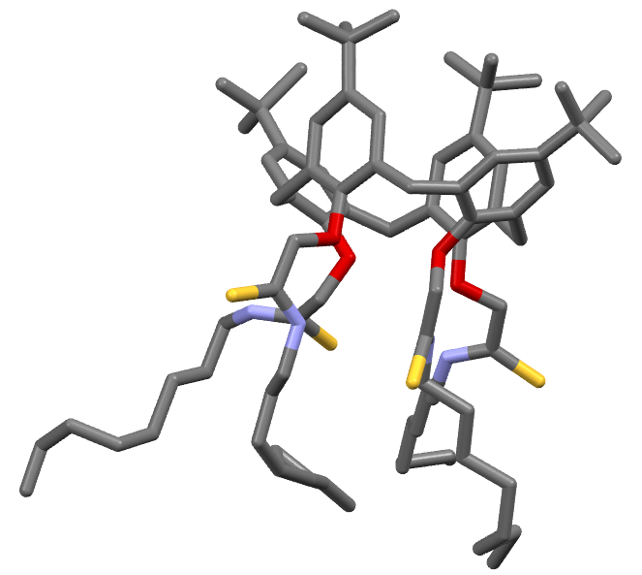
Figure S5. Stick diagram of 1. S = yellow, O = red, N = pale purple, C = dark grey (The H atoms have been omitted for clarity).

