Supplementary information to:

Telomerase gene expression bioassays indicate metabolic activation of genotoxic lower chlorinated polychlorinated biphenyls

Theresa Vasko¹, Jenny Hoffmann¹, Sonja Gostek¹, Thomas Schettgen¹, Natalia Quinete^{1,2}, Christian Preisinger³, Thomas Kraus¹ and Patrick Ziegler¹

1. Institute for Occupational, Social and Environmental Medicine, RWTH Aachen University, Aachen, Germany
2. Southeast Environmental Research Center, Florida International University Florida, USA.
3. Proteomics Facility, IZKF, RWTH Aachen University, Aachen, Germany

Supplemental Tables

Supplementary Table 1: Participants

 | N | Mean | Median | SD | Minimum | Maximum | 25thPerc. | 50thPerc. | 75thPerc. | 95thPerc.
Female | 15 | 46.4 | 47.8 | 10.3 | 27.5 | 60.6 | 42.8 | 47.8 | 53.1 | 58.5
Male | 77 | 46.8 | 46.3 | 12.5 | 23.1 | 84.3 | 38.0 | 46.3 | 57.5 | 62.5
Total | 92 | 46.7 | 47.6 | 12.2 | 23.1 | 84.3 | 39.3 | 47.6 | 57.0 | 62.3
Table 1a: Age distribution by gender within HELPcB-cohort 2011

 | N | Mean | Median | SD | Minimum | Maximum | 25thPerc. | 50thPerc. | 75thPerc. | 95thPerc.
Female | 15 | 50.3 | 51.6 | 10.3 | 31.5 | 64.6 | 46.8 | 51.6 | 57.1 | 62.5
Male | 77 | 50.7 | 50.2 | 12.4 | 27.1 | 88.3 | 41.9 | 50.2 | 61.1 | 66.4
Total | 92 | 50.6 | 51.4 | 12.1 | 27.1 | 88.3 | 43.2 | 51.4 | 60.7 | 66.3
Table 1b: Age distribution by gender within HELPcB-cohort 2015

 | N | Mean | Median | SD | Minimum | Maximum | 25thPerc. | 50thPerc. | 75thPerc. | 95thPerc.
Female | 56 | 43.7 | 45.3 | 13.8 | 18.7 | 67.9 | 30.2 | 45.3 | 56.2 | 63.3
Male | 46 | 42.4 | 45.0 | 14.0 | 24.6 | 70.3 | 27.5 | 45.0 | 52.9 | 64.1
Total | 102 | 43.1 | 45.0 | 13.9 | 18.7 | 70.3 | 29.3 | 45.0 | 55.4 | 64.0
Table 1c: Age distribution by gender within indoor-cohort

Supplementary Table 2: Distribution of non-dioxin-like PCB congeners within cohorts

 | PCB 28 | PCB 52 | PCB 101 | PCB ∑ lc | PCB 138 | PCB 153 | PCB 180 | PCB ∑ ndl
N valid | 92 | 92 | 92 | 92 | 92 | 92 | 92 | 92
N missing | 0 | 0 | 0 | 0 | 0 | 0 | 0 | 0
Mean | 0.629 | 0.104 | 0.222 | 0.954 | 2.047 | 2.147 | 1.359 | 6.507
Median | 0.054 | 0.005 | 0.019 | 0.079 | 0.699 | 0.945 | 0.782 | 2.634
SD | 2.582 | 0.680 | 1.365 | 3.397 | 3.467 | 3.102 | 1.843 | 10.253
Minimum | 0.005 | 0.005 | 0.005 | 0.015 | 0.101 | 0.129 | 0.081 | 0.358
maximum | 23.957 | 6.552 | 13.127 | 25.220 | 22.124 | 16.225 | 10.238 | 65.533
25thPerc. | 0.024 | 0.005 | 0.005 | 0.035 | 0.401 | 0.538 | 0.369 | 1.547
50thPerc. | 0.054 | 0.005 | 0.019 | 0.079 | 0.699 | 0.945 | 0.782 | 2.634
75thPerc. | 0.305 | 0.025 | 0.049 | 0.426 | 2.066 | 2.165 | 1.259 | 6.046
95thPerc. | 1.936 | 0.198 | 0.384 | 2.859 | 8.596 | 9.054 | 5.409 | 26.120
Table 2a: Distribution of non-dioxin like (ndl) PCB congeners with sum of lower chlorinated (lc) PCB 28, PCB 52 and PCB 101 and the sum of all non-dioxin like PCBs within HELPcB-cohort 2011
 | PCB 28 | PCB 52 | PCB 101 | PCB ∑ lc | PCB 138 | PCB 153 | PCB 180 | PCB ∑ ndl
N valid | 92 | 92 | 92 | 92 | 92 | 92 | 92 | 92
N missing | 0 | 0 | 0 | 0 | 0 | 0 | 0 | 0
Mean | 0.221 | 0.007 | 0.017 | 0.245 | 1.821 | 2.098 | 1.445 | 5.613
Median | 0.014 | 0.005 | 0.005 | 0.032 | 0.643 | 0.818 | 0.766 | 2.240
SD | 0.895 | 0.007 | 0.030 | 0.919 | 2.872 | 3.025 | 1.960 | 8.033
Minimum | 0.005 | 0.005 | 0.005 | 0.015 | 0.076 | 0.109 | 0.067 | 0.266
Maximum | 7.716 | 0.051 | 0.233 | 7.859 | 15.723 | 15.911 | 9.500 | 42.306
25thPerc. | 0.005 | 0.005 | 0.005 | 0.015 | 0.384 | 0.550 | 0.410 | 1.469
50thPerc. | 0.014 | 0.005 | 0.005 | 0.032 | 0.643 | 0.818 | 0.766 | 2.240
75thPerc. | 0.098 | 0.005 | 0.015 | 0.131 | 1.944 | 2.366 | 1.458 | 6.295
95thPerc. | 0.575 | 0.018 | 0.074 | 0.635 | 6.721 | 7.246 | 6.070 | 20.486
Table 2b: Distribution of non-dioxin like (ndl) PCB congeners with sum of lower chlorinated (lc) PCB 28, PCB 52 and PCB 101 and the sum of all non-dioxin like PCBs within HELPcB-cohort 2015

 | PCB 28 | PCB 52 | PCB 101 | PCB ∑ lc | PCB 138 | PCB 153 | PCB 180 | PCB ∑ ndl
N valid | 102 | 102 | 102 | 102 | 102 | 102 | 102 | 102
N missing | 0 | 0 | 0 | 0 | 0 | 0 | 0 | 0
Mean | 0.069 | 0.020 | 0.014 | 0.103 | 0.342 | 0.553 | 0.454 | 1.451
Median | 0.033 | 0.013 | 0.005 | 0.052 | 0.254 | 0.413 | 0.288 | 1.115
SD | 0.085 | 0.024 | 0.015 | 0.117 | 0.290 | 0.495 | 0.461 | 1.297
Minimum | 0.005 | 0.005 | 0.005 | 0.015 | 0.040 | 0.054 | 0.028 | 0.137
Maximum | 0.489 | 0.176 | 0.078 | 0.710 | 1.504 | 2.637 | 2.669 | 6.940
25thPerc. | 0.012 | 0.005 | 0.005 | 0.025 | 0.123 | 0.171 | 0.105 | 0.424
50thPerc. | 0.033 | 0.013 | 0.005 | 0.052 | 0.254 | 0.413 | 0.288 | 1.115
75thPerc. | 0.107 | 0.024 | 0.017 | 0.157 | 0.491 | 0.763 | 0.644 | 2.035
95thPerc. | 0.175 | 0.052 | 0.047 | 0.276 | 0.858 | 1.368 | 1.277 | 3.677
Table 2c: Distribution of non-dioxin like (ndl) PCB congeners with sum of lower chlorinated (lc) PCB 28, PCB 52 and PCB 101 and the sum of all non-dioxin like PCBs within indoor-cohort

Supplementary Table 3: Distribution of dioxin-like PCB congeners within cohorts
 | PCB 77 | PCB 81 | PCB 105 | PCB 114 | PCB 118 | PCB 123 | PCB 126 | PCB 156 | PCB 157 | PCB 167 | PCB 169 | PCB 189
N valid | 92 | 92 | 92 | 92 | 92 | 92 | 92 | 92 | 92 | 92 | 92 | 92
N missing | 0 | 0 | 0 | 0 | 0 | 0 | 0 | 0 | 0 | 0 | 0 | 0
Mean | 0.005 | 0.005 | 0.297 | 0.038 | 0.932 | 0.016 | 0.005 | 0.266 | 0.049 | 0.099 | 0.005 | 0.029
Median | 0.005 | 0.005 | 0.045 | 0.012 | 0.200 | 0.005 | 0.005 | 0.103 | 0.019 | 0.030 | 0.005 | 0.017
SD | 0.002 | 0.002 | 0.801 | 0.066 | 2.197 | 0.042 | 0.001 | 0.455 | 0.093 | 0.181 | 0.000 | 0.042
Minimum | 0.005 | 0.005 | 0.005 | 0.005 | 0.019 | 0.005 | 0.005 | 0.011 | 0.005 | 0.005 | 0.005 | 0.005
Maximum | 0.028 | 0.028 | 5.864 | 0.406 | 16.893 | 0.337 | 0.012 | 2.576 | 0.697 | 1.308 | 0.005 | 0.242
25thPerc. | 0.005 | 0.005 | 0.019 | 0.005 | 0.084 | 0.005 | 0.005 | 0.058 | 0.011 | 0.019 | 0.005 | 0.005
50thPerc. | 0.005 | 0.005 | 0.045 | 0.012 | 0.200 | 0.005 | 0.005 | 0.103 | 0.019 | 0.030 | 0.005 | 0.017
75thPerc. | 0.005 | 0.005 | 0.165 | 0.031 | 0.691 | 0.005 | 0.005 | 0.225 | 0.040 | 0.093 | 0.005 | 0.026
95thPerc. | 0.005 | 0.005 | 0.988 | 0.160 | 3.640 | 0.046 | 0.005 | 1.062 | 0.182 | 0.379 | 0.005 | 0.099
Table 3a: Distribution of dioxin like PCB congeners within HELPcB-cohort 2011

 | PCB 77 | PCB 81 | PCB 105 | PCB 114 | PCB 118 | PCB 123 | PCB 126 | PCB 156 | PCB 157 | PCB 167 | PCB 169 | PCB 189
N valid | 92 | 92 | 92 | 92 | 92 | 92 | 92 | 92 | 92 | 92 | 92 | 92
N missing | 0 | 0 | 0 | 0 | 0 | 0 | 0 | 0 | 0 | 0 | 0 | 0
Mean | 0.005 | 0.005 | 0.124 | 0.030 | 0.484 | 0.008 | 0.005 | 0.281 | 0.047 | 0.090 | 0.005 | 0.032
Median | 0.005 | 0.005 | 0.030 | 0.005 | 0.140 | 0.005 | 0.005 | 0.074 | 0.014 | 0.030 | 0.005 | 0.013
SD | 0.000 | 0.000 | 0.302 | 0.060 | 1.006 | 0.011 | 0.000 | 0.544 | 0.091 | 0.152 | 0.000 | 0.055
Minimum | 0.005 | 0.005 | 0.005 | 0.005 | 0.014 | 0.005 | 0.005 | 0.005 | 0.005 | 0.005 | 0.005 | 0.005
Maximum | 0.005 | 0.005 | 1.912 | 0.341 | 6.321 | 0.086 | 0.005 | 3.318 | 0.573 | 0.791 | 0.005 | 0.314
25thPerc. | 0.005 | 0.005 | 0.005 | 0.005 | 0.056 | 0.005 | 0.005 | 0.055 | 0.005 | 0.015 | 0.005 | 0.005
50thPerc. | 0.005 | 0.005 | 0.030 | 0.005 | 0.140 | 0.005 | 0.005 | 0.074 | 0.014 | 0.030 | 0.005 | 0.013
75thPerc. | 0.005 | 0.005 | 0.092 | 0.022 | 0.435 | 0.005 | 0.005 | 0.198 | 0.034 | 0.085 | 0.005 | 0.026
95thPerc. | 0.005 | 0.005 | 0.398 | 0.146 | 1.853 | 0.021 | 0.005 | 1.357 | 0.219 | 0.373 | 0.005 | 0.140
Table 3b: Distribution of dioxin like PCB congeners within HELPcB-cohort 2015
 | PCB 77 | PCB 81 | PCB 105 | PCB 114 | PCB 118 | PCB 123 | PCB 126 | PCB 156 | PCB 157 | PCB 167 | PCB 169 | PCB 189
N valid | 102 | 102 | 102 | 102 | 102 | 102 | 102 | 102 | 102 | 102 | 102 | 102
N missing | 0 | 0 | 0 | 0 | 0 | 0 | 0 | 0 | 0 | 0 | 0 | 0
Mean | 0.005 | 0.005 | 0.013 | 0.006 | 0.072 | 0.005 | 0.005 | 0.054 | 0.010 | 0.016 | 0.005 | 0.010
Median | 0.005 | 0.005 | 0.005 | 0.005 | 0.053 | 0.005 | 0.005 | 0.045 | 0.005 | 0.012 | 0.005 | 0.005
SD | 0.000 | 0.000 | 0.012 | 0.004 | 0.060 | 0.000 | 0.000 | 0.054 | 0.008 | 0.014 | 0.000 | 0.009
Minimum | 0.005 | 0.005 | 0.005 | 0.005 | 0.005 | 0.005 | 0.005 | 0.005 | 0.005 | 0.005 | 0.005 | 0.005
Maximum | 0.005 | 0.005 | 0.063 | 0.028 | 0.307 | 0.005 | 0.005 | 0.311 | 0.047 | 0.071 | 0.005 | 0.055
25thPerc. | 0.005 | 0.005 | 0.005 | 0.005 | 0.026 | 0.005 | 0.005 | 0.014 | 0.005 | 0.005 | 0.005 | 0.005
50thPerc. | 0.005 | 0.005 | 0.005 | 0.005 | 0.053 | 0.005 | 0.005 | 0.045 | 0.005 | 0.012 | 0.005 | 0.005
75thPerc. | 0.005 | 0.005 | 0.018 | 0.005 | 0.107 | 0.005 | 0.005 | 0.075 | 0.014 | 0.023 | 0.005 | 0.013
95thPerc. | 0.005 | 0.005 | 0.037 | 0.013 | 0.203 | 0.005 | 0.005 | 0.140 | 0.026 | 0.043 | 0.005 | 0.025
Table 3c: Distribution of dioxin like PCB congeners within indoor-cohort

Supplementary Fig. 1: Structural formulas of OH-PCBs used in this study.
3-OH-CB28
3-OH-CB101
4-OH-CB101
3´-OH-CB28
PCB28
Cl
Cl
Cl
Cl
Cl
Cl
HO
Cl
Cl
Cl
OH
Cl
Cl
Cl
OH
4´-OH-CB31
Cl
Cl
Cl
HO
4-OH-CB25
Cl
Cl
Cl
OH
Cl
Cl
PCB101
Cl
Cl
Cl
Cl
Cl

Cl
Cl
Cl
OH
Cl
Cl

Supplementary Fig. 2: Full-length Western Blot H2Ax. Exposure time: 50 seconds. Last sample was not part of the experiment.

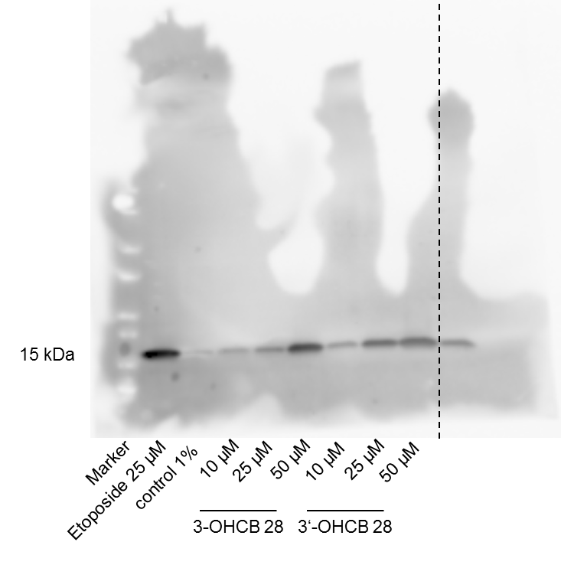

Supplementary Fig. 3: Full-length Western Blot β-Actin (stripped after γH2Ax detection). Exposure time: 110 seconds. Last sample was not part of the experiment.

