Supplementary Materials for

Unprecedented rains are damaging for surface microbial communities in the hyperarid core of the Atacama Desert

A. Azua-Bustos^{1,2*}, A. G. Fairén^{1,3*}, C. González Silva⁴, C. Ascaso⁵, D. Carrizo¹, M.Á. Fernández-Martínez¹, M. Fernández-Sampedro¹, L. García-Descalzo¹, M. García-Villadangos¹, M.P. Martin-Redondo¹, L. Sánchez-García¹, J. Wierzchos⁵, and V. Parro¹

Affiliations:
¹ Centro de Astrobiología (CSIC-INTA), 28850 Madrid, Spain.
² Instituto de Ciencias Biomédicas, Facultad de Ciencias de la Salud, Universidad Autónoma de Chile, Santiago, Chile.
³ Department of Astronomy, Cornell University, Ithaca 14853 NY, USA.
⁴ Centro de Investigación del Medio Ambiente (CENIMA), Universidad Arturo Prat, Iquique, Chile.
⁵ Museo Nacional de Ciencias Naturales (CSIC), 28006 Madrid, Spain.

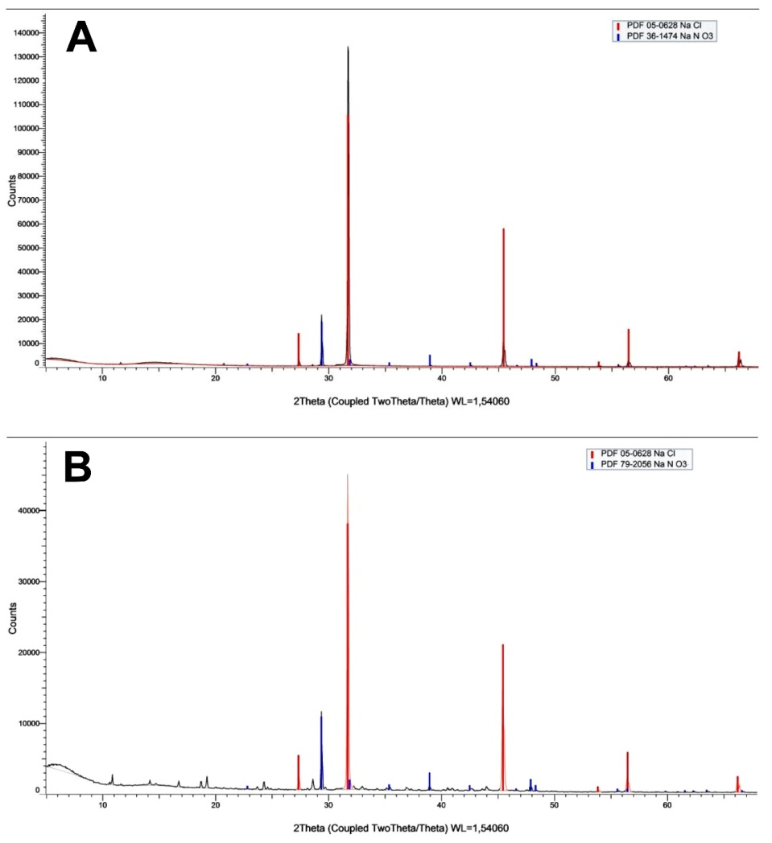
Fig. S1. XRD graphs of the sampled lagoons. (A) Large lagoon. (B) Medium sized lagoon. XRD could not be performed in samples of the small lagoon because its extreme salinity maintained these samples liquefied despite several crystallization attempts, suggesting the presence of perchlorates⁵⁴.

Table S1. Lipid biomarkers identified in the lagoons. (nd: not detected).
 | Lipid Biomarker | Small | Medium | Large
 | n-alkanes
 | Heptadecane (C19) | nd | 0,001 | nd
 | Eicosane (C20) | 0,002 | 0,001 | 0,003
 | Heneicosane (C21) | 0,001 | 0,005 | 0,004
 | Docosane (C22) | 0,002 | 0,002 | 0,002
 | Tricosane (C23) | 0,005 | 0,012 | 0,010
 | Tetracosane (C24) | 0,002 | 0,002 | 0,007
 | Pentacosane (C25) | 0,012 | 0,013 | 0,012
 | Hexacosane (C26) | 0,005 | 0,014 | 0,012
 | Heptacosane (C27) | 0,026 | 0,029 | 0,034
 | Octacosane (C28) | 0,011 | 0,013 | 0,015
 | Nonacosane (C29) | 0,035 | 0,035 | 0,043
 | Triacontane (C30) | 0,017 | 0,014 | 0,018
 | Hentriacontane (C31) | 0,024 | 0,038 | 0,022
 | Pristane (2,4,10,14-tetramethylpentadecane) | nd | nd | nd
 | Phytane (2,4,10,14-tetramethylhexadecane) | nd | nd | nd
 | n-carboxylic acids
 | Hexadecanoic acid (C16:0) | 0,06 | 0,16 | 0,12
 | 16-methylheptadecanoic acid (iso C18) | nd | 0,05 | 0,03
 | Octadecanoic acid (C18:0) | 0,09 | 0,18 | 0,15
 | 14-methylhexadecanoic acid (anteiso C17) | nd | nd | nd
 | Heptadecanoic acid (C17:0) | nd | nd | nd
 | 15-methylheptadecanoic acid (anteiso C18) | nd | nd | nd
 | 15-methylhexadecanoic acid (iso C17) | nd | nd | nd
 | n-alkanols
 | Dodecanol (C22) | nd | nd | nd
 | Tridecanol (C23) | nd | nd | nd
 | Tetradecanol (C24) | nd | nd | nd
 | Pentadecanol (C25) | nd | nd | nd
 | Hexadecanol (C26) | nd | nd | nd
 | Heptadecanol (C27) | nd | nd | nd
 | Octadecanol (C28) | nd | nd | nd
 | Sterols
 | Cholesterol | nd | nd | nd
 | Stigmastanol | nd | nd | nd
 | β-Sitosterol | nd | nd | nd

Table S2. Inductively coupled plasma mass spectrometry (ICP-MS) conditions.
 | Component/Parameter | Type/value
 | Nebulizer | MEINHARD® pluss Glass Type C
 | Spray Chamber(Peltier-cooled) | Glass Cyclonic At 5°C
 | Sampler and skimmer cones | Nickel
 | Sample Uptake Rate | 350μL/min
 | PF Power | 1600 W
 | Injector | 2.0 mm Id quartz
 | Sweeps | 20
 | Dwell Time | 25
 | Replicates | 3
 | Mixing Tee | On-line addition of internal standard

Table S3. Standards used in ICP-MS.

Element | External Standard1 (ppb) | QC.Std1 (ppb)
Ag | 50 | 100
Al | 49 | 98
As | 490 | 980
B | 490 | 980
Ba | 48.5 | 97
Be | 510 | 1020
Bi | 49 | 98
Ca | 4945 | 9890
Cd | 49.5 | 99
Co | 49.5 | 99
Cr | 49.5 | 99
Cu | 49.5 | 99
Fe | 500 | 1000
Ga | 49.5 | 99
K | 49 | 98
Li | 49.5 | 99
Mg | 49 | 98
Mn | 49.5 | 99
Mo | 49.5 | 99
Na | 48.5 | 97
Ni | 49.5 | 99
Pb | 49 | 98
Rb | 49.5 | 99
Se | 505 | 1010
Sr | 500 | 1000
Te | 49.5 | 99
Tl | 49.5 | 99
U | 49 | 98
V | 49 | 98
Zn | 495 | 990
Ce | 50 | 100
Dy | 50 | 100
Er | 50 | 100
Eu | 50 | 100
Gd | 50 | 100
Ho | 50 | 100
La | 50 | 100
Lu | 50 | 100
Nd | 50 | 100
Pr | 50 | 100
Sm | 50 | 100
Sc | 50 | 100
Tb | 50 | 100
Th | 50 | 100
Tm | 50 | 100
Y | 50 | 100
Yb | 50 | 100

Table S4. ICP-MS electronic dilutions conditions.

 | Element | Mass | Abundance | RPa value
 | Na | 23 | 100% | 0.018
 | K | 39 | 93% | 0.015

Table S5. ICP-MS gas conditions.

 | Element | Isotope analyzed | He flow (KED mode)(l/min)
 | Al | 27 | 1
 | Mn | 55 | 1
 | Cu | 65 | 1
 | Co | 59 | 1
 | Cd | 111 | 1
 | Ba | 137 | 1
 | Pb | 208 | 1
 | U | 238 | 1
 | Na | 23 | 4
 | Mg | 24 | 4
 | K | 39 | 4
 | Ca | 44 | 4
 | Cr | 52 | 4
 | Fe | 56 | 4
 | Ni | 60 | 4
 | Zn | 66 | 4
 | As | 75 | 4
 | P | 31 | 4

