Supplementary Online Material for

Systematic Study of Ferromagnetism
in Cr_{x}Sb_{2-x}Te₃ Topological Insulator Thin Films
using Electrical and Optical Techniques

Angadjit Singh^{a,*}, Varun Kambojª, Jieyi Liuª, Justin Llandro^{a,c}, Liam B. Duffy^{b}, Satyaprasad P. Senanayakª, Harvey E. Beereª, Adrian Ionescuª, David A. Ritchieª, Thorsten Hesjedal^{b,*} and Crispin H.W. Barnes^{a,*}

ªCavendish Laboratory, University of Cambridge, J. J. Thomson Avenue,
Cambridge CB3 0HE, United Kingdom

^{b}Clarendon Laboratory, Department of Physics,University of Oxford, Oxford OX1 3PU, United Kingdom

^{c} Laboratory for Nanoelectronics and Spintronics, Research Institute of Electrical Communication, Tohoku University, 2-1-1 Katahira, Aoba-ku, Sendai 980-8577, Japan

Correspondence to: as2331@cam.ac.uk, chwb101@cam.ac.uk

Keywords: topological insulators, Cr-doped Sb₂Te₃, anomalous Hall effect, ion gel gating, THz spectroscopy, MOKE, RKKY interaction

Supplementary Section S1: X-ray photoelectron spectroscopy (XPS)
Figure S1. X-ray photoelectron spectroscopy (XPS) spectra in the Te 3d region as a function of Cr concentration x.

Figure S1 shows XPS data measured in the Te 3d region. In order to confirm that Cr is occupying Sb sites, and not Te sites, we analyze the Te 3d peaks for the highly doped samples with x = 0.58 and x = 0.76. When comparing these doping concentrations, we only observe a negligible shift of 0.4 eV of the peak position of the Te 3d peaks at ~573eV. This slight shift in the XPS peaks could be due to the relative distribution of the Te-O and Cr-O bonds inside the crystal structure. Nevertheless, it should be noted that the peaks at 576 eV and 586 eV are difficult to be discerned as Cr-O or Te-O as their binding energies are very similar.

Supplementary Section 2: Magneto Optical Kerr Effect (MOKE) setup.

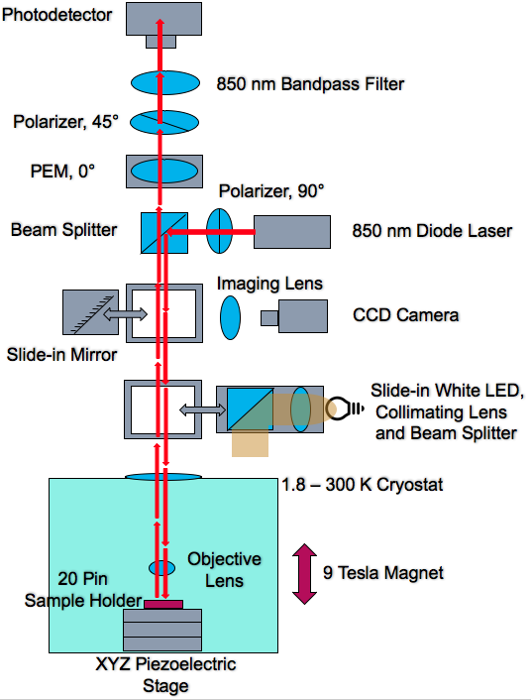
Figure S2. Schematics of the polar MOKE setup.

The light coming from an 850 nm diode laser was polarized by a Glan-Taylor polarizer and reflected by a beam splitter into the vertical main optical path. After passing through the cryostat window, the laser was focused down to a 3 μm spot on the sample via an objective lens. The then reflected light travelled through a PEM, a second Glan-Taylor polarizer, and an 850 nm bandpass filter before reaching the detector. A slide-in imaging system consisting of a CCD camera and a white illumination bulb is available if an optical image is to be captured.

Supplementary Section 3.1: Angular-dependent Hall measurements on Cr_{0.76}Sb_{1.24}Te_{3.}

I
θ
B
B’
Figure S3.1 (a). Angular dependence of the Hall resistance R_{xy} at 1.8 K for a representative 20-QL-thick Cr_{0.76}Sb_{1.24}Te₃ sample. The sketch on the right illustrates the definition of the out-of-plane angle θ with respect to the direction of the applied current I (θ = 0° along I).

Angular magneto-transport measurements were carried out on a 20-QL-thick Cr_{0.76}Sb_{1.24}Te₃ sample as shown in Figure S3. As the angle θ of the sample changes from out-of-plane (θ = 90°) to in-plane (θ = 0°), the value of R_{xy} reduces and the slope gradually changes from positive to negative until we see a parabolic dependence at θ = 0°. This parabolic behavior at θ = 0° indicates a strong spontaneous out-of-plane magnetization at zero field, confirming the out-of-plane magnetic anisotropy of the films.

Supplementary Section 3.2: Magnetotransport measurements on an undoped, 20-nm-thick Sb₂Te₃ thin film topological insulator
(a)
(b)
Figure S3.2. (a) Weak antilocalization effect in an undoped Sb₂Te₃ sample. Normalized conductivity changes as a function of magnetic field measured at 1.7 K. Each data set (dots) is fitted to the HLN formula. The cusp in conductance (or dip in resistance) is a characteristic feature of the WAL effect. (b) Normalized longitudinal resistance of a pure Sb₂Te₃ showing the WAL effect compared to a Cr doped Sb₂Te₃ sample with x = 0.15.

To check whether Sb₂Te₃ is a TI or not, we conducted magnetotransport measurements on a 20-nm-thick Sb₂Te₃ thin film grown on a sapphire substrate. Figure S3.2 (a) displays the normalised magneto-conductivity for the sample, defined as ∆$σ_{xx}= σ_{xx}\left(B\right)- σ_{xx}\left(0\right)$, at 1.7 K as a function of magnetic field B. A sharp increase in the conductivity is observed at low magnetic field B. This demonstrates the weak antilocalization (WAL) behaviour, a phenomenon which demonstrates both the Dirac nature of the surface state carriers as well as the strong spin−orbit interaction in pristine TI materials^{25,26,27}.
The HLN equation describes the quantum correction to the conductivity due to localization or anti-localization effects as²⁷:
∆$σ_{xx}= σ_{xx}\left(B\right)- σ_{xx}\left(0\right)= α\frac{e^{2}}{2π^{2 }ℏ}\left[ln\left(\frac{ℏ}{4eBL_{φ}^{2}}\right)- Ψ\left(\frac{1}{2}+\frac{ℏ}{4eBL_{φ}^{2}}\right)\right]$ (1)
where $∆σ_{xx}$ indicates the normalized 2D sheet conductivity, B is the magnetic field perpendicular to the plane of the film, $e$ is the electron charge, $ℏ$ is the reduced Planck constant,$Ψ$ is the digamma function, $α$ is the number of topological surface modes (TSM) and $L_{φ}$ is the phase coherence length.
We further obtained the value of the prefactor α by fitting the normalized conductvity data (dotted line) with the HLN model (solid line) described by equation 1 in Ref. [27] . A value of α ≈ 1 was obtained which strongly suggests a surface dominated transport with two symmetric decoupled channels (top and bottom), as expected in a pristine TI thin film²⁶. When the samples were physically doped with Cr, instead of observing the WAL effect (a dip in resistance at 0 T or peak in conductance) as shown in Figure S3.2(a), we observed a peak in the resistance at ~ 0 T (or dip in conductance) corresponding to the magnetoresistance effect as shown in the Figure S3.2(b) for x = 0.15. A similar increase in the resistance was also observed with increasing x as displayed in Figure 2(a,e) of the manuscript.

Supplementary Section 4: Electrostatic ion gel gating
(b)
(a)
Insulating Al₂O₃
substrate
ion gel DEME-TFSI
S
D
G
TI thin film Hall bar
V_{xx}
V_{xy}
Figure S4. (a) Schematic of the ion gel drop casted on top of a Hall bar (b) Gate bias dependence of the Hall traces R_{xy} in a sample with x = 0.58 at 1.8 K showing a decrease in the AHE from +3V to -3V.
To check if the controllability of the electrostatic gating was reproducible, the measurements presented in the main text were repeated on a sample with x = 0.58. The results were taken using the opposite sequence, i.e., first +3 V, followed by 0 V and then -3 V. The results are very similar to those reported in the main text, showing an increase in the anomalous Hall resistance at -3 V with decreased carrier density compared to +3V. This directly suggests carrier-mediated magnetism attributed to the RKKY mechanism.

Supplementary Section 5.1: Real and imaginary transmission spectra through 20-QL-thick Cr_{x}Sb_{2-x}Te₃ films.

(a)
(b)

Figure S5.1. (a) Imaginary and (b) real transmission spectra as a function of frequency for different Cr concentrations.

Figure S5.1 shows the imaginary and real components of transmission, obtained from the Fourier transform of the time resolved primary pulse response [Figure 5(a) in the main text], through a 20-QL-thick Cr_{x}Sb_{2-x}Te₃ film at 4 K. The imaginary part of the transmission signal reflects the accompanying phase changes in the real part of the transmission.

Supplementary Section 5.2: THz response of the (0001)-oriented sapphire substrate and the 20-QL Cr_{0.76}Sb_{1.24}Te₃ film.

(a)
(b)

Figure S5.2. (a) Time-domain ps pulse response for transmission through a 20-QL Cr_{0.76}Sb_{1.24}Te₃ film. The reference is transmission through the (0001) sapphire substrate. The inset shows a magnified time-domain ps pulse response for both cases. (b) Normalized transmission amplitude spectra with respect to the substrate (at the same temperature), obtained from the Fourier transform of the temporal THz signal through Cr_{0.76}Sb_{1.24}Te₃ from 250 K to 5 K.

The time-resolved THz transmission through a 20-QL Cr_{0.76}Sb_{1.24}Te₃ film was measured at various temperatures as shown in Figure S5.2(a). We further normalized the Fourier transform of the transmission through the Cr_{0.76}Sb_{1.24}Te₃ film to the signal through the sapphire substrate at the same temperature, to remove any substrate effects [see Figure S5.2 (b)].

