Supplementary Information

Direct isotopic evidence of biogenic methane production and efflux from beneath a temperate glacier

Burns, Rª; Wynn PM^{a*}; Barker, Pª; McNamara, N^{b}; Oakley, S^{b}; Ostle, Nª; Stott, AW^{b}; Tuffen, Hª; Zheng Zhouª; Tweed, FS^{c}; Chesler, A^{a,d}; Stuart, Mª

ªLancaster Environment Centre, University of Lancaster, Lancaster,
LA1 4YQ. UK.

^{b}Centre for Ecology and Hydrology, Lancaster, LA1 4AP. UK

^{c} Geography, Staffordshire University, College Road, Stoke-on-Trent, Staffordshire, ST4 2DE. UK

^{d}School of Earth and Climate, The University of Maine, 5790 Bryand Global Sciences Center,
Orono, ME 04469. USA

* Corresponding author. Tel. +44(0)1524 510235. E-mail address: p.wynn@lancaster.ac.uk
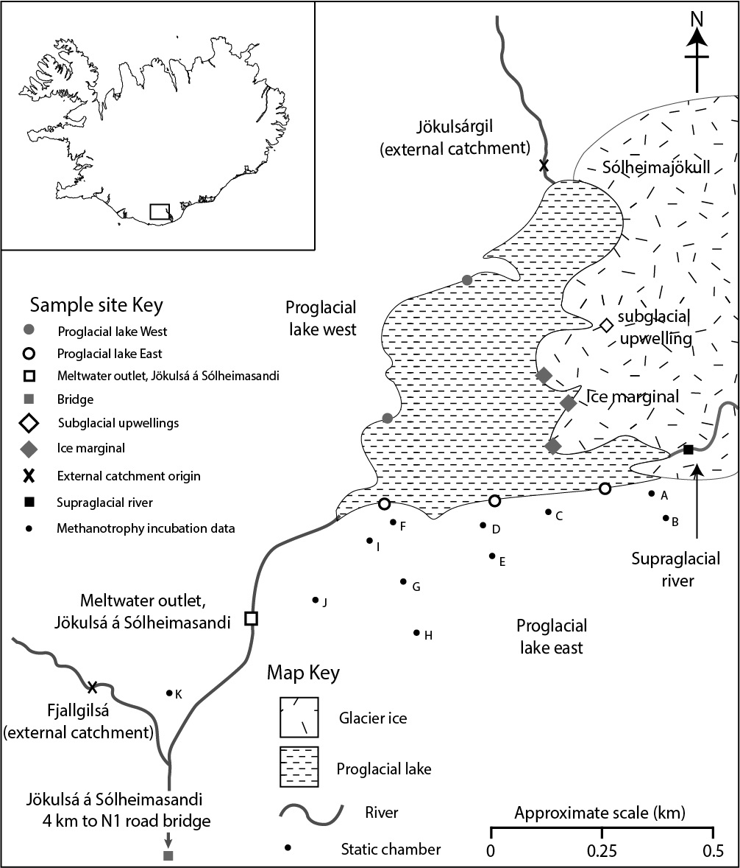

Supplementary Figure S1: Location map of Sólheimajökull, Iceland, site characteristics and sampling locations during 2013-2017. Sólheimajökull is an Icelandic maritime glacier located on the south coast of Iceland, draining the Mýrdalsjökull ice cap. It is 8 km long, temperate, non-surging, and has a maximum ice-covered catchment area of 78 km² that extends from the ice-marginal proglacial lake towards the southwestern rim of the Katla subglacial caldera.

Supplementary Figure S2: Incubation of subglacial sediments to determine rates and characteristics of both methane production (methanogenesis) and methane consumption (methanotrophy). S2a: Methane production from incubated sediments over a 49-day incubation period. Extrapolated methane production rate of 1.1 x 10⁷ fmol per g dry weight sediment per hour. This production rate compares to other published values ranging between 126 fmol g⁻¹ hr⁻¹ (incubations undertaken at 15°C^{[10]}); to 10⁵ fmol g⁻¹ hr⁻¹ (incubations undertaken at 10°C^{[9]}) in Canadian and Antarctic sediments respectively. S2b: Methanotrophic activity over a 7-day incubation period. Extrapolated methane consumption rate of 9.6 x 10⁹ fmol per g dry weight of sediment per hour. S2c: The isotopic fractionation trajectory of δ¹³CCH₄ and DCH₄ during incubation of sediments to stimulate methanotrophic activity. S2d: Changes in the carbon and hydrogen isotopic value of residual methane during incubation and methanotrophy of subglacial sediments. Fractionation between the starting methane isotopic composition (CH_{4(i)}) and composition of residual methane (CH_{4(t)}) is quantified as α=1.019 for fractionation of ¹³C/¹²C, and for fractionation of D/H as α=1.197 (see methods in main manuscript for calculation). The calculated gradient is compared to field data (this study) in Figure 1.

Table S1: Methane flux data from static chambers located within the proglacial sedimentary deposits of Sólheimajökull. Data are presented as µM CH₄ m⁻² day⁻¹ with the range of values given in parentheses and number of replicates presented as n =. The location of each experimental chamber is given in Supplementary Figure S1.

Static chamber | Day of year 2013  (µM CH₄ m⁻² day⁻¹) |  |  |  |  |  |  | Day of year 2014  (µM CH₄ m⁻² day⁻¹)
Static chamber | 187 | 190 | 192 | 195 | 196 | 198 | 203 | 136
A |  | -0.0054  (-0.0264 to 0.0059)  n=3 |  | 0.0392  (-0.0327 to 0.1256  n=3 |  |  |  | -0.0301  (-0.0442 to -0.0143  n=3
B |  |  |  |  | 0.000  (-0.0057 to 0.0029  n=3
C |  | 0.0055  (-0.0038 to 0.0008)  n=3 |  | 0.0019  (-0.0155 to -0.0082)  n=3 |  |  |  | 0.0033  (-0.0047 to 0.0099)  n=3
D |  |  |  |  | -0.0058  (-0.0082 to -0.0041)  n=3
E |  |  |  |  |  | -0.0047  (-0.0091 to 0.0070)  n=3
F | -0.0258  (-0.0552 to 0.0033)  n=3 | 0.0355  (0.0341 to 0.0828)  n=3 | -0.0092  (-0.0191 to 0.0072)  n=3 | -0.0041  (-0.0114 to 0.0000)  n=3 |  |  |  | -0.0781  n=1
G |  |  | 0.0160  (-0.0008 to 0.0322)  n=3 | 0.0023  (-0.0007 to 0.0060)  n=3
H |  |  | 0.0009  (-0.0086 to 0.0141)  n=3 | -0.0002  (-0.0070 to 0.0039)  n=3
I |  |  | -0.0038  (-0.0139 to 0.0029)  n=3
J |  |  |  |  |  | 0.0069  (-0.0124 to 0.04234)  n=3
K |  |  |  |  |  |  | 0.0053  (0.0016 to 0.0089)  n=3

