High-throughput screens identify HSP90 inhibitors as potent therapeutics that target inter-related growth and survival pathways in advanced prostate cancer
Keith H. Jansson¹, John B. Tucker¹, Lauren E. Stahl¹, John K. Simmons², Caitlyn Fuller¹, Michael L. Beshiri¹, Supreet Agarwal¹, Lei Fang¹, Paul G. Hynes¹, Aian Neil Alilin¹, Ross Lake¹, Yasmine C. Abbey¹, Jacob Cawley¹, Caitlin M. Tice¹, JuanJuan Yin¹, Crystal McKnight³, Carleen Klummp-Thomas³, Xiaohu Zhang³, Rajarshi Guha³, Shelley Hoover², R. Mark Simpson², Holly M. Nguyen⁴, Eva Corey⁴, Craig J. Thomas³, David A. Proia⁵, Kathleen Kelly¹

Supplementary Materials:

Materials and Methods

Supplementary Figure 1. PCAP cell lines characterization.

Supplementary Figure 2A. Violin plot of ganetespib MAXR values from multiple cancer cell lines across various histologies analyzed in the MIPE screen at NCATS. B. Comparison of HSP70 protein induction between ganetespib and onalespib in PCAP-1 cells.

Supplementary Figure 3. qPCR and western blot analysis of G2/M progression proteins and AR in PCAP and LNCaP cell lines.

Supplementary Figure 4. Plot of individual tumor volumes for ganetespib + castration study on LuCaP 136 in vivo.

Supplementary Table 1. Antibodies used for western blots and IHC.

Supplementary Table 2. Primers used for Real Time qPCR.

Supplementary Table 3. Complete list of compounds from the MIPE library that displayed -1.1 or -1.2 curve response class activity in at least 4 of 7 PCAP cell lines.

Supplementary Table 4. List of compounds from the MIPE library that did not display activity against a majority (4 of 7) PCAP cell lines.

Supplementary References.

Materials and Methods
Established Human Cell Line Culture Conditions:
LAPC4, LNCaP, LNCaP-AR, DU145, and PC-3 cells were obtained from ATCC and cultured as described previously^{1,2}.

Efficacy Studies in vitro:
PCAP cell lines were processed to single cells as described earlier. Processed cells were seeded in 96 well plates at a concentration of 2,000 cells/well to reach 40-50% confluency 24 hours post-plating. Ganetespib was purchased from Selleckchem.com (S1159) and the HSP90 inhibitors onalespib, SNX2112, and XL888 were generously provided by the laboratory of Dr. Len Neckers. The next day the seeded cells were drugged in a ten point, serial-diluted, dose response assay starting with 1μM as the maximum concentration. After a 48 hour incubation, the assay was terminated with MTS according to the manufacturer instructions (G3581, Promega) on a plate reader at 490nM absorbance. Background absorbance was removed and each well was normalized to the average of the DMSO treated wells. All concentrations of each drug were assayed in triplicate and each cell line was repeated a minimum of three times. Dose response data were plotted and analyzed statistically using GraphPad Prism 6 software.

Flow Cytometry Analysis:
PCAP, LNCaP, and LAPC4 cell lines at 50% confluency were drugged with DMSO vehicle control or 125nM ganetespib for 24 or 48 hours. Approximately five million live cells in 500uL PBS were fixed in 4.5 mL cold 100% EtOH, centrifuged at 1000 X g for 5 minutes, and resuspended in 1 mL of staining solution (0.1% Triton X-100, 0.2mg/mL RNAse A, 0.02mg/mL propidium iodide). A minimum of 30,000 events were measured for each cell line under each treatment condition on an LSR Fortessa (BD Biosciences) set to gate out aggregated cell doublets. Analysis was performed using FlowJo (FlowJo, LLC) and each experiment was repeated a minimum of 3 times.

Three-Dimensional Culture of PCAP Cell Lines:
PCAP cell lines were processed to single cells as described earlier. Fifty microliters of a solution containing a 1:1 ratio of Matrigel® (354234, Corning) and 1000 cells in Stemgent was pipetted into each well of a 24-well plate, incubated for one hour at 37°, and 500uL of Stemgent was added to each well. Cultures were treated 24 hours post-plating with DMSO or 16nM ganetespib. Media was exchanged with or without ganetespib every 3-4 days for one week. Individual spheres were counted using phase contrast microscopy, with spheres defined as three dimensional organoids greater than 50μm. Each experiment was completed in duplicate a minimum of three times.

Western Blot Analysis:
All protein was extracted using RIPA buffer supplemented with phosphatase and protease inhibitors. Samples were prepared as follows. Cell lines: Cell lines were treated with DMSO or 125nM ganetespib 24 hours post-seeding (at 40-50% confluency) for 24 or 48 hours. Organoids: LuCaP organoids cultured for two weeks in 12-well plates were exposed to DMSO or 125nM ganetespib for 24 or 48 hours. Cells were extracted from the matrix by incubating 90 minutes with dispase (1 mg/mL). Tumors: Pb-Cre4+;Ptenfl/fl;P53fl/fl GEMM and LuCaP PDX tumors were harvested, snap frozen in liquid N₂, and dounce homogenized. Western blots were performed on 4-20% Tris Glycine gels (05671093, BioRad), transferred to PVDF membranes, and blocked in PBS-T containing 5% dry milk. Primary antibodies (Supplementary Table 1) were incubated overnight at 4° C and secondary antibodies were applied the next day for 1 hour at room temperature using a concentration of 1:2000. Western blots were exposed using Clarity Western ECL Substrate (170-5061, BioRad) on a ChemiDoc Touch exposure system (BioRad). All western blots are representative of a minimum of three experiments. Control and ganetespib-treated samples were run adjacently on the same gels, unless indicated otherwise.

Immunohistochemistry:
Prostate tumors from PB-Cre4;Pten^{fl/fl};Tp53^{fl/fl} GEMM mice and subcutaneous LuCaP 136 tumors were fixed in 4% PFA, sectioned, and H&E stained at Histoserv Inc (Germantown, MD). Slides were processed, stained, and imaged as described previously (Supplementary Table 1)³.
Real-time qPCR:
LuCaP 73, LuCaP 136, LuCaP 141, and LuCaP 167 tumors were processed and grown as described earlier. For organoid RNA, 500 μl of Trizol was dispensed into each well, incubated for 10 minutes, and extracted using 200 μL of a chloroform/isoamyl alcohol solution. RNA was purified with a Qiagen RNeasy Mini Kit (Qiagen cat. # 74106), cDNA was generated using using SuperScript VILO MasterMix (Invitrogen cat. #11755) on 100 ng of RNA followed by PCR utilizing a FastStart Universal SYBR Green Master Mix (Roche # 04913850001) done on an Applied Biosystems StepOnePlus Real-Time PCR machine. Primers are shown in Supplementary Table 2. Data were normalized to control employing the 2^{-ΔΔC}_{T} method as described previously⁴.

Statistical Analysis:
Statistical analyses were performed using a two-tailed Student’s t-test, unless indicated otherwise. Asterisks mark comparisons considered statistically significant with a P-value<0.05, unless indicated otherwise.

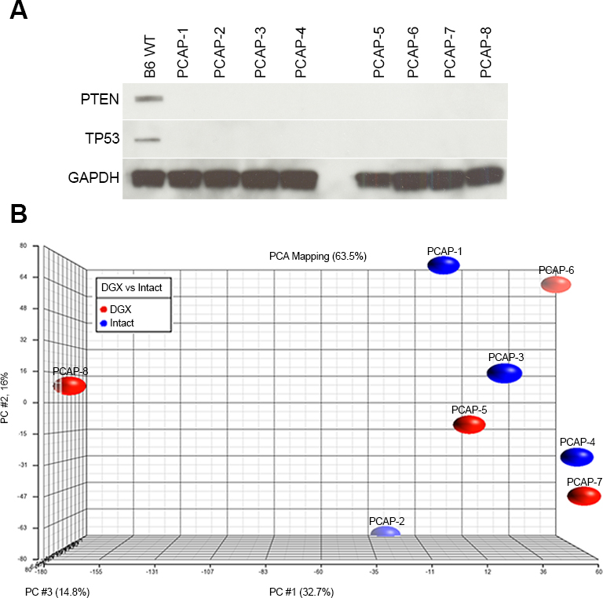
Supplementary Figure 1.

Supplementary Figure 1. PCAP cell lines characterization. A. Protein lysates from PCAP cell lines 1-8 were probed for PTEN, TP53, and GAPDH. B. Principle component analysis (PCA) of PCAP gene expression; color of oval represents castration status of the donor mouse.

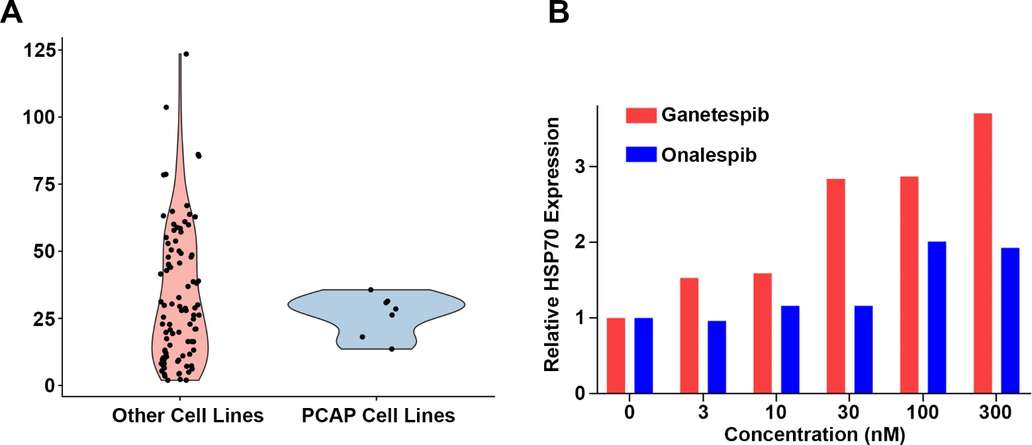

Supplementary Figure 2.

Supplementary Figure 2A. Violin plot of ganetespib MAXR values from multiple cancer cell lines across various histologies analyzed in the MIPE screen at NCATS. B. PCAP-1 cells were treated with indicated concentrations of ganetspib or onalespib for 24 hours and probed for HSP70 protein expression. Data were normalized to GAPDH for loading and then to HSP70 expression in the untreated cells.
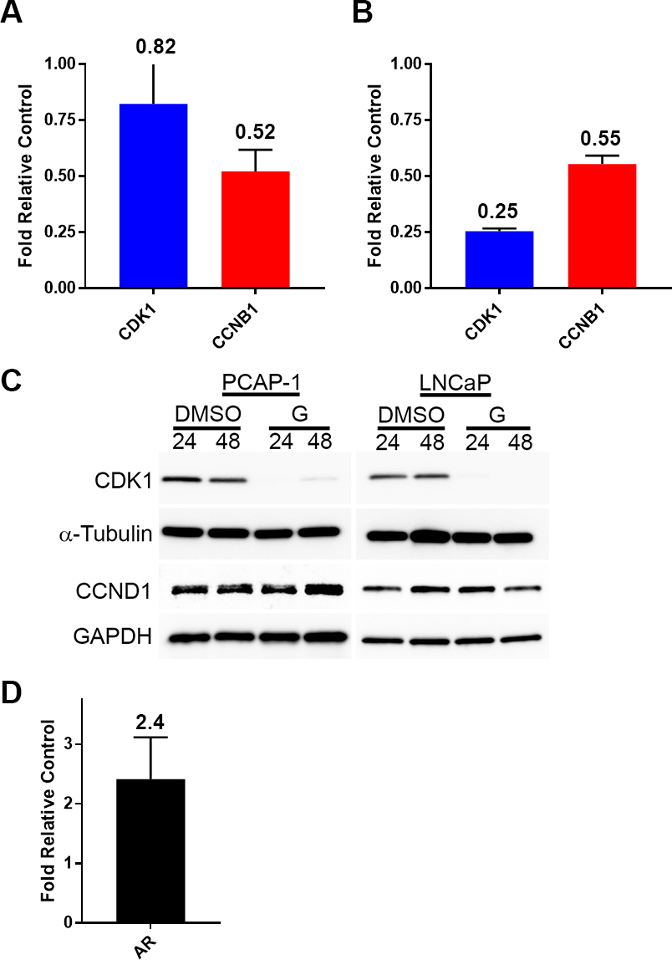
Supplementary Figure 3.
Supplementary Figure 3. A. qPCR analysis of PCAP-1 G2/M progression proteins following 24 hours 125 nM ganetespib treatment. B. qPCR analysis of LNCaP G2/M progression proteins after 24 hours 125 nM ganetespib exposure. C. PCAP-1 and LNCaP cells were treated with 125nM ganetespib for 24 or 48 hours and probed for CDK1 and CCND1. Vertical white space between images indicates separate gels. D. PCAP-1 Ar gene expression 24 hours after 125nM ganetespib treatment. qPCR data displayed as expression relative to untreated control +/- SEM (n=3).

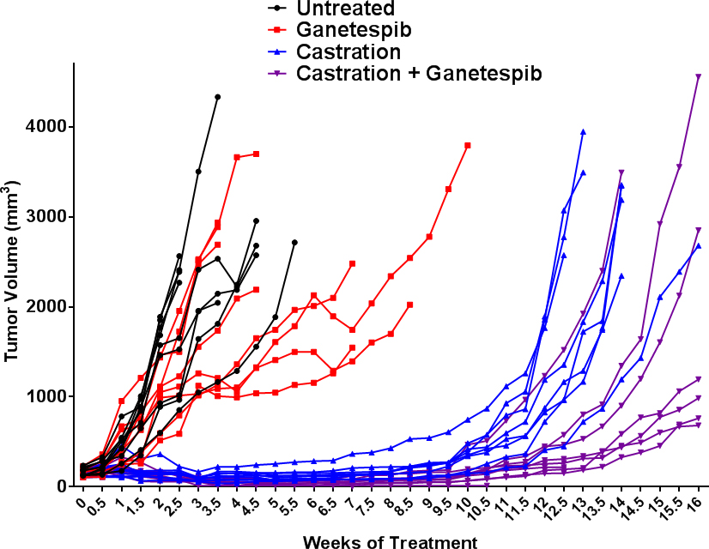
Supplementary Figure 4.

Supplementary Figure 4. Graph of individual LuCaP 136 tumors for untreated (black), ganetespib (red), castrated (blue), and ganetespib + castrated (purple) presented as tumor volume. Data plotted to 16 weeks post treatment initiation, when the last castrated mouse was taken after reaching max allowable tumor burden.

Supplementary Table 1. Antibodies used for western blots and IHC.
1° Antibody | Company, Catalogue # | Dilution
α tubulin | Sigma, T6199 | 1 : 2000
AKT | Cell Signaling, 2938 | 1 : 1000
p-AKT (S473) | Cell Signaling, 9271 | 1 : 1000
AR | AbCam, ab133273 | 1 : 1000
Caspase-3 | Cell Signaling, 9662 | 1 : 1000
Cleaved Caspase-3 (IHC) | Cell Signaling, 9661 | 1 : 300
CDC2 | Cell Signaling, 77055 | 1 : 1000
CHEK1 | Santa Cruz, sc-8408 | 1 : 200
CCNB1 | Cell Signaling, 4135 | 1 : 500
CCND1 | Santa Cruz, sc-718 | 1 : 200
ERK 1/2 | Cell Signaling, 4695, | 1 : 1000
ERK 2 | Santa Cruz, sc-1647 | 1 : 500
p-ERK 1/2 | Cell Signaling, 4370 | 1 : 1000
HSP70 | Santa Cruz, sc-1060 | 1 : 1000
PTEN | Cell Signaling, 9188S | 1 : 1000
RPS6 | Cell Signaling, 2317S | 1 : 1000
p-RPS6 (S240/244) | Cell Signaling, 22155 | 1 : 1000
TP53 | Cell Signaling, 2524S | 1 : 1000

Supplementary Table 2. Primers used for Real Time qPCR.
Human | GENE | Forward (5'-3') | Reverse (5'-3')
 | AR | GGAAGCTGCAAGGTCTTCTT | CGAAGACGACAAGATGGACAA
 | CCNB1 | GGAAACATGAGAGCCATCCTAA | CTGCATGAACCGATCAATAATGG
 | CDK1 | CACATGAGGTAGTAACACTCTGG | GTTCAGCAAATATGGTGCCTATAC
 | FKBP5 | AAACGAAGGAGCAACAGTAGAA | TTGGAATGTCGTGGTCTTCTC
 | HPRT1 | CTTTCCTTGGTCAGGCAGTATAA | AGTCTGGCTTATATCCAACACTTC
 | KLK3 | CACACCCGCTCTACGATATG | GAGGTCCACACACTGAAGTT
 | PMEPA1 | GTCTGCACGGTCCTTCATC | GATTCCGTTGCCTGACACT
 | NKX3.1 | AGCCAGAAAGGCACTTGG | TCACCTGAGTGTGGGAGAA
Mouse | Ar | GTTGGCGGTCCTTCACTAAT | CTCATCCTCACACACTGGCT
 | Ccnb1 | CAACTCTGCAGCACTACCTATC | CCACAGTTCACCATGACTACAT
 | Cdk1 | AG GCGTTTGGAATACCGAT | AACCGGAGTGGAGTAACGAG

Supplementary Table 3. Complete list of compounds from the MIPE library that displayed -1.1 or -1.2 curve response class activity in at least 4 of 7 PCAP cell lines. Sorted by mode of action.

Name | Target | Mode of Action (MoA)
Rolofylline | ADORA1 | Adenosine A1 antagonist
Cladribine | ADA | Adenosine deaminase inhibitor
A-674563 | AKT1 | Akt1/PKA inhibitor
Mithramycin | ADH1A | Alcohol dehydrogenase inhibitor
Temocapril hydrochloride | ACE | Angiotensin-I converting enzyme inhibitor
Spectinomycin hydrochloride |  | Antibiotic
Thiamphenicol |  | Antibiotic
Salinomycin | WNT1 | Anticoccidial/antibacterial
Antimycin A | ATP synthase | Antifungal agent
Natamycin | ergosterol | Antifungal agent
Artemisinin |  | Antimalarial agent
Artenimol |  | Antimalarial agent
Methylene blue |  | Antimalarial agent
Daunorubicin |  | Antineoplastic antibiotic
Echinomycin |  | Antineoplastic antibiotic
Elactocin |  | Antineoplastic antibiotic
Fenbendazole |  | Antiparasitic agent
Emetine |  | Antiprotozoal agent
ASR-isobudimer-SO2Ph-4-CH2OC(O)NMe2 |  | Artemesinin analogue
BTM-2C-dimer allyl oxime |  | Artemesinin analogue
BTM-2C-dimer ketone |  | Artemesinin analogue
Oligomycin A | ATP synthase | ATP synthase inhibitor
VE-821 | ATR | ATR kinase inhibitor
ABT-737 | BCL2L1 | Bcl-xL, Bcl-2, Bcl-w inhibitor
Navitoclax | BCL2L1 | Bcl-xL, Bcl-2, Bcl-w inhibitor
Carvedilol | ADRB1 | Beta1-adrenoceptor antagonist
I-BET762 | BRD4 | Bromodomain-containing protein 4 (Brd4, HUNK1) inhibitor
HMSL10077 | BTK | BTK inhibitor
Monatepil |  | Calcium channel blocker
Calhex-231 | CASR | Calcium-sensing receptor (CaSR) agonist
AT7519 | CDK1 | CDK 1 & 2 inhibitor
CGP-60474 | CDK1 | CDK1/2 inhibitor
NU-6027 | CDK1 | CDK1/2 inhibitor
RGB-286147 | CDK1 | CDK1/2/3/7/9 inhibitor
R-547 | CDK1 | CDK1/2/4 inhibitor
7-Hydroxystaurosporine | CDK1 | CDK1/2/4/6
Flavopiridol | CDK1 | CDK1/2/4/6/7/9 inhibitor
BS-194 | CDK1 | CDK1/2/5/9 inhibitor
Dinaciclib | CDK1 | CDK1/2/5/9 inhibitor
AZD-5438 | CDK1 | CDK1/Cyclin B1 inhibitor; CDK2/Cyclin A inhibitor; CDK2/Cyclin E inhibitor
SNS-032 | CDK2 | CDK2,7,9 inhibitor
PHA-690509 | CDK2 | CDK2/Cyclin A inhibitor
Fascaplysin | CDK4 | CDK4/6 inhibitor
DA-3003-1 | CDC25 | Cell division cycle CDC25 phosphatase inhibitor
Lumacaftor | CFTR | CFTR channel modulator
CHIR-124 | CHEK1 | Chk1 inhibitor
PF-477736 | CHEK1 | Chk1 inhibitor
Rabusertib | CHEK1 | Chk1 inhibitor
SCH-900776 | CHEK1 | Chk1 inhibitor
SM-164 | XIAP | cIAP1/2 and XIAP inhibitor
PD-173955 | SRC | cSRC inhibitor
Itraconazole |  | Cytochrome inhibitor
Methotrexate | DHFR | Dihydrofolate reductase (DHFR) inhibitor
Pralatrexate | DHFR | Dihydrofolate reductase (DHFR) inhibitor
Trimetrexate | DHFR | Dihydrofolate reductase (DHFR) inhibitor
5-Azacitidine | DNMT1 | DNA methyltransferase (DNMT) inhibitor
NSC-48006 | DNMT1 | DNA methyltransferase (DNMT) inhibitor
Clofarabine |  | DNA polymerase inhibitor
Camptothecin | TOP1 | DNA topoisomerase I inhibitor
SN-38 | TOP1 | DNA topoisomerase I inhibitor
Aclarubicin | TOP2A | DNA topoisomerase II inhibitor
Doxorubicin | TOP2A | DNA topoisomerase II inhibitor
Epirubicin hydrochloride | TOP2A | DNA topoisomerase II inhibitor
Idarubicin hydrochloride | TOP2A | DNA topoisomerase II inhibitor
Mitoxantrone | TOP2A | DNA topoisomerase II inhibitor
Pirarubicin | TOP2A | DNA topoisomerase II inhibitor
KU 0060648 | PRKDC | DNA-dependent protein kinase (DNA-PK) inhibitor
Rifapentine | PRKDC | DNA-directed RNA polymerase inhibitor
Vanoxeamine |  | Dopamine reuptake inhibitor
Bupropion hydrochloride | SLC6A3 | Dopamine transporter (DAT) inhibitor
Pluripotin | RASAL1 | Dual RASGAP/Erk inhibitor
Afatinib | EGFR | EGFR (HER1; erbB1) inhibitor
AG-1478 | EGFR | EGFR (HER1; erbB1) inhibitor
Neratinib | EGFR | EGFR (HER1; erbB1) inhibitor
OSI-420 | EGFR | EGFR (HER1; erbB1) inhibitor
PD-153035 | EGFR | EGFR (HER1; erbB1) inhibitor
Pelitinib | EGFR | EGFR (HER1; erbB1) inhibitor
Fulvestrant | ESR1 | Estrogen receptor antagonist
HMSL10084 | FLT3 | FLT3
GSK-1292263A | GPR119 | Glucose-dependent insulinotropic receptor (GDIR, GPR119) agonist
Cyanein | GBF1 | Golgi-specific brefeldin A-resistance guanine nucleotide exchange factor 1 (GBF1) inhibitor
6-Bromoindirubin-3'-acetoxime | GSK3B | GSK-3 inhibitor
Alvespimycin hydrochloride | HSP90AB1 | Heat shock protein 90 (hsp90) inhibitor
AT-13387AU | HSP90AB1 | Heat shock protein 90 (hsp90) inhibitor
CNF-2024 | HSP90AB1 | Heat shock protein 90 (hsp90) inhibitor
Ganetespib | HSP90AB1 | Heat shock protein 90 (hsp90) inhibitor
KW-2478 | HSP90AB1 | Heat shock protein 90 (hsp90) inhibitor
Retaspimycin | HSP90AB1 | Heat shock protein 90 (hsp90) inhibitor
SNX-2112 | HSP90AB1 | Heat shock protein 90 (hsp90) inhibitor
SNX-5422 | HSP90AB1 | Heat shock protein 90 (hsp90) inhibitor
Tripterin | HSP90AB1 | Heat shock protein 90 (hsp90) inhibitor
VER-82576 | HSP90AB1 | Heat shock protein 90 (hsp90) inhibitor
Sapitinib | ERBB2 | HER2/3 (erbB2) inhibitor
Quisinostat hydrochloride | HDAC1 | Histone deacetylase (HDAC) 1 inhibitor
Trichostatin A | HDAC1 | Histone deacetylase (HDAC) 1 inhibitor
Mocetinostat | HDAC1 | Histone deacetylase (HDAC) 1 inhibitor
AR-42 | HDAC1 | Histone deacetylase (HDAC) 1/2 inhibitor
Pracinostat | HDAC1 | Histone deacetylase (HDAC) 1/2 inhibitor
ISOX | HDAC1 | Histone deacetylase (HDAC) 6 inhibitor
Abexinostat | HDAC1 | Histone deacetylase (HDAC) inhibitor
Dacinostat | HDAC1 | Histone deacetylase (HDAC) inhibitor
Givinostat hydrochloride | HDAC1 | Histone deacetylase (HDAC) inhibitor
M344 | HDAC1 | Histone deacetylase (HDAC) inhibitor
Panobinostat | HDAC1 | Histone deacetylase (HDAC) inhibitor
Romidepsin | HDAC1 | Histone deacetylase (HDAC) inhibitor
2-Methoxyestradiol | HIF1A | Hypoxia inducible factor 1-alpha inhibitor
Birinapant | XIAP | IAP inhibitor
Phloretin | ICAM1 | ICAM1 and VCAM1 expression inhibitor
TPCA-1 | IKBKB | IKK beta inhibitor
GMX-1778 | IKBKB | IKK inhibitor
IMD-0354 | IKBKB | IKK-2 inhibitor
CAY10581 | IDO1 | Indoleamine 2,3-dioxygenase (IDO) inhibitor
AVN-944 | IMPDH1 | Inosine 5'-monophosphate dehydrogenase (IMPDH) inhibitor
Mycophenolate mofetil | IMPDH1 | Inosine 5'-monophosphate dehydrogenase (IMPDH) inhibitor
Mycophenolic acid | IMPDH1 | Inosine 5'-monophosphate dehydrogenase (IMPDH) inhibitor
NCGC00188382-01 | ITK | ITK inhibitor
NCGC00344990-01 | ITK | ITK inhibitor
NCGC00344999-01 | ITK | ITK inhibitor
Lestaurtinib | JAK1 | Jak/Tyk/Flt inhibitor
SR-3306 | MAPK8 | JNK 1/2/3 inhibitor
Posaconazole | CYP51A1 | Lanosterol 14alpha-demethylase inhibitor
AMG-47a | LCK | Lck kinase inhibitor
KHS101 |  | Lineage-specific differentiation enhancer
Azalomycin-B |  | Macrolide antibiotic
Pimecrolimus |  | Macrolide antibiotic
MI-2 | MALT1 | MALT1 inhibitor
AS-602801 | AS-602801 | MAPK8
BI-D1870 | RPS6KA1 | MAPKAP-K1 (RSK; p90Rsk) inhibitor
Pimasertib | MAP2K1 | MEK 1/2 inhibitor
Trametinib | MAP2K1 | MEK 1/2 inhibitor
AZD-8330 | MAP2K1 | MEK inhibitor
KUC111774N-03 |  | Microphthalmia-associated transcription factor (MITF) inhibitor
Chlorhexidine | MMP1 | MMP inhibitor
GM-6001 | MMP1 | MMP inhibitor
BEZ-235 | MTOR | mTOR inhibitor
GDC-0980 | MTOR | mTOR inhibitor
PF-05212384 | MTOR | mTOR inhibitor
Torin-1 | MTOR | mTOR inhibitor
Torin-2 | MTOR | mTORC1 inhibitor
AZD-2014 | MTOR | mTORC1/2 inhibitor
AZD-8055 | MTOR | mTORC1/2 inhibitor
INK-128 | MTOR | mTORC1/2 inhibitor
KU-0063794 | MTOR | mTORC1/2 inhibitor
OSI-027 | MTOR | mTORC1/2 inhibitor
WYE-125132 | MTOR | mTORC1/2 inhibitor
Rotenone | NDUFAF1 | NADH-ubiquinone oxidoreductase (complex I) inhibitor
Withaferin A | NFKB1 | NF-kappaB Activation inhibitor
Bardoxolone methyl | NFKB1 | NF-kappaB signaling inhibitor
JTC-801 | OPRL1 | ORL1 (OP4, NOP) antagonist
Prasugrel | P2RY12 | P2Y12 (P2T) antagonist
KUC107871N-04 | p97 | p97 ATPase inhibitor
GB 83 | PAR2 | PAR2 antagonist
Amuvatinib | PDGFRA | PDGFR alpha inhibitor
Dioscin | PRDX1 | Peroxiredoxins (PRDX) 1/6
MP-10 | PDE10A | Phosphodiesterase PDE10A inhibitor
Tadalafil | PDE5A | Phosphodiesterase V (PDE5) inhibitor
Verteporfin |  | Photosensitizer
CAY10505 | PIK3CG | PI3K gamma inhibitor
CUDC-907 | PIK3CA | PI3K inhibitor
GNE-477 | PIK3CA | PI3K inhibitor
GNE-493 | PIK3CA | PI3K inhibitor
PF-04691502 | PIK3CA | PI3K inhibitor
PIK-75 | PIK3CA | PI3K inhibitor
PKI-402 | PIK3CA | PI3K inhibitor
ZSTK-474 | PIK3CA | PI3K inhibitor
BAG-956 | PIK3CA | PI3K/PDK1 inhibitor
BKM-120 | PIK3CA | PI3Kalpha inhibitor
GSK-615 | PIK3CA | PI3Kalpha inhibitor
CH-5132799 | PIK3CA | PI3Kalpha, beta, gamma inhibitor
PI-103 | PIK3CA | PI3Kalpha, beta, gamma inhibitor
GSK-2126458 | PIK3CA | PI3Kalpha/beta/delta/gamma inhibitor
GDC-0349 | PIM3 | Pim-3 kinase inhibitor, mTOR
Triciribine | AKT1 | PKB/Akt inhibitor
Triciribine phosphate | AKT1 | PKB/Akt inhibitor
Midostaurin | PRKCA | PKC/flt3 inhibitor
Enzastaurin | PRKCA | PKCa, PKCb, PKCg inhibitor
ON-01910 | PLK1 | Polo-like kinase-1 (Plk-1) inhibitor
Monensin sodium salt |  | Polyether antibiotic
Nanchangmycin |  | Polyether antibiotic
Cantharidin | PPP1CA | PP-1 Inhibitor; PP-2A inhibitor
Mifepristone | PGR | Progesterone receptor antagonist
Bortezomib | PSMD1 | Proteasome inhibitor
Carfilzomib | PSMD1 | Proteasome inhibitor
Delanzomib | PSMD1 | Proteasome inhibitor
Ixazomib citrate | PSMD1 | Proteasome inhibitor
Marizomib | PSMD1 | Proteasome inhibitor
MG-115 | PSMD1 | Proteasome inhibitor
MG-132 | PSMD1 | Proteasome inhibitor
MLN-2238?? | PSMD1 | Proteasome inhibitor
Oprozomib | PSMD1 | Proteasome inhibitor
cycloheximide |  | Protein synthesis inhibitor
Berberine | PTP4A1 | Protein tyrosine phosphatase (PTP) inhibitor
Tioguanine |  | Purine antagonist
2-Fluoroadenosine | PNP | Purine-nucleoside phosphorylase inhibitor
Carmofur |  | Pyrimidine antagonist
Floxuridine |  | Pyrimidine antagonist
Fluorouracil |  | Pyrimidine antagonist
MLN-2480 | BRAF | Raf kinase inhibitor
Resistomycin | POLR2A | RNA polymerase inhibitor
BI-78D3 | MAPK8 | SAPK1 (JNK) inhibitor
Idronoxil | SPHK1 | Sphingosine kinase 1 (SphK1) inhibitor
LLL-12 | STAT3 | STAT-3 inhibitor
Niclosamide | STAT3 | STAT-3 inhibitor
MK-8245 | SCD | Stearoyl-CoA desaturase inhibitor
Sepantronium bromide | BIRC5 | Survivin inhibitor
Fostamatinib disodium | SYK | Syk kinase inhibitor
SB-505124 |  | TGF-bR1 (ALK4/5) inhibitor
SB-525334 |  | TGF-bR1 (ALK5) inhibitor
Auranofin | TXNRD1 | Thioredoxin reductase inhibitor
Pemetrexed disodium | TYMS | Thymidylate synthase inhibitor
Raltitrexed | TYMS | Thymidylate synthase inhibitor
Trifluridine | TYMS | Thymidylate synthase inhibitor
CPG-52364 | TLR7 | TLR 7, 8 and 9 antagonist
Methylrosaniline chloride |  | TNFR1 (p55/CD120a) modulator
GSK-1016790A | TRPV4 | TRPV4 agonist
Lexibulin hydrochloride | TUBB | Tubulin depolymerization inhibitor
E-7010 | TUBB | Tubulin polymerization inhibitor
Indibulin | TUBB | Tubulin polymerization inhibitor
Ombrabulin | TUBB | Tubulin polymerization inhibitor
Vindesine sulfate | TUBB | Tubulin polymerization inhibitor
Vinflunine | TUBB | Tubulin polymerization inhibitor
Vinorelbine | TUBB | Tubulin polymerization inhibitor
Noscapine | TUBB | Tubulin polymerization inhibitor
Spautin-1 | USP10 | Ubiquitin specific peptidase (USP10/13) inhibitor
NCGC00262398 | USP2 | USP2 inhibitor
Vargatef | FLT1 | VEGFR-1/2/3 inhibitor
AG-13958 | FLT1 | VEGFR-2 (FLK-1/KDR) inhibitor
Takeda-6d | FLT1 | VEGFR-2 (FLK-1/KDR) inhibitor
MK-1775 | WEE1 | Wee1 kinase inhibitor
ICG-001 | WNT5A | Wnt signaling inhibitor

Supplementary Table 4. List of compounds from the MIPE library that did not display activity against a majority (4 of 7) PCAP cell lines. Sorted by mode of action.
Name | Target | Mode of Action (MoA)
Aurora A Inhibitor I | AURKA | Aurora A inhibitor
MK-5108 | AURKA | Aurora A inhibitor
JNJ-7706621 | AURKA | Aurora kinase inhibitor
CCT-129202 | AURKA | Aurora kinase inhibitor
Hesperadin | AURKA | Aurora kinase inhibitor
PF-03814735 | AURKA | Aurora kinase inhibitor
ENMD-981693 | AURKA | Aurora-A inhibitor
Alisertib | AURKA | Aurora-A inhibitor
MLN-8054 | AURKA | Aurora-A inhibitor
ZM-447439 | AURKA | Aurora-A/B inhibitor
AZD-1152-HQPA | AURKA | Aurora-A/B inhibitor
AT-9283 | AURKA | Aurora-A/B inhibitor
TAK-901 | AURKA | Aurora-A/B inhibitor
PHA-680632 | AURKA | Aurora-A/B/C inhibitor
Tozasertib | AURKA | Aurora-A/B/C kinase inhibitor
SNS-314 | AURKA | Aurora-A/B/C kinase inhibitor
AMG-900 | AURKA | Aurora-A/B/C kinase inhibitor
Danusertib | AURKA | Aurora-A/B/C kinase inhibitor
CYC-116 | AURKA | Aurora-A/B/C kinase inhibitor
CCT-137690 | AURKA | Aurora-A/B/C kinase inhibitor
GSK-1070916A | AURKB | Aurora-B/C inhibitor
Abiraterone | AR | Androgen biosynthesis inhibitor
Orteronel |  | Androgen biosynthesis inhibitor
Andarine | AR | Selective androgen receptor modulators (SARM)
Ostarine | AR | Selective androgen receptor modulators (SARM)
Galeterone | AR | Selective androgen receptor modulators (SARM)
Flutamide | AR | Androgen receptor antagonist
Nilutamide | AR | Androgen receptor antagonist
Hydroxyflutamide | AR | Androgen receptor antagonist
Cyproterone acetate | AR | Androgen receptor antagonist
Finasteride | AR | Androgen receptor antagonist
Diindolylmethane | AR | Androgen receptor antagonist
(R)-Bicalutamide | AR | Androgen receptor antagonist
Bicalutamide | AR | Androgen receptor antagonist
MDV-3100 | AR | Androgen receptor antagonist
RD-162 | AR | Androgen receptor antagonist
17 alpha-propionate | AR | Androgen receptor antagonist
ARN-509 | AR | Androgen receptor antagonist
INO-1001 | PARP1 | PARP inhibitor
AG-14361 | PARP1 | PARP-1 inhibitor
Iniparib | PARP1 | PARP-1 inhibitor
A-966492 | PARP1 | PARP-1 inhibitor
Olaparib | PARP1 | PARP-1/PARP-2 inhibitor
Veliparib | PARP1 | PARP-1/PARP-2 inhibitor
Rucaparib | PARP1 | PARP-1/PARP-2 inhibitor
Niraparib | PARP1 | PARP-1/PARP-2 inhibitor
IWP-2 |  | Porcupine (Wnt) inhibitor
LGK974 |  | Porcupine (Wnt) inhibitor
PNU-74654 | WNT5A | Wnt signaling inhibitor
KY02111 | WNT5A | Wnt signaling inhibitor
Wnt-C59 | WNT5A | Wnt signaling modulator
Salinomycin | WNT1 | Anticoccidial/Antibacterial

Supplementary References

1 Yin, J. et al. Activation of the RalGEF/Ral pathway promotes prostate cancer metastasis to bone. Mol Cell Biol 27, 7538-7550, doi:10.1128/MCB.00955-07 (2007).
2 Klein, K. A. et al. Progression of metastatic human prostate cancer to androgen independence in immunodeficient SCID mice. Nat Med 3, 402-408 (1997).
3 Abou-Kheir, W. G., Hynes, P. G., Martin, P. L., Pierce, R. & Kelly, K. Characterizing the contribution of stem/progenitor cells to tumorigenesis in the Pten-/-TP53-/- prostate cancer model. Stem Cells 28, 2129-2140, doi:10.1002/stem.538 (2010).
4 Livak, K. J. & Schmittgen, T. D. Analysis of relative gene expression data using real-time quantitative PCR and the 2(-Delta Delta C(T)) Method. Methods 25, 402-408, doi:10.1006/meth.2001.1262 (2001).

