Supporting Information

Self-Transforming Configuration Based on Atmospheric-Adaptive Materials for Solid Oxide Cells

Seona Kim, Seungtae Lee, Junyoung Kim, Jeeyoung Shin*, and Guntae Kim*

.

Figure S1. XPS spectra of the Ba 3d peaks for (a) Pr_{0.5}Ba_{0.5}MnO₃(before reduction) (b) PrBaMn₂O₅ (after reduction).

Figure S2. XPS spectra of the Mn 2p_{3/2} peaks for (a) Pr_{0.5}Ba_{0.5}Mn_{0.85}Co_{0.15}O₃(before reduction) (b) PrBaMn_{1.7}Ba_{0.3}O₅ (after reduction).

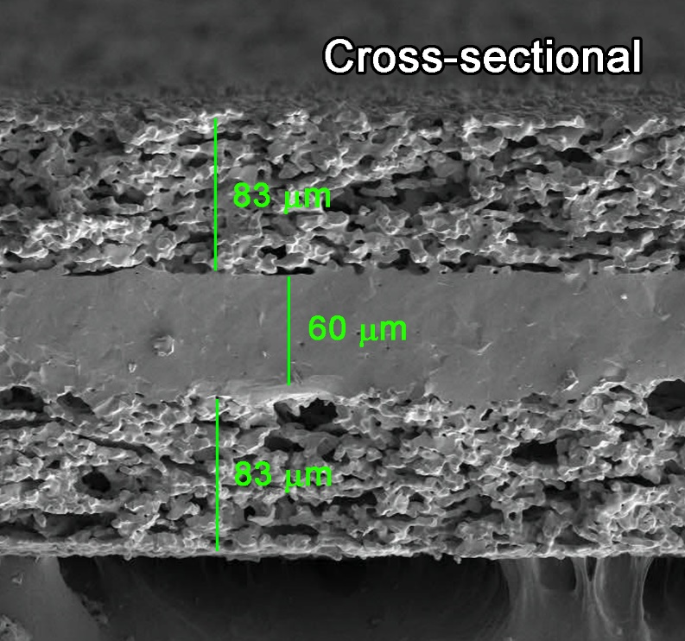
Figure S3. Cross sectional scanning electron microscopy (SEM) image of trple-layer LSGM electrolyte-supported cell with the configuration of porous LSGM | dense LSGM | porous LSGM).

Figure S4. Impedance spectra of the transforming cell with the configuration of PBMCo-LSGM/LSGM/S-PBMCo-LSGM using H₂ as fuel and air as the oxidant.

Figure S5. (a) Experimental and simulated Nyquist plots of PBMCo-LSGM composite on a LSGM symmetric cell. (b) Comparison of R₂, R₃, and R_{p} for PBMCo-LSGM composites on a LSGM symmetric cell based on the fitting result by the equivalent circuit shown as an inset

Table S1. Electrochemical impedance spectroscopy fitting results of PBMCo-LSGM measured at various temperature in air
Temp. [ºC] | Half-cell test [Ω cm²]
Temp. [ºC] | Measured | Fitted
Temp. [ºC] | Cathodic loss (R_{p}) | R₂ | R₃ | R_{p}
800 | 0.033 | 0.031 | 0.002 | 0.033
750 | 0.073 | 0.036 | 0.036 | 0.072
700 | 0.189 | 0.071 | 0.118 | 0.189

Table S2. Electrochemical impedance spectroscopy results
Temp. [ºC] | Transforming cell test |  | Half-cell test
Temp. [ºC] | Ohmic resistance  [Ω cm²] | Polarization resistance  [Ω cm²] | Cathodic loss  [Ω cm²]
800 | 0.147 | 0.139 | 0.033
750 | 0.187 | 0.273 | 0.073
700 | 0.244 | 0.530 | 0.189

Table S3. Summary of the electrochemical performances of SSOFC system with H₂ fuel.
Material |  |  | Fabrication | SSOFC system |  |  | Ref.
Electrode |  | Electrolyte | Fabrication | Maximum power density  (W cm⁻²) | Polarization resistance  (Ω cm²) | Temp.  (ºC) | Ref.
Air side | Fuel side
PBMCo-ªLSGM |  | LSGM | Infiltration | 1.10 | 0.14 | 800 | This work
La_{0.7}Ca_{0.3}Cr_{0.97}O_{3-δ} -^{b}YSZ |  | YSZ | Pechini | 0.05 | 0.3 | 800 | 1
La_{0.7}Ca_{0.3}Cr_{0.97}O_{3-δ} -^{c}GDC |  | LSGM | ^{d}GNP | 0.21 | - | 800 | 2
La_{0.75}Sr_{0.25}Cr_{0.5}Mn_{0.5}O_{3-δ} -YSZ |  | YSZ | Solid state reaction | 0.55 | 0.18 | 950 | 3
La_{0.75}Sr_{0.25}Cr_{0.5}Mn_{0.5}O_{3-δ} -YSZ-GDC |  | YSZ | Combustion synthesis | 0.40 | 0.49 | 950 | 4
Pr_{0.75}Ca_{0.3}Cr_{0.6}Mn_{0.4}O_{3-δ} |  | YSZ | Freeze-dried method | 0.25 | - | 950 | 5
Sr₂Fe_{1.5}Mo_{0.5}O_{6-δ} |  | LSGM | GNP | 0.62 | 0.45 | 800 | 6
Pr_{0.5}Ba_{0.4}Ca_{0.1}MnO₃  +Co-Fe (catalyst) |  | LSGM+^{e}LDC (buffer layer) | Pechini+Infiltration | 1.10 | - | 800 | 7
^{f}NBSCF-+GDC | PrBaMn₂O₅ | LSGM+LDC (buffer layer) | Pechini | 0.45 | - | 800 | 8
^{g}GBSCF | Ce-Pd | YSZ | Infiltration | 0.6 | 0.134 | 700 | 9
GBSCF | PrBaMn₂O₅ | YSZ | Infiltration | 0.53 | 0.20 | 700 | 10
SrCo_{0.8}Fe_{0.2}O_{3-δ} (SCF) | Sr₂MgMoO_{6-δ} | LSGM+LDC | Combustion synthesis | 0.84 |  | 800 | 11
ª La_{1-x}Sr_{x}Ga_{1-y}Mg_{y}O_{3-δ}, ^{b} Yittria-stabilized zirconia (YSZ), ^{c} Gadolinium doped ceria (GDC), ^{d} Glycine-nitrate process (GNP),
^{e} Lanthanum doped ceria (LDC), ^{f} NdBa_{0.5}Sr_{0.5}Co_{1.5}Fe_{0.5}O_{5+d} (NBSCF), ^{g} GdBa_{0.5}Sr_{0.5}CoFeO_{5+d} (GBSCF)
Reference
1. B. Lin, S. Wang, X. Liu, and G. Meng, J. Alloys Compd., 490, 214–222 (2010).
2. Y. Zhang, Q. Zhou, and T. He, J. Power Sources, 196, 76–83 (2011) http://dx.doi.org/10.1016/j.jpowsour.2010.07.035.
3. J. C. Ruiz-Morales, J. Canales-Vázquez, J. Peña-Martínez, D. M. López, and P. Núñez, Electrochim. Acta, 52, 278–284 (2006).
4. J. C. Ruiz-Morales et al., J. Eur. Ceram. Soc., 27, 4223–4227 (2007).
5. A. El-Himri, D. Marrero-López, J. C. Ruiz-Morales, J. Peña-Martínez, and P. Núñez, J. Power Sources, 188, 230–237 (2009) http://linkinghub.elsevier.com/retrieve/pii/S0378775308022027.
6. Q. Liu, X. Dong, G. Xiao, F. Zhao, and F. Chen, Adv. Mater., 22, 5478–5482 (2010).
7. S. Choi et al., J. Mater. Chem. A, 4, 1747–1753 (2016) http://xlink.rsc.org/?DOI=C5TA08878J.
8. S. Sengodan et al., Nat. Mater., 14, 205–209 (2014) http://www.nature.com/doifinder/10.1038/nmat4166.
9. S. Kim et al., ChemSusChem, 8, 3153–3158 (2015) http://doi.wiley.com/10.1002/cssc.201500509.
10. S. Kim et al., Electrochim. Acta, 225, 399–406 (2017) http://linkinghub.elsevier.com/retrieve/pii/S0013468616327372.
11. P. Scribe et al., Science (80-. )., 2, 254–258 (2006).

