Title: Hotspots of recent hybridization between pigs and wild boars in Europe
Laura Iacolina, Cino Pertoldi, Marcel Amills, Szilvia Kusza, Hendrik-Jan Megens, Valentin Adrian Bâlteanu, Jana Bakan, Vlatka Cubric-Curik, Ragne Oja, Urmas Saarma, Massimo Scandura, Nikica Šprem, Astrid Vik Stronen

Supplementary Table S1. Animals analysed for this study. a) wild boar (WB); b) domestic pig (DP). Population = Country (for WB)/breed (for DP) of origin of the animals, N = number of genotypes, Cluster = cluster the population was assigned to for some of the analysis.
a)
Population | Population abbreviation | N | Cluster | Cluster abbreviation
Bosnia | Bos | 13 | Balkans | WB-Bal
Bulgaria | Bul | 5 | Balkans | WB-Bal
Croatia | Cro | 15 | Balkans | WB-Bal
Greece | Gre | 8 | Balkans | WB-Bal
Serbia | Ser | 14 | Balkans | WB-Bal
Slovenia | Slv | 12 | Balkans | WB-Bal
Hungary | Hun | 14 | Carpathians | WB-Car
Romania | Rom | 18 | Carpathians | WB-Car
Slovakia | Slk | 5 | Carpathians | WB-Car
Portugal | Por | 9 | Iberia | WB-Ibe
Spain | Spa | 14 | Iberia | WB-Ibe
Italy | Ita | 19 | Italy | WB-Ibe
Sardinia | Sar | 25 | Sardinia | WB-Ibe
Austria | Aus | 9 | Central-West Europe | WB-CW
Belgium | Bel | 6 | Central-West Europe | WB-CW
France | Fra | 25 | Central-West Europe | WB-CW
Germany | Ger | 16 | Central-West Europe | WB-CW
Luxembourg | Lux | 4 | Central-West Europe | WB-CW
Netherlands | Ned | 25 | Central-West Europe | WB-CW
Estonia | Est | 15 | Central-North-Eastern Europe | WB-CNE
Finland | Fin | 3 | Central-North-Eastern Europe | WB-CNE
Poland | Pol | 12 | Central-North-Eastern Europe | WB-CNE
Russia | Rus | 4 | Central-North-Eastern Europe | WB-CNE
Armenia | Arm | 3 | Near Eastern | WB-NE
Iran | Ira | 5 | Near Eastern | WB-NE
Turkey | Tur | 8 | Near Eastern | WB-NE
TOT |  | 306

b)
Population | Population abbreviation | N | Country | Cluster | Cluster abbreviation
Black Slavonian | BS | 10 | Croatia | Balkans | DP-Bal
Turopolje | TU | 13 | Croatia | Balkans | DP-Bal
Mangaliza | MA | 25 | cross-country | Carpathians | DP-Car
Poland domestic | PO | 8 | Poland | Central-East Europe | DP-CE
Pulawska Spot | PU | 11 | Poland | Central-East Europe | DP-CE
Estonia domestic | ES | 12 | Estonia | Central-Nord Europe | DP-CN
Linderodssvin | LI | 10 | Sweden | Central-Nord Europe | DP-CN
Berkshire | BK | 8 | - | Commercial | DP-Com
Duroc | DU | 10 | - | Commercial | DP-Com
Large White | LW | 7 | - | Commercial | DP-Com
Pietrain | PI | 10 | - | Commercial | DP-Com
Yorkshire | YO | 9 | - | Commercial | DP-Com
Angler Sattleschwein | AS | 9 | Germany | Central-West Europe | DP-CW
Bunte Bentheimer | BB | 11 | Germany | Central-West Europe | DP-CW
Presticke | PR | 15 | Czech Republic | Central-West Europe | DP-CW
Bisaro | BI | 11 | Portugal | Iberia | DP-Ibe
Cato Murciano | CM | 25 | Spain | Iberia | DP-Ibe
Iberian | IB | 19 | Spain | Iberia | DP-Ibe
Manchado de Jabugo | MJ | 6 | Spain | Iberia | DP-Ibe
Negra Iberica | NI | 13 | Spain | Iberia | DP-Ibe
Retinto | RE | 9 | Spain | Iberia | DP-Ibe
Calabrese | CA | 10 | Italy | Italy | DP-Ita
Casertana | CT | 7 | Italy | Italy | DP-Ita
Cinta Senese | CS | 8 | Italy | Italy | DP-Ita
Mora Romagnola | MR | 8 | Italy | Italy | DP-Ita
Nera Siciliana | NS | 7 | Italy | Italy | DP-Ita
Sarda | SA | 8 | Italy (Sardinia) | Italy | DP-Ita
TOT |  | 299

Supplementary Table S2. Maximum K values used for Admixture analysis and K value identified by cross-validation (CV) method.
Dataset | 30K | 1K | 30K-CV | 1K-CV
All | 30 | 30 | 27 | 27
Wild boar | 20 | 20 | 12 | 12
Balkans | 15 | 15 | 10 | 9
Carpathians | 10 | 15 | 9 | 11
Central Europe | 20 | 20 | 14 | 15
Iberia | 15 | 20 | 10 | 12
Italy | 15 | 20 | 13 | 12
Northern Europe | 10 | 15 | 8 | 9
Sardinia | 10 | 15 | 9 | 8

Supplementary Table S3. Pairwise F_{ST} values, all comparisons were significant (p < 0.05). Abbreviations are the same as in Table S1.

 | DP-Com | DP-CN | DP-CE | DP-CW | DP-Ita | DP-Ibe | DP-Car | DP-Bal | WB-Sar | WB-Ita | WB-CW | CNE-WB | WB-Ibe | WB-Car | WB-Bal | WB-NE
DP-Com | -
DP-CN | 0.053 | -
DP-CE | 0.062 | 0.084 | -
DP-CW | 0.045 | 0.064 | 0.074 | -
DP-Ita | 0.070 | 0.086 | 0.108 | 0.078 | -
DP-Ibe | 0.063 | 0.081 | 0.099 | 0.070 | 0.056 | -
DP-Car | 0.096 | 0.113 | 0.134 | 0.100 | 0.077 | 0.070 | -
DP-Bal | 0.113 | 0.132 | 0.152 | 0.117 | 0.105 | 0.097 | 0.112 | -
WB-Sar | 0.193 | 0.216 | 0.241 | 0.200 | 0.165 | 0.161 | 0.161 | 0.220 | -
WB-Ita | 0.164 | 0.182 | 0.208 | 0.171 | 0.140 | 0.135 | 0.123 | 0.186 | 0.124 | -
WB-CW | 0.144 | 0.158 | 0.179 | 0.147 | 0.118 | 0.111 | 0.090 | 0.155 | 0.137 | 0.088 | -
CNE-WB | 0.149 | 0.165 | 0.189 | 0.154 | 0.129 | 0.122 | 0.102 | 0.166 | 0.143 | 0.087 | 0.053 | -
WB-Ibe | 0.156 | 0.175 | 0.200 | 0.162 | 0.138 | 0.127 | 0.123 | 0.183 | 0.175 | 0.127 | 0.074 | 0.100 | -
WB-Car | 0.144 | 0.160 | 0.183 | 0.148 | 0.126 | 0.121 | 0.101 | 0.163 | 0.143 | 0.083 | 0.068 | 0.036 | 0.113 | -
WB-Bal | 0.148 | 0.163 | 0.184 | 0.151 | 0.123 | 0.119 | 0.096 | 0.158 | 0.135 | 0.071 | 0.065 | 0.042 | 0.110 | 0.018 | -
WB-NE | 0.224 | 0.245 | 0.275 | 0.236 | 0.234 | 0.227 | 0.232 | 0.277 | 0.307 | 0.273 | 0.235 | 0.211 | 0.303 | 0.194 | 0.186 | -
Supplementary Figure S1. Admixture plots of European wild boar and domestic pigs based on 30K SNPs. Plots represent (a) Central Europe (K=14), (b) Iberia (K=10), (c) Italy (K=13), (d) Sardinia (K=9), (e) Balkans (K=10), (f) Carpathians (K=9) and (g) Northern Europe (K=8). Abbreviations correspond to Population abbreviation in Table S1.
a)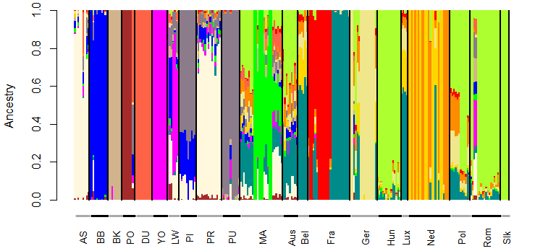b)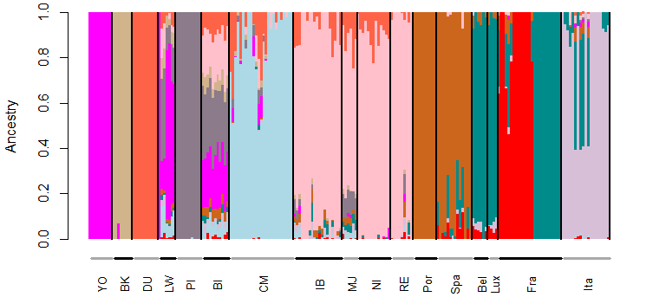
c)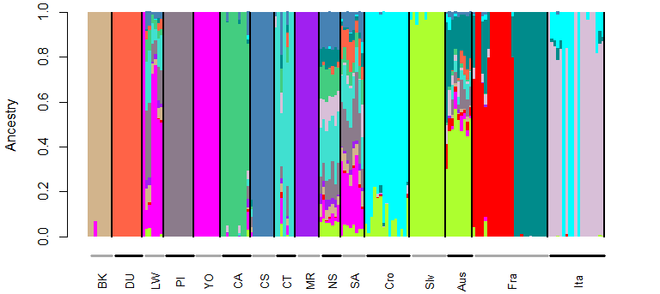d)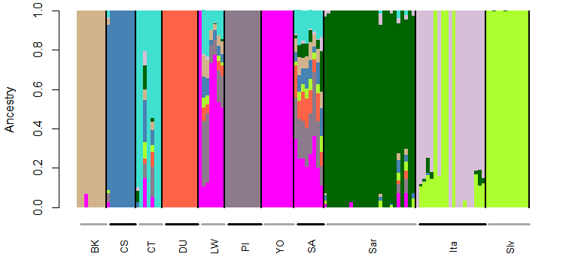e)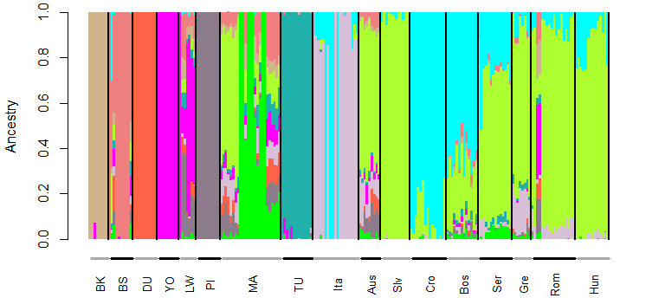
f)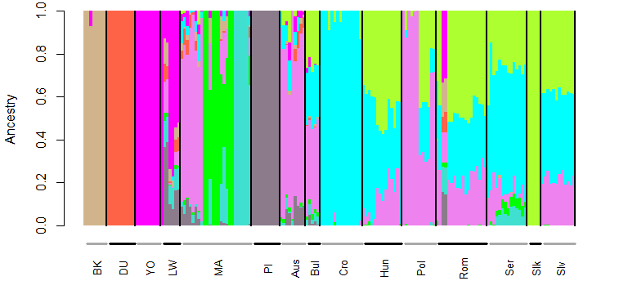
g)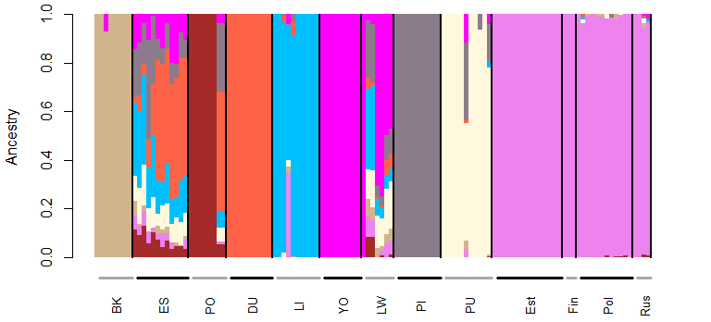
Supplementary Figure S2. Admixture plots of European wild boar and domestic pigs for K 2-4. Plots represent: (a) K=2 with 30K SNPs, (b) K=2 with 1K SNPs, (c) K=3 with 30K SNPs, (d) K=3 with 1K SNPs, (e) K=4 with 30K SNPs, (f) K=4 with 1K SNPs. Abbreviations correspond to Cluster abbreviation in Table S1.
(a)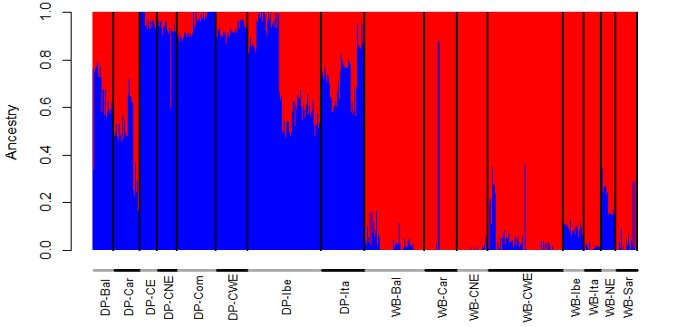(b)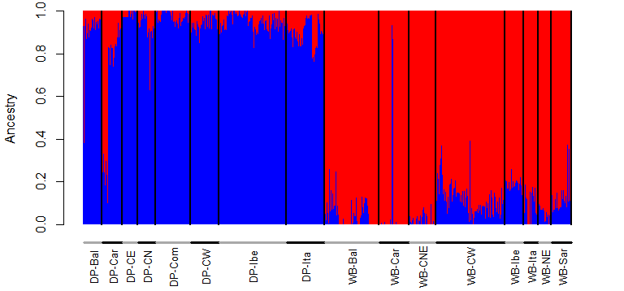
(c)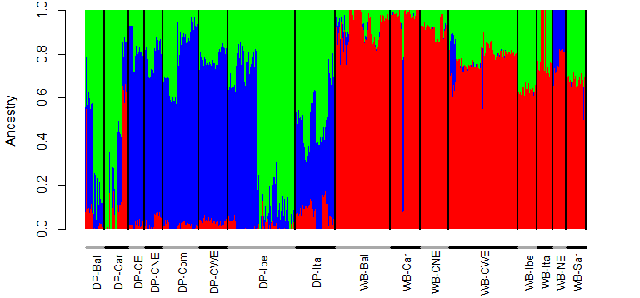(d)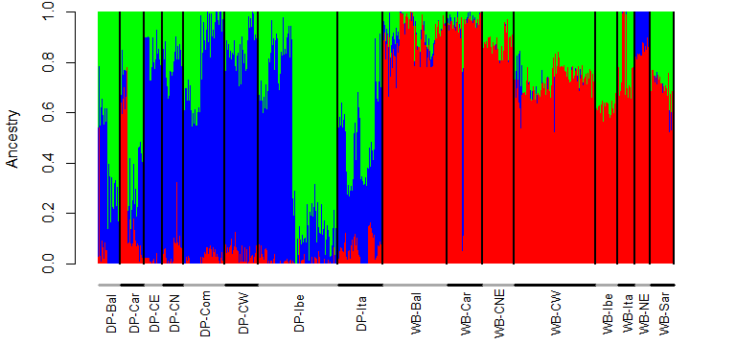
(e)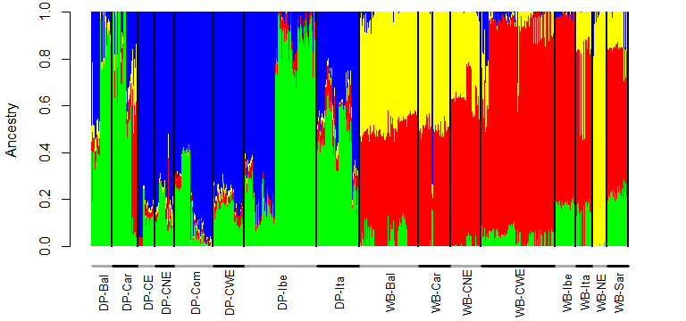(f)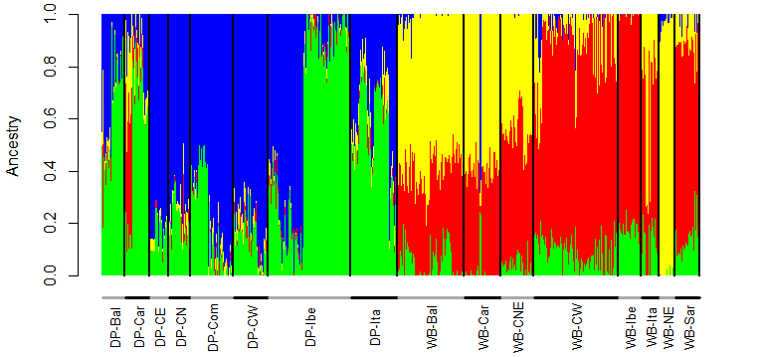

Supplementary Figure S3. Admixture plots of European wild boar and domestic pigs based on 1K SNPs. Plots represent (a) Central Europe (K=15), (b) Iberia (K=12), (c) Italy (K=12), (d) Sardinia (K=8), (e) Balkans (K=9), (f) Carpathians (K=11) and (g) Northern Europe (K=9). Abbreviations correspond to Population abbreviation in Table S1.
a)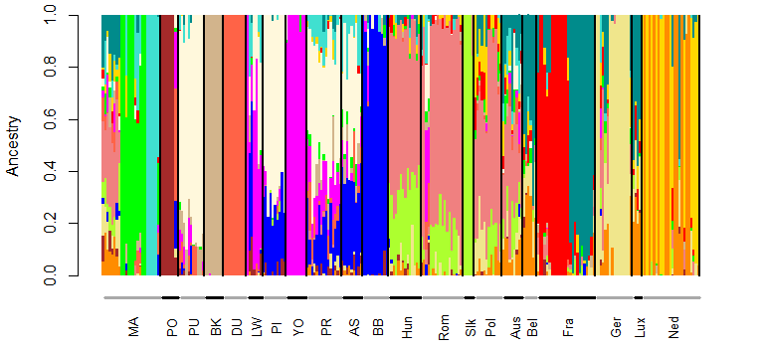b)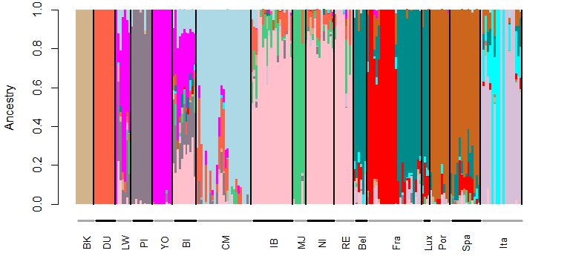
c)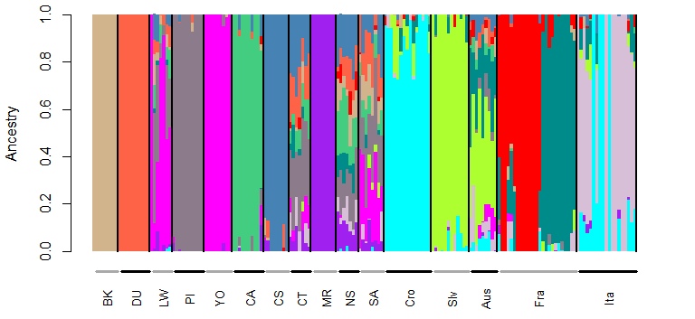d)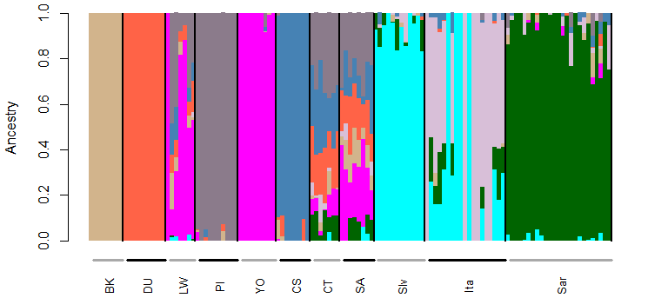e)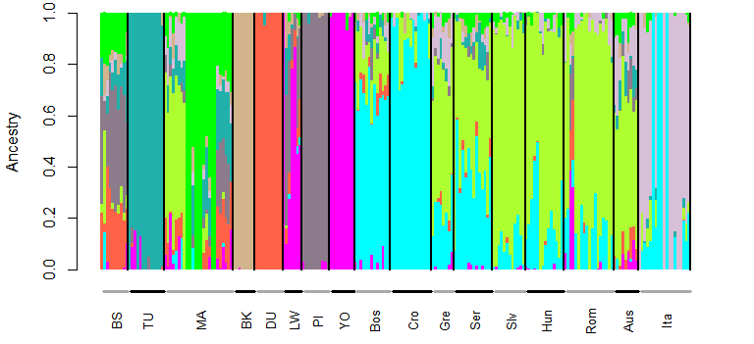f)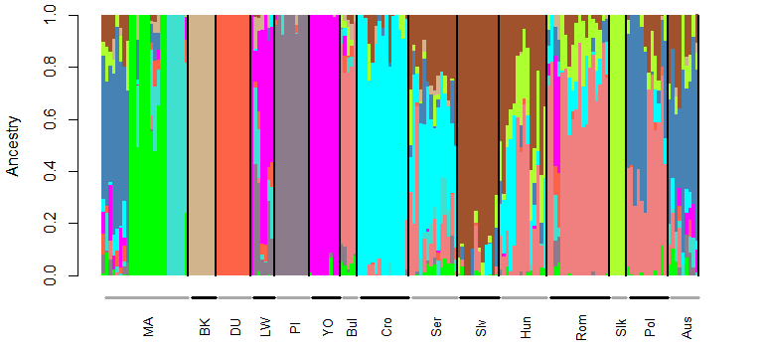g)