Jonathan CJ Wei# ^{a,b} and Isha N Haridass# ^{c,a}, Michael L Crichton ^{d}, Yousuf H Mohammed ª, Stefano C Meliga ^{b}, Washington Y Sanchez ª, Jeffrey E Grice ª, Heather AE Benson ^{c}, Michael S Roberts* ^{a,e}, Mark AF Kendall* ^{f}

Space- and time-resolved investigation on diffusion kinetics of human skin following macromolecule delivery by microneedle arrays

ª Diamantina Institute, Faculty of Medicine, The University of Queensland, Woolloongabba QLD 4102, Australia ^{b} Australian Institute for Bioengineering and Nanotechnology, The University of Queensland, St Lucia QLD 4072, Australia ^{c} School of Pharmacy and Biomedical Sciences, Curtin Health Innovation Research Institute, Curtin University, Bentley WA 6102, Australia ^{d} Institute of Mechanical, Process and Energy Engineering, School of Engineering and Physical Sciences, Heriot-Watt University, Edinburgh, EH14 4AS, United Kingdom ^{e} Basil Hetzel Institute for Translational Health Research, School of Pharmacy and Medical Sciences, University of South Australia, Adelaide SA 5011, Australia ^{f} Australian National University, Canberra ACT 0200, Australia

#These authors contributed equally and share lead authorship.
*Corresponding authors: m.roberts@uq.edu.au, mark.kendall@anu.edu.au,

Supplementary information

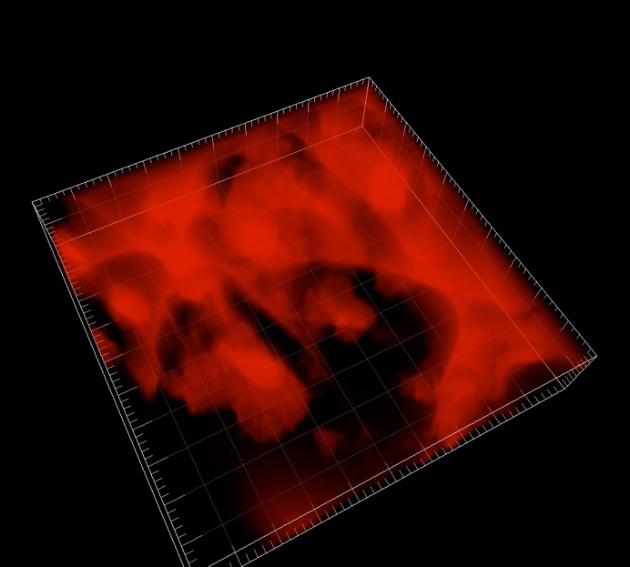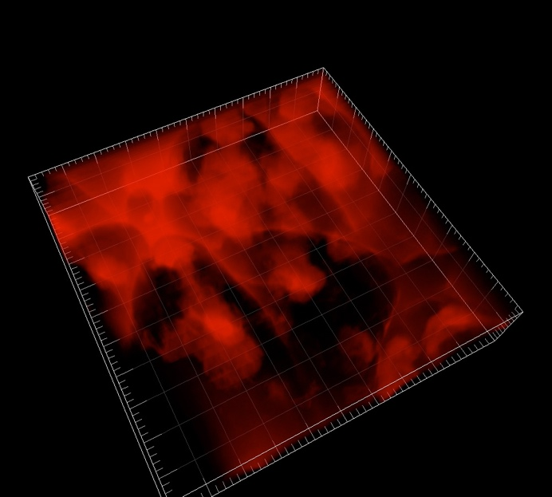
Figure S 1. Before and after screenshots of a representative stack visualised in 3D, from 0-30 minutes after patching, red channel, perspective view. Full video attached.

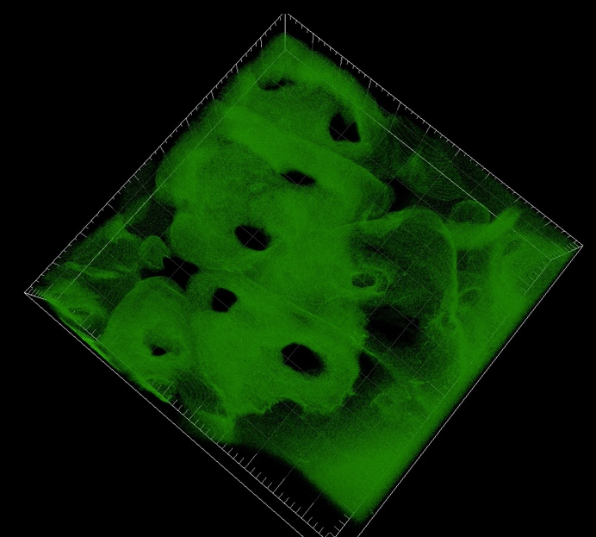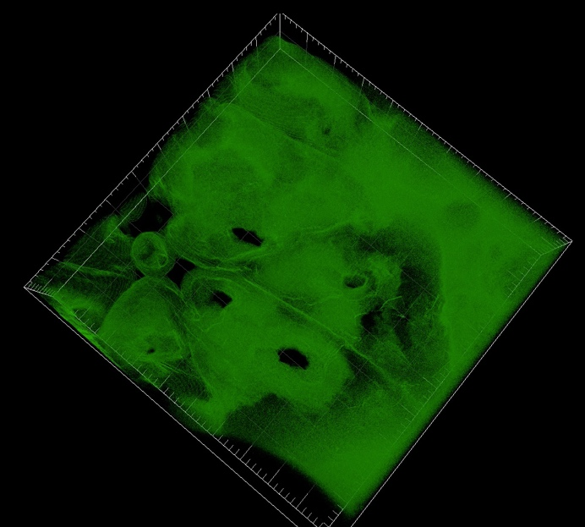
Figure S 2. Before and after screenshots of a representative stack visualised in 3D, from 0-30 minutes after patching, green channel, perspective view. Full video attached.

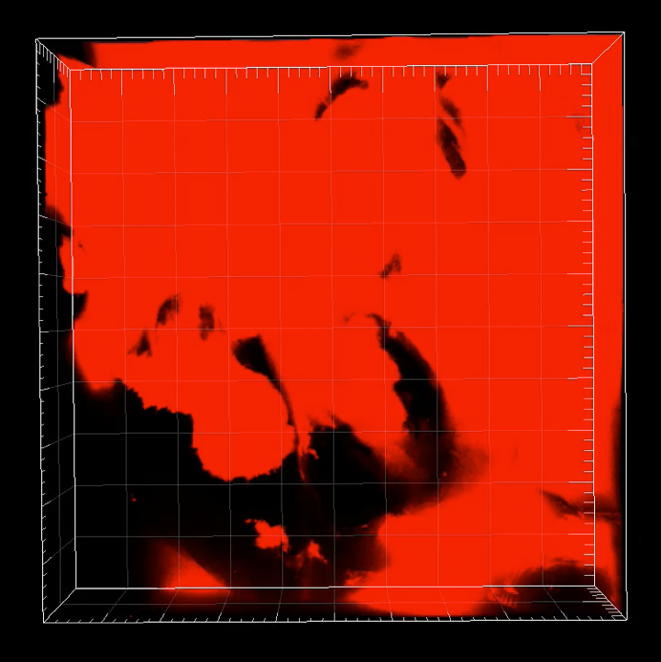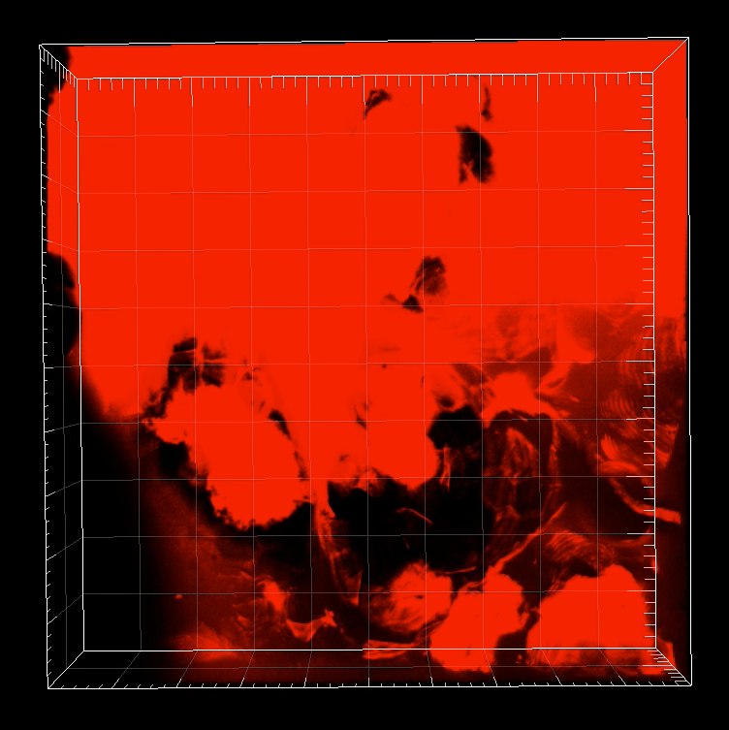
Figure S 3. Before and after screenshots of a representative stack visualised in 3D, from 0-30 minutes after patching, red channel, top view. Full video attached.

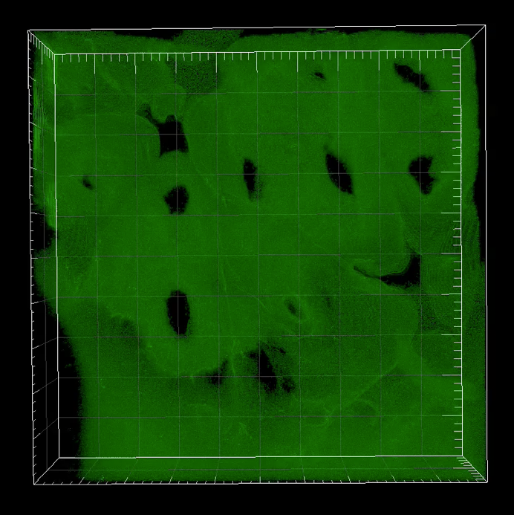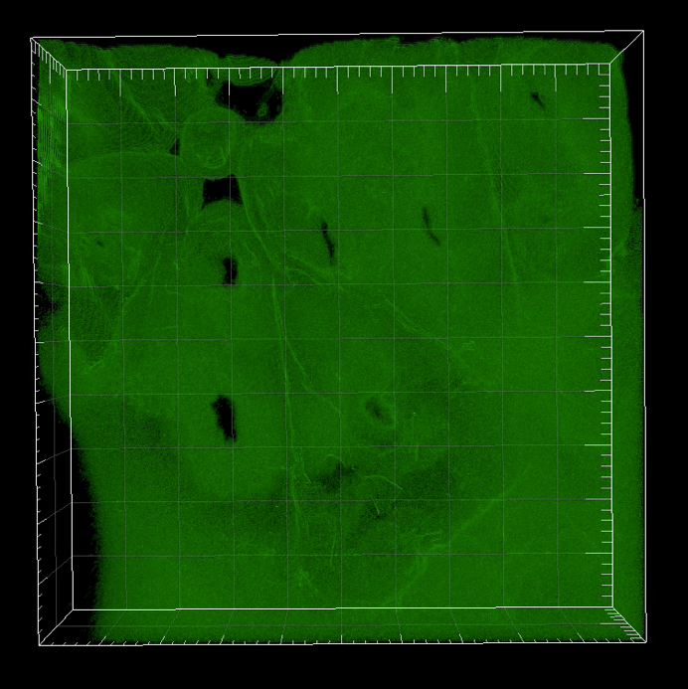
Figure S 4. Before and after screenshots of a representative stack visualised in 3D, from 0-30 minutes after patching, green channel, top view. Full video attached.

