Cardiovascular risk algorithms in primary care.
Results from the DETECT study

Tanja B. Grammer, MD^{1,2*}, Alexander Dressel, PhD², Ingrid Gergei², Marcus E. Kleber, PhD^{2,3}, Ulrich Laufs, MD⁴, Hubert Scharnagl, PhD⁵, Uwe Nixdorff, MD⁶, Jens Klotsche, PhD⁷, Lars Pieper, PhD⁸, David Pittrow, PhD⁹, Sigmund Silber, MD¹⁰, Hans-Ulrich Wittchen, MD^{11,12}, Winfried März, MD^{2,5,13}

¹University of Heidelberg, Mannheim Medical Faculty, Mannheim Institute of Public Health, Social and Preventive Medicine, Mannheim, Germany
²University of Heidelberg, Mannheim Medical Faculty, Department of Internal Medicine V (Nephrology, Hypertensiology, Rheumatology, Endocrinology, Diabetology), Mannheim, Germany
³Friedrich-Schiller-Universität Jena, Institute of Nutrition Science, Jena, Germany
⁴Clinic and Polyclinic of Cardiology, Univesity Clinic Leipzig, Leipzig, Germany
⁵Medical University of Graz, Clinical Institute of Medical and Chemical Laboratory Diagnostics, Graz, Austria
⁶European Prevention Center, EPC GmbH, Düsseldorf, Germany
⁷German Research Center of Rheumatology Berlin, Leibnitz Institute, Berlin, Germany
⁸Charité Universitätsmedizin Berlin, Institute of Social Medicine, Epidemiology and Health Economics, Berlin, Germany
⁹Technical University Dresden, Medical Faculty, Institute of Clinical Pharmacology, Dresden, Germany
¹⁰Cardiology Outpatient Clinic Tal, Munich, Germany
¹¹Technical University Dresden, Institute of Clinical Psychology and Psychotherapy, Dresden, Germany
¹²Max-Planck- Institute of Psychiatry, Munich, Germany
¹³Synlab Services GmbH, Synlab Academy, Mannheim and Augsburg, Germany

Supplementary Information

Supplementary Figure 1
Comparison of risk algorithms by scatterplots. Based on the results of the first cross-sectional study of the DETECT population 10-years risks for each patient in the sample (n = 2463, subgroup aged 40-65 years) were calculated with all specified algorithms.
Abscissa: Framingham CVD (clinical endpoints: coronary death, myocardial infarction, coronary insufficiency, angina pectoris, heart failure, stroke, transient cerebral ischemia, peripheral arterial occlusive disease, EP4).
Ordinates: A) PROCAM I (clinical endpoint: coronary death, myocardial infarction, EP1); B) Reynolds (clinical endpoint: myocardial infarction, stroke, coronary revascularization, cardiovascular death, EP2); C) Framingham hard-CE (clinical endpoint: coronary death, myocardial infarction, EP1); D) Framingham CHD1 (clinical endpoint: coronary death, myocardial infarction, coronary insufficiency, angina pectoris, heart failure, EP3); E) Framingham CHD2 (clinical endpoint as Framingham CHD1); F) ARRIBA (clinical endpoint: myocardial infarction, stroke, coronary revascularization, cardiovascular death, EP2); G) ASCVD (clinical endpoint: myocardial infarction, stroke, coronary revascularization, cardiovascular death, EP2); H) ESC HeartScore (clinical endpoint: cardiovascular mortality, EP5).
If risks were derived from tables and these risks assumed discrete values ony, several patients fall together in one data point. PROCAM II is not shown here, since the continuous risk formula is not published and the score derived from the panels can assume five levels only.

Supplementary Figure 2
Embedding the scores in the three-dimensional space by means of multidimensional scaling. Based on the Spearman correlation matrix the items of which can be construed as "distances" between the scores, a multidimensional scaling was carried out; the projections of the "score points" in a three-dimensional space, spanned by the vectors to the three largest values of the Spearman correlation matrix were performed. The smaller the "distance" is between two scores the more similar they are.

Supplementary Table 1. Characteristics of the entire third layer laboratory subgroup of the DETECT study and of the subpopulation without CVD examined in the current study
Variable | Third layer  laboratory subgroup | Current  study population  w/o CVD and DM | P²
Number | 7519 | 4044
Female, n (%) | 4438 (59) | 2641 (65.3) | <0.001
Age (years) | 57.7±14.4 | 53.8±13.7 | <0.001
HDL cholesterol (mg/dl) | 54.4±18.7 | 57.2±18.8 | <0.001
LDL cholesterol (mg/dl) | 127.5±33.9 | 129.3±33.3 | <0.001
Cholesterol (mg/dl) | 223.2±43.3 | 225.9±41 | <0.001
Triglycerides (mg/dl)¹ | 128.4 (72.5,227.2) | 118.7 (68.5,205.8) | <0.001
HbA1c (%) | 5.6±0.9 | 5.3±0.3 | <0.001
Glucose (mg/dl) | 114.7±39.6 | 101.7±16.3 | <0.001
hsCRP (mg/l)¹ | 2.3 (0.7,7.1) | 2 (0.7,6.4) | <0.001
Arterial hypertension, n (%) | 3615 (49) | 1502 (37.14) | <0.001
Systolic blood pressure (mm Hg) | 132.6±18.6 | 129.5±17.5 | <0.001
Diastolic blood pressure (mm Hg) | 80.1±10 | 79.6±9.8 | <0.001
Smoking never/ex/current (%) | 3994/1734/1519 (55.1/23.9/21) | 2291/819/934 (56.7/20.3/23.1) | <0.001
Positive family history, n (%) | 2207 (30.4) | 1082 (26.8) | <0.001
BMI (kg/m²) | 27.2±4.9 | 26.4±4.6 | <0.001
Medication
Antihypertensive medication, n (%) | 2821 (37.5) | 1086 (26.9) | <0.001
Lipid lowering medication, n (%) | 1134 (15.1) | 313 (7.7) | <0.001
Antithrombotics, n (%) | 1121 (14.9) | 226 (5.6) | <0.001
Antidiabetic medication n, (%) | 979 (13) | 0 (0) | <0.001
Clinical endpoints during follow-up
Death, n (%) | 279 (3.7) | 75 (1.9) | <0.001
Cardiovascular Death, n (%) | 210 (2.8) | 57 (1.4) | <0.001
Non letal myocardial infarctions, n (%) | 85 (1.1) | 19 (0.5) | <0.001
PTCA/ACVB, n (%) | 186 (2.5) | 36 (0.9) | <0.001
Stroke, TIA, n (%) | 189 (2.5) | 69 (1.7) | <0.001
Symptomatic periperal arterial disease, n (%) | 112 (1.5) | 32 (0.8) | <0.001
Endpoint 1 (PROCAM-I, FRS-hard-CVE), n (%) | 319 (4.2) | 72 (1.8) | <0.001
Endpoint 2 (Reynolds, ASCVD, ARRIBA), n (%) | 390 (5.2) | 101 (2.5) | <0.001
Endpoint 3 (FRS-CHD1, FRS-CHD1), n (%) | 519 (6.9) | 132 (3.3) | <0.001
Endpoint 4 (FRS-CVD), n (%) | 775 (10.3) | 220 (5.4) | <0.001
¹ Values for triglycerides and hsCRP in brackets correspond to logarithmic standard intervals
² Student´s T test and exact Fisher´s test in the case of continuous and categorial variables, respectively (by comparing the current study population with its complement in the third-layer laboratory subgroup)

Supplementary Table 2. Characteristics of the third layer laboratory subgroup of the DETECT study without CVD and DM and of the subpopulation without CVD and DM examined in the current study

Variable | Third layer  laboratory subgroup w/o CVD and DM | Current  study population  w/o CVD and DM | P²
Number | 4473 | 4044
Female, n (%) | 2927 (65.4) | 2641 (65.3) | 0.594
Age (years) | 53.9±13.8 | 53.8±13.7 | 0.306
HDL cholesterol (mg/dl) | 57.2±18.7 | 57.2±18.8 | 0.719
LDL cholesterol (mg/dl) | 129.5±33.3 | 129.3±33.3 | 0.319
Cholesterol (mg/dl) | 226.1±41.2 | 225.9±41 | 0.456
Triglycerides (mg/dl)¹ | 118.9 (68.6,206.1) | 118.7 (68.5,205.8) | 0.589
HbA1c (%) | 5.3±0.3 | 5.3±0.3 | 0.761
Glucose (mg/dl) | 101.8±16.4 | 101.7±16.3 | 0.064
hsCRP (mg/l)¹ | 2 (0.7,6.4) | 2 (0.7,6.3) | 0.425
Arterial hypertension n (%) | 1647 (37.6) | 1502 (37.1) | 0.03
Systolic blood pressure (mm Hg) | 129.6±17.6 | 129.5±17.5 | 0.575
Diastolic blood pressure (mm Hg) | 79.6±9.8 | 79.6±9.8 | 0.571
Smoking never/ex/current (%) | 2455/861/1006 (56.8/19.9/23.3) | 2291/819/934 (56.7/20.3/23.1) | 0.093
Positive family history, n (%) | 1163 (26.7) | 1082 (26.8) | 0.894
BMI (kg/m²) | 26.4±4.6 | 26.4±4.6 | 0.879
Medication
Antihypertensive medication, n (%) | 1197 (26.8) | 1086 (26.9) | 0.688
Lipid lowering medication, n (%) | 350 (7.8) | 313 (7.7) | 0.508
Antithrombotics, n (%) | 240 (5.4) | 226 (5.6) | 0.042
Clinical endpoints during follow-up
Death, n (%) | 87 (2) | 75 (1.9) | 0.195
Cardiovascular Death, n (%) | 68 (1.5) | 57 (1.4) | 0.092
Non letal myocardial infarctions, n (%) | 20 (0.5) | 19 (0.5) | 0.715
PTCA/ACVB, n (%) | 40 (0.9) | 36 (0.9) | 0.79
Stroke, TIA, n (%) | 75 (1.7) | 69 (1.7) | 0.843
Symptomatic periperal arterial disease, n (%) | 33 (0.7) | 32 (0.8) | 0.365
Endpoint 1 (PROCAM-I, FRS-hard-CVE), n (%) | 79 (1.8) | 72 (1.8) | 1
Endpoint 2 (Reynolds, ASCVD, ARRIBA), n (%) | 113 (2.5) | 101 (2.5) | 0.63
Endpoint 3 (FRS-CHD1, FRS-CHD1), n (%) | 154 (3.4) | 132 (3.3) | 0.051
Endpoint 4 (FRS-CVD), n (%) | 249 (5.6) | 220 (5.4) | 0.267
¹ Values for triglycerides and hsCRP in brackets correspond to logarithmic standard intervals
² Student´s T test and exact Fisher´s test in the case of continuous and categorial variables, respectively (by comparing the current study population with its complement in the third-layer laboratory subgroup)

Supplementary Table 3. Characteristics of study participants living in East and West Germany.

Variable | East Germany | West Germany | P³
Number | 1253 | 2791
female, n (%) | 836 (66.7) | 1805 (64.7) | 0.211
Age (years) | 54.1±13 | 53.7±14.1 | 0.358
HDL cholesterol (mg/dl) | 58±18.7 | 56.8±18.8 | 0.075
LDL cholesterol (mg/dl) | 129.4±32.6 | 129.3±33.7 | 0.941
Cholesterol (mg/dl) | 228.2±40.8 | 224.9±41 | 0.020
Triglycerides (mg/dl)³ | 123.92 (71.1,215.9) | 116.43 (67.4,201.2) | 0.001
HbA1c (%) | 5.3±0.3 | 5.3±0.3 | 0.087
Glucose (mg/dl) | 102.8±16.9 | 101.2±16 | 0.005
hsCRP (mg/l)³ | 2 (0.7,6.2) | 2.02 (0.6,6.4) | 0.807
Arterial hypertension, n (%) | 498 (39.7) | 1004 (36) | 0.022
Systolic blood pressure (mm Hg) | 129.1±16.4 | 129.7±17.9 | 0.251
Diastolic blood pressure (mm Hg) | 79.6±8.8 | 79.6±10.2 | 0.914
Smoking never/ex/current (%) | 768/246/239 (61.3/19.6/19.1) | 1523/573/695 (54.6/20.5/24.9) | <0.001
Positive family history, n (%) | 355 (28.3) | 727 (26.1) | 0.134
BMI (kg/m²) | 26.6±4.6 | 26.3±4.7 | 0.023
Medication
Antihypertensive medication, n (%) | 395 (31.5) | 691 (24.8) | <0.001
Lipid lowering medication, n (%) | 106 (8.5) | 207 (7.4) | 0.253
Antithrombotics, n (%) | 75 (6) | 151 (5.4) | 0.46
Clinical endpoints during follow-up
Death, n (%) | 20 (1.6) | 55 (2) | 0.452
Cardiovascular Death, n (%) | 15 (1.2) | 42 (1.5) | 0.475
Non letal myocardial infarctions, n (%) | 4 (0.3) | 15 (0.5) | 0.459
PTCA/ACVB, n (%) | 11 (0.9) | 25 (0.9) | 1
Stroke, TIA, n (%) | 22 (1.8) | 47 (1.7) | 0.896
Symptomatic periperal arterial disease, n (%) | 8 (0.6) | 24 (0.9) | 0.567
Endpoint 1 (PROCAM-I, FRS-hard-CVE), n (%) | 18 (1.4) | 54 (1.9) | 0.305
Endpoint 2 (Reynolds, ASCVD, ARRIBA), n (%) | 28 (2.2) | 73 (2.6) | 0.515
Endpoint 3 (FRS-CHD1, FRS-CHD1), n (%) | 44 (3.5) | 88 (3.2) | 0.566
Endpoint 4 (FRS-CVD), n (%) | 67 (5.4) | 153 (5.5) | 0.94

¹ includes the federal states Berlin, Brandenburg, Mecklenburg-Western Pomerania, Saxony, Saxony-Anhalt, Thuringia
² includes the federal states Baden-Württemberg, Bavaria, Bremen, Hamburg, Hessen, Lower Saxony, North Rhine-Westphalia, Rhineland-Palatinate, Saarland, Schleswig-Holstein
³ Values for triglycerides and hsCRP in brackets correspond to logarithmic standard intervals
⁴ Student´s T test and exact Fisher´s test in the case of continuous and categorial variables, respectively

Supplementary Table 4. Correlations between 10-year risks for cardiovascular events, based on the first visit results of the DETECT study for participants 40-65 years old
(n=2463)

 | PROCAM-I | Reynolds | FRS-hard-CVE | FRS-CHD1 | FRS-CHD2 | FRS-CVD | ARRIBA | ASCVD | ESC-HS
PROCAM-I | 1 | 0.91 | 0.91 | 0.88 | 0.88 | 0.9 | 0.89 | 0.89 | 0.89
Reynolds | 0.92 | 1 | 0.92 | 0.90 | 0.91 | 0.95 | 0.89 | 0.95 | 0.94
FRS-hard-CVE | 0.93 | 0.92 | 1 | 0.87 | 0.89 | 0.94 | 0.95 | 0.96 | 0.89
FRS-CHD1 | 0.89 | 0.89 | 0.86 | 1 | 0.98 | 0.92 | 0.83 | 0.90 | 0.9
FRS-CHD2 | 0.90 | 0.90 | 0.88 | 0.97 | 1 | 0.93 | 0.85 | 0.91 | 0.91
FRS-CVD | 0.90 | 0.95 | 0.94 | 0.92 | 0.93 | 1 | 0.90 | 0.96 | 0.92
ARRIBA | 0.90 | 0.89 | 0.95 | 0.82 | 0.84 | 0.90 | 1 | 0.91 | 0.83
ASCVD | 0.91 | 0.94 | 0.95 | 0.89 | 0.90 | 0.96 | 0.90 | 1 | 0.94
ESC-HS | 0.90 | 0.94 | 0.88 | 0.88 | 0.9 | 0.92 | 0.82 | 0.94 | 1

Light grey: correlation coefficiants by Pearson
Dark grey: correlation coefficiants by Spearman
bold: correlation coefficiants greater or equal 0.90
Supplementary Table 5. Pairwise continuous net reclassification improvements (NRI¹) of risk scores (95% CI in brackets, significant NRIs bold)²

 | Reynolds | ASCVD | PROCAM-I | FRS-CHD1 | FRS-CHD2 | FRS-CVD | FRS-hard-CVE | ARRIBA | ESC-HS
Reynolds |  | 0.121  (-0.067,0.268) | -0.157  (-0.282, -0.016) | -0.245  (-0.347, -0.061) | -0.173  (-0.323, 0) | -0.039  (-0.164, 0.151) | -0.114  (-0.244, 0.027) | -0.224  (-0.326, -0.105) | 0.011  (-0.142, 0.183)
ASCVD | -0.121  (-0.268, 0.067) |  | -0.141  (-0.327, 0.004) | -0.229  (-0.377, -0.076) | -0.206  (-0.353, -0.037) | -0.104  (-0.227, 0.020) | -0.219  (-0.356, -0.029) | -0.252  (-0.380, -0.109) | -0.145  (-0.266, -0.008)
PROCAM-I | 0.157  (0.016, 0.282) | 0.141  (-0.004, 0.327) |  | 0.013  (-0.137, 0.158) | 0.052  (-0.103, 0.166) | 0.174  (0.029, 0.321) | 0.050  (-0.058, 0.194) | 0.070  (-0.087, 0.189) | 0.114  (-0.035, 0.268)
FRS-CHD1 | 0.245  (0.061, 0.347) | 0.229  (0.076, 0.377) | -0.013  (-0.158, 0.137) |  | 0.066  (-0.101, 0.261) | 0.306  (0.123, 0.447) | 0.196  (0.060, 0.314) | 0.029  (-0.119, 0.180) | 0.196  (0.007, 0.313)
FRS-CHD2 | 0.173  (0, 0.323) | 0.206  (0.037, 0.353) | -0.052  (-0.166, 0.103) | -0.066  (-0.261, 0.101) |  | 0.268  (0.064, 0.430) | 0.165  (0, 0.298) | -0.024  (-0.164, 0.136) | 0.146  (-0.054, 0.322)
FRS-CVD | 0.039  (0.151, 0.164) | 0.104  (-0.020, 0.227) | -0.174  (-0.321, -0.029) | -0.306  (-0.447, -0.123) | -0.268  (-0.430, -0.064) |  | -0.095  (-0.245, 0.012) | -0.210  (-0.315, -0.078) | 0.015  (-0.131, 0.161)
FRS-hard-CVE | 0.114  (0.027, 0.244) | 0.219  (0.029, 0.356) | -0.05  (-0.194, 0.058) | -0.196  (-0.314, -0.06) | -0.165  (-0.298, 0) | 0.095  (-0.012, 0.245) |  | -0.160  (-0.270, -0.001) | 0.085  (-0.080, 0.234)
ARRIBA | 0.224  (0.105, 0.326) | 0.252  (0.109, 0.38) | -0.07  (-0.189, 0.087) | -0.029  (-0.180, 0.119) | 0.024  (-0.136, 0.164) | 0.21  (0.078, 0.315) | 0.16  (0.001, 0.270) |  | 0.165  (0, 0.291)
ESC-HS | -0.011  (0.183, 0.142) | 0.145  (0.008, 0.266) | -0.114  (-0.268, 0.035) | -0.196  (-0.313, -0.007) | -0.146  (-0.322, 0.054) | -0.015  (-0.161, 0.131) | -0.085  (-0.234, 0.080) | -0.165  (-0.291, 0)
¹ adapted to competing risk prediction models with censored survival data (corresponding to the quantity defined as “1/2 NRI (>0)” in Pencina et al.²¹
² in i^{th} row and j^{th} column: NRI of the j^{th} score in comparison to the i^{th} score on the age interval 20-75 years (n=3794), endpoint: union of EP 1-5 (171 events); median follow-up time: 4.02 years)
Supplementary Table 6. Comparison of prevalence rates of hypertension in German cohorts (%)

 | DEGS1 (N=7096) |  |  |  |  | DETECT  (third layer population, N=7519) |  |  |  | DETECT (N=4044, current study population w/o CVD and DM)
 | Men |  |  | Women |  | Men |  | Women |  |  | Men |  | Women
Age Stratum (years) | N | Prevalence  rate (%) |  | N | Prevalence  rate (%) | N | Prevalence  rate (%) | N | Prevalence  rate (%) |  | N | Prevalence  rate (%) | N | Prevalence  rate (%)
18-29 | Not provided | 16.2 |  | Not provided | 1.8 | 53 | 20.8 | 123 | 6.5 |  | 32 | 21.9 | 88 | 8
30-39 | Not provided | 14.4 |  | Not provided | 4.6 | 243 | 22.2 | 501 | 11.6 |  | 159 | 18.2 | 376 | 9.84
40-49 | Not provided | 39.8 |  | Not provided | 16.4 | 504 | 32.7 | 853 | 20.5 |  | 339 | 25.1 | 677 | 18.9
50-59 | Not provided | 56.8 |  | Not provided | 30.6 | 613 | 53.3 | 791 | 43.9 |  | 329 | 43.5 | 532 | 39.1
60-69 | Not provided | 47.6 |  | Not provided | 43.4 | 914 | 65.5 | 1065 | 60.9 |  | 352 | 50.6 | 571 | 53.2
70-79 | Not provided | 61.3 |  | Not provided | 65.6 | 601 | 71.7 | 784 | 71.3 |  | 166 | 65.1 | 325 | 62.2
 | HYDRA (N=45.093) |  |  |  |  | DETECT  (third layer population, N=7519) |  |  |  | DETECT (N=4044, current study population w/o CVD and DM)
 | Men |  |  | Women |  | Men |  | Women |  |  | Men |  | Women
Age Stratum (years) | N |  | Prevalence  rate (%) | n | Prevalence rate (%) | N | Prevalence  rate (%) | N | Prevalence  rate (%) |  | N | Prevalence  rate (%) | N | Prevalence  rate (%)
16-29 | 385 |  | 17.8 | 277 | 7.8 | 32 | 21.9 | 88 | 8 |  | 32 | 21.9 | 88 | 8
30-44 | 1213 |  | 32.5 | 1226 | 19.9 | 317 | 19.2 | 707 | 13.3 |  | 317 | 19.2 | 707 | 13.3
45-59 | 2469 |  | 57.6 | 2956 | 48.0 | 510 | 38.4 | 878 | 31.8 |  | 510 | 38.4 | 878 | 31.8
60-74 | 4672 |  | 73.6 | 5921 | 73.1 | 464 | 53.9 | 765 | 55.3 |  | 464 | 53.9 | 765 | 55.3
≥75 | 1164 |  | 76.1 | 2461 | 80.4 | 80 | 68.8 | 203 | 64 |  | 80 | 68.8 | 203 | 64

Supplementary Figure 1

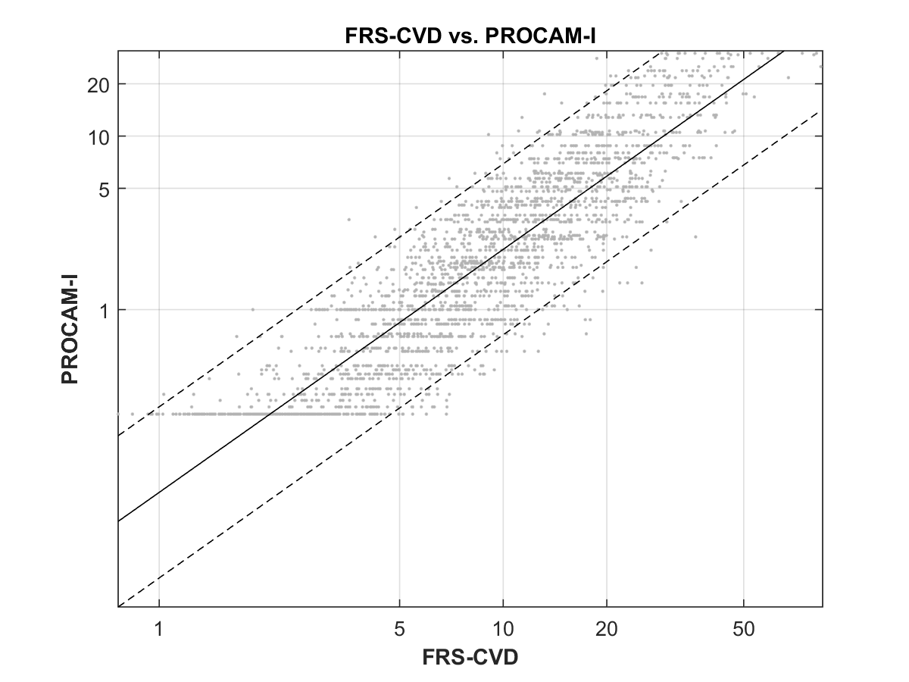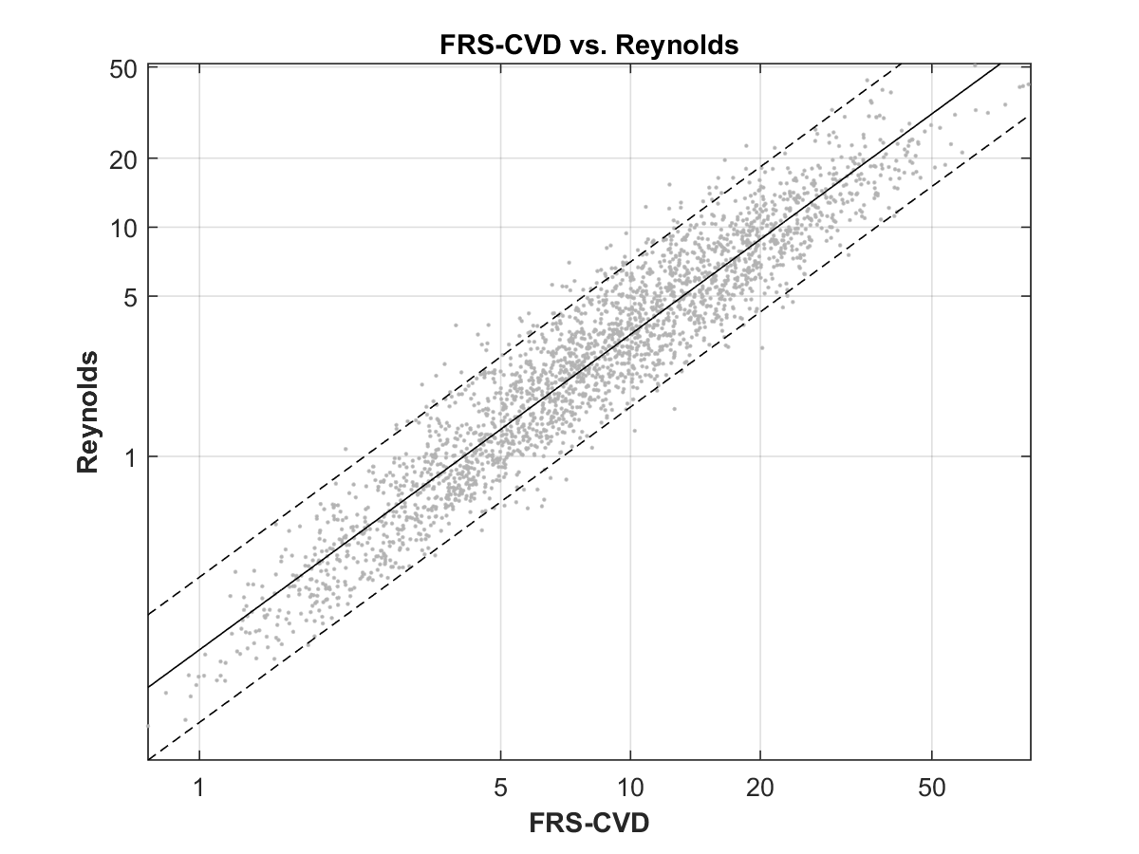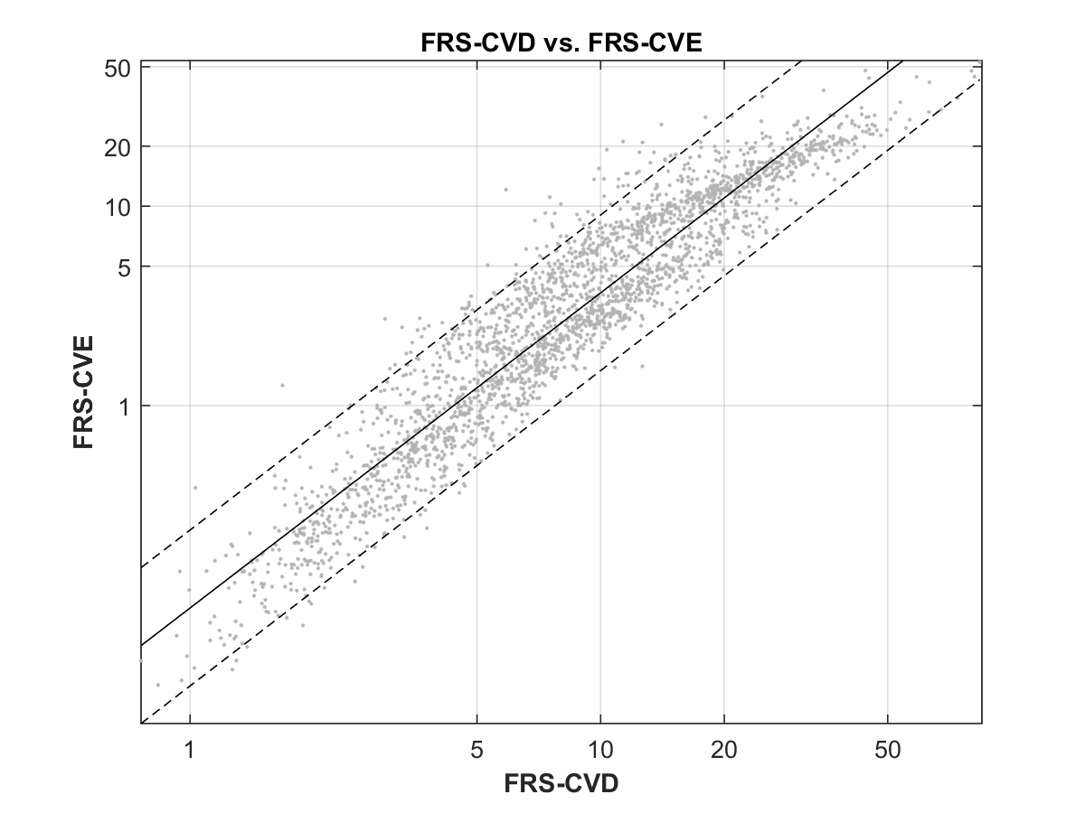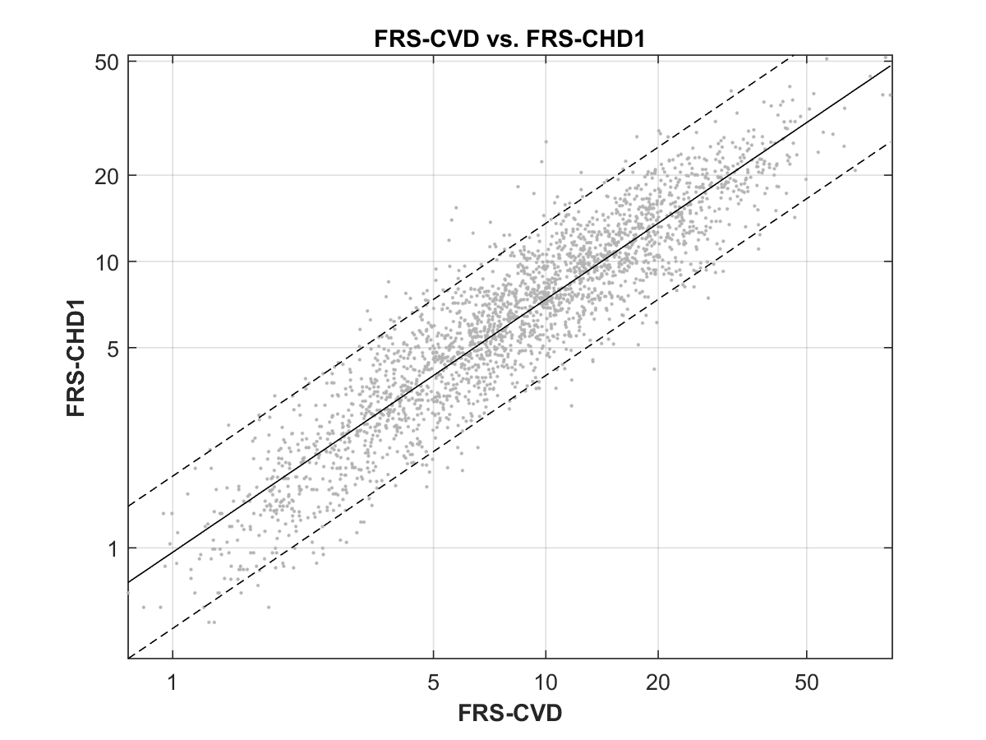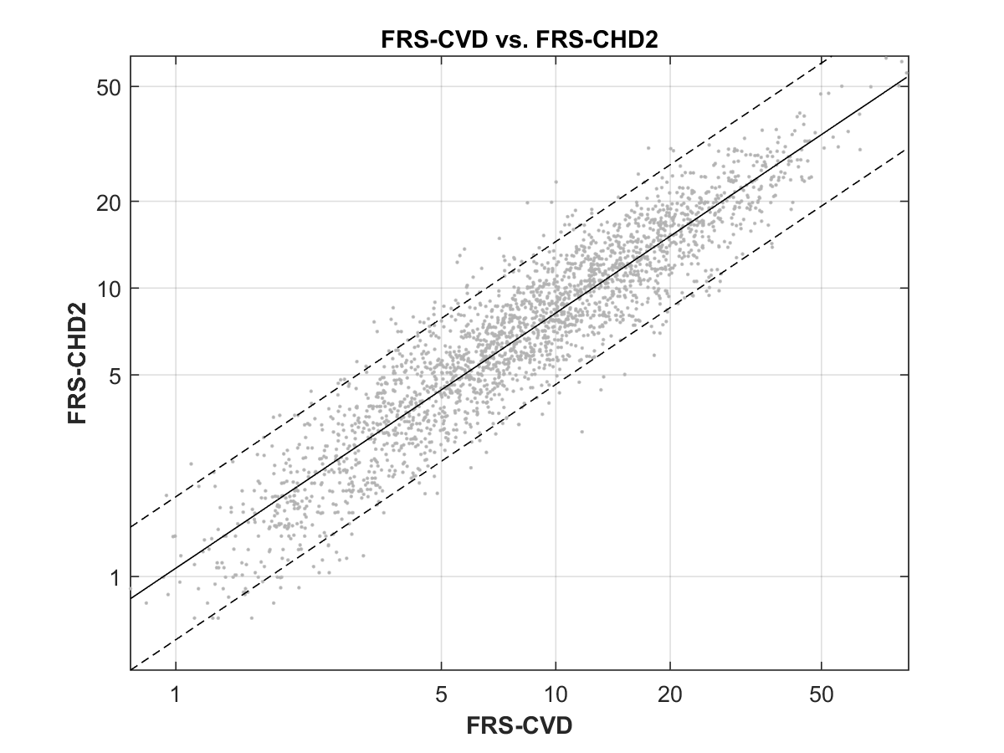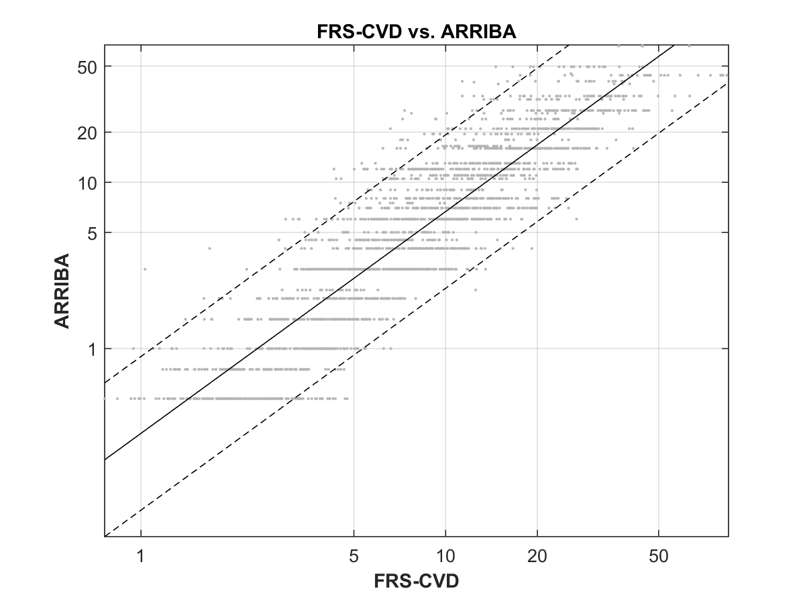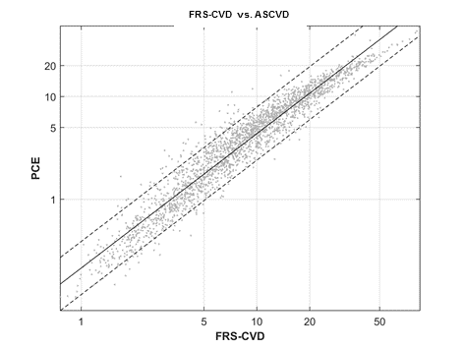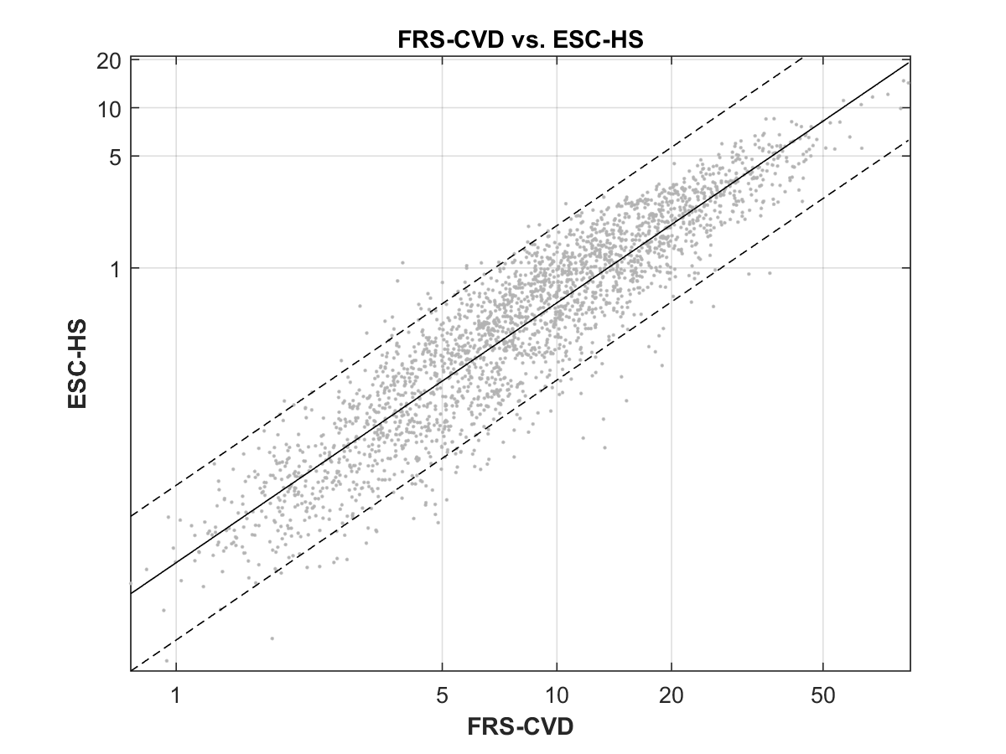
Supplementary Figure 2

