SUPPLEMENTARY INFORMATION for:

Tyrannosaurid-like osteophagy by a Triassic archosaur

Martin Qvarnström¹, Per E. Ahlberg¹ and Grzegorz Niedźwiedzki¹*

¹Department of Organismal Biology, Evolutionary Biology Centre, Uppsala University, Norbyvägen 18A, 752 36 Uppsala, Sweden

*Corresponding author
E-mail address: grzegorz.niedzwiedzki@ebc.uu.se (G. Niedźwiedzki)

Appendix S1. Details about the locality and fossil horizon.

The most productive fossiliferous beds were well exposed between 2007-2014 (but are now under water) in the Lipie Śląskie clay-pit at Lisowice^{10,11,16}. According to comparisons with lithologic descriptions of boreholes^{49,50} this unit is characteristic for the upper Zbąszynek and lower Wielichowo Beds from the north-western and central parts of Poland^{10,11,16,51-54}. The Upper Triassic deposits from Lisowice are also, in part, similar to a local lithostratigraphic unit named the Lisów Beds (or Lisów Formation) known from the two nearly located Solarnia IG-1 and Lubliniec IG-1⁵⁵ boreholes in Silesia, and also to the so-called Woźniki Formation exposed in some places near Lubliniec⁵⁵. This simple lithostratigraphic correlation is also consistent with biostratigraphic data (conchostracans and palynomorphs) collected from the Lisowice exposure and their correlation with borehole records from the Polish Lowland (see below).
Identifications of palynomorph fossils in the grey and organic-rich strata at the Lipie Śląskie clay-pit^{10,11,16} suggest a correlation of this unit with the Corollina meyeriana Zone, Subzone IVb (upper part) and Subzone IVc (middle-upper Norian and uppermost Norian-lowermost Rhaetian respectively⁵⁶⁻⁵⁸) and also Ricciisporites tuberculatus Zone (middle-upper Rhaetian in age⁵⁶⁻⁵⁸), which are well-defined based on core material from the central and northern part of Poland^{53,54,56,58}. The upper Zbąszynek Beds apparently continues into the upper Arnstad, upper Löwenstein, Trossingen, and lower part of the Exter Formation of the upper Middle to Upper Keuper (upper Norian–Rhaetian) in the middle-eastern part of the Germanic Basin⁵³, which contains the geologically oldest fossils of early mammaliaforms and a diversified fauna of early dinosaurs⁵⁹⁻⁶¹. In the Polish geological literature, the lithostratigraphic unit represented at the Lipie Śląskie clay-pit has been referred to as Norian⁶² or Rhaetian “sensu polonico” ⁵¹⁻⁵³. Recently, some authors^{63,64} included the bone-bearing deposits from Lisowice to a re-defined Grabowa Formation and suggest middle Norian age of this tetrapod fauna. This is mainly based on chemostratigraphical correlations with support of palynological studies (e.g. identification of Corollina meyeriana Subzone IVb in Lipie Śląskie clay-pit section). Such an interpretation is contradicted by paleontological and biostratigraphical data collected from Lisowice section (see below) and other bone-bearing Late Triassic sites in Silesia.
The bone and coprolite-bearing intervals are rich in organic remains and macrofossils of plants. The dominant plant species at Lisowice is a conifer closely similar to Brachyphyllum, Pagiophyllum or Hirmeriella, as is the case with the upper Norian-Rhaetian and Lower Jurassic floras of the region^{65,66}. The second most common plant species is represented by twigs and seeds closely similar to Stachyotaxus septentrionalis (Agardh, 1823), a taxon characteristic for the Rhaetian of Greenland and Scania⁶⁷⁻⁶⁹. Other plant fossils, which are currently examined in detail, are represented by cycadophytes, ginkgophytes, and pteridosperms⁷⁰.
Several other findings are also suggestive of an early Rhaetian age including: numerous cuticle fragments and rare leaf fragments or fructifications (Peltaspermum rotula Harris, 1937) of the typical Rhaetian seed-fern Lepidopteris ottonis (Goeppert, 1836) ⁷¹⁻⁷⁵; the isoëtalean macrospores Trileites cf. pinguis (Harris, 1935) and Horstisporites bertelseni Fuglewicz, 1977^{76,77}; and the conchostracans Gregoriusella polonica Kozur, Niedźwiedzki et Sulej, 2010, Euestheria sp., and Shipingia sp. collected mainly from layers located below upper bone-bearing interval^{16,78}. Monospecific assemblages with G. polonica are known from the lower Exter Formation of northern Germany (early Rhaetian) and the upper Redonda Formation of New Mexico (latest Norian-early Rhaetian), with this species occurring above the Shipingia olseni Zone, which is correlated with the late Norian Sevatian substage^{64,79}. The S. olseni Zone is followed by a short interval that contains both abundant specimens of the very small form G. polonica and the last specimens of S. gerbachmanni; this interval could be either latest Norian or earliest Rhaetian⁸⁰.

Appendix S2. Supporting References.

49. Dadlez, R., Kopik, J. Problem retyku w zachodniej Polsce na tle profile w Książu Wielkopolskim. Kwartalnik Geologiczny 7, 131–158 (1963).

50. Deczkowski, Z. Noryk–Retyk, Jura dolna. In: S. Marek and M. Pajchlowa (eds), Epikontynentalny perm i mezozoik w Polsce. Prace Państwowego Instytutu Geologicznego 153, 174–235 (1997).

51. Franz, M., Bachmann, G.H., Beutler, G. Retyk sensu polonico versus Rhaet sensu germanico – new results. Schriftenreihe der Deutschen Gesellschaft für Geowissenschaften 53, 99–100 (2007a).

52. Franz, M., Bachmann, G. H., Beutler, G. Sedimentology and Facies of the Polish Retyk and the German Arnstadt and Exter Formations (Norian, Rhaetian) in the eastern Central European Basin (CEB). Schriftenreihe der Deutschen Gesellschaft für Geowissenschaften 53, 101 (2007b).

53. Franz, M. Litho- und Leitflächenstratigraphie, Chronostratigraphie, Zyklo- und Sequenzstratigraphie des Keupers im östlichen Zentraleuropäischen Becken (Deutschland, Polen) und Dänischen Becken (Dänemark, Schweden). Dissertation zur Erlangung des akademischen Grades doctor rerum naturalium (Dr. rer. nat.) vorgelegt der Naturwissenschaftlichen Fakultät III der Martin-Luther-Universität Halle-Wittenberg, verteidigt am 08.12.2008: 1–198 (2008).

54. Pieńkowski, G., Niedźwiedzki, G., Waksmundzka, M. Sedimentological, palynological, and geochemical studies of the terrestrial Triassic–Jurassic boundary in north-western Poland. Geological Magazine 149, 308–332 (2012).

55. Haisig, J., Kotlicki, S., Wilanowski, S., Żurek, W. Objaśnienia do szczegółowej mapy geologicznej Polski, Arkusz Lubliniec. 46 pp. Wydawnictwa Geologiczne, Warszawa (1983).

56. Orłowska-Zwolińska, T. Palinostratygrafia epikontynentalnych osadów wyższego triasu w Polsce. Prace Instytutu Geologicznego 104, 1–88 (1983).

57. Orłowska-Zwolińska, T. Palynological zones of the Polish epicontinental Triassic. Bulletin of Polish Academy of Sciences, Earth Sciences 33, 107–119 (1985).

58. Fijałkowska-Mader, A. A record of climatic changes in the Triassic palynological spectra from Poland. Geological Quarterly 59, 615–653 (2015).

59. Clemens, W.A. Rhaeto-Liassic mammals from Switzerland and West Germany. Zitteliana, Abhandlungen der Bayerischen Staatssammlung für Paläontologie und Historische Geologie 5, 51–92 (1980).

60. Kielan-Jaworowska, Z., Cifelli, R.L., Luo, Z.-X. 2004. Mammals from the Age of Dinosaurs: Origins, Evolution, and Structure. 630 pp. Columbia University Press, New York.

61. Seegis, D. Tetrapoden. In: Deutsche Stratigraphische Kommission (ed.), Stratigraphie von Deutschland, Keuper-Band. Courier Forschungsinstitut Senckenberg 253, 50–51 (2005).

62. Szulc, J., Gradziński, M., Lewandowska, A., Heunisch, C. The Upper Triassic crenogenic limestones in Upper Silesia (southern Poland) and their paleoenvironmental context. In: A.M., Alonso-Zarza, L.H., Tanner (eds.), Paleoenvironmental Record and Applications of Calcretes and Palustrine Carbonates. Geological Society of America Special Papers 416, 133–151 (2006).

63. Szulc, J., Racki, G. Grabowa Formation – the basic lithostratigraphic unit of the Upper Silesian Keuper. Przegląd Geologiczny 63, 103–113 (2015).

64. Lucas, S.G. Age and correlation of Late Triassic tetrapods from southern Poland. Annales Societatis Geologorum Poloniae 85, 627–635 (2015).

65. Clement–Westerhof, J.A., Van Konijnenburg–Van Cittert, J.H.A. New data on the fertile organs leading to a revised concept of the Cheirolepidiaceae. Review of Palaeobotany and Palynology 68, 147–179 (1991).

66. Reymanówna, M. Two conifers from the Liassic flora of Odrowaz in Poland. In: J. Kovar–Eder (ed.), Palaeovegetational Development in Europe and Regions Relevant to its Palaeofloristic Evolution, Proceedings of the Pan-European Palaeobotanical Conference, Vienna, 19-23 September 1991, 307–311(1992).

67. Harris, T.M. 1932. The fossil flora of Scoresby Sound East Greenland. Part 4: Gingkoales, Coniferales, Lycopodiales and isolated fructifications. Meddelelser om Grønland 112, 1–12.

68. Arndt, S. Morphologie und Systematik ausgewählter Mesozoischer Koniferen. Palaeontographica B 262, 1–23 (2002).

69. Taylor, T.N., Taylor, E.L., Krings, M. Paleobotany – the biology and evolution of fossil plants. Academic Press, Burlington ⁄ Elsevier, Amsterdam, XXII + 1230 pp. (2009).

70. Wawrzyniak, Z. Późnotriasowa flora z Lipia Śląskiego, 76 pp. MSc Thesis, Wydział Nauk o Ziemi, Uniwersytet Śląski, Sosnowiec (2010).

71. Staneczko, K. Nowe dane paleobotaniczne na temat górnego triasu z Lipia Śląskiego koło Lublińca (południowa Polska). Geo-Sympozjum Młodych Badaczy Silesia 2007, 155–168 (2007).

72. Wawrzyniak, Z., Ziaja, J. 2009. Wstepne wyniki badan gornotriasowej makroflory Lipia Śląskiego, Polska. Geologia 35, 105–106.

73. Wawrzyniak, Z. 2011. The Upper Triassic cuticles from Lipie Śląskie (South Poland) In: M. Bąk, M.A. Kaminski, A. Waśkowska (eds), Integrating Microfossil Records from the Oceans and Epicontinental Seas. Grzybowski Foundation Special Publication 17, 140–141.

74. Pacyna, G. Plant remains from the Polish Triassic. Present knowledge and future prospects. Acta Palaeobotanica 51, 3–33 (2014).

75. Zatoń, M. et al. Coprolites of Late Triassic carnivorous vertebrates from Poland: An integrative approach. Palaeogeography, Palaeoclimatology, Palaeoecology 430, 21–46 (2015).

76. Fuglewicz, R. New species of megaspores from the Trias of Poland. Acta Palaeontologica Polonica 22, 405–431 (1977).

77. Fuglewicz, R., Śnieżek, P. Upper Triassic megaspores from Lipie Śląskie near Lubliniec. Przegląd Geologiczny 28, 459–461 (1980).

78. Kozur, H.W., Weems, R.E. The biostratigraphic importance of conchostracans in the continental Triassic of the northern hemisphere. In: S.G. Lucas (ed.) The Triassic Timescale. Geological Society of London Special Publications 334, 315–417 (2010).

79. Lucas, S.G., Tanner, L.H., Kozur, H.W., Weems, R.E., Heckert A.B. The Late Triassic timescale: Age and correlation of the Carnian–Norian boundary. Earth-Science Reviews 114, 1–18 (2012).

80. Barth, G.K., Kozur, H. A latest Norian age for insect-bearing beds of the Fuchsberg andLangenberg near Seinstedt, northern foreland of the Harz Mountains (Lower Saxony, Germany). Fossil Record 3. New Mexico Museum of Natural History and Science, Bulletin 53, 157–165 (2011).

Appendix S3. Supporting Figures.
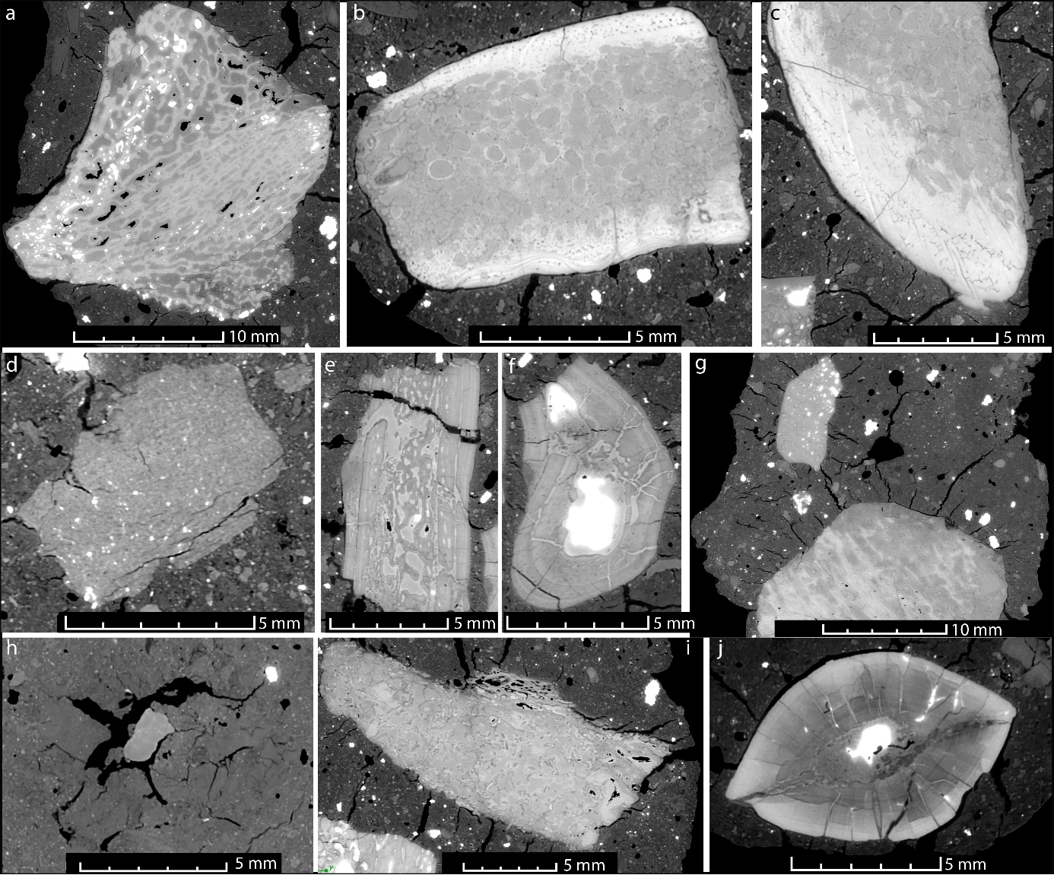

Supp. Fig. 1. Virtual sections showing bone inclusions from the scanned S. wawelski coprolites. a. A large bone fragment with complex morphology and thin cortical bone that likely derives from a juvenile dicynodont (ZPAL V.33/345). b-c. A large, heavily remodelled, bone fragment displaying osteocytes and vascularization. The wavy structure of the cortical bone and the high density suggest that it derives from a temnospondyl prey (ZPAL V.33/345). d. Bone heavily degraded from digestive etching. Note that the internal morphology (and histology) is almost unrecognizable (ZPAL V.33/345). e. Cross section of rib? (ZPAL V.33/345). f. Cross section of rib? (ZPAL V.33/345). g. Bone inclusions and cracks developed in the coprolite matrix around the bones indicating desiccation (and shrinking) of the faeces before burial (ZPAL V.33/341). h. Bone and casts of completely dissolved bone (ZPAL V.33/344). i. Remodelled bone with highly vascularized cortex (ZPAL V.33/344). j. Cross section through the serrated tooth with plenty of cracks developed in the dentine (ZPAL V.33/344).

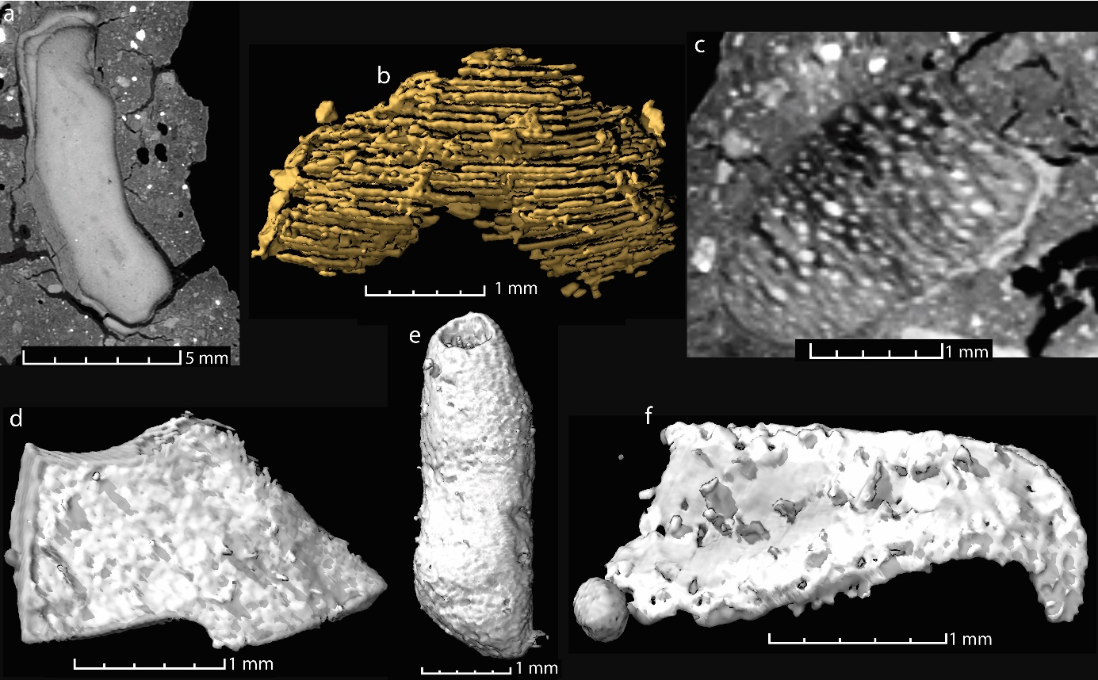

Supp. Fig. 2. Other inclusions from S. wawelski coprolites. a. A possible charcoal fragment (ZPAL V.33/345). b-c. A structure composed of parallel-running, 40-80 µm thick fibres, of animal or plant origin (ZPAL V.33/344). d. A low-density structure of unknown origin (ZPAL V.33/345). e. Tube-shaped inclusion of unknown origin (ZPAL v33 345). f. Small hooklet of, perhaps, plant or arthropod origin (ZPAL V.33/345).

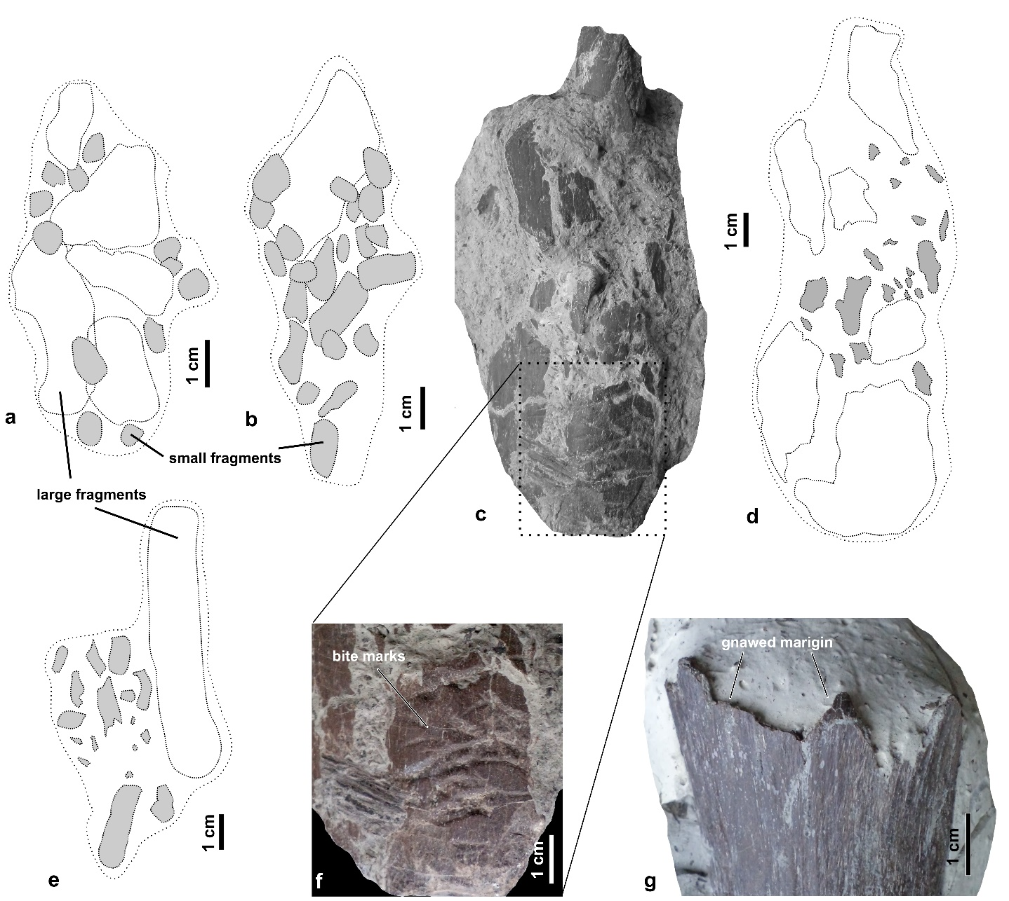

Supp. Fig. 3. Supposed regurgitalites of S. wawelski. a, b, e. Schematic drawings (general shape, composition) of regurgitalites with bone fragments. c, d. A large regurgitalite specimen (ZPAL V.33/704) containing bone fragments with sharp margins. f. Enlargement of bone fragment with traces of tooth marks. g. Dicynodont bone fragment with a sharp, probably gnawed, margin.

