Visit-to-visit HbA1c and glucose variability and the risks of macrovascular and microvascular events in the general population

Ji-Yong Jang, Shinje Moon, Sungsoo Cho, Kyoo Ho Cho, Chang-Myung Oh

Supplement Figure 1. Study profile.
HbA1c variability assessed using the coefficient of variation (CV) of HbA1c measurements obtained throughout the study period. HbA1c, glycated hemoglobin

Supplement Figure 2. The relationship between the percentile of each glucose measures and the odds ratio for primary endpoints* adjusted for age and sex. A, HbA1c-CV; B, FBG-CV; C, PBG-CV
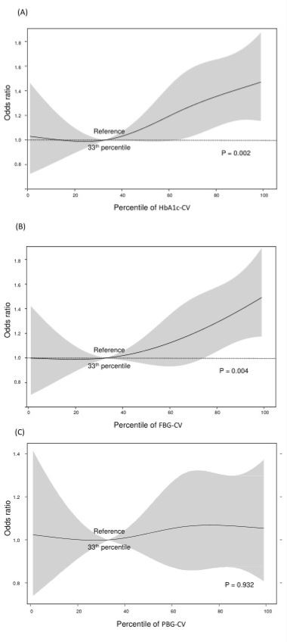
CV: Coefficient of Variation. *Primary endpoint was composite of Macro (composite of CAD, MI, CHF or ischemic stroke )- and Microvascular event (defined as Creatine Clearance < 60ml/min/ 1.73m²)
Supplement Table 1. Serial change of Coefficient of variation(CV), HbA1c, Fasting blood glucose, post 2hour blood glucose, muscle mass and fat mass through follow-up duration.
HbA1c variability groups
HbA1c, % | 1st tertile | 2nd tertile | 3rd tertile | p
New onset DM, n(%) | 6 (0.3) | 26 (1.2) | 254 (11.9) | <0.001
Visit 1 (mean±SD, (CV)) | 5.5±0.3 (0.056) | 5.5±0.3 (0.059) | 5.6±0.4 (0.076) | <0.001
Visit 2 | 5.7±0.3 (0.060) | 5.7±0.3 (0.058) | 5.8±0.5 (0.096) | 0.35
Visit 3 | 5.4±0.3 (0.056) | 5.4±0.3 (0.062) | 5.4±0.4 (0.082) | <0.001
Visit 4 | 5.5±0.3 (0.056) | 5.5±0.4 (0.066) | 5.5±0.5 (0.088) | 0.23
Visit 5 | 5.5±0.3 (0.075) | 5.6±0.4 (0.065) | 5.7±0.5 (0.096) | <0.001
Visit 6 | 5.5±0.3 (0.074) | 5.5±0.4 (0.065) | 5.7±0.5 (0.093) | <0.001
*Difference between  Visit 1 and Visit 6 | 0.00±0.17 | 0.01±0.29 | 0.11±0.55 | <0.001
FBG, mg/dL | 1st tertile | 2nd tertile | 3rd tertile | p
Visit 1 | 87±9 | 87±9 | 88±10 | <0.001
Visit 2 | 90±10 | 90±10 | 91±10 | 0.001
Visit 3 | 90±9 | 90±9 | 91±10 | <0.001
Visit 4 | 91±9 | 92±10 | 94±13 | <0.001
Visit 5 | 94±9 | 95±10 | 98±14 | <0.001
Visit 6 | 93±9 | 94±9 | 97±14 | <0.001
*Difference between  Visit 1 and Visit 6 | 6±10 | 7±10 | 8±12 | <0.001
PBG, mg/dL | 1st tertile | 2nd tertile | 3rd tertile | p
Visit 1 | 120±32 | 121±34 | 128±40 | <0.001
Visit 2 | 119±34 | 120±35 | 124±38 | <0.001
Visit 3 | 123±37 | 124±37 | 131±44 | <0.001
Visit 4 | 128±38 | 127±38 | 137±47 | <0.001
Visit 5 | 126±36 | 127±38 | 137±49 | <0.001
Visit 6 | 126±36 | 127±38 | 136±49 | <0.001
*Difference between  Visit 1 and Visit 6 | 7±36 | 8±37 | 12±45 | <0.001
Muscle mass /BMI, m² | 1st tertile | 2nd tertile | 3rd tertile | p
Visit 1 | 1.80±0.33 | 1.81±0.32 | 1.80±0.32 | 0.53
Visit 2 | 1.82±0.33 | 1.83±0.33 | 1.81±0.33 | 0.18
Visit 3 | 1.82±0.34 | 1.83±0.33 | 1.81±0.33 | 0.11
Visit 4 | 1.82±0.34 | 1.82±0.33 | 1.79±0.33 | 0.02
Visit 5 | 1.80±0.33 | 1.81±0.33 | 1.78±0.33 | 0.01
Visit 6 | 1.78±0.33 | 1.80±0.34 | 1.76±0.33 | 0.006
*Difference between  Visit 1 and Visit 6 | -0.009±0.091 | -0.015±0.091 | -0.018±0.097 | 0.07
Fat mass/BMI, m² | 1st tertile | 2nd tertile | 3rd tertile | p
Visit 1 | 0.67±0.15 | 0.67±0.15 | 0.68±0.15 | 0.32
Visit 2 | 0.66±0.15 | 0.66±0.15 | 0.66±0.15 | 0.18
Visit 3 | 0.66±0.15 | 0.66±0.15 | 0.67±0.15 | 0.08
Visit 4 | 0.66±0.15 | 0.66±0.15 | 0.68±0.15 | 0.001
Visit 5 | 0.66±0.15 | 0.66±0.15 | 0.68±0.15 | <0.001
Visit 6 | 0.67±0.15 | 0.67±0.15 | 0.69±0.15 | <0.001
*Difference between  Visit 1 and Visit 6 | 0.003±0.087 | 0.001±0.089 | 0.003±0.094 | 0.35
Values are presented as mean ± standard deviation (SD). Abbreviation: BMI, body mass index; FBG, fasting blood glucose; PBG, post 2hour blood glucose. * Difference between Visit 1 and Visit 6 was calculated by subtracted the value of Visit 1 from the value of Visit 6.

Supplement Table2. Multivariate Cox analysis for Primary and Secondary endpoints*
 | Primary endpoint† |  | Microvascular |  | Macrovascular
 | HR(95% CI) | p | HR(95% CI) | p | HR(95% CI) | p
Mean HbA1c | 1.62 (1.23-2.13) | 0.001 | 2.04 (1.44-2.91) | <0.001 | 1.33(0.62-2.85) | 0.46
HbA1c-CV 1st tertile | Reference |  | Reference |  | Reference
2nd tertile | 1.34 (1.07-1.67) | 0.01 | 1.38(1.08-1.75) | 0.01 | 1.19(0.72-1.98) | 0.49
3rd tertile | 1.36 (1.08-1.70) | 0.01 | 1.31 (1.02-1.68) | 0.04 | 1.18 (0.70-2.00) | 0.53
P for trend |  | 0.01 |  | 0.03 |  | 0.76
Mean FBG | 0.99 (0.97-1.00) | 0.04 | 0.98 (0.97-0.99) | 0.005 | 1.00(0.97-1.02) | 0.72
FBG-CV 1st tertile | Reference |  | Reference |  | Reference
2nd tertile | 1.18 (0.94-1.48) | 0.15 | 1.11 (0.88-1.41) | 0.37 | 1.69 (0.93-3.05) | 0.08
3rd tertile | 1.32 (1.04-1.67) | 0.02 | 1.21 (0.94-1.56) | 0.14 | 2.32 (1.30-4.12) | 0.004
P for trend |  | 0.07 |  | 0.33 |  | 0.01
Mean PBG | 1.00 (0.99-1.01) | 0.32 | 1.00 (0.99-1.01) | 0.36 | 1.01(1.00-1.01) | 0.005
PBG-CV 1st tertile | Reference |  | Reference |  | Reference
2nd tertile | 1.10 (0.89-1.36) | 0.36 | 1.02 (0.81-1.28) | 0.88 | 2.07 (1.19-3.60) | 0.01
3rd tertile | 1.02 (0.82-1.28) | 0.84 | 0.97 (0.76-1.24) | 0.82 | 1.85 (1.05-3.26) | 0.03
P for trend |  | 0.63 |  | 0.93 |  | 0.03
HR, hazard ratio; CI, confidence interval; HbA1c, glycated haemoglobin; CV, coefficient of variation; FBG, fasting blood glucose; PBG, post 2-h blood glucose.
*The Cox regression multivariate analysis included age, sex, previous hypertension, myocardial infarction, coronary artery disease, dyslipidaemia, body mass index (BMI), low-density lipoprotein cholesterol, fat mass/BMI, muscle mass/BMI, mean HbA1c, mean FBG, mean PBG, and the tertile categories of the HbA1c, FBG, and PBG variability groupings and metabolic syndrome. † The primary outcome was a composite of macrovascular events (coronary artery disease, myocardial infarction, congestive heart failure, or stroke) and microvascular events (a creatinine clearance rate of <60 mL/min/1.73 m²).

