The role of Mannose Binding Lectin in the immune response against Borrelia burgdorferi sensu lato

Jeroen Coumou^{1*}, Alex Wagemakers¹, Sukanya Narasimhan², Tim J. Schuijt¹, Jasmin. I. Ersoz¹, Anneke Oei³, Onno J. de Boer⁴, Joris J. T. H. Roelofs⁴, Erol Fikrig² and Joppe W. Hovius¹

¹ Amsterdam UMC, University of Amsterdam, Center for Experimental and Molecular Medicine, Meibergdreef 9, Amsterdam, Netherlands.
² Department of Internal Medicine, Yale University School of Medicine, 06511 New Haven, CT, USA.
³ Amsterdam UMC, University of Amsterdam, Department of Medical Microbiology, Meibergdreef 9, Amsterdam, Netherlands.
⁴ Amsterdam UMC, University of Amsterdam, Department of Pathology, Amsterdam Cardiovascular Sciences, Amsterdam Infection & Immunity, Meibergdreef 9, Amsterdam, Netherlands.

Supplemental figures and tables

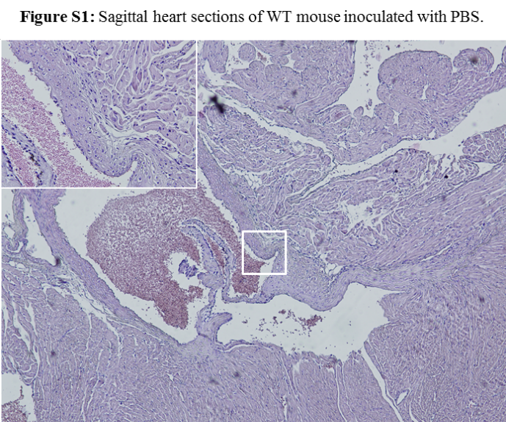
Figure S1. Five µm-thick sagittal heart sections were stained with hematoxylin and eosin. A carditis score was performed by an independent pathologist who was blinded to the experimental design on a scale from 0-3 with 0 being no, 1 mild, 2 moderate, and 3 being severe carditis. Carditis was characterized by disperse inflammation at the atrioventricular junction and aortic root.

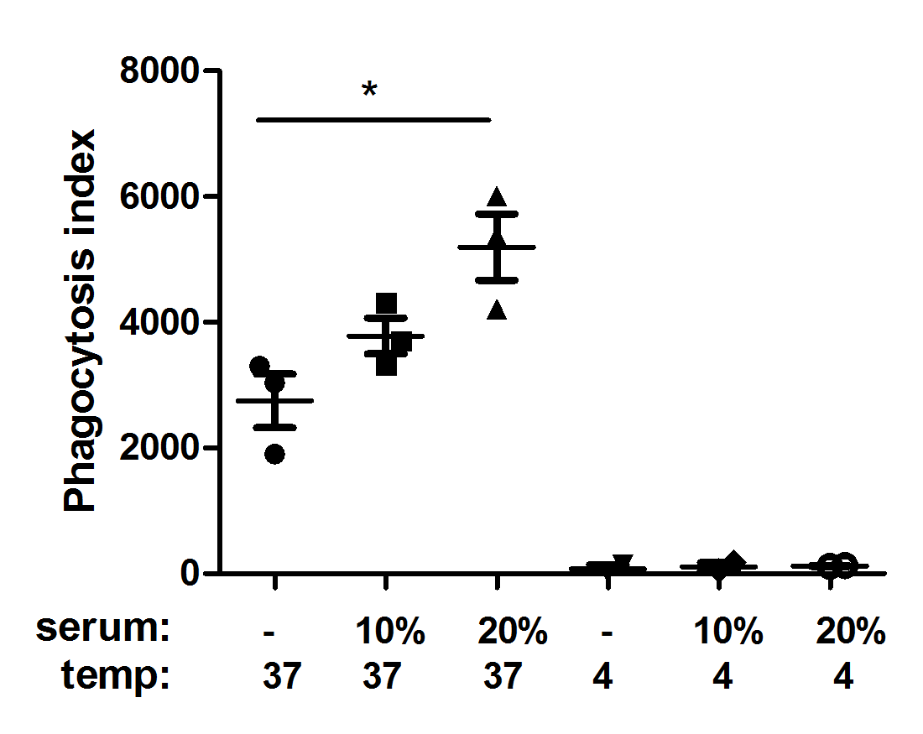
Figure S2. Pilot experiment to determine optimal serum concentration for phagocytosis of B. burgdorferi by by murine macrophages. Macrophages were collected from peritoneal fluid from WT mice. Macrophages (50.000 per sample) were incubated with WT serum or MBL deficient serum and B. burgdorferi N40 spirochetes (MOI:25). Phagocytosis of CFSE-labeled viable B. burgdorferi N40 by murine macrophages was determined by FACS analysis and expressed as the phagocytosis index. Error bars represent mean ± SEM and mean values significantly different in a Student’s t-test are indicated by asterisks (* p < 0.05).

Supplemental Table 1. Culture of B. burgdorferi from murine tissue.
weeks after sacrifice | positive cultures in skin | positive cultures in bladder
1 | WT: 8/8  MBL -/-: 8/8 | WT: 0/8  MBL -/-: 0/8
3 | X  X | WT: 7/8*  MBL -/-: 5/8*
WT and MBL deficient mice (8 per group) were infected with 10⁶ B. burgdorferi N40 via subcutaneous inoculation. Mice were sacrificed after 14 days and assessed for B. burgdorferi burden by culture. In intervals of 1 week, cultures were examined for live spirochetes under dark field microscopy. * In the WT group, 1 bladder sample got contaminated, in the MBL deficient group 2 bladder samples got contaminated and in tissue from 1 mice, no spirochetes were seen.
Supplemental Table 2. Cytokine levels measured in supernatant of murine whole blood from WT or MBL deficient mice
 | Medium only |  |  | B. burgdorferi N40
 | WT | MBL -/- | p-value | WT | MBL -/- | p-value
TNF-α | 6 (2-10) | 2 (1-4) | 0.08 | 11055 (8869-13242) | 13464 (9353-16044) | 0.82
IL-6 | 3 (<-3) | 6 (<-21) | 0.39 | 662 (67-1008) | 327 (190-571) | 0.19
IL-10 | < | < |  | 201 (68-371) | 121 (9-371) | 0.41
MCP-1 | < | < |  | 23 (< - 80) | 28 (<-128) | 0.87
IFN-y | < | < |  | < | <
IL-12p70 | < | < |  | < | <
Mean values (range in parenthesis) are shown. All values are in pg/mL.
< : below detection limit (2.5 pg / mL).

