Supplementary Material of

Dietary niacin intake predicts the decrease of liver fat content during
a lifestyle intervention
Katarzyna Linder, MD^{1,2,3}, Caroline Willmann, MD^{1,2}, Konstantinos Kantartzis, MD^{1,2,3}, Jürgen Machann, PhD^{2,3,4}, Fritz Schick, MD, PhD^{2,3,4}, Marjo Graf¹, Sabine Kümmerle¹, Hans-Ulrich Häring, MD ^{1,2,3}, Andreas Fritsche, MD ^{1,2,3}, Norbert Stefan, MD ^{1,2,3}, Róbert Wagner, MD^{1,2,3}

Supplementary Figure 1 A and B
Tertiles of change of BMI during lifestyle intervention (A) with corresponding linear regression models representing the interactions between BMI change and baseline niacin intake (B) on fold change of liver fat (interaction p=0.04).
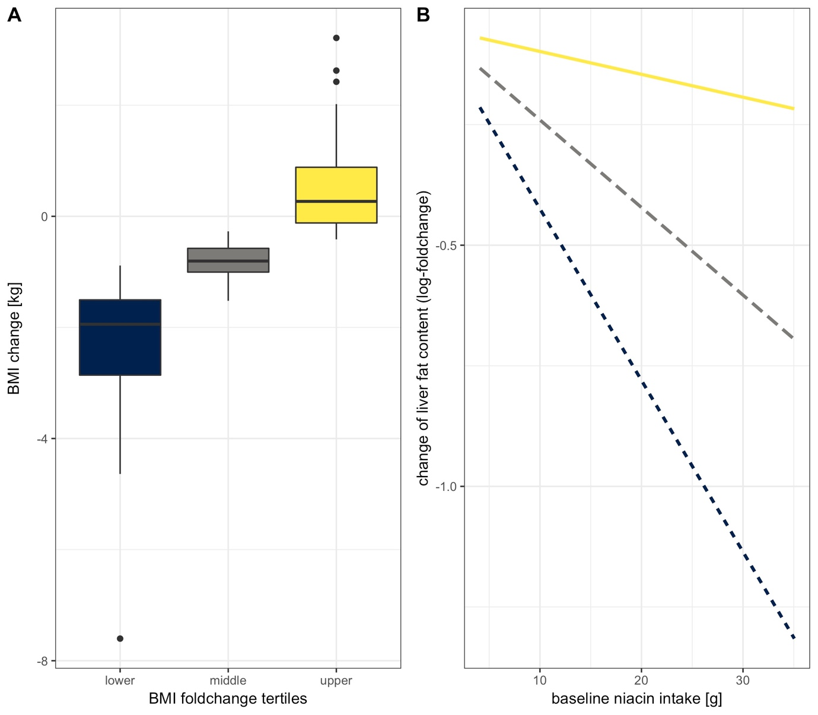

Supplementary Table 1
Correlation of niacin intake (mg/day) with energy intake and macronutrient composition of the diet at baseline (before lifestyle intervention) in the TULIP study (N=202)
 | Correlation coefficient (r) | p-value
Energy intake (kCal/day) | 0.55 | <0.0001
Carbohydrates (% of energy intake) | -0.33 | <0.0001
Fats (% of energy intake) | 0.08 | 0.28
Proteins (% of energy intake) | 0.31 | <0.0001

