Supporting information:
Multi Band Gap Electronic Structure In CH₃NH₃PbI₃
Khuong P. Ong,¹ Shunnian Wu,¹ Tien Hoa Nguyen,² David J. Singh,³ Zhen Fan,⁴ Michael B. Sullivan,¹ and Cuong Dang,²
¹ Institute of High Performance Computing, Agency of Science, Technology and Research (A*STAR), 1 Fusionopolis Way, 138632, Singapore
² Centre for OptoElectronics and Biophotonics (COEB), School of Electrical and Electronic Engineering, The Photonics Institute (TPI), Nanyang Technological University Singapore, 50 Nanyang Avenue, 639798, Singapore
³ Department of Physics and Astronomy, University of Missouri, Columbia, MO 65211-7010 USA
⁴ Institute for Advanced Materials and Guangdong Provincial Key Laboratory of Optical Information Materials and Technology, South China Academy of Advanced Optoelectronics, South China Normal University, Guangzhou 510006, China
AUTHOR INFORMATION
Corresponding Author: Khuong P. Ong
*Email: ongpk@ihpc.a-star.edu.sg

Table S1. B-M equation fitted volume at minimum energy
 | cubic
PBEsol | 252.8933
PBE-vdW-D2 | 251.70
PBE-vdW-D3 | 199.1863

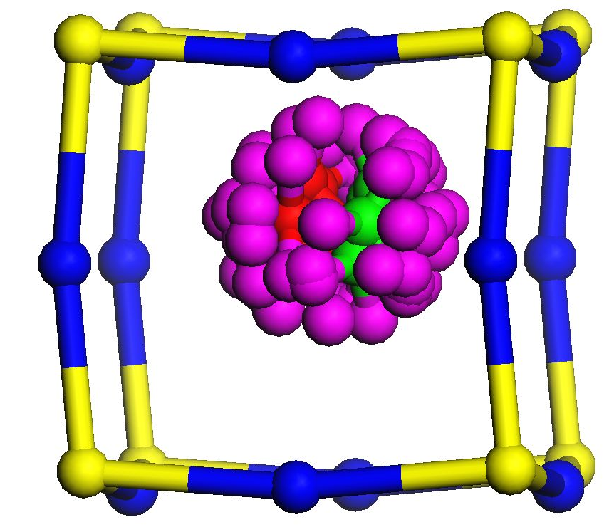
Fig.S1. Quasi molecule CH₃NH₃ in the cuboctahedral PbI₃
To evaluate the effect of MA rotation to the splitting of the energy band structures we calculate the Rashba spin-orbit interaction coefficient which is given by $α_{C}=\frac{{∆E}_{C}}{2{∆k}_{C}}$,¹ here ΔE_{C} and Δk_{C} is the energy and momentum splitting in the conduction band due to the spin-orbit coupling (see Fig.S1. and Ref.[1] for details). Since the splitting in the valence band is small (see Fig.3) therefore we only evaluate the splitting in the conduction band.

Table S2. The Rashba coefficient of MAPbI₃ in Pm-3m and P4mm structures
Lattice constant ( Å) | $α_{C}=\frac{{∆E}_{C}}{2{∆k}_{C}}$ [eV Å ⁻¹]
Lattice constant ( Å) | AX | AΓ | AM | AZ
Pm-3m [110]
6.320 | 1.45 | 1.24 | 1.66
6.375 | 1.27 | 1.23 | 1.49
6.438 | 1.01 | 0.94 | 1.29
6.500 | 0.97 | 0.91 | 1.07
6.627 | 0.75 | 0.50 | 0.71
P4mm [001]
6.320 | 1.79 | 1.80 | 1.35 | 1.47
6.375 | 1.74 | 1.72 | 1.37 | 1.25
6.438 | 1.86 | 1.75 | 1.66 | 1.03
6.500 | 1.66 | 1.53 | 1.88 | 0.82
6.627 | 1.73 | 1.69 | 2.00 | 0.44
P4mm [110]
6.320 | 1.51 | 0.94 | 1.59
6.375 | 1a.56 | 1.11 | 1.8
6.438 | 1.64 | 1.28 | 1.98
6.500 | 1.71 | 1.31 | 1.88
6.627 | 1.66 | 1.38 | 1.81

Volume evolution of the Rashba spin-orbit interaction coefficient in different directions AX, AΓ, AM and AZ when MA molecule is in different directions [001] and [110] is given in Fig.5. The results showed that for Pm-3m structure, the Rashba spin-orbit interaction coefficient decreases with the increase of volume in all directions of the energy splitting when MA molecule is in [110] or [001] directions. The deformation from Pm-3m structure to P4mm structure when MA molecule is in [110] direction increases the Rashba spin-orbit coefficient results in all directions but when MA molecule is in [001] direction the Rashba spin-orbit interaction coefficient in AX and AΓ direction does not change much and increase/decrease along the AM/AZ direction, respectively.
Fig.S2. Volume evolution of the Rashba spin- orbit interaction coefficient in different directions AX, AΓ, AM and AZ when MA molecule is in different directions [001] and [110].

References
1. T. Etienne, E. Mosconi, and F. D. Angelis, Dynamical Origin of the Rashba Effect in organohalide Lead Perovskites: A key to suppressed Carrier Recombination on Perovskite Solar cells, J. Phys. Chem. Lett. 7, 1638 (2016)

