The future of extreme climate in Iran

Saeid Ashraf Vaghefi, Malihe Keykhai, Farshid Jahanbakhshi, Jaleh Sheikholeslami, Azadeh Ahmadi, Hong Yang, Karim C. Abbaspour

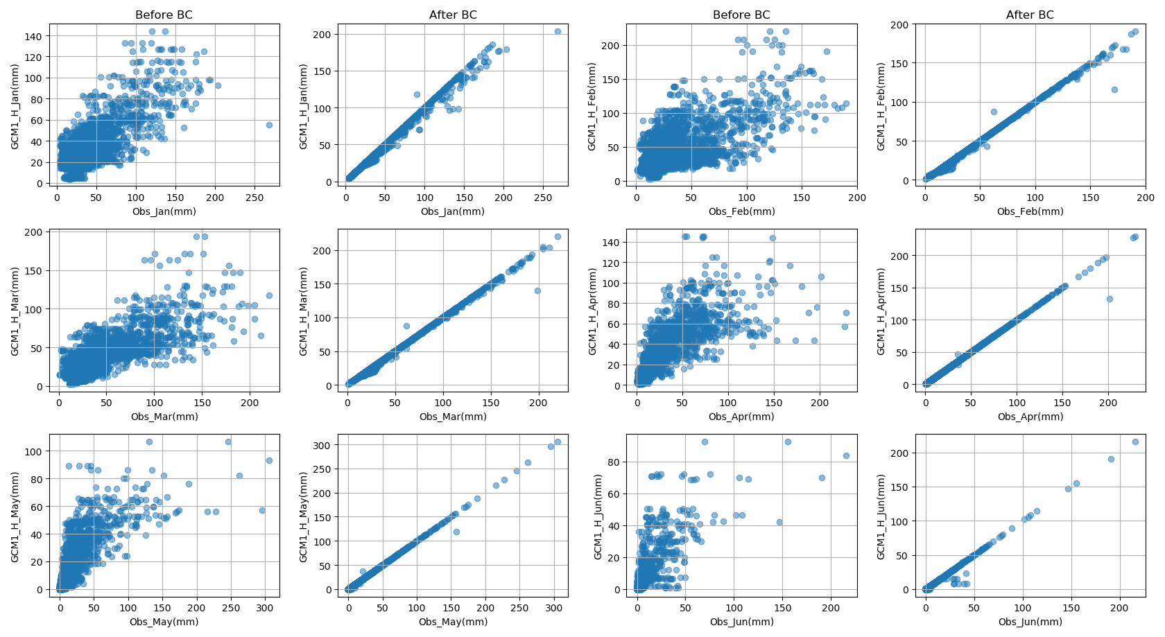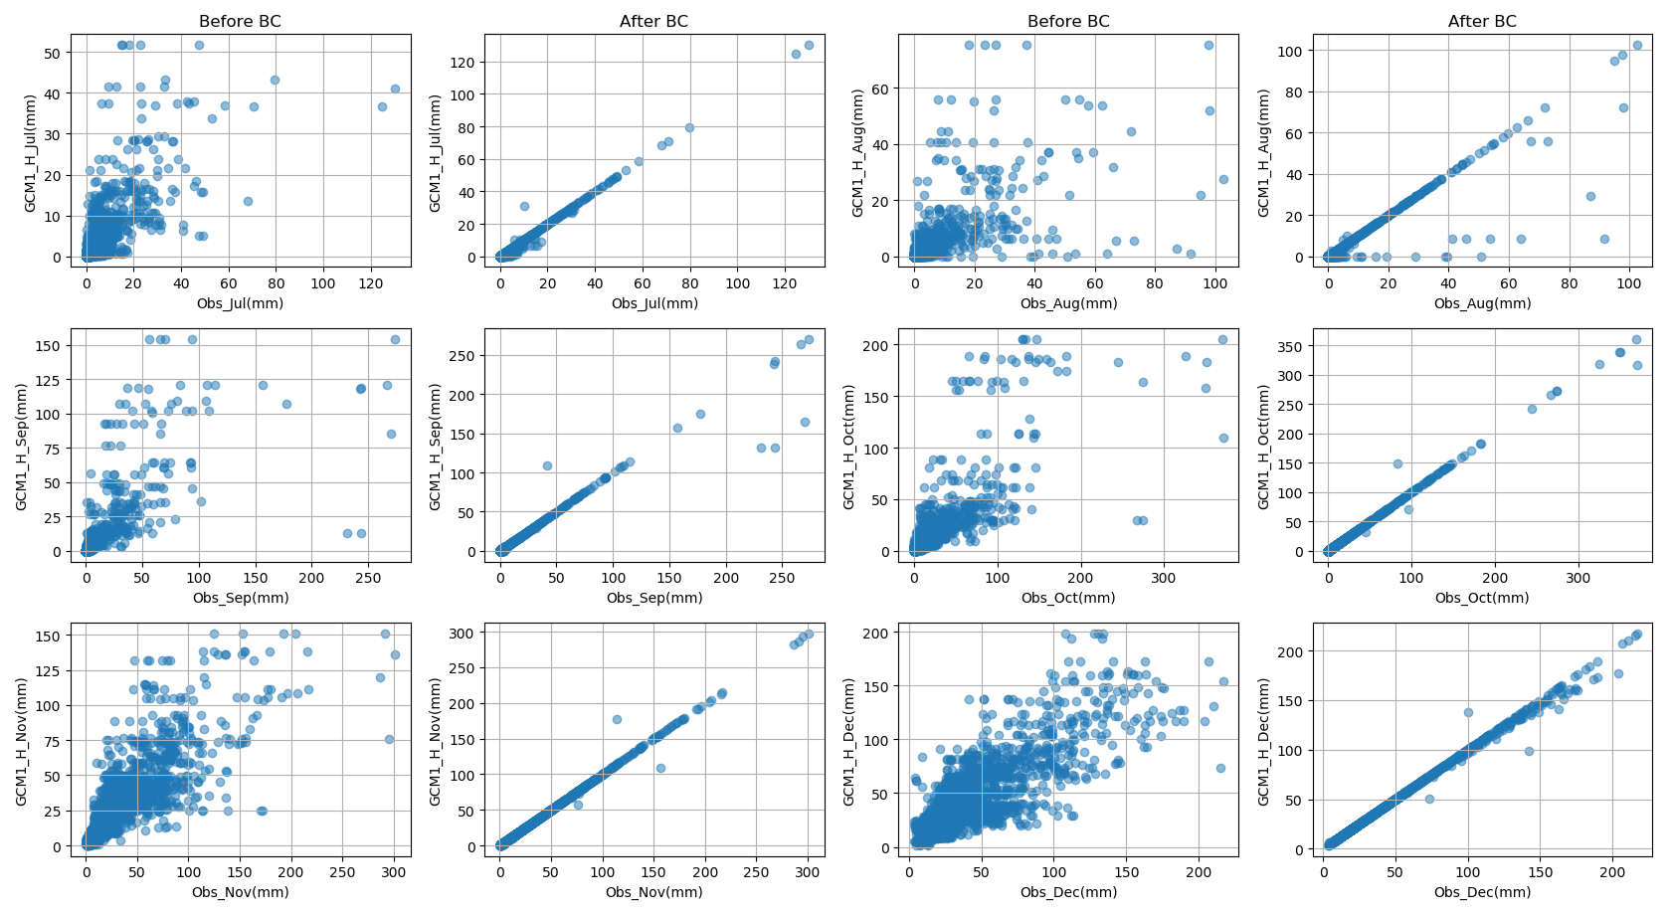
Figure S1. Comparison of monthly precipitation between observed data and GCM1 historical scenario before and after applying bias correction (ratio method). H:historic, BC:bias corrected

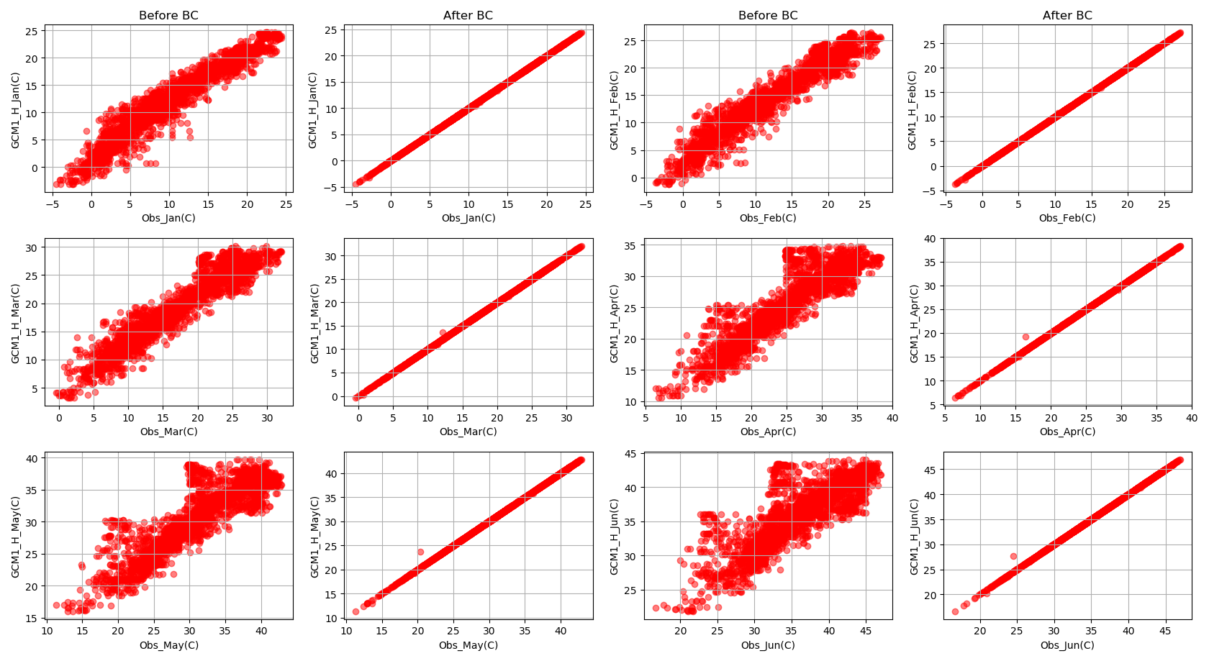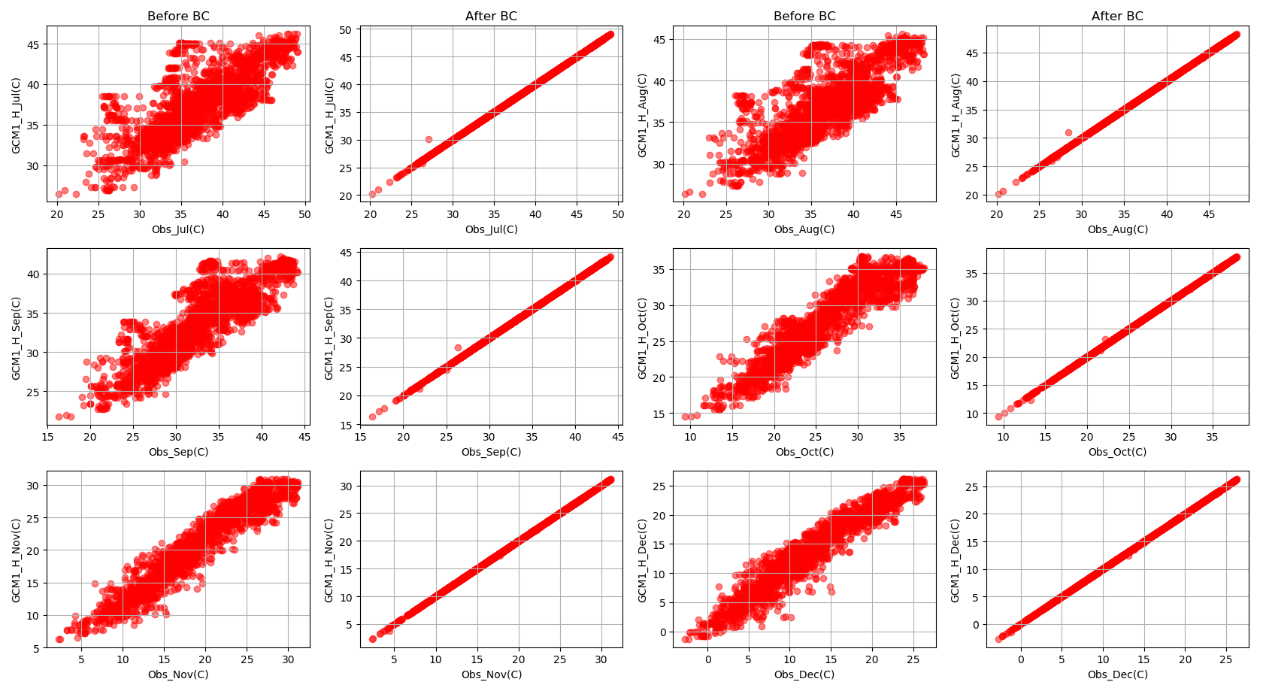
Figure S 2. Comparison of monthly maximum temperature between observed data and GCM1 historical scenario before and after applying bias correction (additive method). H:historic, BC:bias corrected

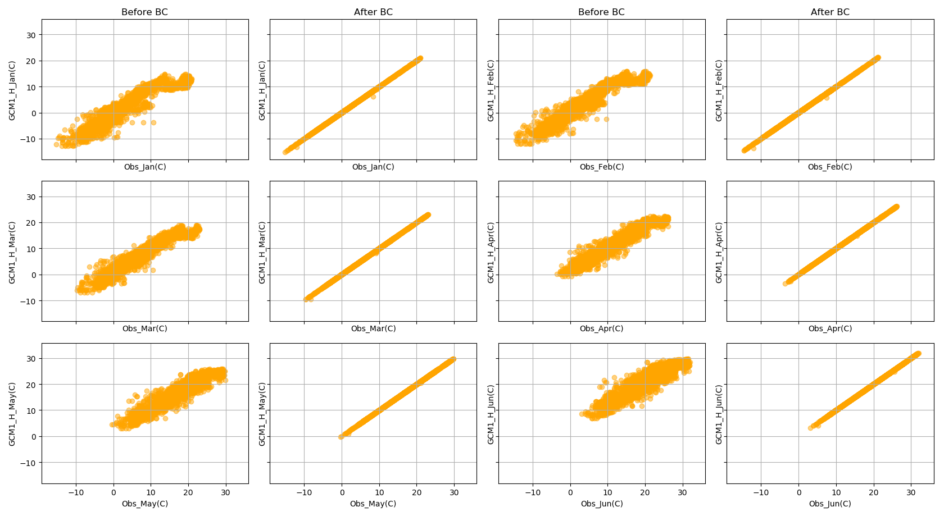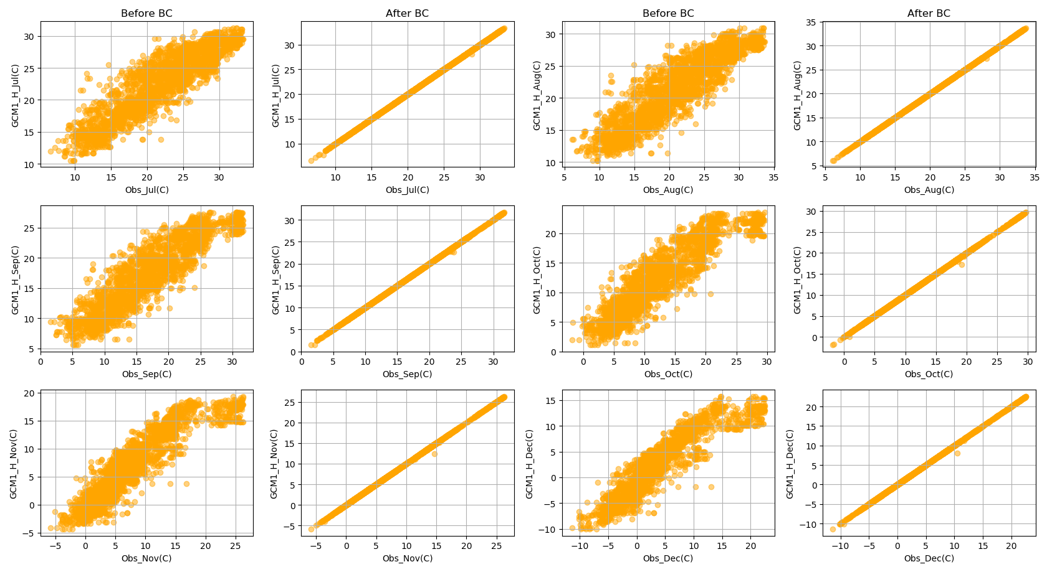
Figure S3. Comparison of monthly minimum temperature between observed data and GCM1 historical scenario before and after applying bias correction (additive method). H:historic, BC:bias corrected

