A New Stress Test for Knee Joint Cartilage – Supplementary File
Chinmay S. Paranjape^{*1}, Hattie C. Cutcliffe^{*1,2}, Steven C. Grambow³, Gangadhar M. Utturkar¹,
Amber T. Collins¹, William E. Garrett¹, Charles E. Spritzer⁴, Louis E. DeFrate^{1,2,5}

¹Department of Orthopaedic Surgery, ²Department of Biomedical Engineering,
³Department of Biostatistics and Bioinformatics, ⁴Department of Radiology
Duke University, Durham, NC, ⁵Department of Mechanical Engineering and Materials Science,
Duke University, Durham, NC
*These authors are co-first authors on this manuscript and contributed equally to its writing.

Corresponding Author:
Louis E. DeFrate, Ph.D.
Frank H. Bassett III, M.D. Associate Professor in Orthopaedic Surgery
Associate Professor in Biomedical Engineering
Duke University Medical Center
Medical Sciences Research Building I
203 Research Drive, Room 375
DUMC Box 3093, Durham, NC 27710
Phone: 919-681-9959
Email: lou.defrate@duke.edu

Supplementary File
The following plots illustrate all data points (in addition to the mean and 95% confidence intervals) for Figures 2 and 3 of the main text.

Figure 2a: Overall compressive strain (mean, 95% confidence interval) in tibial cartilage as a function of walk duration, for a fixed normalized walking speed (Fr = 0.25); sample size (n) = 10 for all time points except 60 min where n = 8; compressive strain significantly increased (Spearman correlation, p < 0.05) with increasing walk duration in a nonlinear fashion (lines represent the NLME fits of the Kelvin-Voigt two-parameter creep model to the duration data while shading represents the 95% prediction interval for the median of this fit).

Figure 2b: Medial compartment compressive strain (mean, 95% confidence interval) in tibial cartilage as a function of walk duration, for a fixed normalized walking speed (Fr = 0.25); sample size (n) = 10 for all time points except 60 min where n = 8; compressive strain significantly increased (Spearman correlation, p < 0.05) with increasing walk duration in a nonlinear fashion (lines represent the NLME fits of the Kelvin-Voigt two-parameter creep model to the duration data while shading represents the 95% prediction interval for the median of this fit).

Figure 2c: Lateral compartment compressive strain (mean, 95% confidence interval) in tibial cartilage as a function of walk duration, for a fixed normalized walking speed (Fr = 0.25); sample size (n) = 10 for all time points except 60 min where n = 8; compressive strain significantly increased (Spearman correlation, p < 0.05) with increasing walk duration in a nonlinear fashion (lines represent the NLME fits of the Kelvin-Voigt two-parameter creep model to the duration data while shading represents the 95% prediction interval for the median of this fit).

Figure 3a: Overall compressive strain (mean, 95% confidence interval) in tibial cartilage as a function of normalized walking speed (Froude Number, Fr), for a fixed walk duration (30 minutes); sample size (n) = 7 for Fr = 0.1, n = 10 for Fr = 0.25, n = 8 for Fr = 0.40; compressive strain significantly increased (linear mixed model, p < 0.05) with increased normalized walking speed for the overall tibia and medial tibial plateau, but not for the lateral tibial plateau.

Figure 3b: Medial compartment compressive strain (mean, 95% confidence interval) in tibial cartilage as a function of normalized walking speed (Froude Number, Fr), for a fixed walk duration (30 minutes); sample size (n) = 7 for Fr = 0.1, n = 10 for Fr = 0.25, n = 8 for Fr = 0.40; compressive strain significantly increased (linear mixed model, p < 0.05) with increased normalized walking speed for the overall tibia and medial tibial plateau, but not for the lateral tibial plateau.

Figure 3c: Lateral compartment compressive strain (mean, 95% confidence interval) in tibial cartilage as a function of normalized walking speed (Froude Number, Fr), for a fixed walk duration (30 minutes); sample size (n) = 7 for Fr = 0.1, n = 10 for Fr = 0.25, n = 8 for Fr = 0.40; compressive strain significantly increased (linear mixed model, p < 0.05) with increased normalized walking speed for the overall tibia and medial tibial plateau, but not for the lateral tibial plateau.

The following plots illustrate the NLME model evaluation tools provided by the saemix package (Comets et al. 2017) for the Kelvin-Voigt two-parameter creep model fit of the duration data. Model evaluations are given for the fits to the overall strain, medial strain, and lateral strain. The Q-Q plots and frequency vs NPDE (normalized prediction distribution errors) plots indicate that the model fits the data well, while the NPDE vs X and NPDE vs Predicted Y plots indicate that the error is randomly distributed, further indicating good model diagnostics.

Reference:
Comets, E., Lavenu, A. & Lavielle, M. Parameter estimation in nonlinear mixed effect models using saemix, and R implementation of the SAEM algorithm. Journal of Statistical Software 80, 1-41, doi:10.18637/jss.v080.i03 (2017).

Overall strain:

Medial Strain:
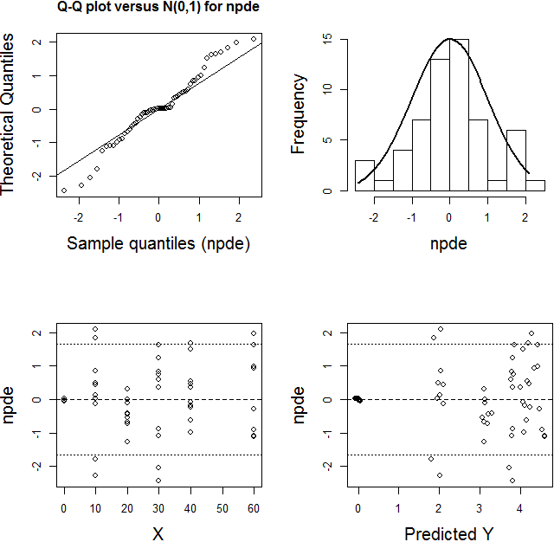

Lateral Strain:
