A Human iPSC-derived 3D platform using primary brain cancer cells to study drug development and personalized medicine

Authors
Simon Plummer^{1*}, Stephanie Wallace¹, Graeme Ball², Roslyn Lloyd³, Paula Schiapparelli⁴, Alfredo Quiñones-Hinojosa⁴, Thomas Hartung^{5,6}, David Pamies^{5,7}.

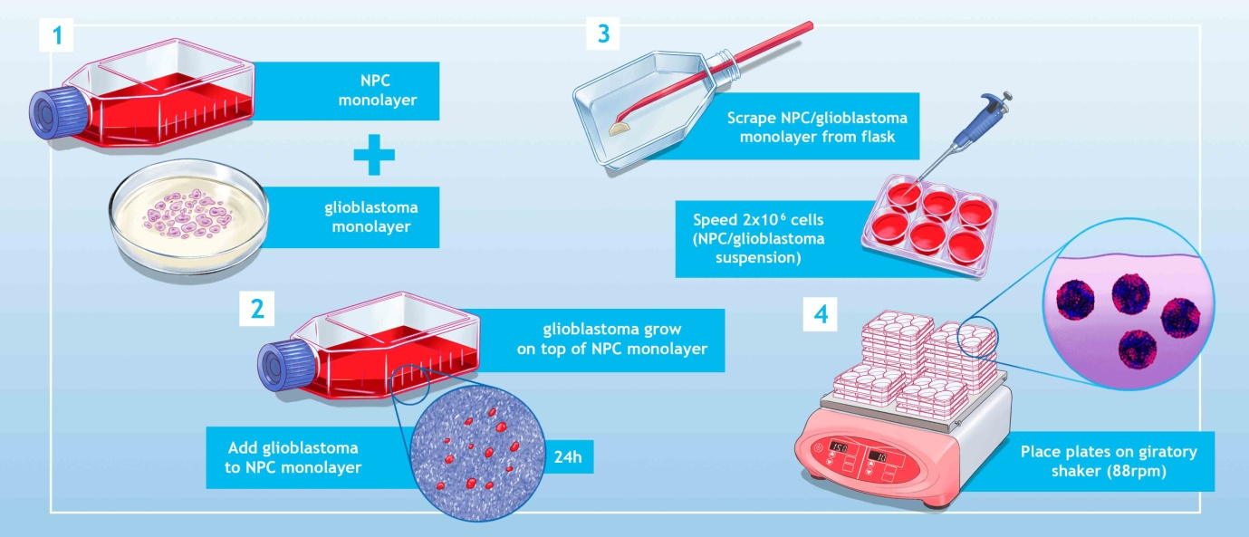

Figure 1. Supplementary data: Schematic showing the process for making the gBS. Briefly, neural progenitor cells (NPCs) and glioblastoma cells were cultured separately to form monolayers and then the glioblastoma cells were scraped off, dissociated by pipetting and seeded on top of the NPC monolayers. Once the glioblastoma cells have attached to the NPCs, the flask was scraped using a rubber policeman and the cells were dissociated by pipetting and seeded into 6-well plates. The cells were then incubated (4-7 weeks) in a CO₂ incubator on a giratory shaker until the gBS spheroids (~500 per well) were formed. Following drug treatment(s), spheroids for microTMA analysis were selected randomly from each well.

