Hydrogen gas distribution in organs after inhalation: Real-time monitoring of tissue hydrogen concentration in rat

Ryo Yamamoto, MD,¹ Koichiro Homma, MD, PhD,^{1,*} Sayuri Suzuki, PhD,¹ Motoaki Sano, MD, PhD, ² Junichi Sasaki, MD, PhD¹

¹Department of Emergency and Critical Care Medicine, Keio University School of Medicine, Tokyo, Japan
²Department of Cardiology, Keio University School of Medicine, Tokyo, Japan

*Corresponding author:
Koichiro Homma, MD, PhD, Department of Emergency and Critical Care Medicine, Keio University School of Medicine, Tokyo, Japan
Email: homma@keio.jp

Supplementary figure S1
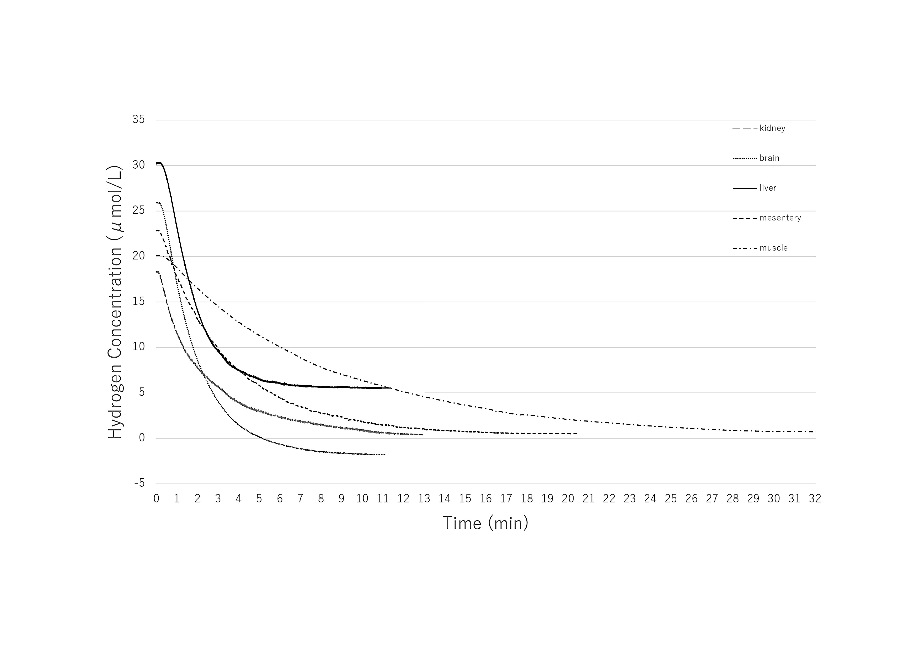
Supplementary figure legend

Supplementary Figure S1. Hydrogen desaturation dynamics. After terminating inhalation, the hydrogen concentration in each organ returned to baseline. The hydrogen concentration decreased more gradually in thigh muscle versus the other organs, while the concentration decreased at similar rates in the brain, liver, kidney and mesentery fat.

Supplementary Table

Table S1. Time measurements in organs
 | Time measurements (min)
 | Tzero | T10 | T63 | T90 | Tsat | Tzero-adjusted
Brain | 0.36 | 0.52 | 1.89 | 3.62 | 6.31 | 0.43
Liver | 0.48 | 0.66 | 2.07 | 4.21 | 7.82 | 0.46
Kidney | 0.59 | 0.74 | 2.12 | 4.56 | 8.22 | 0.54
Mesentery | 0.61 | 0.89 | 3.17 | 5.73 | 9.36 | 0.79
Muscle | 1.01 | 1.66 | 7.44 | 14.43 | 20.15 | 1.16

