Supplementary Materials

NMR Analysis on Molecular Interaction of Lignin with Amino Acid Residues of Carbohydrate-Binding Module from Trichoderma reesei Cel7A

Authors
Yuki Tokunaga¹, Takashi Nagata², Takashi Suetomi¹, Satoshi Oshiro¹, Keiko Kondo², Masato Katahira² & Takashi Watanabe¹*
Affiliations
¹Research Institute for Sustainable Humanosphere (RISH), Kyoto University, Uji 611-0011, Japan.
²Institute of Advanced Energy (IAE), Kyoto University, Uji 611-0011, Japan.

*twatanab@rish.kyoto-u.ac.jp

Plasmid construction
Figure S1. Map of the His tag-TrCBM1-GFP expressing plasmid. DNA sequences of TrCBM1 and thrombin cleavage site were inserted in pRSET-EmGFP vector (Thermo Fisher Scientific).
Purification process of TrCBM1
The expressed ¹⁵N-labeled TrCBM1 comprised a native protein (TrCBM1-A) and a mutant protein (TrCBM1-B) with additional two residues, DR, at the N-terminus. The differences in molecular mass ascribed to the additional DR residues were confirmed by MALDI-TOF-MS (Fig. S2). In the final purification step, the two proteins were separated by cation-exchange chromatography (Fig. S3). Throughout this study, we used the native protein (TrCBM1-A) and designated as TrCBM1 in the main text. The differential molecular mass of the native and mutant TrCBM1s were also confirmed by SDS-PAGE (Fig. S4).

Figure S2. MALDI-TOF-MS spectrum of the purified ¹⁵N-labeled TrCBM1 containing two fractions. Differential molecular mass between TrCBM1-A and -B was 277 corresponding to additional ¹⁵N-labeled residues at the N-terminus.

TrCBM1-B
TrCBM1-A
Figure S3. Cation exchange chromatogram of native and mutant ¹⁵N-labeled TrCBM1. Solid line: absorbance of 280 nm. Dotted line: Percentage of elution buffer. ¹⁵N-labeled TrCBM1 mixture in a 20 mM citric acid buffer (pH 3.0) was loaded on a 1ml Hi Trap SP HP column (GE Healthcare, IL, USA). ¹⁵N-labeled TrCBM1 was eluted using a 0–1 M NaCl gradient in a 20 mM citric acid buffer (pH 3.0). The first eluted fraction was TrCBM1-A, and the second fraction was TrCBM1-B.

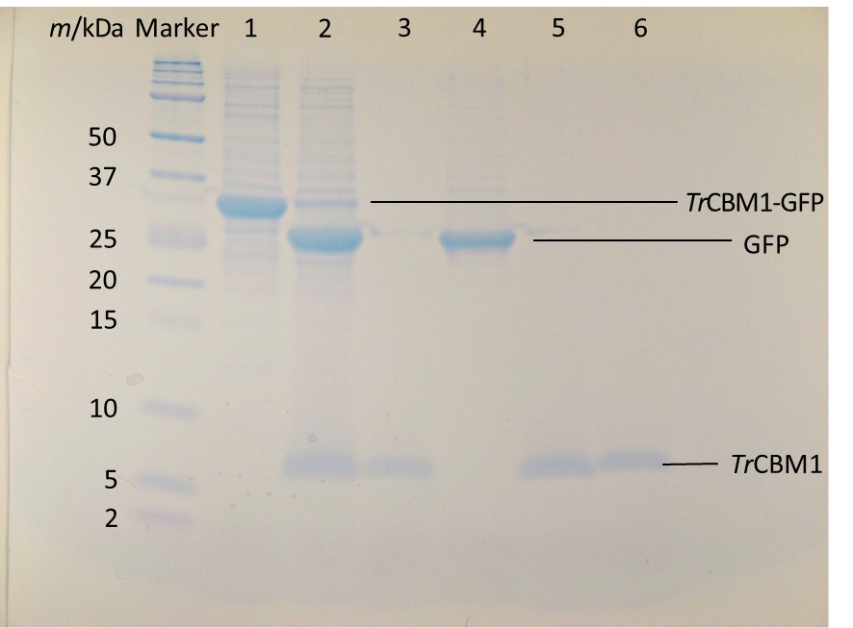
Figure S4. Purity analyses of ¹⁵N-labeled TrCBM1 by SDS-PAGE; A full-length gel of Figure 3. Lanes 1 and 2: the protein fractions before and after cleavage of GFP using thrombin. Lanes 3 and 4: the protein fractions that passed through and were trapped in a benzamidine column, respectively. Lanes 5 and 6: TrCBM1-A and B separated by the cation-exchange chromatography on a Hi Trap SP HP column.

Signal assignment of ¹³C/¹⁵N-labeled TrCBM1

Table S1. Chemical shifts (ppm) for the assigned ¹⁵N, ¹H^{N}, ¹³Cα, ¹³Cβ, and C’ of TrCBM1
An asterisk indicates that the chemical shift was not determined.
Residue | ¹⁵N | ¹H^{N} | ¹³Cα | ¹³Cβ | C’
(W) | 121.90 | 8.12 | 57.23 | 29.54 | 176.65
(G) | 110.56 | 8.18 | 45.28 | - | 173.69
(S) | 116.88 | 8.11 | 56.76 | 63.42 | 172.95
(P) | - | - | 63.64 | 32.10 | 176.61
T1 | 112.61 | 7.96 | 61.12 | 71.34 | 173.99
Q2 | * | * | * | * | *
S3 | * | * | 58.24 | 64.75 | 174.68
H4 | 120.72 | 8.74 | 55.79 | 28.91 | *
Y5 | * | * | 61.20 | 36.46 | 175.62
G6 | 110.33 | 8.72 | 44.54 | - | 172.01
Q7 | 123.16 | 8.62 | 55.76 | 27.54 | 174.94
C8 | 116.00 | 7.90 | 55.44 | 46.51 | 171.68
G9 | 108.29 | 6.63 | 44.98 | - | 170.96
G10 | 112.10 | 8.61 | 43.43 | - | 174.60
I11 | 124.62 | 8.32 | 64.60 | 38.32 | 177.83
G12 | 117.23 | 9.07 | 45.31 | - | 173.87
Y13 | 121.93 | 7.90 | 58.38 | 38.76 | 175.93
S14 | 123.87 | 8.29 | 57.42 | 64.09 | *
G15 | * | * | * | * | *
P16 | - | - | 63.20 | 32.24 | 178.45
T17 | 111.58 | 8.42 | 61.05 | 70.05 | 173.80
V18 | 121.76 | 7.28 | 61.79 | 32.42 | 175.66
C19 | 125.55 | 8.54 | 55.01 | 39.55 | 174.98
A20 | 124.09 | 8.10 | 52.05 | 19.54 | 176.65
S21 | 115.27 | 8.43 | 60.27 | 62.72 | 175.10
G22 | 114.24 | 8.84 | 44.61 | - | 174.05
T23 | 110.92 | 8.16 | 59.35 | 72.34 | 172.62
T24 | 111.56 | 8.87 | 60.31 | 72.08 | 172.78
C25 | 122.45 | 8.80 | 56.09 | 38.69 | 173.94
Q26 | * | * | 54.83 | 30.02 | 175.14
V27 | 125.61 | 8.56 | 63.01 | 32.47 | 176.71
L28 | 129.90 | 8.56 | 56.94 | 42.57 | 176.94
N29 | 115.75 | 8.59 | 53.13 | 37.43 | 173.14
P30 | - | - | 65.86 | 32.02 | 175.93
Y31 | 112.86 | 8.65 | 58.79 | 38.98 | 175.17
Y32 | 124.88 | 7.91 | 61.01 | 42.65 | 172.86
S33 | 124.71 | 6.69 | 56.23 | 65.75 | 171.94
Q34 | 127.49 | 9.06 | 54.01 | 34.69 | 175.03
C35 | 123.64 | 8.42 | 53.76 | 37.61 | 174.73
L36 | 128.91 | 8.87 | 53.64 | 47.50 | *
(T) | * | * | * | * | *
(S) | * | * | * | * | *
(P) | - | - | * | * | *
(E) | * | * | 57.05 | 29.95 | 176.41
(F) | 119.63 | 7.85 | 57.57 | 39.57 | 175.27
(L) | 122.97 | 7.92 | 55.31 | 42.35 | 176.62
(V) | 122.40 | 7.76 | 60.46 | 32.54 | 174.20
(P) | - | - | 63.49 | 31.95 | 176.03
(R) | 127.13 | 7.98 | 57.35 | 31.65 | 181.07

