Members of the endocannabinoid system are distinctly regulated in inflammatory bowel disease and colorectal cancer

Magdalena Grill¹, Christoph Högenauer^{2,3}, Andreas Blesl², Johannes Haybaeck^{4,5,6}, Nicole Golob-Schwarzl⁵, Nerea Ferreirós⁷, Dominique Thomas⁷, Robert Gurke⁷, Martin Trötzmüller⁸, Harald C. Köfeler^{8,9}, Birgit Gallé¹⁰, Rudolf Schicho^{1,3,*}

¹ Otto Loewi Research Center, Division of Pharmacology, Medical University of Graz, Graz, Austria.
² Division of Gastroenterology and Hepatology, Department of Internal Medicine, Medical University
of Graz, Graz, Austria
³ BioTechMed, Graz, Austria
⁴ Department of Pathology, Otto von Guericke University, Magdeburg, Germany
⁵ Diagnostic and Research Institute of Pathology, Medical University of Graz, Graz, Austria
⁶ Department of Pathology, Medical University of Innsbruck, Innsbruck, Austria
⁷ Institute of Clinical Pharmacology, Goethe University, Frankfurt/Main, Germany
⁸ Core Facility for Mass Spectrometry, Center for Medical Research, Medical University of
Graz, Graz, Austria
⁹ Omics Center Graz, BioTechMed-Graz, 8010 Graz, Austria
¹⁰ Core Facility Molekularbiologie, Center for Medical Research, Medical University of Graz, Graz,
Austria

* Corresponding author:

Rudolf Schicho, PhD
Otto Loewi Research Center, Division of Pharmacology, Medical University of Graz, Universitätsplatz 4/I, 8010 Graz, Austria
phone: +43316-385-74114
fax: +43316-385-79613
email: rudolf.schicho@medunigraz.at

Supplementary Table S1
mRNA analysis of intestinal mucosal biopsies assessed by NanoString technology
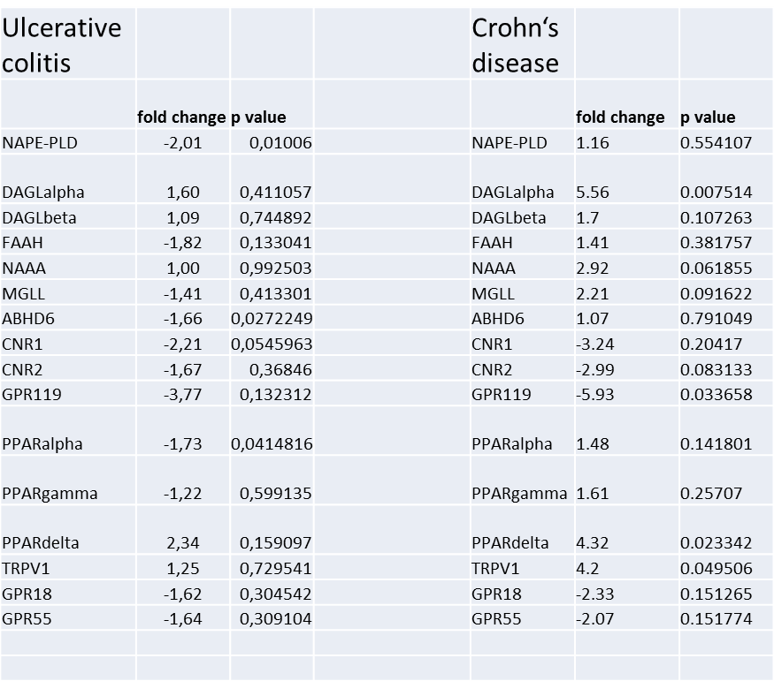

Supplementary Table S2
Mass spectrometry
Information on gradient and flow rate.
Time | Flow rate (µL/min) | Solvent A (%) | Solvent B (%)
0.00 | 500 | 80.0 | 20.0
0.50 | 500 | 80.0 | 20.0
0.60 | 500 | 40.0 | 60.0
8.00 | 500 | 36.5 | 63.5
8.01 | 500 | 5.0 | 95.0
10.00 | 500 | 5.0 | 95.0
10.01 | 500 | 80.0 | 20.0
12.00 | 500 | 80.0 | 20.0

Information on LC- and MS-parameter.
parameter | setting
Injection volume | 10 µL
Column oven temperature | 50 °C
Curtain gas (nitrogen) | 45 psi
Ionspray voltage | 4500 V
Source temperature | 450 °C
Nebulizer gas (nitrogen) | 40 psi
Auxiliary/Turbo heater gas (nitrogen) | 60psi
Collision gas (nitrogen) | 9 psi
Detection MS/MS | Multiple Reaction Monitoring (MRM)
Q1/Q3 resolution | unit/unit

Information on MRM-transitions, used IS and LLOQ- and ULOQ-values for all analytes.
Analyt | Q1 | Q3 (Quan/Qual) | IS | LLOQ (ng/mL) | ULOQ (ng/mL)
AEA | 348.3 | 287.3 / 62.2 | AEA-d₈ | 0.10 | 2.00
PEA | 300.2 | 62.2 / 283.2 | PEA-d₄ | 0.50 | 10.00
OEA | 326.3 | 62.2 / 309.2 | OEA-d₄ | 0.25 | 5.00
1-AG* | 379.2 | 287.3 / 269.2 | 1-AG-d₅* | 0.25 | 5.00
2-AG* | 379.2 | 287.3 / 269.2 | 2-AG-d₅* | 0.25 | 5.00
*1-AG and 2-AG cannot be distinguished by mass spectrometric detection but were base line separated by the used LC-method.

Supplementary information S3
LPI extraction and measurement
Lipid extraction was carried out from 150 μL of plasma sample in the presence of 10 μL of LPI 17:1 (100 μM) as internal standard according to a modified version of the original extraction protocol published by Matyash et al. (2008). Methanol (1.5 mL) and MTBE (5 mL) were added to the samples in 12 mL glass tubes with teflon lined caps and the mixture was incubated for 10 min in an overhead shaker at room temperature. After addition of 1.25 mL deionized water and 10 min of additional shaking, the mixture was centrifuged for 5 min at 1350 g and the upper phase was transferred to a new glass tube. The lower phase was re-extracted with 2 mL of the upper phase of MTBE/methanol/deionized water (10:3:2.5, v/v/v) and again the upper phase was collected, combined with the upper phase from the first extraction, evaporated in a vacuum centrifuge (Thermo Fisher Scientific, Waltham, MA, USA) and dissolved in 500 µL chloroform/methanol (1:1, v/v) for storage at −80 °C. Prior to analysis, the storage solvent was evaporated under a gentle stream of nitrogen and the sample reconstituted in the same volume of injection solvent isopropanol/ chloroform/ methanol (90:5:5, v/v/v).
LC-MS measurements for LPI quantification were performed with slight modifications as previously described in Triebl et al. (2017). Briefly, chromatographic separation was performed on a Waters (Waters, Milford, MA, USA) BEH C8 column (100 × 1 mm, 1.7 µm), thermostatted to 50 °C in a Dionex Ultimate 3000 RS UHPLC system. Mobile phase A was deionized water containing 1 vol% of 1 M aqueous ammonium formate (final concentration 10 mmol/L) and 0.1 vol% of formic acid as additives. Mobile Phase B was a mixture of acetonitrile/isopropanol 5:2 (v/v) with the same additives. Gradient elution started at 50% mobile phase B, rising to 100% B over 15 min; 100% B were held for 10 min and the column was re-equilibrated with 50% B for 8 min before the next injection. The flow rate was 150 µL/min, the samples were kept at 8 °C and the injection volume was 2 µL. The Orbitrap Velos Pro hybrid mass spectrometer (Thermo Fisher Scientific Inc., Waltham, MA, USA) was operated in Data Dependent Acquisition mode using an inclusion list of all theoretical possible LPI species. Prior to experiments, lens settings were tuned and source parameters were optimized to the signal of LPI 17:1 using the deprotonated molecule. Every sample was measured in negative polarity using a HESI II ion source. Ion source parameters for negative polarity were as follows: Source Voltage: 3.9 kV; Source Temperature: 400 °C; Sheath Gas: 35 arbitrary units; Aux Gas: 10 arbitrary units; Sweep Gas: 0 arbitrary units; Capillary Temperature: 300 °C. Automatic gain control target value was set to 10⁶ ions to enter the mass analyzer, with a maximum ion accumulation time of 500 ms. Full scan profile spectra from m/z 425 to 900 in negative ion mode were acquired in the Orbitrap mass analyzer at a resolution setting of 100 000 at m/z 400. For MS/MS experiments, the 10 most abundant ions of the full scan spectrum - using a inclusion list of deprotonated LPI species - were sequentially fragmented in the ion trap using He as collision gas (CID, Normalized Collision Energy: 50; Isolation Width: 1.5; Activation Q: 0.2; Activation Time: 10) and centroided product spectra at normal scan rate (33 kDa/s) were collected. The exclusion time was set to 11 s.
LC/MS data were processed using Lipid Data Analyzer (LDA) (Hartler et al., 2017)). Briefly, the algorithm identifies lipids with a 3D algorithm, using the three dimensions m/z, retention time, and intensity to correctly integrate peaks, while also taking into account the isotopic distribution. MS/MS spectra are considered for confirmation of structures by characteristic head group and fatty acyl fragments. Lipids are annotated according to the official international shorthand nomenclature (Liebisch et al., 2013).

Hartler J, Triebl A, Ziegl A, Trötzmüller M, Rechberger GN, Zeleznik OA, Zierler KA, Torta F, Cazenave-Gassiot A, Wenk MR, Fauland A, Wheelock CE, Armando AM, Quehenberger O, Zhang Q, Wakelam MJO, Haemmerle G, Spener F, Köfeler HC, Thallinger GG. Deciphering lipid structures based on platform-independent decision rules. Nat Methods. 2017;14(12):1171-1174. doi: 10.1038/nmeth.4470.

Liebisch G, Vizcaíno JA, Köfeler H, Trötzmüller M, Griffiths WJ, Schmitz G, Spener F, Wakelam MJ. Shorthand notation for lipid structures derived from mass spectrometry. J Lipid Res. 2013;54(6):1523-30.

Matyash V, Liebisch G, Kurzchalia TV, Shevchenko A, Schwudke D. Lipid extraction by methyl-tert-butyl ether for high-throughput lipidomics. J Lipid Res. 2008;49(5):1137-46. doi: 10.1194/jlr.D700041-JLR200.

Triebl A, Trötzmüller M, Hartler J, Stojakovic T, Köfeler HC. Lipidomics by ultrahigh performance liquid chromatography-high resolution mass spectrometry and its application to complex biological samples.
J Chromatogr B Analyt Technol Biomed Life Sci. 2017;1053:72-80. doi: 10.1016/j.jchromb.2017.03.027.

