The circulating form of neprilysin is not a general biomarker for overall survival in treatment-naïve cancer patients

Noemi Pavo MD*, Henrike Arfsten MD*, Anna Cho*, Georg Goliasch MD*, Philipp E. Bartko MD*, Raphael Wurm MD*, Claudia Freitag*, Heinz Gisslinger MD‡, Gabriela Kornek MD‡, Guido Strunk MSc PhD§, Markus Raderer MD‡, Christoph Zielinski MD‡, Martin Hülsmann MD*

* Department of Internal Medicine II, Clinical Division of Cardiology, Medical University of Vienna, Vienna, Austria
‡ Department of Internal Medicine I, Clinical Division of Oncology, Medical University of Vienna, Vienna, Austria
§ Complexity Research, Vienna, Austria; FH Campus Vienna, Vienna, Austria and Technical University Dortmund, Dortmund, Germany

* Address for correspondence:
Martin Hülsmann MD
Department of Cardiology, Medical University of Vienna, Austria
Währinger Gürtel 18-20.
1090 Vienna, Austria
Tel.: +43-1-40400-46140
Fax: +43-1-40400-42160
E-mail: martin.huelsmann@meduniwien.ac.at

SUPPLEMENTARY FIGURE

Supplementary Figure 1. Circulating NEP levels according to disease stage in a treatment-naïve unselected cohort of cancer patients. cNEP levels are represented as Tukey boxplots. There were no significant differences in cNEP levels between A. tumor stages or B. non-metastatic vs. metastatic disease according to tumor entity. Due to the logartithmic scale cNEP values of 0 cannot be displayed (129 samples).

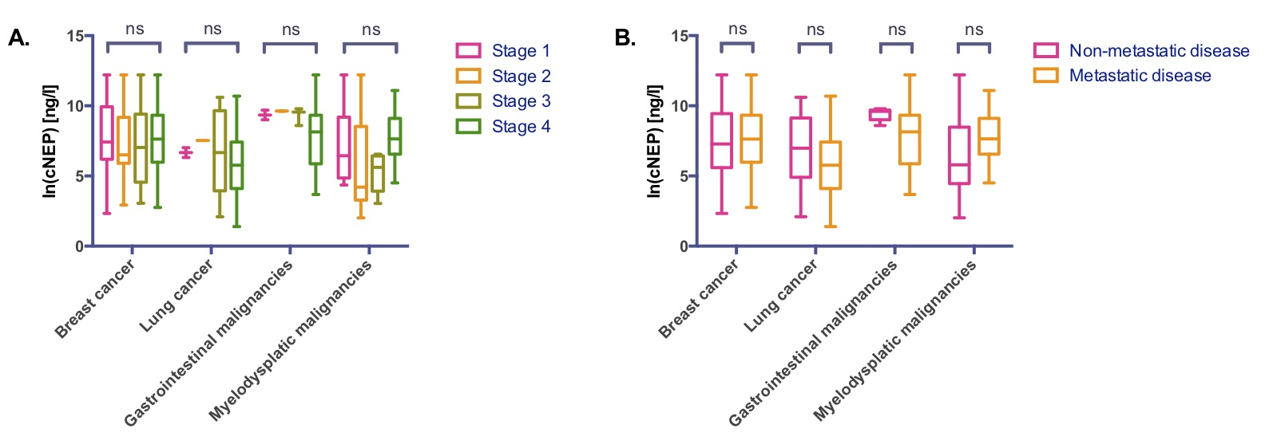

SUPPLEMENTARY TABLE

Supplementary Table 1. Tumor entities of treatment-naïve cancer patients (n=555). Counts are given as numbers and percentages.
 | Cancer patients (n=555)
Tumor entity
Lung cancer, n (%) | 61 (11.0%)
Breast cancer, n (%) | 146 (26.3%)
Brain tumor, n (%) | 23 (4.1%)
ENT-tumor, n (%) | 33 (5.9%)
Gastrointestinal tumors, n (%) | 67 (12.1%)
Myelodyplastic malignancies, n (%) | 68 (12.3%)
Myeloproliferative neoplasias, n (%) | 99 (17.8%)
Esophageal cancer, n (%) | 11 (2.0%)
Testicular cancer, n (%) | 2 (0.4%)
Neuroendocrine tumor, n (%) | 11 (2.0%)
Sarcoma, n (%) | 9 (1.6%)
Mesothelioma, n (%) | 3 (0.6%)
Prostate cancer, n (%) | 2 (0.4%)
Renal cell carcinoma, n (%) | 4 (0.7%)
Thymoma, n (%) | 1 (0.2%)
Skin cancer, n (%) | 2 (0.4%)
Urogenital tumors, n (%) | 2 (0.4%)
Oral cancer, n (%) | 1 (0.2%)
Other, n (%) | 10 (1.8%)

ENT – ear, nose, throat; Myelodysplastic malignancies – haematological malignancies with abnormal differentiation of myeloid or lymphoid cell lines (e.g. AML, ALL, lymphomas, multiple myeloma); Myeloproliferative neoplasias – haematological neoplasias with normal cell differentiation (e.g. essential thrombocytosis, polycythemia vera, myelofibrosis).

