Increased susceptibility of airway epithelial cells from ataxia-telangiectasia to S. pneumoniae infection due to oxidative damage and impaired innate immunity

Abrey J. Yeo¹, Anna Henningham², Emmanuelle Fantino², Sally Galbraith², Lutz Krause³, Claire E. Wainwright^{2,4}, Peter D. Sly², Martin F. Lavin^{1,*}

¹ Neuroscience& Infectious Disease Group, The University of Queensland Centre for Clinical Research, Herston, Queensland, Australia
² Children's Lung, Environment and Asthma Research (CLEAR) Group, Child Health Research Centre, The University of Queensland, South Brisbane, Queensland, Australia
³The University of Queensland Diamantina Institute, Translational Research Institute, Woolloongabba, Queensland, Australia
⁴Lady Cilento Children’s Hospital, South Brisbane, Queensland, Australia
*Corresponding Author: Martin F. Lavin. Cancer and Neuroscience, the University of Queensland Centre for Clinical Research, Building 71/918 RBWH, Herston, Brisbane, Australia. E-mail: m.lavin@uq.edu.au

Supplementary Material
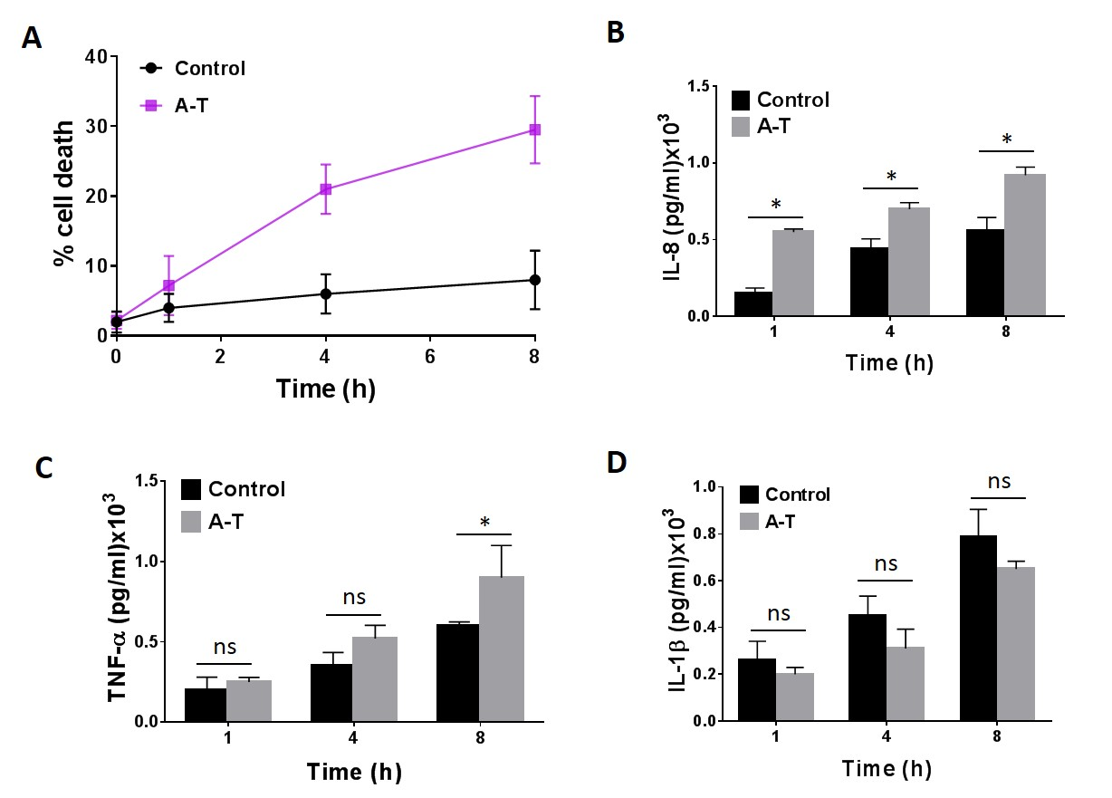
Supplementary Figure 1: Sensitivity in A-T airway epithelial cells to heat-killed S. pneumoniae infection.
A. Percentage of cell death induced by heat-killed S. pneumoniae infection in control and A-T cells. B and C. Moderate increase in inflammasome-independent pro-inflammatory cytokines IL-8 and TNF-α respectively in A-T as compared to control cells following exposure to heat-killed S. pneumoniae. D. Moderate induction of inflammasome-dependent cytokine IL-1β in control and A-T cells. A-T n=2, healthy controls n=2. All data were plotted as the mean ± s.d of three separate experiments. Unpaired, two-tailed Mann-Whitney test was performed. ns; not significant, *p<0.05.

Time Point | Control | A-T Patient
1 h | 1.2 x 10E6 | 1.5 x 10E6
4 h | 1.5 x 10E6 | 1.5 x 10E6
8 h | 2.1 x 10E6 | 2.4 x 10E6
Supplementary Table 1: Enumeration of bacterial numbers from supernatant from control and A-T cells at 1, 4 and 8h post-infection.

