Supplementary Materials to

Weak localization and small anomalous Hall conductivity in ferromagnetic Weyl semimetal Co₂TiGe
Rajendra P. Dulal^{1,2}, Bishnu R. Dahal³, Andrew Forbes^{1,2}, Niraj Bhattarai^{1,2}, Ian L. Pegg^{1,2}, & John Philip*^{1,2}
¹Department of Physics, The Catholic University of America, Washington, D. C., 20064 ²The Vitreous State Laboratory, The Catholic University of America, Washington, D. C., 20064 ³Department of Physics, South Dakota State University, Brookings, SD, 57007
*To whom correspondence should be addressed. Email: philip@cua.edu

- Morphological of CTG thin film
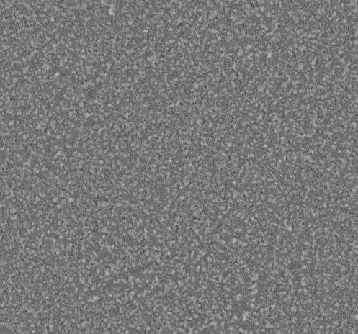
Figure S1 shows the SEM image of uniform and continuous CTG thin film of 50 nm.
Figure S1. Morphology. SEM image of 50 nm CTG thin film.
10 μm

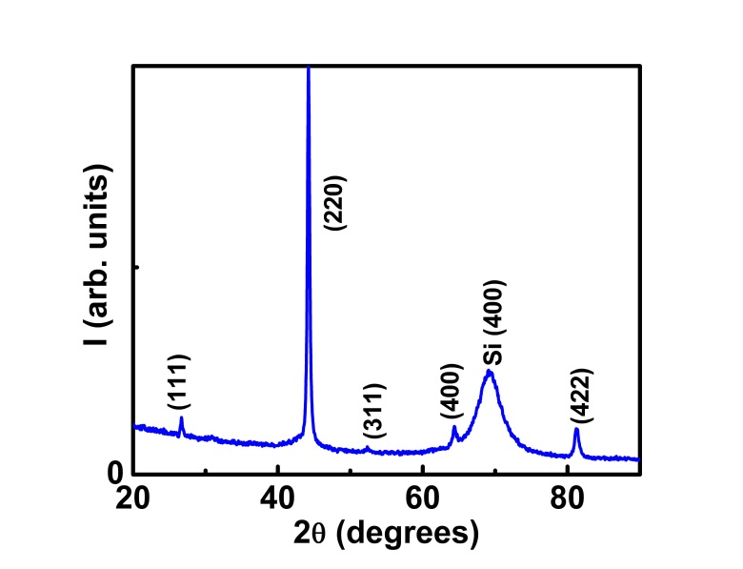
- Structural characterization
Figure S2. Structure . XRD pattern of CTG thin film. The broad peak at 68º is from Silicon (100) substrate.
The XRD pattern is displayed in Figure S2. Co₂XZ Heusler alloys can crystallize with different degrees of chemical order: a fully chemically ordered L2₁ phase, a B2 phase with disorder between X and Z lattices but regular occupation on the Co atomic sites, or a fully disordered A2 phase with random occupation of the Co, X and Z atomic sites [1]. Using XRD spectrum, the ordered L2₁ structure can be characterized by the presence of odd superlattices reflections like (111) or (311). These reflections are absent in the B2 form, which is characterized by h+k+l = 4n +2 superlattice reflections like (002). The h+k+l = 4n reflections like (004) or (422) are fundamental types and are unaffected by chemical disordering [2]. In our thin film, (111) peak is present whereas (200) peak is absent. The absence of (200) peak might indicate B32- type disorder in our thin film. However, Intensities of (200) peak could be undetectable if all the elements of the Heusler Compounds are from the same row of periodic table [2]. Hence, our alloy exhibit the L2₁ ordered crystal structure with space group Fm$\overline{3}$m.

- Chemical Mapping
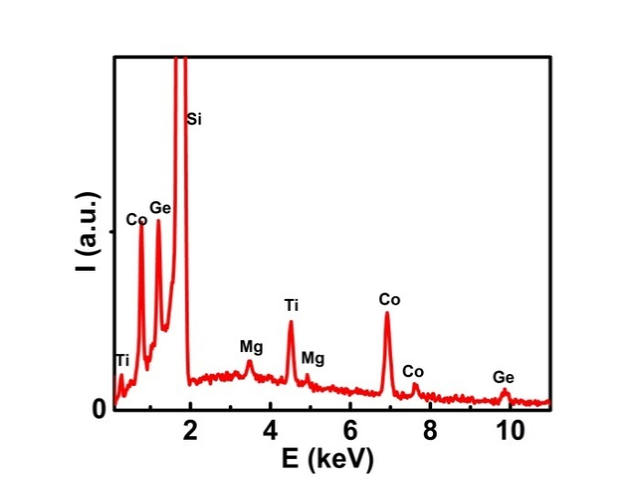
Figure S3 demonstrates the chemical mapping of CTG thin film. The stoichiometric ratio of Co:Ti:Ge is equal to 50:24.8:25.2.
Figure S3. Chemical Mapping. Energy dispersive X-ray (EDX) spectrum of CTG film.
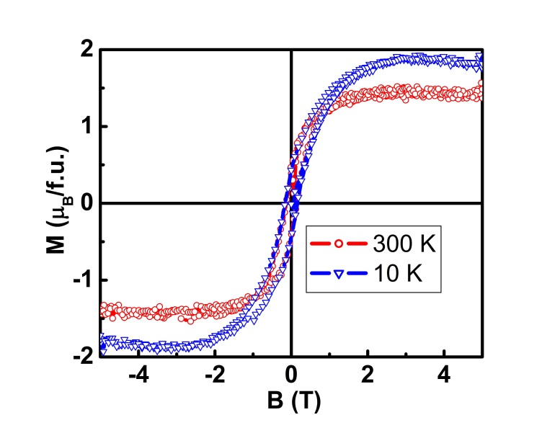
- Magnetic characterization – Magnetization vs Field
Figure S4. Magnetic Characterization. Field variation of magnetization at 300 and 10 K
Magnetization versus magnetic field curve displays ferromagnetic behavior. The magnetic moment is reduced when the temperature is increased to 300 K.

- Magnetic characterization – Magnetization vs temperature
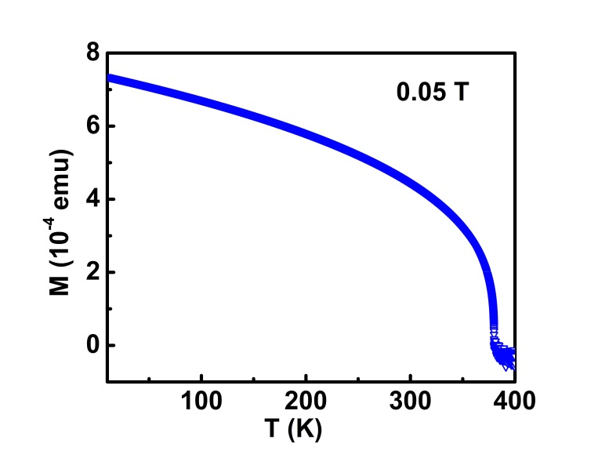
The variation of magnetization with temperature is recorded from 10 to 400 K at a 0.05 T field. First sample is cooled to 10 K and a magnetic field of 0.05 T is applied, then the magnetization of the CTG thin film is measured up to 400 K. The transition temperature is observed at 379 K.
Figure S5. Magnetic Characterization. Magnetization curve as a function of temperature of CTG thin film.

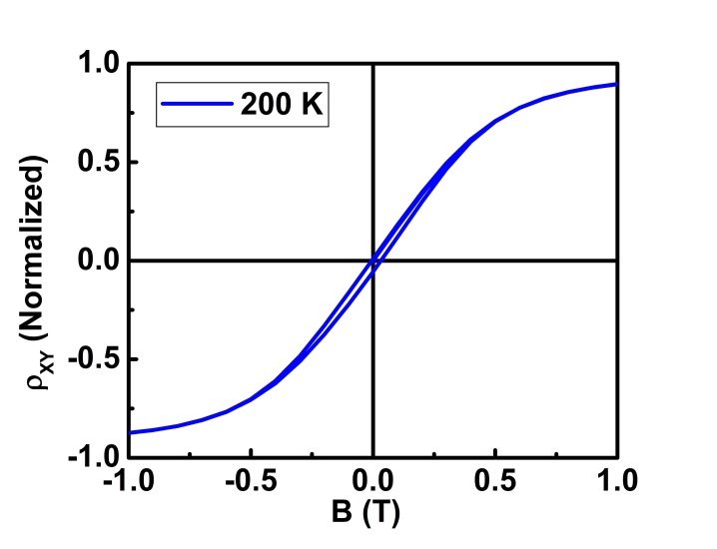
- Hall resistivity at 200 K
Figure S6. Hall resistivity. Hall resistivity exhibits loop behavior.

- Webster, P., & Ziebeck, K., Magnetic Properties of Metals, Alloys and Compounds of d-elements with Main Group Elements. Part 2 in Landolt-Bornstein- Group III Condensed Matter 19c (ed. Wijn, H. P. J.) 75-79, doi:10.1007/b33550 (Springer, Berlin, Heidelberg 1988).
- Graf, T., & Felser, C. Crystal Structure of Heusler Compounds in Spintronics: From Materials to Devices (ed. Felser, C., & Fecher, G. H.) 45-49, doi:10.1007/978-90-481-3832-63 (Springer, Netherlands, 2013

