Graphene Oxide Induced Surface Modification for Functional Separators in Lithium Secondary Batteries

Ju Young Kim*, Dong Ok Shin, Kwang Man Kim, Jimin Oh, Jumi Kim, Seok Hun Kang, Myeong Ju Lee, Young-Gi Lee*

Research Group of Multidisciplinary Sensors, Electronics and Telecommunications Research Institute (ETRI), Daejeon 34129, Republic of Korea

*Corresponding authors.
E-mail address: juyoung@etri.re.kr (J.Y. Kim), lyg@etri.re.kr (Y.-G. Lee).
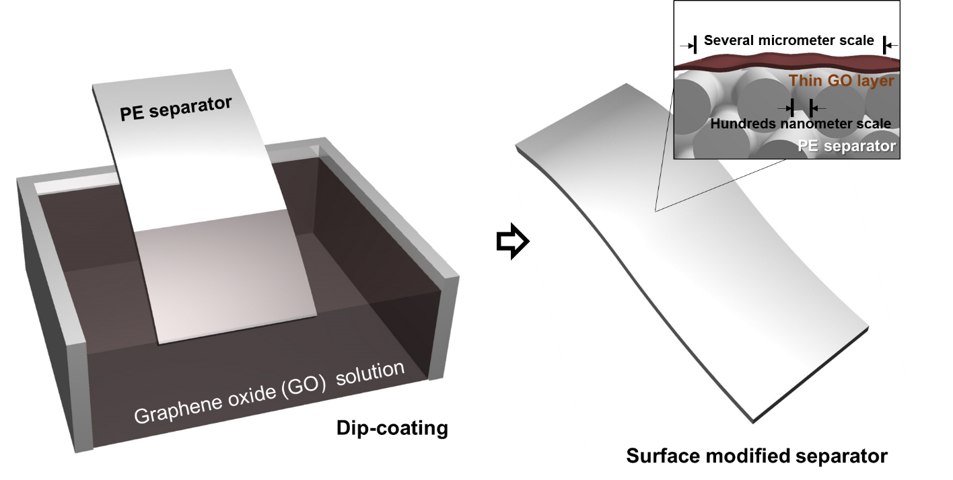
Figure S1. Schematic illustration of the graphene oxide induced surface modification of the conventional separators.

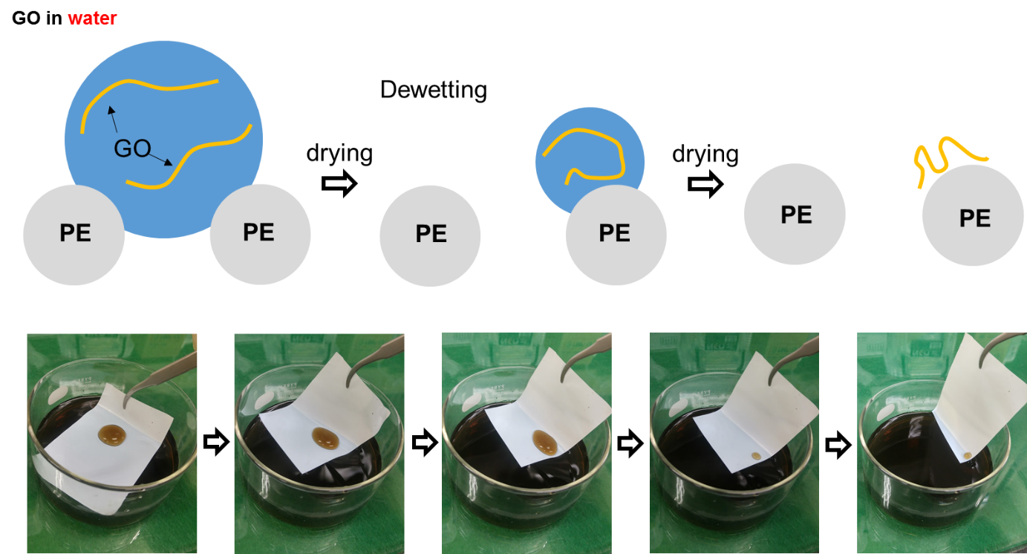
Figure S2. Schematic illustration and photograph of the separator coating by the water-based solution of graphene oxide.

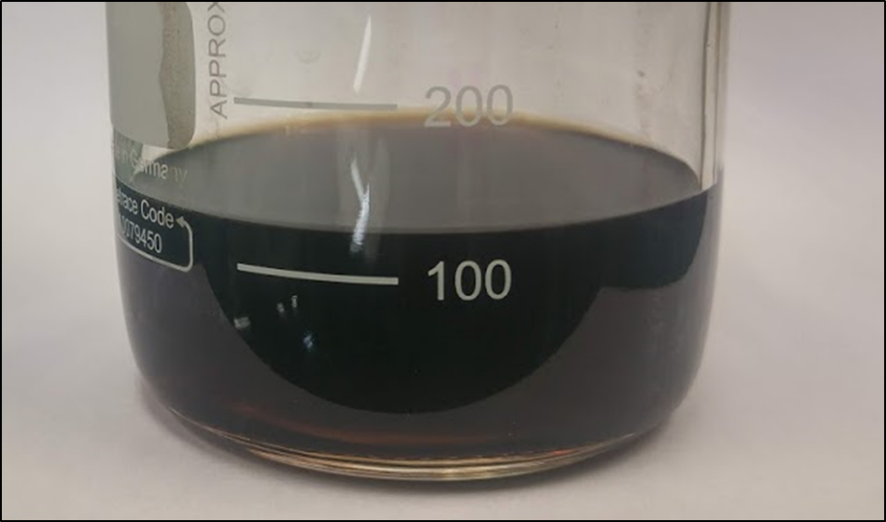
Figure S3. Photograph of the stable GO dispersion in IPA/water solvent.

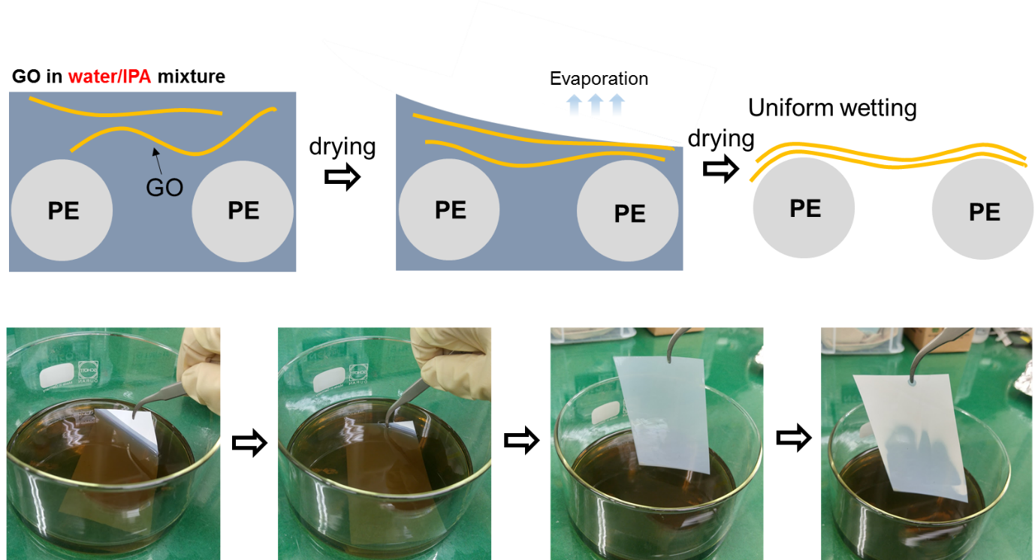
Figure S4. Schematic illustration and photograph of separator coating by the water/IPA (1/ 20 by volume ratio)-based solution of graphene oxide

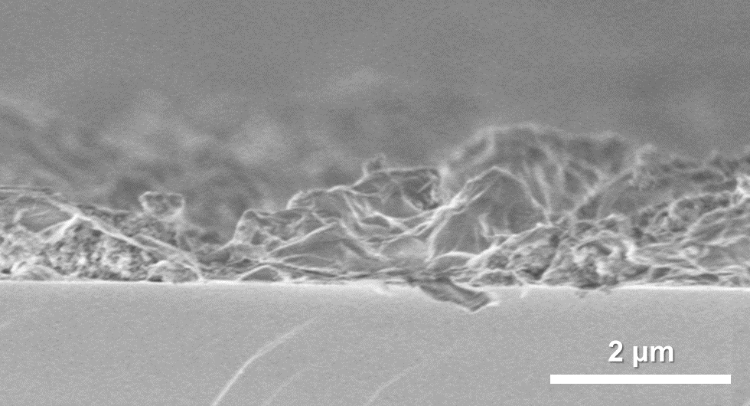
Figure S5. The side view SEM image of GO-SiO₂ coated separator. For clear observation, the GO-SiO₂ coating on silicon substrate was performed with same coating process, instead of separator.

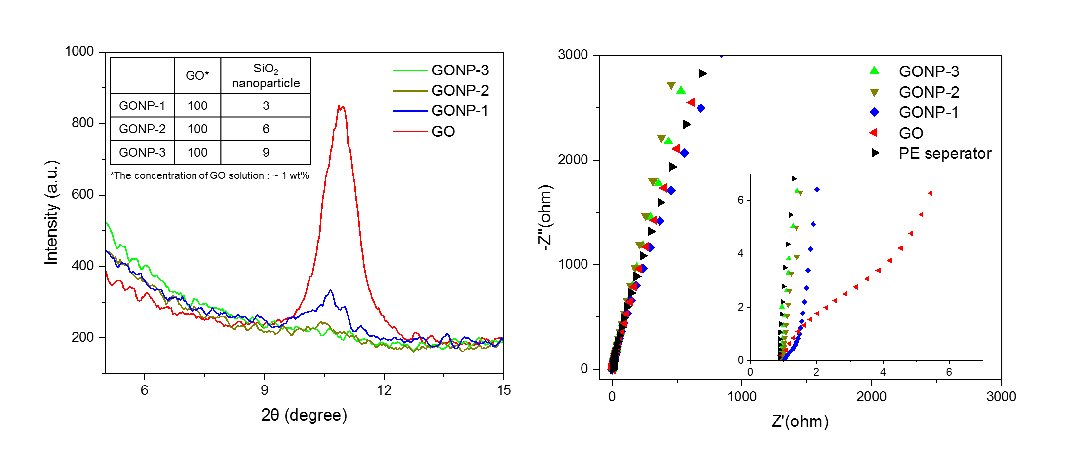
Figure S6. XRD and impedance results of the GO-SiO₂ separators in relation to the blending ratio of GO and SiO₂ nanoparticles.

