ZeBRα a universal, multi-fragment DNA-assembly-system with minimal hands-on time requirement

David Richter^{1*}, Katharina Bayer¹, Thomas Toesko¹& Stefan Schuster¹
¹Department of Animal Physiology, University of Bayreuth, 95440 Bayreuth, Germany.
Supplementary Information

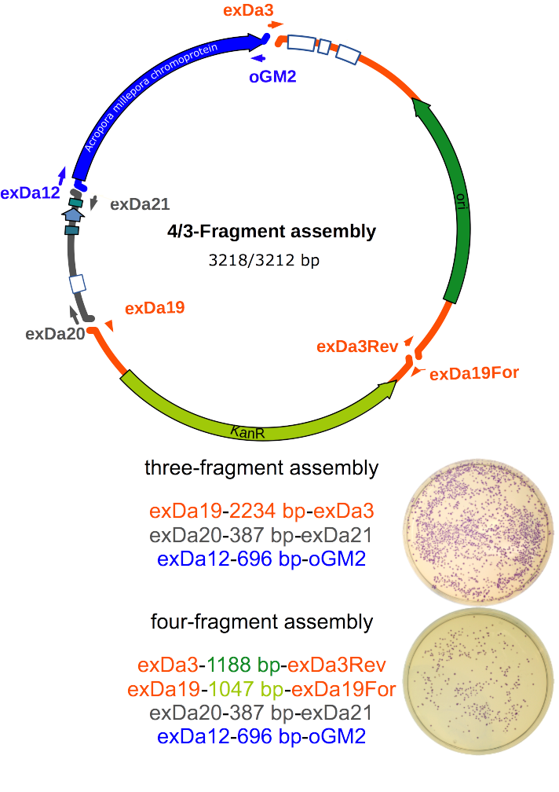
Figure S1. Fragments used in three- and four-fragment assemblies. Plasmid map of three- and four-way assemblies and the used PCR-fragments. A blue chromoprotein was used as readout for the potency of the PPY extracts. The three-fragment- assembly consists of three PCR-fragments with about 15 bp overlapping ends. The fragments correspond to a kanamycin resistant vector backbone, a promoter and the ORF coding for the blue chromoprotein. In the case of a four-fragment-assembly, the plasmid vector was recombined from two separate PCR-fragments. The number of blue colonies that appear after transformation is proportional to the recombination capacity of the cell extract (lower left corner)

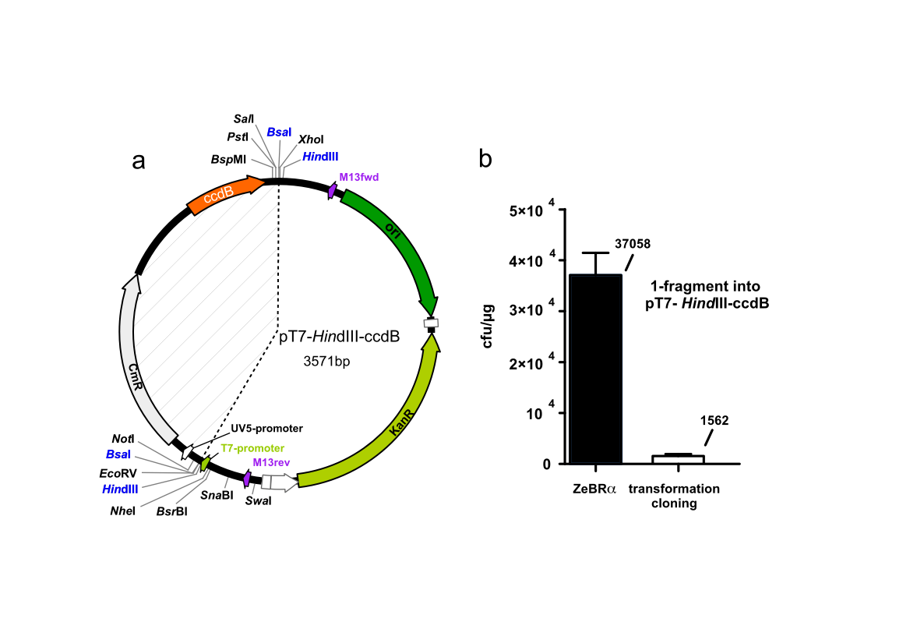
Figure S2. Plasmid map and performance of pT7-HindIII-ccdB in ZeBRα cloning. a, Two HindIII and two BsaI sites flank the toxic-placeholder- ccdB, allowing convenient linearization and removal of ccdB. Unique sites are available on either side of ccdB (bold). Chloramphenicol acetyl-transferase coding gene (CmR), is part of the placeholder cassette and prevents ccdB-loss during plasmid propagation. The dotted lines encompass the region removed during cloning. b, ZeBRα: PPY-extract mediated assembly of a 700 bp PCR-fragment with 15 bp identical ends shared with the vector into pT7-HindIII-ccdB is about 23 times more efficient than “transformation-cloning”

Figure S3. Cell extracts derived from E. coli K12 strains have high detergent dependent recombinogenic capacity without ectopic expression of phage proteins. a, NEB 5-alpha extracts of four detergents and the commercial CelLytic were tested for their ability to join three PCR-fragments resulting in a plasmid conferring blue colony phenotype or white colonies indicating defective assemblies as described for PPY cells.
Extracts derived from NEB 5-alpha produced more than 10⁴ cfu/µg with about 1-4% defective colonies. CHAPS and SB-12 were more efficient than the other detergents but also produced slightly more defective colonies. All extracts were prepared from a blend of three independently fermented cultures b, JM109 extracts of four detergents and the commercial CelLytic were tested for their ability to join three PCR-fragments resulting in a plasmid conferring blue colony phenotype or white colonies indicating defective assemblies as described for PPY cells. Extracts derived from JM109 produced at least 10⁴ cfu/µg. CHAPS being the least effective and CelLytic and OTG being the most recombinogenic producing almost 3x10⁴ cfu/µg. Generally JM109 derived extracts produced more defective colonies than NEB 5-alpha extracts. All extracts were prepared from a blend of three independently fermented cultures. All assemblies were column-purified before transformation into NEB 5-alpha.

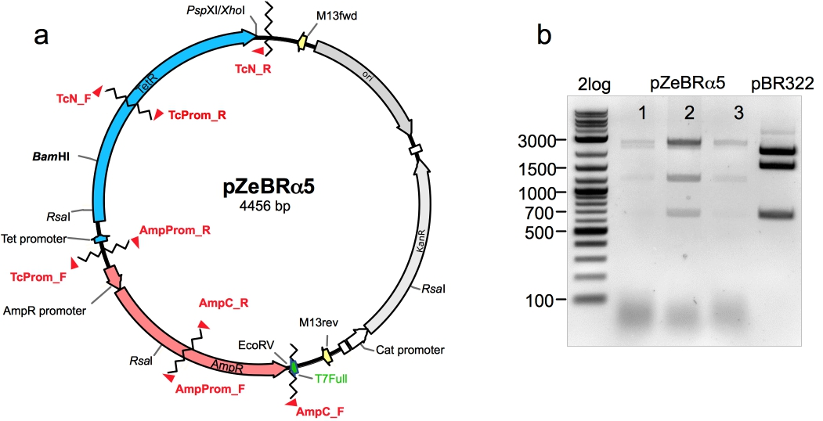

Figure S4. Five-fragment ZeBRα-assembly for estimating the fidelity of the reaction results in the triple-antibiotic resistant pZeBRα. a, Plasmid map of the pZeBRα. Selected restriction enzyme recognition sites are shown in black. PCR-primers used for amplification of assembled fragments and their respective binding sites (arrowheads) are shown in red. The blue and red arrows indicate the bla and tetA genes conferring resistance to ampicillin and tetracycline respectively. The criss-cross line indicates the fusion sites of the individual fragments. The plasmid backbone is derived from pT7-HindIII-ccdB HindIII b, characteristic RsaI digestion pattern of pZeBRα and pBR322, latter served as template for generating the cloned fragments.

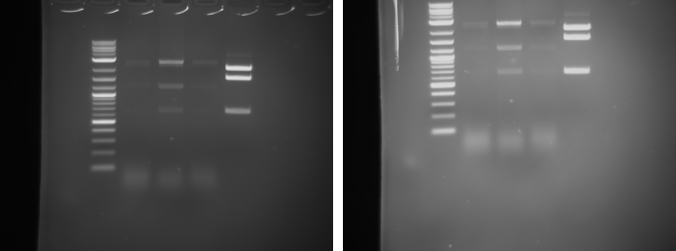

Figure S5. Five-fragment ZeBRα-assembly confirmation of the pZeBRα- vector identity conferring triple-antibiotic resistant by restriction enzyme digestion. a, the gel-images are unedited raw images displaying the result of the restriction enzyme digestion seen in Figure S4.

Table S1/S2. CCMB80 chemically competent PPY cells are not suitable for “transformation-cloning”.

_{Transformation-cloning PPY} 70 ng/µl linear Vector

cfu/µg total | cfu/µg GFP⁺
960 | 0
1000 | 0
360 | 40
1280 | 40

pT7-Hind-ccdB (*120 ng/µl) BsaI-FastAP-column-purified
lacP+RBS 50 ng/µl- 280 bp
GFP-ORF 50 ng/µl -760 bp
*Corresponding to 70 ng/µl linear Vector

_{Transformation-cloning PPY} 29.5 ng/µl linear Vector

cfu/µg total | cfu/µg GFP⁺
1680 | 120
1480 | 80
0 | 0

pT7-Hind-ccdB (*50 ng/µl) BsaI-FastAP-column-purified
lacP+RBS 50 ng/µl- 280 bp
GFP-ORF 50 ng/µl -760 bp
*Corresponding to 29.5 ng/µl linear Vector

Table S3. Modified non-inducing PAG medium for PPY.

Amount | Component
9.07 ml | ddH₂O
20 µl | 1M MgSO₄
1 µl | 1M FeCl₃ in 1.2M HCl
125 µl | 40%(w/v) glucose
500 µl | 20xP
125 mg | Leucine
62.5 mg | Isoleucine
62.5 mg | Valine
10 µl | Streptomycin (50 mg/ml)

Table S4. Complete autoinduction medium used for induction of Redα.

Amount | Component
185.6 ml | ZY-Medium
0.4 ml | 1M MgSO₄
0.02 ml | 1M FeCl₃ in 1.2M HCl
4 ml | 50x 5052-Arabinose
10 ml | 20x P
0.05 ml | Streptomycin (50 mg/ml)

Table S5. Composition of inducing 50x 5052-Arabinose medium.

Amount | Component
25 g | Glycerol
73 ml | H₂O
2.5 g | Glucose
10 g | L-(+)-Arabinose

Table S6. Composition of non-inducing 50x 5052-Lactose medium.

Amount | Component
25 g | Glycerol
73 ml | H₂O
2.5 g | Glucose
10 g | L-(+)-Lactose

Table S7. Composition of 20xP.

Amount | Component
90 ml | ddH₂O
14.2 g | Na₂HPO₄
13.6 g | KH₂PO₄
6.6 g | (NH₄)₂SO₄

pH of 50-fold dilution should be ~6.7

Table S8. ZY-Medium.

Amount | Component
10 g | tryptone
5 g | Yeast-extract
Ad 1 liter H₂O

Table S9. PCR-Conditions for preparing the DNA-fragments used for testing the PPY extract.

3-fragment  assembly | Fragment | Template  Primer | PCR conditions
3-fragment  assembly | insert | pSB1C3-K592009  oGM12  oGM2 | 98°C for 30 s; 98°C for 10 s; 70°C for 20 s; 72°C for 30 s (repeated for 28 cycles); 72°C for 2:00
3-fragment  assembly | promoter | pSB1C3-J04450  exDa20  exDa21 | 98°C for 30 s; 98°C for 10 s; 60°C for 20 s; 72°C for 15 s (repeated for 28 cycles); 72°C for 2:00
3-fragment  assembly | ori | pSB1K3-J04450  exDa3  exDa19 | 98°C for 30 s; 98°C for 10 s; 62°C for 20 s; 72°C for 1:40 (repeated for 25 cycles); 72°C for 2:00

4-fragment assembly | insert | pSB1C3-K592009  oGM12  oGM2 | 98°C for 30 s; 98°C for 10 s; 70°C for 20 s; 72°C for 30 s (repeated for 28 cycles); 72°C for 2:00
4-fragment assembly | promoter | pSB1C3-J04450  exDa20  exDa21 | 98°C for 30 s; 98°C for 10 s; 60°C for 20 s; 72°C for 15 s (repeated for 28 cycles); 72°C for 2:00
4-fragment assembly | KanR | pSB1K3-J04450  exDa19.For  exDa19 | 98°C for 30 s; 98°C for 10 s; 68°C for 15 s; 72°C for 30 s (repeated for 25 cycles); 72°C for 2:00
4-fragment assembly | ori | pSB1K3-J04450  exDa3  exDa3.Rev | 98°C for 30 s; 98°C for 10 s; 70°C for 15 s; 72°C for 30 s (repeated for 25 cycles); 72°C for 2:00

Table S10. PCR-Conditions for preparing the DNA-fragments for ZeBRα.

ZeBRα-assembly | Fragment | Template  Primer | PCR conditions
ZeBRα-assembly | GFP 760 bp | UAS-PSD95-GFP  ZebraGFP_Fw  ZebraGFP_Rw | 98°C for 30 s; 98°C for 10 s; 64°C for 20 s; 72°C for 30 s (repeated for 32 cycles); 72°C for 2:00
ZeBRα-assembly | promoter 280 bp | pSB1K3-J04450  ZebraProm_Fw  ZebraProm_Rw | 98°C for 30 s; 98°C for 10 s; 62°C for 20 s; 72°C for 20 s (repeated for 32 cycles); 72°C for 2:00
ZeBRα-assembly | vector | pT7-HindIII-ccdB | BsaI-digested, FastAP-dephosphorylated-column-purified (120 ng/µl)

Table S11. PCR-Conditions for preparing the DNA-fragments for ZeBRα5.

ZeBRα-assembly | Fragment | Template  Primer | PCR conditions
ZeBRα-assembly | Tc1 690 bp | pBR322  TcN_F  TcN_R | 98°C for 1min; 98°C for 10 s; 66°C for 25 s; 72°C for 25 s (repeated for 30 cycles); 72°C for 2:00
ZeBRα-assembly | Tc2 647bp | **Tc 671 bp  TcProm_F  TcProm_R | 98°C for 1min; 98°C for 10 s; 67°C for 25 s; 72°C for 25 s (repeated for 30 cycles); 72°C for 2:00
ZeBRα-assembly | Ap1 641 bp | pBR322  AmpProm_F  AmpProm_R | 98°C for 1min; 98°C for 10 s; 66°C for 25 s; 72°C for 25 s (repeated for 30 cycles); 72°C for 2:00 25
ZeBRα-assembly | Ap2 480 bp | pBR322  AmpC_F  AmpC_R | 98°C for 1min; 98°C for 10 s; 66°C for 25 s; 72°C for 25 s (repeated for 30 cycles); 72°C for 2:00
ZeBRα-assembly | vector | pT7-HindIII-ccdB | BsaI-digested, FastAP-dephosphorylated-column-purified (120 ng/µl)

ZeBRα-assembly | Fragment | Template  Primer | PCR conditions
ZeBRα-assembly | **Tc 671bp | pBR322  TcProm_F  TcProm_R1 | 98°C for 1min; 98°C for 10 s; 67°C for 25 s; 72°C for 25 s (repeated for 30 cycles); 72°C for 2:00

Table S12. Primer Sequences used, naming as in²².

Primer | Sequence
oGM2 | ATTTGATGCCTGGTTATTAGGCGACCACAGGTTTGCGTGC
exDa3/oGM3 | GGTCGCCTAATAACCAGGCATCAAATAAAACGAAAGGCT
*exDa3 Rev | GACTCGAGCTCGAGCTGTCAGACCAAGTTTACT
oGM12 | AGGAGAAATACTAGATGAGTGTGATCGCTAAACAAATGACCTACAAGG
exDa20 | TGAGTTGAAGGATCAGCTTCTAAGAAACCATTATTATCATGACATTAACC
exDa21 | AGCGATCACACTCATCTAGTATTTCTCCTCTTTCTCTAGTATGTG
exDa19 | TGGTTTCTTAGAGCTGATCCTTCAACTCAGCA
*exDa19For | GCTCGAGCTCGAGTCCCGTCAAG
*ZebraGFP_Fw | GAAATACTAGCCATGGTGAGCAAGGG
*ZebraGFP_Rw | GGAGAAGCTTGCGATATCCGCGGCCGCTTT
*ZebraProm_Fw | CCAAGCTTTTTAAACTCGAGTGGAATTCGCGGCCG
*ZebraProm_Rw | CTCACCATGGCTAGTATTTCTCCTCTTTCTCTAGTATG
*AmpC_F | GGAGAagcttgcGATATCGGTCTGACAGTTACCAATGCTTAATC
*AmpC_R | TGACAACGATCGGAGGACCG
*AmpProm_F | CCTCCGATCGTTGTCAGAAGTAAG
*AmpProm_R | CATGAGAATTCTTGAAGACGAAAGGG
*TcProm_F | CGTCTTCAAGAATTCTCATGTTTGACAG
*TcProm_R | ACTCCTGCATTAGGAAGCAGC
*TcN_F | GCTTCCTAATGCAGGAGTCGC
*TcN_R2 | CGCTGCAGCCATTCAGGTCGAGGTGG
*TcN_R1 | CCAAGCTTTTTAAACTCGAGCGCTGCAGCCATTCAG

* denotes primers designed for this study

Table S13. Composition of SLiCE/ZeBRα-assembly.

Component | Reagents
E. coli extract | n-Octyl-β-D-thioglucopyranosid, 1%(w/v) in 50 mM Tris-HCl pH 7.5
T4-ligase-buffer | #B0202S, (New England Biolabs)
NAD⁺ | 10 mM in H₂O (Carl Roth)
H₂O | MilliQ autoclaved
vector | pT7-Hind-ccdB (120 ng/µl) BsaI-digested, FastAP-dephos.-column-purified
insert 1 | lacP+RBS 50 ng/µl- 280 bp column-purified
insert 2 | GFP-ORF 50 ng/µl -760 bp column-purified

Table S14. SLiCE/ZeBRα-assembly.

_{ZeBR}α
Component | Amount
E. coli extract/PPY or NEB 5-alpha | 1 µl
T4-ligase-buffer | 1 µl
NAD⁺ | 1 µl
H₂O | 4 µl
vector | 1 µl
insert 1 | 1 µl
insert 2 | 1 µl
Σ 10 µl
incubate 30’ RT
column-purification
elute in 8 µl, transform into NEB 5-alpha

Table S15. SLiCE/ZeBRα-assembly.

_{ZeBR}α5
Component | Amount
E. coli extract/PPY or NEB 5-alpha | 1 µl
T4-ligase-buffer | 1 µl
NAD⁺ | 1 µl
H₂O | 2 µl
vector | 1 µl
Fragment-1 | 1 µl
Fragment-2 | 1 µl
Fragment-3 | 1 µl
Fragment-4 | 1 µl
Σ 10 µl
incubate 35’ RT
column-purification
elute in 8 µl, transform into NEB 5-alpha
Inserts were 100 ng/µl each

Table S16. Transformation-cloning.

_{Transformation-cloning}
Component | Amount
vector | 1 µl
insert 1 | 1 µl
insert 2 | 1 µl
Σ 3 µl
incubate 30’ RT
transform into NEB 5-alpha

Remarks:
- Column-purification is the main source of variance, the amount of recovered DNA varied considerably.
- Loading the flow through repetitively, using the maximum volume binding buffer and reloading the eluted DNA onto the column in the final step moderately increased the recovery rates.
- Increasing the DNA content of the assembly reactions increases the number of colonies.
- SOC-Medium with glycine as outgrowth medium is beneficial.
- Plating all cells increases the colony numbers. Therefore after the incubation in the outgrowth-medium cells are gently spun down at 5000 rpm for 1’, the medium is decanted and the cells are gently re-suspended in 100 µl SOC or LB for spreading.

