Title: Species-specific alterations in Anopheles mosquito olfactory responses caused by Plasmodium infection

Authors: Stanczyk NM^{1,2}(CO), Brugman VA¹(CO), Austin V¹, Sanchez-Roman Teran F¹, Gezan SA³, Emery M⁴, Visser TM⁵, Dessens, JT⁶, Stevens W¹, Smallegange R⁵, Takken W⁵, Hurd, H⁷, John Caulfield⁴, Birkett M⁴, Pickett J⁴, Logan JG¹ *

Affiliations:
¹ Department of Disease Control, Faculty of Infectious and Tropical Diseases, London School of Hygiene and Tropical Medicine, Keppel Street, London, WC1E 7HT, UK

² Department of Environmental Systems Science, ETH Zürich, Switzerland

³ School of Forest Resources and Conservation, University of Florida, Gainesville, Florida, USA

⁴ Department of Biointeractions and Crop protection, Rothamsted research, UK
⁵ Department of Plant Sciences, Laboratory of Entomology, Wageningen University & Research, The Netherlands
⁶ Department of Pathogen Molecular Biology, Faculty of Infectious and Tropical Diseases, London School of Hygiene and Tropical Medicine, Keppel Street, London, WC1E 7HT, UK
⁷ School of Life Sciences, Keele University, Staffordshire, ST5 5BG, UK

Supplementary Material

Table S1: GC-EAG peaks in volatile odour samples collected from human feet confirmed by co-injection. An. gambiae infected with P. falciparum infection stages tested with EAG: O = oocyst, S = sporozoite, U1 = uninfected control for oocyst stage, U2 = uninfected control for sporozoite stage. Where a peak consisted of multiple compounds which could not be separated, all are listed. N = 4-6 replicates for all treatments. KI = Kovats Index.
Peak | Compound | KI | Infection stage responding | Peak | Compound | KI | Infection stage responding
1 | N,N-Dimethylformamide | 737 | U1+U2+O+S | 20 | Acetophenone | 1041 | O
2 | Toluene | 754 | O+S | 21 | Nonanal | 1085 | O+S
3 | Unidentified | 778 | U2+S | 22 | Undecane | 1099 | U2
4 | Hexanal | 777 | S |  | 2-Ethylhexanoic acid | 1104 | U2
5 | Unidentified | 788 | U1+S | 23 | Camphor | 1124 | U2
6 | Unidentified | 799 | O+S | 24 | 1-Nonanol | 1159 | U1+O
7 | 4-Hydroxy-4-methyl-2-pentanone | 815 | O+S |  | Unidentified | 1173 | U1+O
8 | 2,4-Dimethylheptane | 827 | U2+S | 25 | Benzothiazole | 1202 | O
9 | Unidentified | 832 | U1 | 26 | Unidentified | 1261 | U1+U2
10 | Ethylbenzene | 852 | U2 | 27 | Unidentified | 1288 | O
11 | 1,3-Dimethylbenzene | 860 | S | 28 | 4-Ethylbenzoic acid | 1335 | O
12 | 4-Methyloctane | 868 | U1+S | 29 | Tetradecane | 1399 | U1
13 | Styrene | 878 | O | 30 | Verdyl acetate | 1404 | S
14 | Nonane | 902 | U2 | 31 | Geranylacetone | 1434 | U1
15 | Benzaldehyde | 934 | U1 | 32 | 1-Dodecanol | 1460 | U1
16 | Phenol | 956 | O+S | 33 | Pentadecane | 1500 | U1
 | 3-Ethyltoluene | 955 | O+S | 34 | Dodecanoic acid | 1535 | S
 | 4-Ethyltoluene | 957 | O+S | 35 | Unidentified | 1590 | S
17 | 2-Ethyltoluene | 969 | U1+S | 36 | Unidentified | 1662 | O
18 | Decane | 998 | U2+S | 37 | Isopropyl myristate | 1810 | U2
19 | Limonene | 1026 | U1+O+S

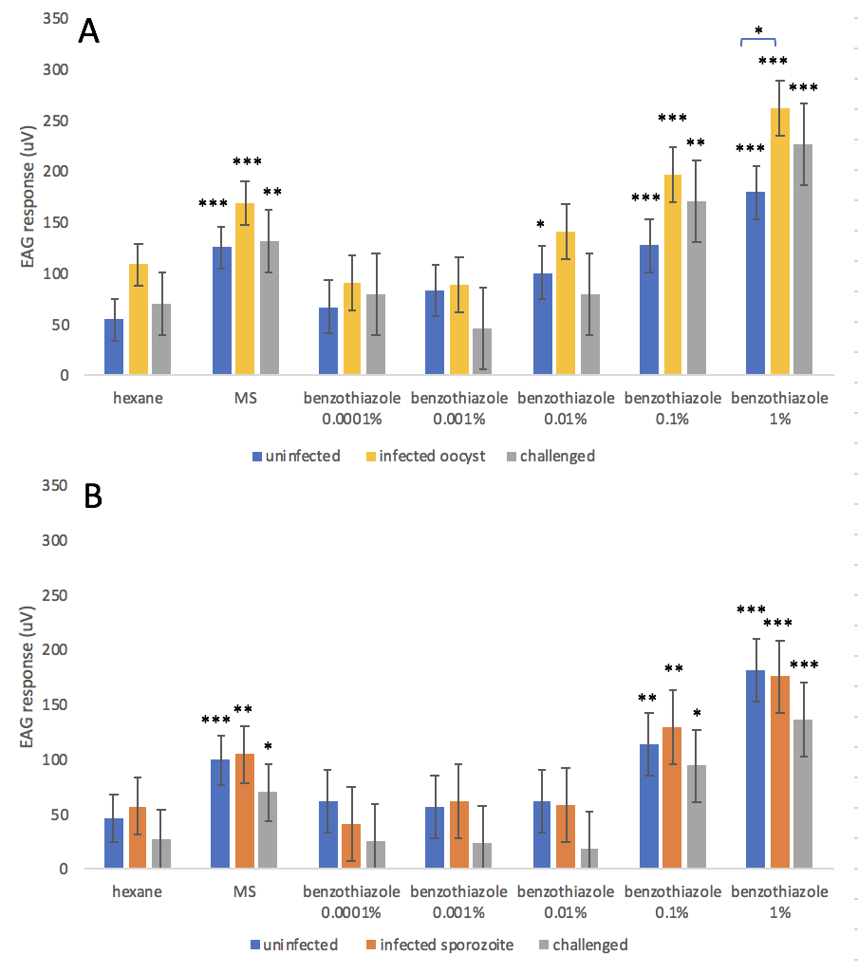

Fig S1. Dose response EAG to benzothiazole of female An. stephensi mosquitoes given an uninfected bloodmeal (control) or P. berghei infected bloodmeal which showed the presence (infected) or absence (challenged) of parasites upon dissection. EAG was carried out at: A) 8-10 days post challenge (oocyst stage), or B) 15-16 days post challenge (sporozoite stage). Here, compounds are tagged when significantly different from the negative control (*** p<0.001, ** p<0.01, * p<0.05) or, as indicated with a comparative line, when different between infection status.

