Examination of the temporal and spatial dynamics of the gut microbiome in newborn piglets reveals distinct microbial communities in six intestinal segments

Ying Liu^{1,2†}, Zhijun Zheng^{3,4†}, Lihuai Yu¹, Sen Wu¹, Li Sun¹, Shenglong Wu^{1,5}, Qian Xu^{3,4}, Shunfeng Cai^{3,4}, Nan Qin^{3 ,4} & Wenbin Bao^{1,5}

¹College of Animal Science and Technology, Yangzhou University, Yangzhou 225009, China. ²School of Life Science, Huaiyin Normal University, Huaian 223001, China. ³Realbio Genomics Institute, Shanghai, 200123, China. ⁴Shenzhen Jinrui Biotechnology, Co. Ltd., Shenzhen 518000, China. ⁵Joint International Research Laboratory of Agriculture & Agri-Product Safety, Yangzhou University, Yangzhou 225009, China.†Equal contributors

Ying Liu^{1,2}
Email: yddkly@163.com
Zhijun Zheng^{3,4}
E-mail: zhengzj@realbio.cn
Lihuai Yu¹
E-mail: lhyu@yzu.edu.cn
Sen Wu¹
E-mail: 15705273995@163.com
Li Sun¹
E-mail: sl19920327@163.com
Shenglong Wu^{1,5}
E-mail: slwu@yzu.edu.cn
Qian Xu^{3,4}
E-mail: xuq@realbio.cn
Shunfeng Cai^{3,4}
E-mail: caisf@realbio.cn

Corresponding author: Wenbin Bao
Address: Key Laboratory for Animal Genetics, Breeding, Reproduction and Molecular Design of Jiangsu Province, College of Animal Science and Technology, Yangzhou University, Yangzhou, Jiangsu 225009, P. R. China;
Tel.: 86-514-87979350; Fax: 86-514-87350440; E-mail: wbbao@yzu.edu.cn
Nan Qin
Address: Realbio Genomics Institute, Shanghai, 200123, China; E-mail: qinnan001@126.com

Supplementary information
Table S1
Diet composition and nutrient levels
Day 1 - Day 35 | Breastfeeding
Day 36 - Day 180 | Grower diets  (feed formulation prepared in our laboratory)
Day 36 - Day 180 | Ingredient | Percentage (%)
Day 36 - Day 180 | Corn | 30
Day 36 - Day 180 | Bran | 25
Day 36 - Day 180 | Soybean meal | 14
Day 36 - Day 180 | Green bran | 27
Day 36 - Day 180 | Premix1) | 4
Day 36 - Day 180 | Dietary nutrient levels2)
Day 36 - Day 180 | Digestible energy | 12.77 MJ/kg
Day 36 - Day 180 | Crude protein | 15.53%
Day 36 - Day 180 | Crude fiber | 5.79%
Day 36 - Day 180 | Ca | 0.70%
Day 36 - Day 180 | P | 1.39%
Day 36 - Day 180 | Lysine | 0.71%
1)The premix provided the following per kg of diets: Fe (as ferrous sulfate) 80 mg, Cu (as copper sulfate) 15 mg, Zn (as zinc sulfate) 80 mg, Mn (as manganese sulfate) 5 mg, Se (as sodium selenite) 0.10 mg, I (as potassium iodide) 0.10 mg, VA 4 480 IU, VD3 500 IU, VE 20 IU, VK3 2.20 mg, VB1 1.80 mg, VB2 2.20 mg, VB6 1.50 mg, VB12 12 ug, folic acid 0.30 mg, biotin 0.05 mg, nicotinic acid 10 mg, calcium pantothenate 8 mg.
2)Nutrient levels were calculated values.

Table S2
The numbers of Clean tags and data imformation in each sample.
Sample name | Growth stages | Intestinal segments | Clean tags | Clean tags at each stage
M1d-1-Duodenum | Day 1 | Duodenum | 56,304 | 1,641,820
M1d-2-Duodenum | Day 1 | Duodenum | 57,547 | 1,641,820
M1d-3-Duodenum | Day 1 | Duodenum | 38,187 | 1,641,820
M1d-4-Duodenum | Day 1 | Duodenum | 45,081 | 1,641,820
M1d-5-Duodenum | Day 1 | Duodenum | 64,103 | 1,641,820
M1d-1-Jejunum | Day 1 | Jejunum | 57,498 | 1,641,820
M1d-2-Jejunum | Day 1 | Jejunum | 58,240 | 1,641,820
M1d-3-Jejunum | Day 1 | Jejunum | 45,186 | 1,641,820
M1d-4-Jejunum | Day 1 | Jejunum | 64,303 | 1,641,820
M1d-5-Jejunum | Day 1 | Jejunum | 59,671 | 1,641,820
M1d-1-Ileum | Day 1 | Ileum | 63,839 | 1,641,820
M1d-2-Ileum | Day 1 | Ileum | 56,919 | 1,641,820
M1d-3-Ileum | Day 1 | Ileum | 61,789 | 1,641,820
M1d-4-Ileum | Day 1 | Ileum | 49,540 | 1,641,820
M1d-5-Ileum | Day 1 | Ileum | 59,177 | 1,641,820
M1d-1-Caecum | Day 1 | Caecum | 55,929 | 1,641,820
M1d-2-Caecum | Day 1 | Caecum | 63,157 | 1,641,820
M1d-3-Caecum | Day 1 | Caecum | 61,660 | 1,641,820
M1d-4-Caecum | Day 1 | Caecum | 57,657 | 1,641,820
M1d-1-Colon | Day 1 | Colon | 58,630 | 1,641,820
M1d-2-Colon | Day 1 | Colon | 41,563 | 1,641,820
M1d-3-Colon | Day 1 | Colon | 59,093 | 1,641,820
M1d-4-Colon | Day 1 | Colon | 57,443 | 1,641,820
M1d-5-Colon | Day 1 | Colon | 63,581 | 1,641,820
M1d-1-Rectum | Day 1 | Rectum | 56,567 | 1,641,820
M1d-2-Rectum | Day 1 | Rectum | 60,959 | 1,641,820
M1d-3-Rectum | Day 1 | Rectum | 55,769 | 1,641,820
M1d-4-Rectum | Day 1 | Rectum | 57,229 | 1,641,820
M1d-5-Rectum | Day 1 | Rectum | 55,199 | 1,641,820
M7d-1-Duodenum | Day 7 | Duodenum | 60,150 | 1,545,878
M7d-3-Duodenum | Day 7 | Duodenum | 54,515 | 1,545,878
M7d-4-Duodenum | Day 7 | Duodenum | 60,796 | 1,545,878
M7d-5-Duodenum | Day 7 | Duodenum | 62,657 | 1,545,878
M7d-1-Jejunum | Day 7 | Jejunum | 58,887 | 1,545,878
M7d-2-Jejunum | Day 7 | Jejunum | 62,712 | 1,545,878
M7d-4-Jejunum | Day 7 | Jejunum | 55,787 | 1,545,878
M7d-5-Jejunum | Day 7 | Jejunum | 46,084 | 1,545,878
M7d-1-Ileum | Day 7 | Ileum | 55,557 | 1,545,878
M7d-2-Ileum | Day 7 | Ileum | 58,843 | 1,545,878
M7d-3-Ileum | Day 7 | Ileum | 58,834 | 1,545,878
M7d-4-Ileum | Day 7 | Ileum | 55,226 | 1,545,878
M7d-5-Ileum | Day 7 | Ileum | 56,316 | 1,545,878
M7d-1-Caecum | Day 7 | Caecum | 55,276 | 1,545,878
M7d-2-Caecum | Day 7 | Caecum | 59,212 | 1,545,878
M7d-3-Caecum | Day 7 | Caecum | 56,766 | 1,545,878
M7d-4-Caecum | Day 7 | Caecum | 61,222 | 1,545,878
M7d-5-Caecum | Day 7 | Caecum | 57,318 | 1,545,878
M7d-2-Colon | Day 7 | Colon | 56,667 | 1,545,878
M7d-3-Colon | Day 7 | Colon | 59,695 | 1,545,878
M7d-4-Colon | Day 7 | Colon | 55,466 | 1,545,878
M7d-5-Colon | Day 7 | Colon | 61,518 | 1,545,878
M7d-1-Rectum | Day 7 | Rectum | 61,739 | 1,545,878
M7d-2-Rectum | Day 7 | Rectum | 55,936 | 1,545,878
M7d-3-Rectum | Day 7 | Rectum | 39,992 | 1,545,878
M7d-4-Rectum | Day 7 | Rectum | 55,199 | 1,545,878
M7d-5-Rectum | Day 7 | Rectum | 63,508 | 1,545,878
M14d-1-Duodenum | Day 14 | Duodenum | 63,292 | 1,741,195
M14d-2-Duodenum | Day 14 | Duodenum | 59,305 | 1,741,195
M14d-3-Duodenum | Day 14 | Duodenum | 55,616 | 1,741,195
M14d-4-Duodenum | Day 14 | Duodenum | 61,880 | 1,741,195
M14d-5-Duodenum | Day 14 | Duodenum | 57,910 | 1,741,195
M14d-2-Jejunum | Day 14 | Jejunum | 62,622 | 1,741,195
M14d-3-Jejunum | Day 14 | Jejunum | 58,392 | 1,741,195
M14d-4-Jejunum | Day 14 | Jejunum | 63,883 | 1,741,195
M14d-5-Jejunum | Day 14 | Jejunum | 64,728 | 1,741,195
M14d-1-Jejunum | Day 14 | Jejunum | 58,354 | 1,741,195
M14d-2-Ileum | Day 14 | Ileum | 59,106 | 1,741,195
M14d-3-Ileum | Day 14 | Ileum | 55,713 | 1,741,195
M14d-4-Ileum | Day 14 | Ileum | 62,762 | 1,741,195
M14d-5-Ileum | Day 14 | Ileum | 62,940 | 1,741,195
M14d-1-Caecum | Day 14 | Caecum | 59,694 | 1,741,195
M14d-2-Caecum | Day 14 | Caecum | 63,039 | 1,741,195
M14d-3-Caecum | Day 14 | Caecum | 59,256 | 1,741,195
M14d-4-Caecum | Day 14 | Caecum | 61,035 | 1,741,195
M14d-5-Caecum | Day 14 | Caecum | 56,156 | 1,741,195
M14d-1-Colon | Day 14 | Colon | 54,484 | 1,741,195
M14d-2-Colon | Day 14 | Colon | 55,221 | 1,741,195
M14d-3-Colon | Day 14 | Colon | 57,624 | 1,741,195
M14d-4-Colon | Day 14 | Colon | 63,392 | 1,741,195
M14d-5-Colon | Day 14 | Colon | 64,410 | 1,741,195
M14d-1-Rectum | Day 14 | Rectum | 62,807 | 1,741,195
M14d-2-Rectum | Day 14 | Rectum | 62,894 | 1,741,195
M14d-3-Rectum | Day 14 | Rectum | 60,328 | 1,741,195
M14d-4-Rectum | Day 14 | Rectum | 55,293 | 1,741,195
M14d-5-Rectum | Day 14 | Rectum | 59,059 | 1,741,195
M21d-1-Duodenum | Day 21 | Duodenum | 55,551 | 1,667,320
M21d-2-Duodenum | Day 21 | Duodenum | 64,158 | 1,667,320
M21d-3-Duodenum | Day 21 | Duodenum | 63,655 | 1,667,320
M21d-4-Duodenum | Day 21 | Duodenum | 47,785 | 1,667,320
M21d-5-Duodenum | Day 21 | Duodenum | 62,516 | 1,667,320
M21d-2-Jejunum | Day 21 | Jejunum | 63,361 | 1,667,320
M21d-3-Jejunum | Day 21 | Jejunum | 53,607 | 1,667,320
M21d-4-Jejunum | Day 21 | Jejunum | 62,869 | 1,667,320
M21d-5-Jejunum | Day 21 | Jejunum | 57,414 | 1,667,320
M21d-1-Ileum | Day 21 | Ileum | 55,252 | 1,667,320
M21d-2-Ileum | Day 21 | Ileum | 56,145 | 1,667,320
M21d-3-Ileum | Day 21 | Ileum | 62,099 | 1,667,320
M21d-4-Ileum | Day 21 | Ileum | 59,060 | 1,667,320
M21d-1-Caecum | Day 21 | Caecum | 52,095 | 1,667,320
M21d-2-Caecum | Day 21 | Caecum | 64,723 | 1,667,320
M21d-3-Caecum | Day 21 | Caecum | 58,795 | 1,667,320
M21d-4-Caecum | Day 21 | Caecum | 59,552 | 1,667,320
M21d-5-Caecum | Day 21 | Caecum | 64,644 | 1,667,320
M21d-1-Colon | Day 21 | Colon | 58,648 | 1,667,320
M21d-2-Colon | Day 21 | Colon | 57,272 | 1,667,320
M21d-3-Colon | Day 21 | Colon | 61,160 | 1,667,320
M21d-4-Colon | Day 21 | Colon | 58,919 | 1,667,320
M21d-5-Colon | Day 21 | Colon | 59,494 | 1,667,320
M21d-1-Rectum | Day 21 | Rectum | 61,598 | 1,667,320
M21d-2-Rectum | Day 21 | Rectum | 59,861 | 1,667,320
M21d-3-Rectum | Day 21 | Rectum | 59,734 | 1,667,320
M21d-4-Rectum | Day 21 | Rectum | 63,816 | 1,667,320
M21d-5-Rectum | Day 21 | Rectum | 63,537 | 1,667,320
M28d-1-Duodenum | Day 28 | Duodenum | 61,608 | 1,642,921
M28d-2-Duodenum | Day 28 | Duodenum | 64,741 | 1,642,921
M28d-3-Duodenum | Day 28 | Duodenum | 62,214 | 1,642,921
M28d-4-Duodenum | Day 28 | Duodenum | 57,188 | 1,642,921
M28d-5-Duodenum | Day 28 | Duodenum | 56,188 | 1,642,921
M28d-1-Jejunum | Day 28 | Jejunum | 57,444 | 1,642,921
M28d-2-Jejunum | Day 28 | Jejunum | 47,684 | 1,642,921
M28d-3-Jejunum | Day 28 | Jejunum | 64,508 | 1,642,921
M28d-4-Jejunum | Day 28 | Jejunum | 61,349 | 1,642,921
M28d-5-Jejunum | Day 28 | Jejunum | 56,295 | 1,642,921
M28d-1-Ileum | Day 28 | Ileum | 58,927 | 1,642,921
M28d-3-Ileum | Day 28 | Ileum | 47,673 | 1,642,921
M28d-4-Ileum | Day 28 | Ileum | 59,897 | 1,642,921
M28d-5-Ileum | Day 28 | Ileum | 58,795 | 1,642,921
M28d-1-Caecum | Day 28 | Caecum | 56,465 | 1,642,921
M28d-2-Caecum | Day 28 | Caecum | 64,134 | 1,642,921
M28d-3-Caecum | Day 28 | Caecum | 62,941 | 1,642,921
M28d-4-Caecum | Day 28 | Caecum | 56,469 | 1,642,921
M28d-5-Caecum | Day 28 | Caecum | 62,918 | 1,642,921
M28d-1-Colon | Day 28 | Colon | 58,205 | 1,642,921
M28d-2-Colon | Day 28 | Colon | 55,517 | 1,642,921
M28d-4-Colon | Day 28 | Colon | 62,017 | 1,642,921
M28d-5-Colon | Day 28 | Colon | 59,275 | 1,642,921
M28d-1-Rectum | Day 28 | Rectum | 62,950 | 1,642,921
M28d-2-Rectum | Day 28 | Rectum | 45,523 | 1,642,921
M28d-3-Rectum | Day 28 | Rectum | 55,130 | 1,642,921
M28d-4-Rectum | Day 28 | Rectum | 63,318 | 1,642,921
M28d-5-Rectum | Day 28 | Rectum | 63,548 | 1,642,921
M35d-1-Duodenum | Day 35 | Duodenum | 61,960 | 1,778,906
M35d-2-Duodenum | Day 35 | Duodenum | 58,167 | 1,778,906
M35d-3-Duodenum | Day 35 | Duodenum | 56,722 | 1,778,906
M35d-4-Duodenum | Day 35 | Duodenum | 61,814 | 1,778,906
M35d-5-Duodenum | Day 35 | Duodenum | 54,091 | 1,778,906
M35d-1-Jejunum | Day 35 | Jejunum | 58,890 | 1,778,906
M35d-2-Jejunum | Day 35 | Jejunum | 60,203 | 1,778,906
M35d-3-Jejunum | Day 35 | Jejunum | 61,374 | 1,778,906
M35d-4-Jejunum | Day 35 | Jejunum | 62,798 | 1,778,906
M35d-5-Jejunum | Day 35 | Jejunum | 54,918 | 1,778,906
M35d-1-Ileum | Day 35 | Ileum | 57,210 | 1,778,906
M35d-2-Ileum | Day 35 | Ileum | 61,567 | 1,778,906
M35d-3-Ileum | Day 35 | Ileum | 58,143 | 1,778,906
M35d-4-Ileum | Day 35 | Ileum | 56,967 | 1,778,906
M35d-5-Ileum | Day 35 | Ileum | 64,953 | 1,778,906
M35d-1-Caecum | Day 35 | Caecum | 64,727 | 1,778,906
M35d-2-Caecum | Day 35 | Caecum | 55,601 | 1,778,906
M35d-3-Caecum | Day 35 | Caecum | 57,036 | 1,778,906
M35d-4-Caecum | Day 35 | Caecum | 55,152 | 1,778,906
M35d-5-Caecum | Day 35 | Caecum | 61,297 | 1,778,906
M35d-1-Colon | Day 35 | Colon | 58,976 | 1,778,906
M35d-2-Colon | Day 35 | Colon | 48,945 | 1,778,906
M35d-3-Colon | Day 35 | Colon | 60,100 | 1,778,906
M35d-4-Colon | Day 35 | Colon | 64,294 | 1,778,906
M35d-5-Colon | Day 35 | Colon | 63,222 | 1,778,906
M35d-1-Rectum | Day 35 | Rectum | 61,231 | 1,778,906
M35d-2-Rectum | Day 35 | Rectum | 58,761 | 1,778,906
M35d-3-Rectum | Day 35 | Rectum | 57,808 | 1,778,906
M35d-4-Rectum | Day 35 | Rectum | 62,221 | 1,778,906
M35d-5-Rectum | Day 35 | Rectum | 59,758 | 1,778,906
M120d-1-Duodenum | Day 120 | Duodenum | 56,200 | 1,704,472
M120d-2-Duodenum | Day 120 | Duodenum | 57,447 | 1,704,472
M120d-3-Duodenum | Day 120 | Duodenum | 59,258 | 1,704,472
M120d-4-Duodenum | Day 120 | Duodenum | 55,460 | 1,704,472
M120d-1-Jejunum | Day 120 | Jejunum | 57,247 | 1,704,472
M120d-2-Jejunum | Day 120 | Jejunum | 55,232 | 1,704,472
M120d-3-Jejunum | Day 120 | Jejunum | 63,858 | 1,704,472
M120d-4-Jejunum | Day 120 | Jejunum | 61,050 | 1,704,472
M120d-5-Jejunum | Day 120 | Jejunum | 62,037 | 1,704,472
M120d-1-Ileum | Day 120 | Ileum | 64,178 | 1,704,472
M120d-2-Ileum | Day 120 | Ileum | 59,823 | 1,704,472
M120d-3-Ileum | Day 120 | Ileum | 62,117 | 1,704,472
M120d-4-Ileum | Day 120 | Ileum | 62,830 | 1,704,472
M120d-5-Ileum | Day 120 | Ileum | 62,895 | 1,704,472
M120d-1-Caecum | Day 120 | Caecum | 62,848 | 1,704,472
M120d-2-Caecum | Day 120 | Caecum | 62,102 | 1,704,472
M120d-3-Caecum | Day 120 | Caecum | 62,359 | 1,704,472
M120d-4-Caecum | Day 120 | Caecum | 51,557 | 1,704,472
M120d-5-Caecum | Day 120 | Caecum | 61,379 | 1,704,472
M120d-1-Colon | Day 120 | Colon | 55,691 | 1,704,472
M120d-2-Colon | Day 120 | Colon | 63,501 | 1,704,472
M120d-3-Colon | Day 120 | Colon | 55,500 | 1,704,472
M120d-4-Colon | Day 120 | Colon | 55,583 | 1,704,472
M120d-5-Colon | Day 120 | Colon | 63,937 | 1,704,472
M120d-1-Rectum | Day 120 | Rectum | 58,980 | 1,704,472
M120d-2-Rectum | Day 120 | Rectum | 46,665 | 1,704,472
M120d-3-Rectum | Day 120 | Rectum | 50,147 | 1,704,472
M120d-4-Rectum | Day 120 | Rectum | 55,072 | 1,704,472
M120d-5-Rectum | Day 120 | Rectum | 59,519 | 1,704,472
M180d-1-Duodenum | Day 180 | Duodenum | 55,544 | 1,783,935
M180d-2-Duodenum | Day 180 | Duodenum | 62,960 | 1,783,935
M180d-3-Duodenum | Day 180 | Duodenum | 57,609 | 1,783,935
M180d-4-Duodenum | Day 180 | Duodenum | 60,601 | 1,783,935
M180d-5-Duodenum | Day 180 | Duodenum | 54,620 | 1,783,935
M180d-1-Jejunum | Day 180 | Jejunum | 61,363 | 1,783,935
M180d-2-Jejunum | Day 180 | Jejunum | 62,972 | 1,783,935
M180d-3-Jejunum | Day 180 | Jejunum | 64,008 | 1,783,935
M180d-4-Jejunum | Day 180 | Jejunum | 59,510 | 1,783,935
M180d-5-Jejunum | Day 180 | Jejunum | 57,576 | 1,783,935
M180d-1-Ileum | Day 180 | Ileum | 64,262 | 1,783,935
M180d-2-Ileum | Day 180 | Ileum | 55,615 | 1,783,935
M180d-3-Ileum | Day 180 | Ileum | 56,257 | 1,783,935
M180d-4-Ileum | Day 180 | Ileum | 49,273 | 1,783,935
M180d-5-Ileum | Day 180 | Ileum | 55,965 | 1,783,935
M180d-1-Caecum | Day 180 | Caecum | 60,481 | 1,783,935
M180d-2-Caecum | Day 180 | Caecum | 62,479 | 1,783,935
M180d-3-Caecum | Day 180 | Caecum | 63,591 | 1,783,935
M180d-4-Caecum | Day 180 | Caecum | 61,854 | 1,783,935
M180d-5-Caecum | Day 180 | Caecum | 64,392 | 1,783,935
M180d-1-Colon | Day 180 | Colon | 63,287 | 1,783,935
M180d-2-Colon | Day 180 | Colon | 59,503 | 1,783,935
M180d-3-Colon | Day 180 | Colon | 57,941 | 1,783,935
M180d-4-Colon | Day 180 | Colon | 62,312 | 1,783,935
M180d-5-Colon | Day 180 | Colon | 59,011 | 1,783,935
M180d-1-Rectum | Day 180 | Rectum | 56,856 | 1,783,935
M180d-2-Rectum | Day 180 | Rectum | 58,515 | 1,783,935
M180d-3-Rectum | Day 180 | Rectum | 55,906 | 1,783,935
M180d-4-Rectum | Day 180 | Rectum | 61,126 | 1,783,935
M180d-5-Rectum | Day 180 | Rectum | 58,546 | 1,783,935
Sum |  |  | 13,506,447

Table S3
The numbers of OTUs in each sample among different intestinal segments
Sample name | Intestinal segments | OTUs | Average OTUs
M1d-1-Duodenum | Duodenum | 410 | 424.1
M1d-2-Duodenum | Duodenum | 483 | 424.1
M1d-3-Duodenum | Duodenum | 428 | 424.1
M1d-4-Duodenum | Duodenum | 533 | 424.1
M1d-5-Duodenum | Duodenum | 427 | 424.1
M7d-1-Duodenum | Duodenum | 516 | 424.1
M7d-3-Duodenum | Duodenum | 566 | 424.1
M7d-4-Duodenum | Duodenum | 566 | 424.1
M7d-5-Duodenum | Duodenum | 499 | 424.1
M14d-1-Duodenum | Duodenum | 285 | 424.1
M14d-2-Duodenum | Duodenum | 454 | 424.1
M14d-3-Duodenum | Duodenum | 332 | 424.1
M14d-4-Duodenum | Duodenum | 314 | 424.1
M14d-5-Duodenum | Duodenum | 229 | 424.1
M21d-1-Duodenum | Duodenum | 338 | 424.1
M21d-2-Duodenum | Duodenum | 500 | 424.1
M21d-3-Duodenum | Duodenum | 497 | 424.1
M21d-4-Duodenum | Duodenum | 390 | 424.1
M21d-5-Duodenum | Duodenum | 545 | 424.1
M28d-1-Duodenum | Duodenum | 190 | 424.1
M28d-2-Duodenum | Duodenum | 383 | 424.1
M28d-3-Duodenum | Duodenum | 242 | 424.1
M28d-4-Duodenum | Duodenum | 222 | 424.1
M28d-5-Duodenum | Duodenum | 460 | 424.1
M35d-1-Duodenum | Duodenum | 266 | 424.1
M35d-2-Duodenum | Duodenum | 347 | 424.1
M35d-3-Duodenum | Duodenum | 447 | 424.1
M35d-4-Duodenum | Duodenum | 466 | 424.1
M35d-5-Duodenum | Duodenum | 314 | 424.1
M120d-1-Duodenum | Duodenum | 441 | 424.1
M120d-2-Duodenum | Duodenum | 735 | 424.1
M120d-3-Duodenum | Duodenum | 363 | 424.1
M120d-4-Duodenum | Duodenum | 297 | 424.1
M180d-1-Duodenum | Duodenum | 551 | 424.1
M180d-2-Duodenum | Duodenum | 347 | 424.1
M180d-3-Duodenum | Duodenum | 632 | 424.1
M180d-4-Duodenum | Duodenum | 267 | 424.1
M180d-5-Duodenum | Duodenum | 835 | 424.1
M1d-1-Jejunum | Jejunum | 397 | 415.7
M1d-2-Jejunum | Jejunum | 349 | 415.7
M1d-3-Jejunum | Jejunum | 431 | 415.7
M1d-4-Jejunum | Jejunum | 339 | 415.7
M1d-5-Jejunum | Jejunum | 514 | 415.7
M7d-1-Jejunum | Jejunum | 346 | 415.7
M7d-2-Jejunum | Jejunum | 1159 | 415.7
M7d-4-Jejunum | Jejunum | 576 | 415.7
M7d-5-Jejunum | Jejunum | 366 | 415.7
M14d-2-Jejunum | Jejunum | 288 | 415.7
M14d-3-Jejunum | Jejunum | 275 | 415.7
M14d-4-Jejunum | Jejunum | 117 | 415.7
M14d-5-Jejunum | Jejunum | 233 | 415.7
M14d-1-Jejunum | Jejunum | 301 | 415.7
M21d-2-Jejunum | Jejunum | 208 | 415.7
M21d-3-Jejunum | Jejunum | 363 | 415.7
M21d-4-Jejunum | Jejunum | 237 | 415.7
M21d-5-Jejunum | Jejunum | 283 | 415.7
M28d-1-Jejunum | Jejunum | 192 | 415.7
M28d-2-Jejunum | Jejunum | 845 | 415.7
M28d-3-Jejunum | Jejunum | 1006 | 415.7
M28d-4-Jejunum | Jejunum | 337 | 415.7
M28d-5-Jejunum | Jejunum | 508 | 415.7
M35d-1-Jejunum | Jejunum | 457 | 415.7
M35d-2-Jejunum | Jejunum | 385 | 415.7
M35d-3-Jejunum | Jejunum | 396 | 415.7
M35d-4-Jejunum | Jejunum | 171 | 415.7
M35d-5-Jejunum | Jejunum | 851 | 415.7
M120d-1-Jejunum | Jejunum | 255 | 415.7
M120d-2-Jejunum | Jejunum | 403 | 415.7
M120d-3-Jejunum | Jejunum | 349 | 415.7
M120d-4-Jejunum | Jejunum | 445 | 415.7
M120d-5-Jejunum | Jejunum | 354 | 415.7
M180d-1-Jejunum | Jejunum | 554 | 415.7
M180d-2-Jejunum | Jejunum | 234 | 415.7
M180d-3-Jejunum | Jejunum | 553 | 415.7
M180d-4-Jejunum | Jejunum | 340 | 415.7
M180d-5-Jejunum | Jejunum | 381 | 415.7
M1d-1-Ileum | Ileum | 312 | 357.3
M1d-2-Ileum | Ileum | 427 | 357.3
M1d-3-Ileum | Ileum | 459 | 357.3
M1d-4-Ileum | Ileum | 384 | 357.3
M1d-5-Ileum | Ileum | 376 | 357.3
M7d-1-Ileum | Ileum | 310 | 357.3
M7d-2-Ileum | Ileum | 355 | 357.3
M7d-3-Ileum | Ileum | 217 | 357.3
M7d-4-Ileum | Ileum | 432 | 357.3
M7d-5-Ileum | Ileum | 502 | 357.3
M14d-2-Ileum | Ileum | 284 | 357.3
M14d-3-Ileum | Ileum | 300 | 357.3
M14d-4-Ileum | Ileum | 90 | 357.3
M14d-5-Ileum | Ileum | 333 | 357.3
M21d-1-Ileum | Ileum | 224 | 357.3
M21d-2-Ileum | Ileum | 326 | 357.3
M21d-3-Ileum | Ileum | 254 | 357.3
M21d-4-Ileum | Ileum | 424 | 357.3
M28d-1-Ileum | Ileum | 104 | 357.3
M28d-3-Ileum | Ileum | 222 | 357.3
M28d-4-Ileum | Ileum | 250 | 357.3
M28d-5-Ileum | Ileum | 207 | 357.3
M35d-1-Ileum | Ileum | 184 | 357.3
M35d-2-Ileum | Ileum | 314 | 357.3
M35d-3-Ileum | Ileum | 353 | 357.3
M35d-4-Ileum | Ileum | 255 | 357.3
M35d-5-Ileum | Ileum | 386 | 357.3
M120d-1-Ileum | Ileum | 196 | 357.3
M120d-2-Ileum | Ileum | 202 | 357.3
M120d-3-Ileum | Ileum | 519 | 357.3
M120d-4-Ileum | Ileum | 443 | 357.3
M120d-5-Ileum | Ileum | 409 | 357.3
M180d-1-Ileum | Ileum | 687 | 357.3
M180d-2-Ileum | Ileum | 894 | 357.3
M180d-3-Ileum | Ileum | 513 | 357.3
M180d-4-Ileum | Ileum | 467 | 357.3
M180d-5-Ileum | Ileum | 606 | 357.3
M1d-1-Caecum | Caecum | 356 | 526.0
M1d-2-Caecum | Caecum | 818 | 526.0
M1d-3-Caecum | Caecum | 499 | 526.0
M1d-4-Caecum | Caecum | 423 | 526.0
M7d-1-Caecum | Caecum | 308 | 526.0
M7d-2-Caecum | Caecum | 552 | 526.0
M7d-3-Caecum | Caecum | 457 | 526.0
M7d-4-Caecum | Caecum | 472 | 526.0
M7d-5-Caecum | Caecum | 363 | 526.0
M14d-1-Caecum | Caecum | 291 | 526.0
M14d-2-Caecum | Caecum | 609 | 526.0
M14d-3-Caecum | Caecum | 241 | 526.0
M14d-4-Caecum | Caecum | 323 | 526.0
M14d-5-Caecum | Caecum | 513 | 526.0
M21d-1-Caecum | Caecum | 596 | 526.0
M21d-2-Caecum | Caecum | 339 | 526.0
M21d-3-Caecum | Caecum | 439 | 526.0
M21d-4-Caecum | Caecum | 561 | 526.0
M21d-5-Caecum | Caecum | 366 | 526.0
M28d-1-Caecum | Caecum | 452 | 526.0
M28d-2-Caecum | Caecum | 422 | 526.0
M28d-3-Caecum | Caecum | 710 | 526.0
M28d-4-Caecum | Caecum | 327 | 526.0
M28d-5-Caecum | Caecum | 432 | 526.0
M35d-1-Caecum | Caecum | 439 | 526.0
M35d-2-Caecum | Caecum | 748 | 526.0
M35d-3-Caecum | Caecum | 365 | 526.0
M35d-4-Caecum | Caecum | 405 | 526.0
M35d-5-Caecum | Caecum | 661 | 526.0
M120d-1-Caecum | Caecum | 710 | 526.0
M120d-2-Caecum | Caecum | 544 | 526.0
M120d-3-Caecum | Caecum | 547 | 526.0
M120d-4-Caecum | Caecum | 535 | 526.0
M120d-5-Caecum | Caecum | 539 | 526.0
M180d-1-Caecum | Caecum | 918 | 526.0
M180d-2-Caecum | Caecum | 1068 | 526.0
M180d-3-Caecum | Caecum | 937 | 526.0
M180d-4-Caecum | Caecum | 467 | 526.0
M180d-5-Caecum | Caecum | 763 | 526.0
M1d-1-Colon | Colon | 266 | 537.6
M1d-2-Colon | Colon | 321 | 537.6
M1d-3-Colon | Colon | 438 | 537.6
M1d-4-Colon | Colon | 345 | 537.6
M1d-5-Colon | Colon | 492 | 537.6
M7d-2-Colon | Colon | 499 | 537.6
M7d-3-Colon | Colon | 469 | 537.6
M7d-4-Colon | Colon | 286 | 537.6
M7d-5-Colon | Colon | 367 | 537.6
M14d-1-Colon | Colon | 278 | 537.6
M14d-2-Colon | Colon | 618 | 537.6
M14d-3-Colon | Colon | 268 | 537.6
M14d-4-Colon | Colon | 278 | 537.6
M14d-5-Colon | Colon | 499 | 537.6
M21d-1-Colon | Colon | 575 | 537.6
M21d-2-Colon | Colon | 584 | 537.6
M21d-3-Colon | Colon | 603 | 537.6
M21d-4-Colon | Colon | 586 | 537.6
M21d-5-Colon | Colon | 393 | 537.6
M28d-1-Colon | Colon | 500 | 537.6
M28d-2-Colon | Colon | 406 | 537.6
M28d-4-Colon | Colon | 464 | 537.6
M28d-5-Colon | Colon | 505 | 537.6
M35d-1-Colon | Colon | 637 | 537.6
M35d-2-Colon | Colon | 484 | 537.6
M35d-3-Colon | Colon | 318 | 537.6
M35d-4-Colon | Colon | 497 | 537.6
M35d-5-Colon | Colon | 626 | 537.6
M120d-1-Colon | Colon | 991 | 537.6
M120d-2-Colon | Colon | 618 | 537.6
M120d-3-Colon | Colon | 715 | 537.6
M120d-4-Colon | Colon | 503 | 537.6
M120d-5-Colon | Colon | 588 | 537.6
M180d-1-Colon | Colon | 1049 | 537.6
M180d-2-Colon | Colon | 1059 | 537.6
M180d-3-Colon | Colon | 1101 | 537.6
M180d-4-Colon | Colon | 416 | 537.6
M180d-5-Colon | Colon | 786 | 537.6
M1d-1-Rectum | Rectum | 334 | 520.5
M1d-2-Rectum | Rectum | 432 | 520.5
M1d-3-Rectum | Rectum | 357 | 520.5
M1d-4-Rectum | Rectum | 359 | 520.5
M1d-5-Rectum | Rectum | 441 | 520.5
M7d-1-Rectum | Rectum | 343 | 520.5
M7d-2-Rectum | Rectum | 865 | 520.5
M7d-3-Rectum | Rectum | 430 | 520.5
M7d-4-Rectum | Rectum | 300 | 520.5
M7d-5-Rectum | Rectum | 347 | 520.5
M14d-1-Rectum | Rectum | 293 | 520.5
M14d-2-Rectum | Rectum | 620 | 520.5
M14d-3-Rectum | Rectum | 324 | 520.5
M14d-4-Rectum | Rectum | 237 | 520.5
M14d-5-Rectum | Rectum | 520 | 520.5
M21d-1-Rectum | Rectum | 598 | 520.5
M21d-2-Rectum | Rectum | 386 | 520.5
M21d-3-Rectum | Rectum | 510 | 520.5
M21d-4-Rectum | Rectum | 591 | 520.5
M21d-5-Rectum | Rectum | 361 | 520.5
M28d-1-Rectum | Rectum | 457 | 520.5
M28d-2-Rectum | Rectum | 381 | 520.5
M28d-3-Rectum | Rectum | 688 | 520.5
M28d-4-Rectum | Rectum | 348 | 520.5
M28d-5-Rectum | Rectum | 417 | 520.5
M35d-1-Rectum | Rectum | 673 | 520.5
M35d-2-Rectum | Rectum | 588 | 520.5
M35d-3-Rectum | Rectum | 351 | 520.5
M35d-4-Rectum | Rectum | 426 | 520.5
M35d-5-Rectum | Rectum | 672 | 520.5
M120d-1-Rectum | Rectum | 571 | 520.5
M120d-2-Rectum | Rectum | 598 | 520.5
M120d-3-Rectum | Rectum | 696 | 520.5
M120d-4-Rectum | Rectum | 689 | 520.5
M120d-5-Rectum | Rectum | 637 | 520.5
M180d-1-Rectum | Rectum | 1019 | 520.5
M180d-2-Rectum | Rectum | 687 | 520.5
M180d-3-Rectum | Rectum | 921 | 520.5
M180d-4-Rectum | Rectum | 480 | 520.5
M180d-5-Rectum | Rectum | 874 | 520.5
Table S4
The numbers of OTUs in each sample during different growth stages
Sample name | Growth stages | Intestinal segments | OTUs | Average OTUs
M1d-1-Duodenum | Day 1 | Duodenum | 410 | 456.2
M1d-2-Duodenum | Day 1 | Duodenum | 483 | 456.2
M1d-3-Duodenum | Day 1 | Duodenum | 428 | 456.2
M1d-4-Duodenum | Day 1 | Duodenum | 533 | 456.2
M1d-5-Duodenum | Day 1 | Duodenum | 427 | 456.2
M1d-1-Jejunum | Day 1 | Jejunum | 397 | 406
M1d-2-Jejunum | Day 1 | Jejunum | 349 | 406
M1d-3-Jejunum | Day 1 | Jejunum | 431 | 406
M1d-4-Jejunum | Day 1 | Jejunum | 339 | 406
M1d-5-Jejunum | Day 1 | Jejunum | 514 | 406
M1d-1-Ileum | Day 1 | Ileum | 312 | 391.6
M1d-2-Ileum | Day 1 | Ileum | 427 | 391.6
M1d-3-Ileum | Day 1 | Ileum | 459 | 391.6
M1d-4-Ileum | Day 1 | Ileum | 384 | 391.6
M1d-5-Ileum | Day 1 | Ileum | 376 | 391.6
M1d-1-Caecum | Day 1 | Caecum | 356 | 389.5
M1d-2-Caecum | Day 1 | Caecum | 818 | 389.5
M1d-3-Caecum | Day 1 | Caecum | 499 | 389.5
M1d-4-Caecum | Day 1 | Caecum | 423 | 389.5
M1d-1-Colon | Day 1 | Colon | 266 | 372.4
M1d-2-Colon | Day 1 | Colon | 321 | 372.4
M1d-3-Colon | Day 1 | Colon | 438 | 372.4
M1d-4-Colon | Day 1 | Colon | 345 | 372.4
M1d-5-Colon | Day 1 | Colon | 492 | 372.4
M1d-1-Rectum | Day 1 | Rectum | 334 | 384.6
M1d-2-Rectum | Day 1 | Rectum | 432 | 384.6
M1d-3-Rectum | Day 1 | Rectum | 357 | 384.6
M1d-4-Rectum | Day 1 | Rectum | 359 | 384.6
M1d-5-Rectum | Day 1 | Rectum | 441 | 384.6
M7d-1-Duodenum | Day 7 | Duodenum | 516 | 507.5
M7d-3-Duodenum | Day 7 | Duodenum | 566 | 507.5
M7d-4-Duodenum | Day 7 | Duodenum | 566 | 507.5
M7d-5-Duodenum | Day 7 | Duodenum | 499 | 507.5
M7d-1-Jejunum | Day 7 | Jejunum | 346 | 356
M7d-2-Jejunum | Day 7 | Jejunum | 1159 | 356
M7d-4-Jejunum | Day 7 | Jejunum | 576 | 356
M7d-5-Jejunum | Day 7 | Jejunum | 366 | 356
M7d-1-Ileum | Day 7 | Ileum | 310 | 363.2
M7d-2-Ileum | Day 7 | Ileum | 355 | 363.2
M7d-3-Ileum | Day 7 | Ileum | 217 | 363.2
M7d-4-Ileum | Day 7 | Ileum | 432 | 363.2
M7d-5-Ileum | Day 7 | Ileum | 502 | 363.2
M7d-1-Caecum | Day 7 | Caecum | 308 | 430.4
M7d-2-Caecum | Day 7 | Caecum | 552 | 430.4
M7d-3-Caecum | Day 7 | Caecum | 457 | 430.4
M7d-4-Caecum | Day 7 | Caecum | 472 | 430.4
M7d-5-Caecum | Day 7 | Caecum | 363 | 430.4
M7d-2-Colon | Day 7 | Colon | 499 | 433
M7d-3-Colon | Day 7 | Colon | 469 | 433
M7d-4-Colon | Day 7 | Colon | 286 | 433
M7d-5-Colon | Day 7 | Colon | 367 | 433
M7d-1-Rectum | Day 7 | Rectum | 343 | 457
M7d-2-Rectum | Day 7 | Rectum | 865 | 457
M7d-3-Rectum | Day 7 | Rectum | 430 | 457
M7d-4-Rectum | Day 7 | Rectum | 300 | 457
M7d-5-Rectum | Day 7 | Rectum | 347 | 457
M14d-1-Duodenum | Day 14 | Duodenum | 285 | 322.8
M14d-2-Duodenum | Day 14 | Duodenum | 454 | 322.8
M14d-3-Duodenum | Day 14 | Duodenum | 332 | 322.8
M14d-4-Duodenum | Day 14 | Duodenum | 314 | 322.8
M14d-5-Duodenum | Day 14 | Duodenum | 229 | 322.8
M14d-2-Jejunum | Day 14 | Jejunum | 288 | 242.8
M14d-3-Jejunum | Day 14 | Jejunum | 275 | 242.8
M14d-4-Jejunum | Day 14 | Jejunum | 117 | 242.8
M14d-5-Jejunum | Day 14 | Jejunum | 233 | 242.8
M14d-1-Jejunum | Day 14 | Jejunum | 301 | 242.8
M14d-2-Ileum | Day 14 | Ileum | 284 | 308.5
M14d-3-Ileum | Day 14 | Ileum | 300 | 308.5
M14d-4-Ileum | Day 14 | Ileum | 90 | 308.5
M14d-5-Ileum | Day 14 | Ileum | 333 | 308.5
M14d-1-Caecum | Day 14 | Caecum | 291 | 395.4
M14d-2-Caecum | Day 14 | Caecum | 609 | 395.4
M14d-3-Caecum | Day 14 | Caecum | 241 | 395.4
M14d-4-Caecum | Day 14 | Caecum | 323 | 395.4
M14d-5-Caecum | Day 14 | Caecum | 513 | 395.4
M14d-1-Colon | Day 14 | Colon | 278 | 388.2
M14d-2-Colon | Day 14 | Colon | 618 | 388.2
M14d-3-Colon | Day 14 | Colon | 268 | 388.2
M14d-4-Colon | Day 14 | Colon | 278 | 388.2
M14d-5-Colon | Day 14 | Colon | 499 | 388.2
M14d-1-Rectum | Day 14 | Rectum | 293 | 398.8
M14d-2-Rectum | Day 14 | Rectum | 620 | 398.8
M14d-3-Rectum | Day 14 | Rectum | 324 | 398.8
M14d-4-Rectum | Day 14 | Rectum | 237 | 398.8
M14d-5-Rectum | Day 14 | Rectum | 520 | 398.8
M21d-1-Duodenum | Day 21 | Duodenum | 338 | 454
M21d-2-Duodenum | Day 21 | Duodenum | 500 | 454
M21d-3-Duodenum | Day 21 | Duodenum | 497 | 454
M21d-4-Duodenum | Day 21 | Duodenum | 390 | 454
M21d-5-Duodenum | Day 21 | Duodenum | 545 | 454
M21d-2-Jejunum | Day 21 | Jejunum | 208 | 245.5
M21d-3-Jejunum | Day 21 | Jejunum | 363 | 245.5
M21d-4-Jejunum | Day 21 | Jejunum | 237 | 245.5
M21d-5-Jejunum | Day 21 | Jejunum | 283 | 245.5
M21d-1-Ileum | Day 21 | Ileum | 224 | 324
M21d-2-Ileum | Day 21 | Ileum | 326 | 324
M21d-3-Ileum | Day 21 | Ileum | 254 | 324
M21d-4-Ileum | Day 21 | Ileum | 424 | 324
M21d-1-Caecum | Day 21 | Caecum | 596 | 460.2
M21d-2-Caecum | Day 21 | Caecum | 339 | 460.2
M21d-3-Caecum | Day 21 | Caecum | 439 | 460.2
M21d-4-Caecum | Day 21 | Caecum | 561 | 460.2
M21d-5-Caecum | Day 21 | Caecum | 366 | 460.2
M21d-1-Colon | Day 21 | Colon | 575 | 548.2
M21d-2-Colon | Day 21 | Colon | 584 | 548.2
M21d-3-Colon | Day 21 | Colon | 603 | 548.2
M21d-4-Colon | Day 21 | Colon | 586 | 548.2
M21d-5-Colon | Day 21 | Colon | 393 | 548.2
M21d-1-Rectum | Day 21 | Rectum | 598 | 489.2
M21d-2-Rectum | Day 21 | Rectum | 386 | 489.2
M21d-3-Rectum | Day 21 | Rectum | 510 | 489.2
M21d-4-Rectum | Day 21 | Rectum | 591 | 489.2
M21d-5-Rectum | Day 21 | Rectum | 361 | 489.2
M28d-1-Duodenum | 28 days | Duodenum | 190 | 299.4
M28d-2-Duodenum | 28 days | Duodenum | 383 | 299.4
M28d-3-Duodenum | 28 days | Duodenum | 242 | 299.4
M28d-4-Duodenum | 28 days | Duodenum | 222 | 299.4
M28d-5-Duodenum | 28 days | Duodenum | 460 | 299.4
M28d-1-Jejunum | 28 days | Jejunum | 192 | 577.6
M28d-2-Jejunum | 28 days | Jejunum | 845 | 577.6
M28d-3-Jejunum | 28 days | Jejunum | 1006 | 577.6
M28d-4-Jejunum | 28 days | Jejunum | 337 | 577.6
M28d-5-Jejunum | 28 days | Jejunum | 508 | 577.6
M28d-1-Ileum | 28 days | Ileum | 104 | 155.5
M28d-3-Ileum | 28 days | Ileum | 222 | 155.5
M28d-4-Ileum | 28 days | Ileum | 250 | 155.5
M28d-5-Ileum | 28 days | Ileum | 207 | 155.5
M28d-1-Caecum | 28 days | Caecum | 452 | 468.6
M28d-2-Caecum | 28 days | Caecum | 422 | 468.6
M28d-3-Caecum | 28 days | Caecum | 710 | 468.6
M28d-4-Caecum | 28 days | Caecum | 327 | 468.6
M28d-5-Caecum | 28 days | Caecum | 432 | 468.6
M28d-1-Colon | 28 days | Colon | 500 | 502.5
M28d-2-Colon | 28 days | Colon | 406 | 502.5
M28d-4-Colon | 28 days | Colon | 464 | 502.5
M28d-5-Colon | 28 days | Colon | 505 | 502.5
M28d-1-Rectum | 28 days | Rectum | 457 | 458.2
M28d-2-Rectum | 28 days | Rectum | 381 | 458.2
M28d-3-Rectum | 28 days | Rectum | 688 | 458.2
M28d-4-Rectum | 28 days | Rectum | 348 | 458.2
M28d-5-Rectum | 28 days | Rectum | 417 | 458.2
M35d-1-Duodenum | Day 35 | Duodenum | 266 | 368
M35d-2-Duodenum | Day 35 | Duodenum | 347 | 368
M35d-3-Duodenum | Day 35 | Duodenum | 447 | 368
M35d-4-Duodenum | Day 35 | Duodenum | 466 | 368
M35d-5-Duodenum | Day 35 | Duodenum | 314 | 368
M35d-1-Jejunum | Day 35 | Jejunum | 457 | 452
M35d-2-Jejunum | Day 35 | Jejunum | 385 | 452
M35d-3-Jejunum | Day 35 | Jejunum | 396 | 452
M35d-4-Jejunum | Day 35 | Jejunum | 171 | 452
M35d-5-Jejunum | Day 35 | Jejunum | 851 | 452
M35d-1-Ileum | Day 35 | Ileum | 184 | 298.4
M35d-2-Ileum | Day 35 | Ileum | 314 | 298.4
M35d-3-Ileum | Day 35 | Ileum | 353 | 298.4
M35d-4-Ileum | Day 35 | Ileum | 255 | 298.4
M35d-5-Ileum | Day 35 | Ileum | 386 | 298.4
M35d-1-Caecum | Day 35 | Caecum | 439 | 523.6
M35d-2-Caecum | Day 35 | Caecum | 748 | 523.6
M35d-3-Caecum | Day 35 | Caecum | 365 | 523.6
M35d-4-Caecum | Day 35 | Caecum | 405 | 523.6
M35d-5-Caecum | Day 35 | Caecum | 661 | 523.6
M35d-1-Colon | Day 35 | Colon | 637 | 512.4
M35d-2-Colon | Day 35 | Colon | 484 | 512.4
M35d-3-Colon | Day 35 | Colon | 318 | 512.4
M35d-4-Colon | Day 35 | Colon | 497 | 512.4
M35d-5-Colon | Day 35 | Colon | 626 | 512.4
M35d-1-Rectum | Day 35 | Rectum | 673 | 542
M35d-2-Rectum | Day 35 | Rectum | 588 | 542
M35d-3-Rectum | Day 35 | Rectum | 351 | 542
M35d-4-Rectum | Day 35 | Rectum | 426 | 542
M35d-5-Rectum | Day 35 | Rectum | 672 | 542
M120d-1-Duodenum | Day 120 | Duodenum | 441 | 369
M120d-2-Duodenum | Day 120 | Duodenum | 735 | 369
M120d-3-Duodenum | Day 120 | Duodenum | 363 | 369
M120d-4-Duodenum | Day 120 | Duodenum | 297 | 369
M120d-1-Jejunum | Day 120 | Jejunum | 255 | 361.2
M120d-2-Jejunum | Day 120 | Jejunum | 403 | 361.2
M120d-3-Jejunum | Day 120 | Jejunum | 349 | 361.2
M120d-4-Jejunum | Day 120 | Jejunum | 445 | 361.2
M120d-5-Jejunum | Day 120 | Jejunum | 354 | 361.2
M120d-1-Ileum | Day 120 | Ileum | 196 | 353.8
M120d-2-Ileum | Day 120 | Ileum | 202 | 353.8
M120d-3-Ileum | Day 120 | Ileum | 519 | 353.8
M120d-4-Ileum | Day 120 | Ileum | 443 | 353.8
M120d-5-Ileum | Day 120 | Ileum | 409 | 353.8
M120d-1-Caecum | Day 120 | Caecum | 710 | 575
M120d-2-Caecum | Day 120 | Caecum | 544 | 575
M120d-3-Caecum | Day 120 | Caecum | 547 | 575
M120d-4-Caecum | Day 120 | Caecum | 535 | 575
M120d-5-Caecum | Day 120 | Caecum | 539 | 575
M120d-1-Colon | Day 120 | Colon | 991 | 683
M120d-2-Colon | Day 120 | Colon | 618 | 683
M120d-3-Colon | Day 120 | Colon | 715 | 683
M120d-4-Colon | Day 120 | Colon | 503 | 683
M120d-5-Colon | Day 120 | Colon | 588 | 683
M120d-1-Rectum | Day 120 | Rectum | 571 | 638.2
M120d-2-Rectum | Day 120 | Rectum | 598 | 638.2
M120d-3-Rectum | Day 120 | Rectum | 696 | 638.2
M120d-4-Rectum | Day 120 | Rectum | 689 | 638.2
M120d-5-Rectum | Day 120 | Rectum | 637 | 638.2
M180d-1-Duodenum | Day 180 | Duodenum | 551 | 526.4
M180d-2-Duodenum | Day 180 | Duodenum | 347 | 526.4
M180d-3-Duodenum | Day 180 | Duodenum | 632 | 526.4
M180d-4-Duodenum | Day 180 | Duodenum | 267 | 526.4
M180d-5-Duodenum | Day 180 | Duodenum | 835 | 526.4
M180d-1-Jejunum | Day 180 | Jejunum | 554 | 412.4
M180d-2-Jejunum | Day 180 | Jejunum | 234 | 412.4
M180d-3-Jejunum | Day 180 | Jejunum | 553 | 412.4
M180d-4-Jejunum | Day 180 | Jejunum | 340 | 412.4
M180d-5-Jejunum | Day 180 | Jejunum | 381 | 412.4
M180d-1-Ileum | Day 180 | Ileum | 687 | 633.4
M180d-2-Ileum | Day 180 | Ileum | 894 | 633.4
M180d-3-Ileum | Day 180 | Ileum | 513 | 633.4
M180d-4-Ileum | Day 180 | Ileum | 467 | 633.4
M180d-5-Ileum | Day 180 | Ileum | 606 | 633.4
M180d-1-Caecum | Day 180 | Caecum | 918 | 830.6
M180d-2-Caecum | Day 180 | Caecum | 1068 | 830.6
M180d-3-Caecum | Day 180 | Caecum | 937 | 830.6
M180d-4-Caecum | Day 180 | Caecum | 467 | 830.6
M180d-5-Caecum | Day 180 | Caecum | 763 | 830.6
M180d-1-Colon | Day 180 | Colon | 1049 | 882.2
M180d-2-Colon | Day 180 | Colon | 1059 | 882.2
M180d-3-Colon | Day 180 | Colon | 1101 | 882.2
M180d-4-Colon | Day 180 | Colon | 416 | 882.2
M180d-5-Colon | Day 180 | Colon | 786 | 882.2
M180d-1-Rectum | Day 180 | Rectum | 1019 | 796.2
M180d-2-Rectum | Day 180 | Rectum | 687 | 796.2
M180d-3-Rectum | Day 180 | Rectum | 921 | 796.2
M180d-4-Rectum | Day 180 | Rectum | 480 | 796.2
M180d-5-Rectum | Day 180 | Rectum | 874 | 796.2
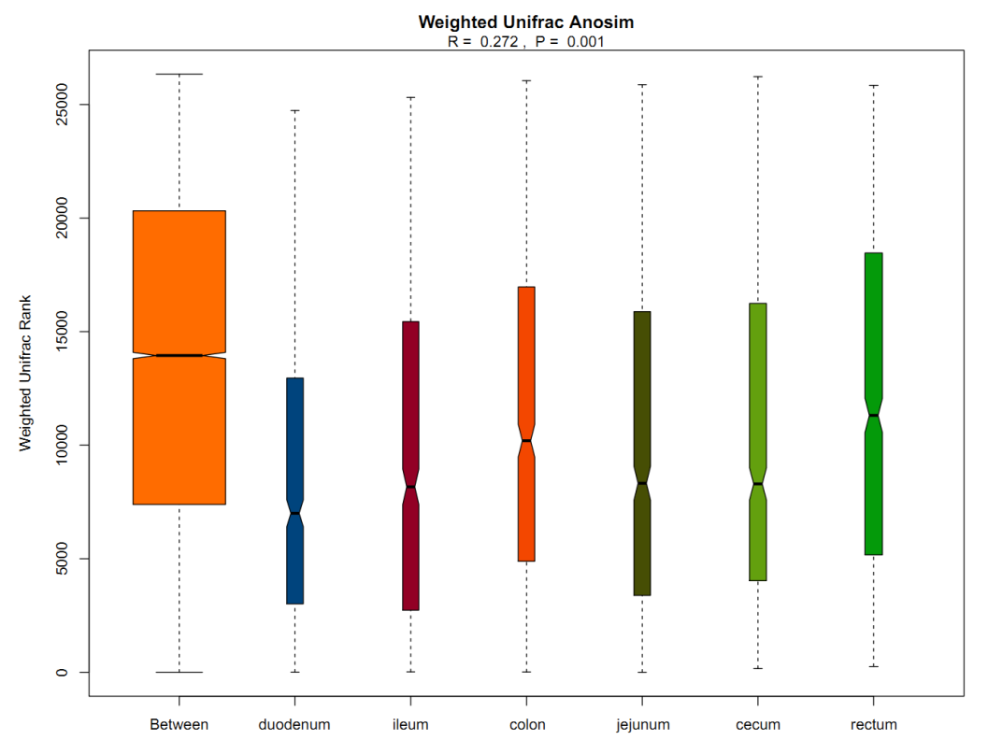
Figure S1. The microbiome differences among the six intestinal segments based on Weighted Unifrac distances.

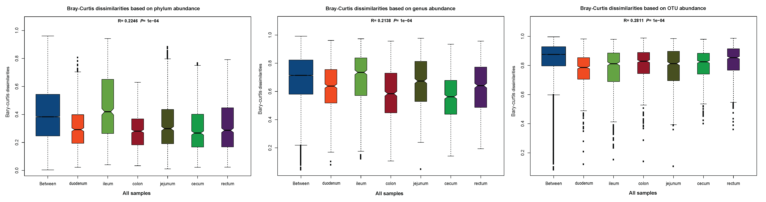
Figure S2. Bray-Curtis dissimilarities was calculated for the six intestinal segments based on the phylum abundance (a), genus abundance (b) and OTU abundance (c).

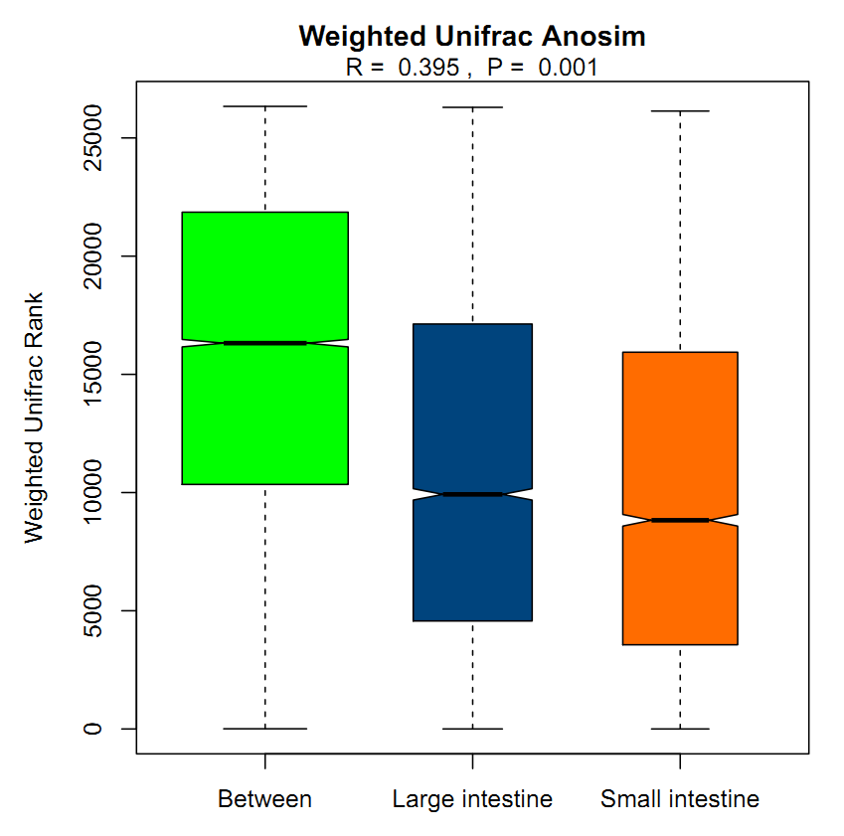
Figure S3. The microbiome difference between the small intestine and large intestine based on Weighted Unifrac distances.

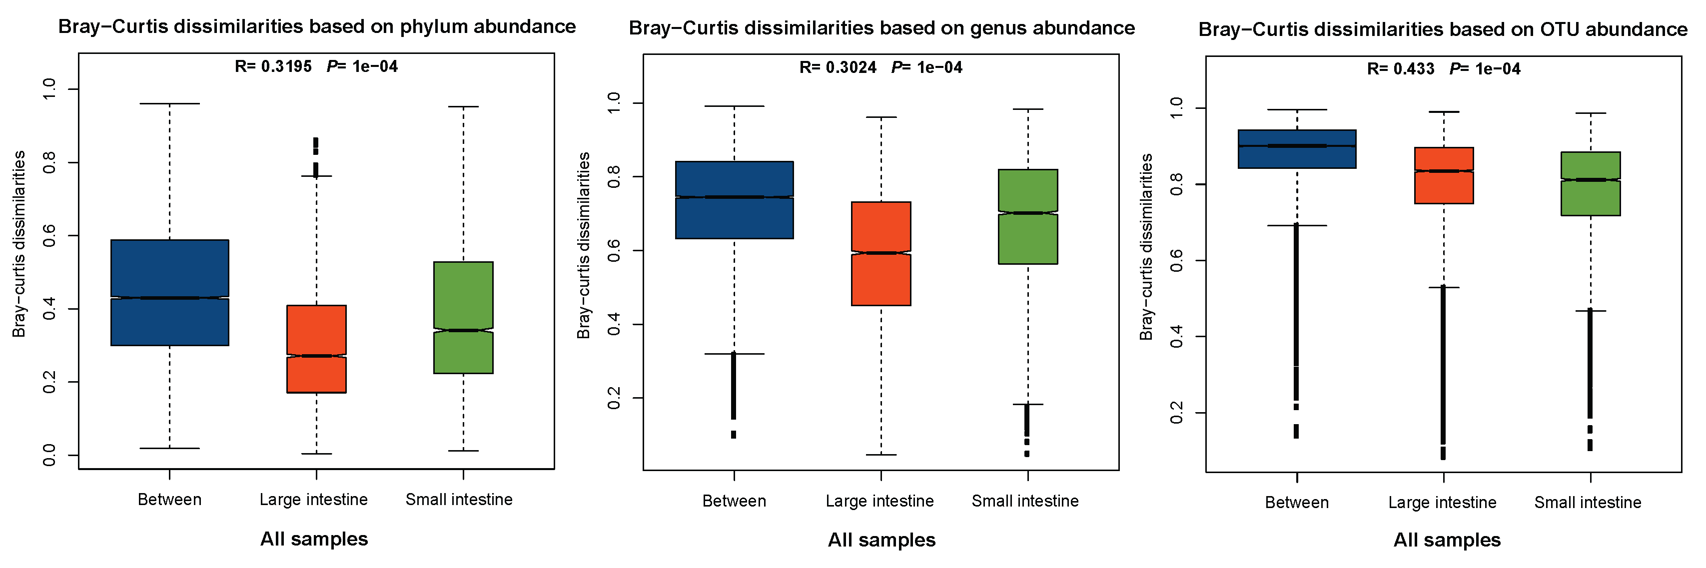
Figure S4. Bray-Curtis dissimilarities was calculated for the small intestine and large intestine based on the phylum abundance (a), genus abundance (b) and OTU abundance (c).
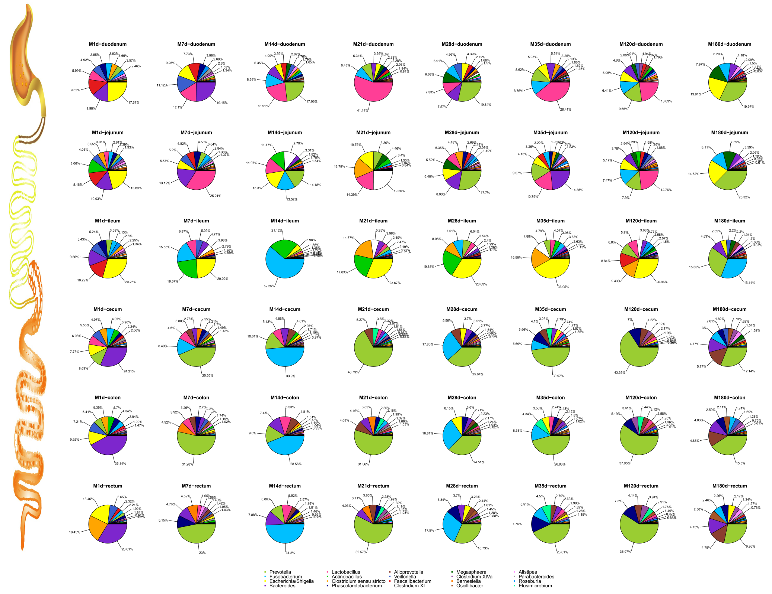

Figure S5. Gut microbiota composition among different intestinal segments during different growth stages at the genus level. The results are arranged into six rows that correspond to the six intestinal segments (i.e., the duodenum, jejunum, ileum, cecum, colon and rectum, from top to bottom) and eight columns that correspond to eight time points (i.e., postnatal days 1, 7, 14, 21, 28, 35, 120 and 180, from left to right). Each pie chart indicates the composition of the gut microbiome in a certain intestinal segment at a given time point. Different colors represent different bacterial genus. The percentages represent the relative abundance of individual genera.
.
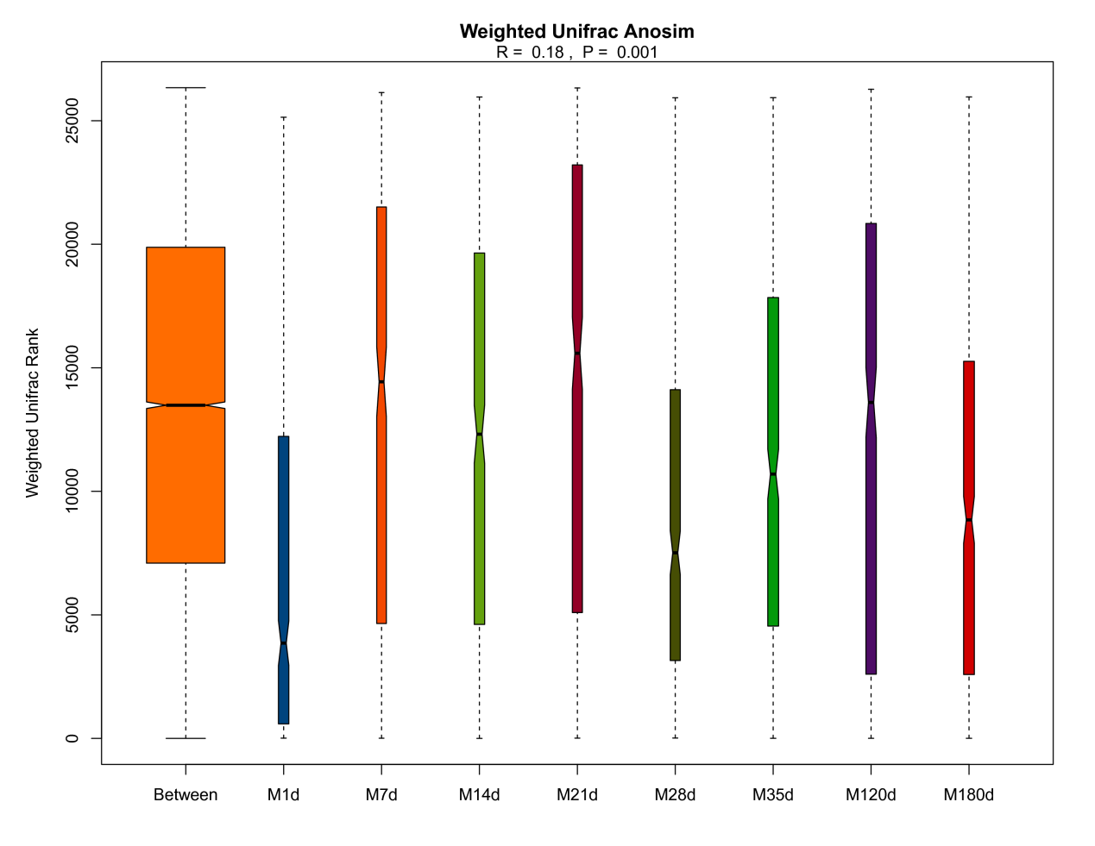
Figure S6. The microbiome differences among the eight postnatal intervals based on Weighted Unifrac distances.

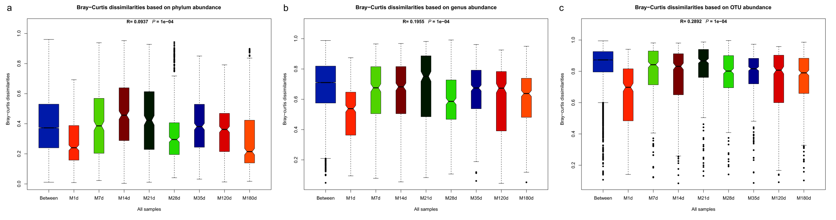
Figure S7. Bray-Curtis dissimilarities was calculated for the the eight postnatal intervals based on the phylum abundance (a), genus abundance (b) and OTU abundance (c).

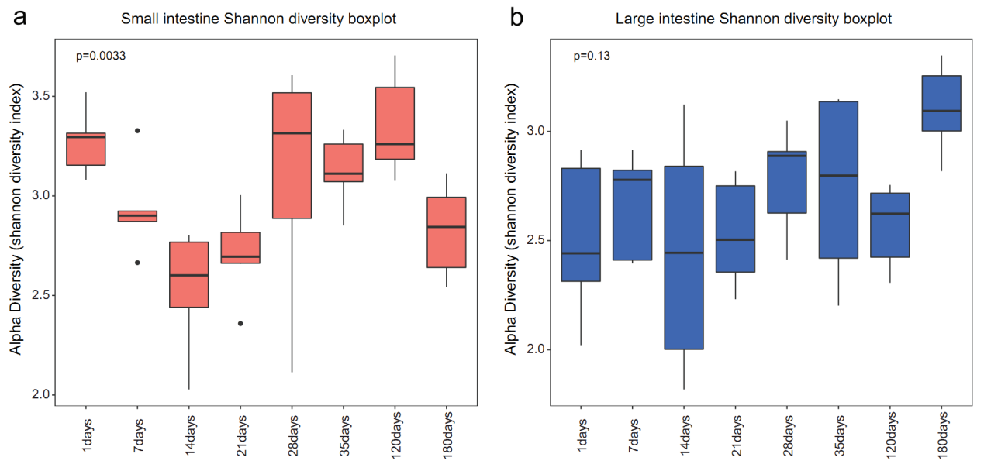
Figure S8. The Shannon diversity indices of the small intestine (a) and large intestine (b). The boxes represent the interquartile range (IQR); the lines in boxes indicate the median values. The whiskers represent the lowest and highest values within 1.5 interquartile range (IQR) from the first and third quartiles. The black dots denote the outliers.

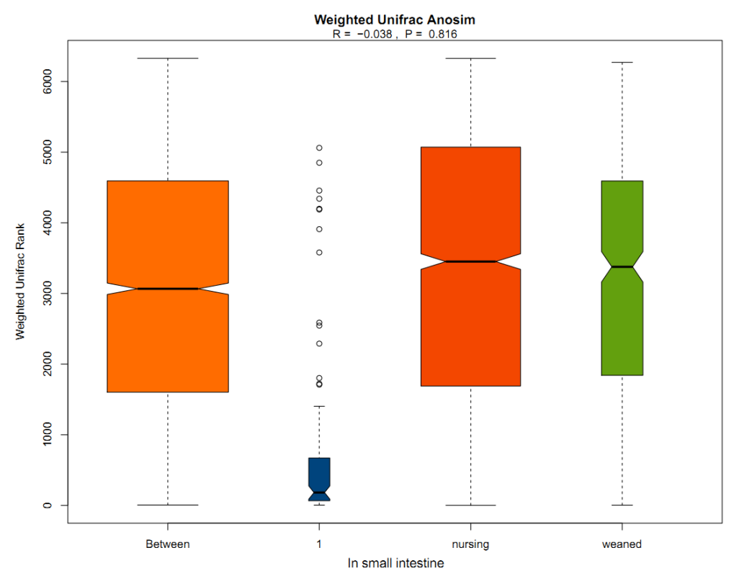
Figure S9. The Weighted Unifrac distances revealed that there was no significant difference among day 1, nursing period and weaning period in the small intestine (R = -0.038, p = 0.816).

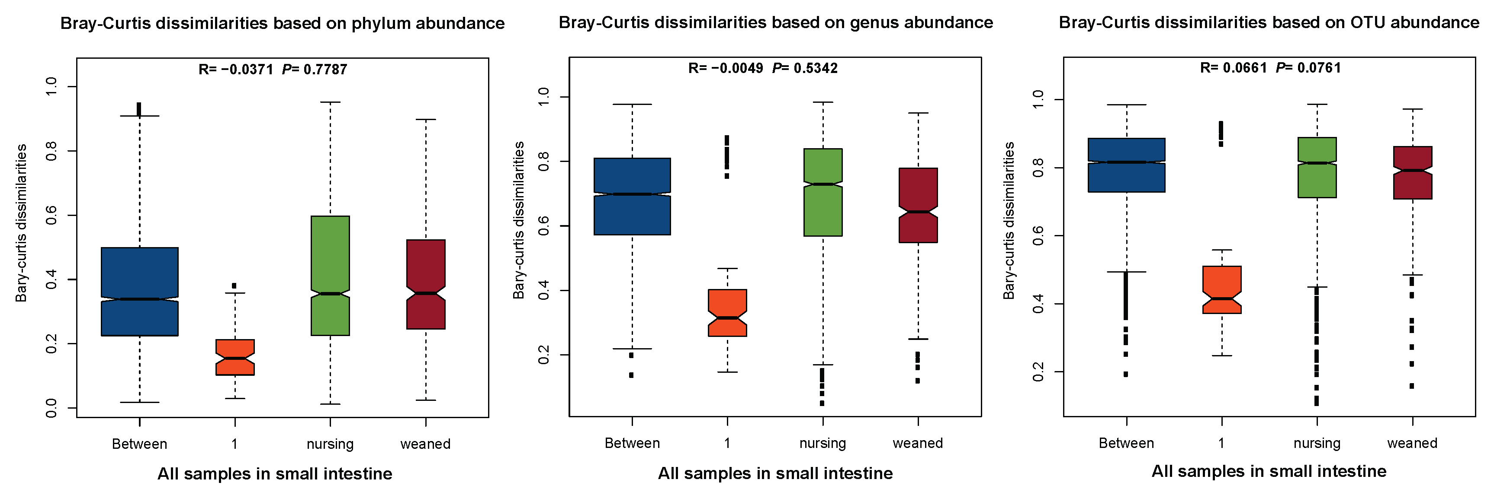
Figure S10. Bray-Curtis dissimilarities was calculated for the small intestine at three time points, namely day 1, nursing period and weaning period based on the phylum abundance (a), genus abundance (b) and OTU abundance (c).

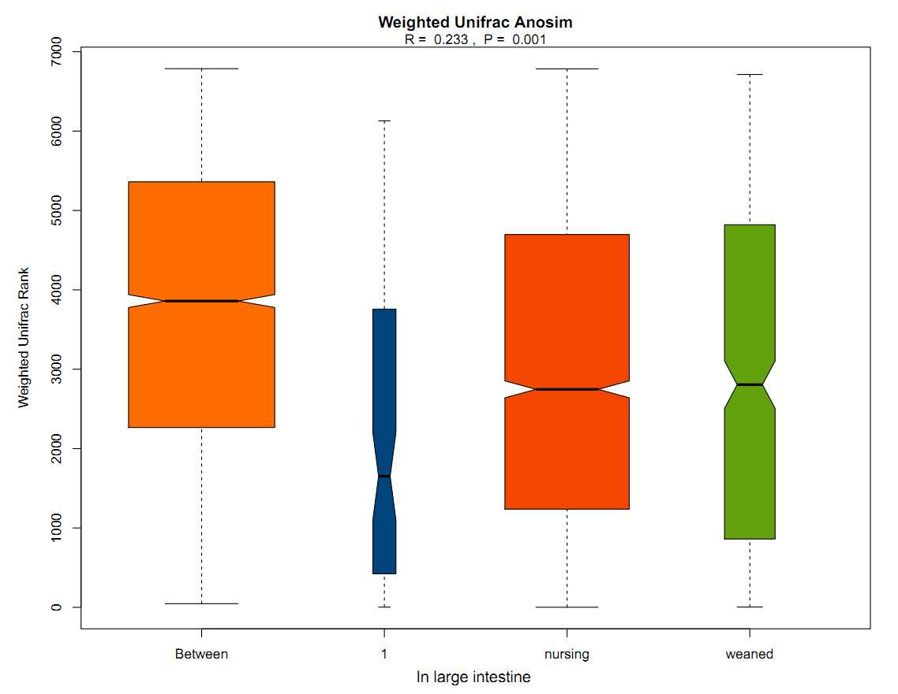
Figure S11. The Weighted Unifrac distances revealed that there was significant difference among day 1, nursing period and weaning period in large intestine (R = 0.233, p = 0.001).

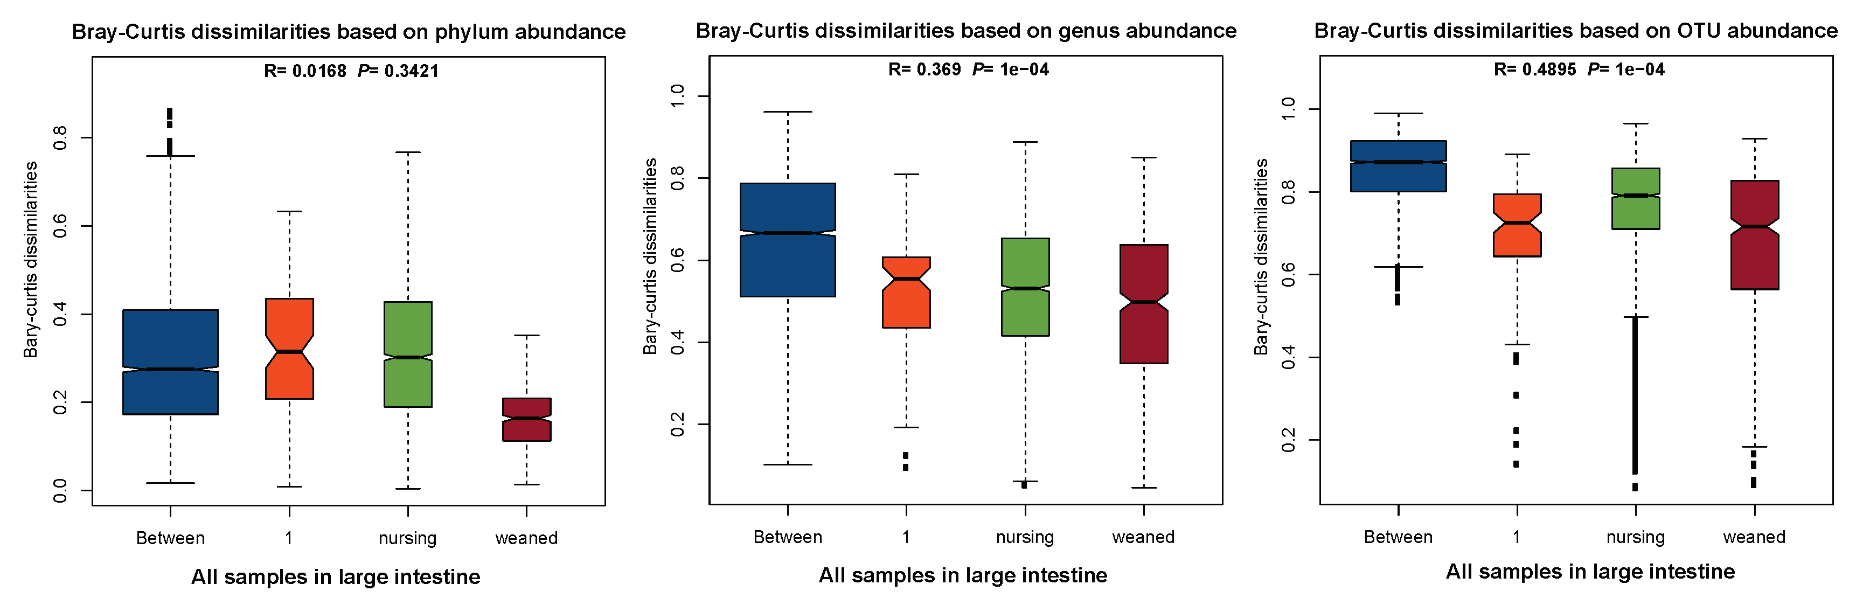
Figure S12. Bray-Curtis dissimilarities was calculated for the large intestine at three time points, namely day 1, nursing period and weaning period based on the phylum abundance (a), genus abundance (b) and OTU abundance (c).

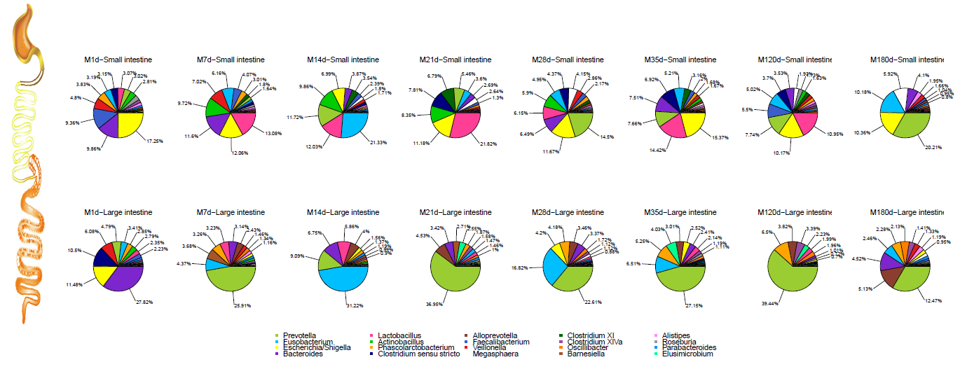Figure S13. Gut microbiota composition at the genus level in the small intestine and large intestine in different growth stages. The first row represents the results of the small intestine, the second row represents the results of the large intestine. The eight columns represent eight time points, namely postnatal day 1, day 7, day 14, day 21, day 28, day 35, day 120 and day 180, from left to right. Each pie chart indicates the composition of the gut microbiome in an intestinal segment at a time point. Different colors represent different bacterial genus.

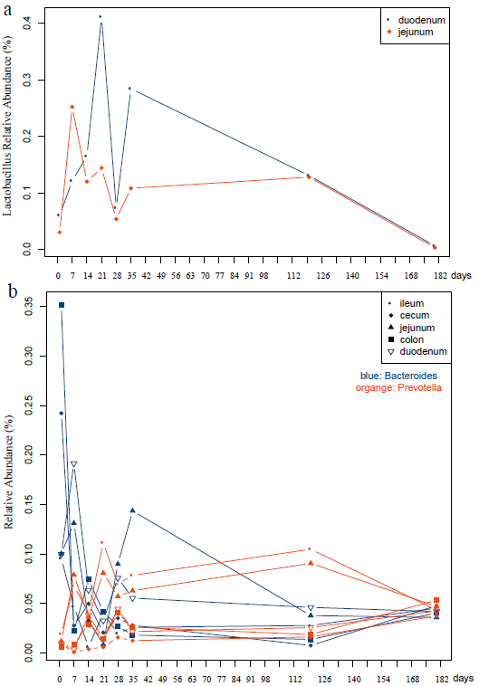

Figure S14. The relative abundance of selected phylotypes that showed responses to dietary changes. a The dynamics of Lactobacillus in duodenum (blue) and jejunum (red). b The dynamics of Bacteroides (blue) and Prevotella (red) different intestine segment. Different symbols denote different intestinal segments.

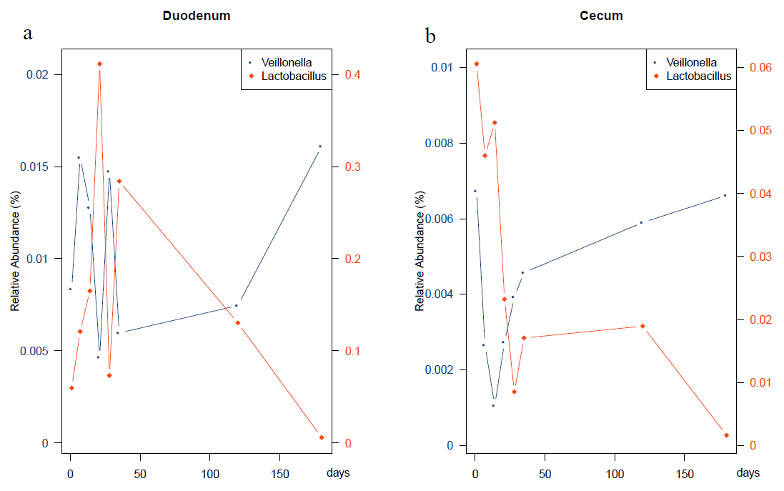
Figure S15. The relative abundance curves of two genera in response to dietary changes. a The dynamics of Veillonella (blue) and Lactobacillus (red) in the duodenum. b The dynamics of Veillonella (blue) and Lactobacillus (red) in the cecum.

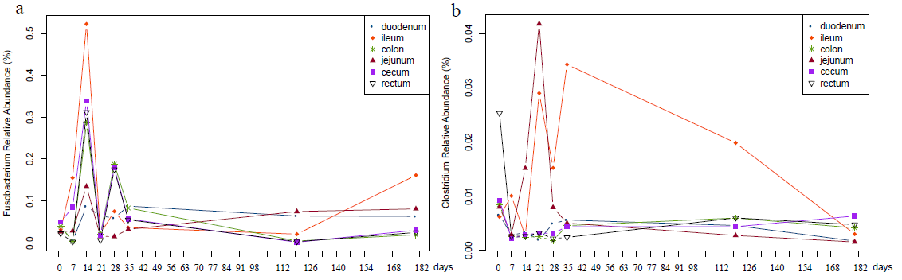
Figure S16. The relative abundance curves of two opportunistic pathogens. a The dynamics of Fusobacterium in different intestinal segments. b The dynamics of Clostridium in different intestinal segments. Different colors represent individual intestinal segments.

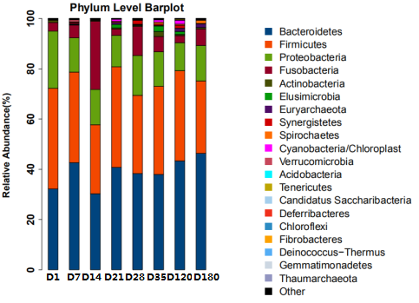

Figure S17. Community composition at the phylum level of the gut microbiota in different growth stages of Meishan pigs.

