Supplementary Information

Multi-metal 4D printing with a desktop electrochemical 3D printer
Xiaolong Chen1*, Xinhua Liu1+, Mengzheng Ouyang2, Jingyi Chen3, Oluwadamilola Taiwo2, Yuhua Xia2, Peter RN Childs1, Nigel P Brandon2 and Billy Wu2-
1 Dyson School of Design Engineering, Imperial College London, UK
2 Department of Earth Science and Engineering, Imperial College London, UK
3 Department of Materials, Imperial College London, UK
Corresponding authors: *x.chen15@imperial.ac.uk, +x.liu15@imperial.ac.uk, -billy.wu@imperial.ac.uk

Electrospun nanofibre nib

Nanofibre mats were formed through the electrospinning of polyacrylonitrile (PAN) dissolved in a dimethylformamide (DMF) solvent. As spun mats were then cut to 17 mm x 17 mm squares with a measured thickness of 50 µm. These mats were then rolled and placed into a tapered plastic nozzle with an end diameter of 400 µm. This is shown in Figure S1.
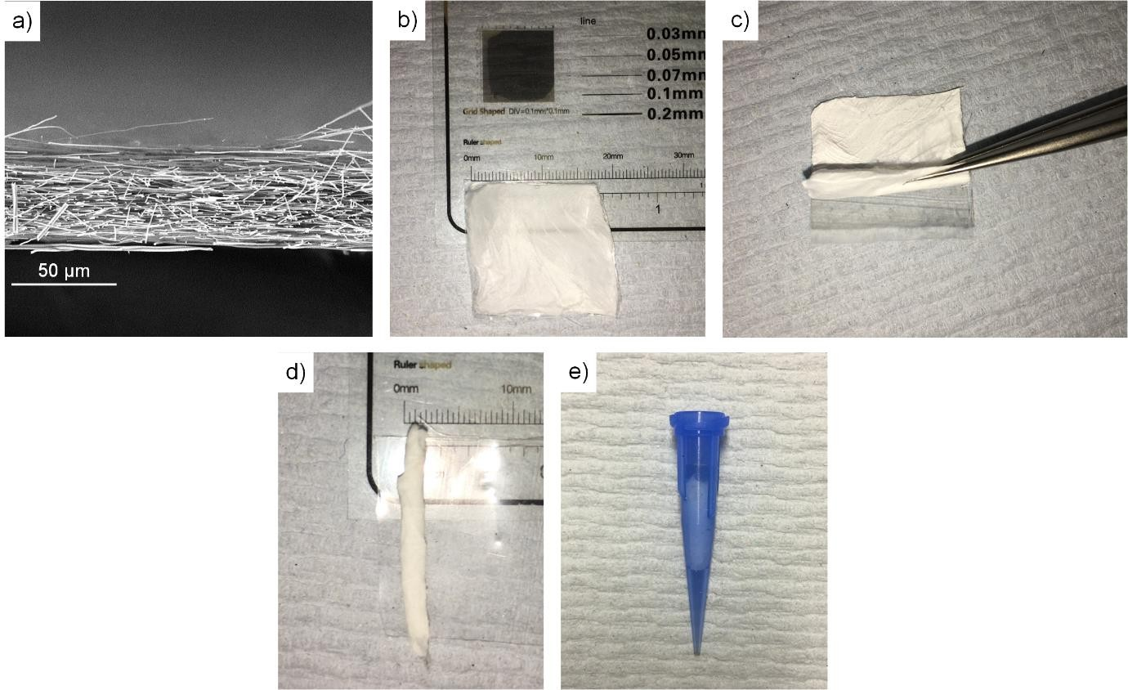
Figure S1: a) SEM image of the electrospun nanofibre mat. b) Photo of flat electrospun mat, c) rolling of the nanofibre mat, d) rolled nanofibre and e) nanofibre nib installed into the nozzle

Optical images of printed strips

Figure S2 shows optical images of the printed samples which were taken on a Zeiss Stemi 508 optical microscope. All the samples were fabricated with a fixed deposition time of 5 hrs for the copper layer and deposition times of 1, 3 and 5 hrs for nickel.
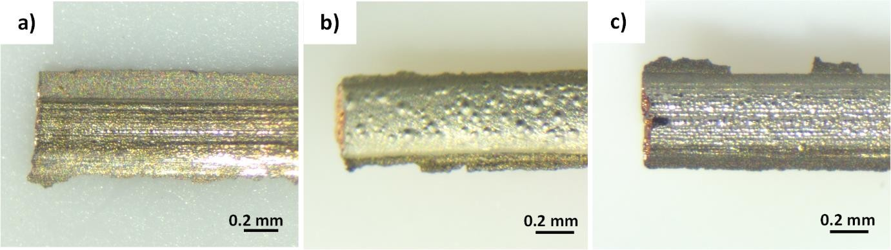
Figure S2: Optical images of the printed bimetallic strips with a 5 hr copper deposition and a) 1 hr, b) 3 hr and c) 5 hr nickel deposition time

Detailed SEM and EDS micrographs for the Cu-Ni-Cu trilayer strip

Figure S3 shows a high magnification SEM image of the Cu-Ni-Cu trilayer with EDS mapping and spectra.
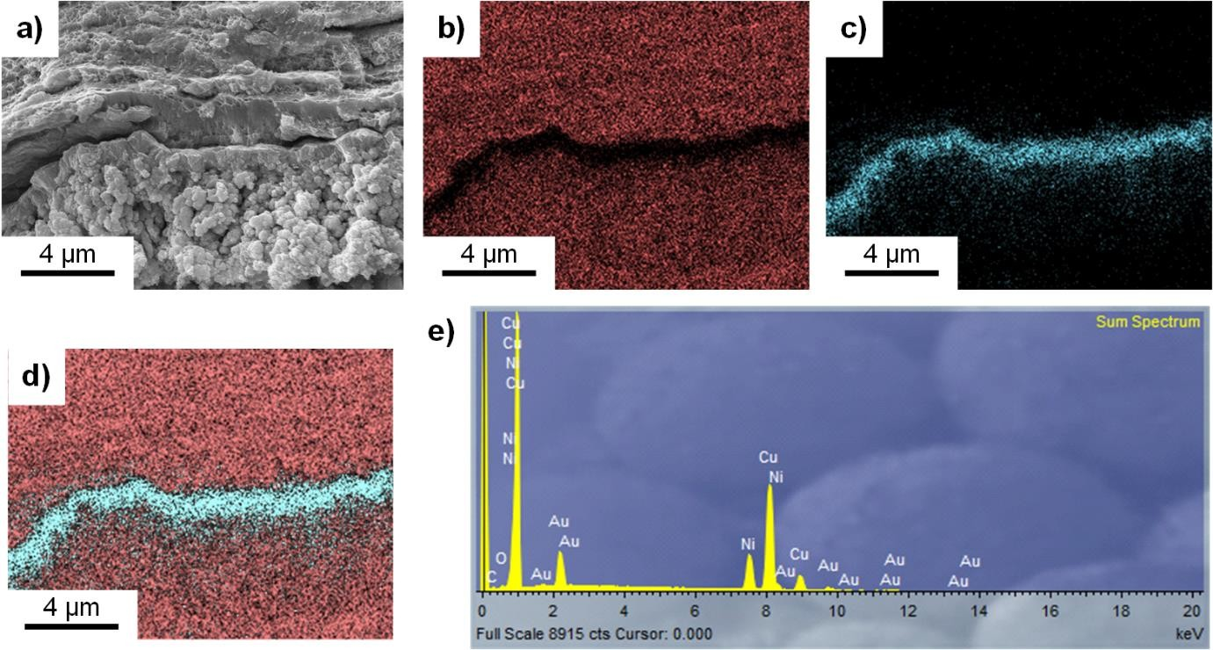
Figure S3: a) SEM micrograph of the cross section of a Cu-Ni-Cu trilayer strip. b) EDS mapping of Cu in the Cu-Ni-Cu trilayer strip, c) EDS mapping of nickel in the Cu-Ni-Cu trilayer strip, d) combined Cu and Ni map. e)
EDS spectra of the Cu-Ni-Cu strip

