TITLE
Gut microbiota profile in children affected by atopic dermatitis and evaluation of intestinal persistence of a probiotic mixture

Authors: Sofia Reddel¹, Federica Del Chierico¹, Andrea Quagliariello¹, Simona Giancristoforo², Pamela Vernocchi¹, Alessandra Russo¹, Alessandro Fiocchi³, Paolo Rossi⁴, Lorenza Putignani^{1,5,*} and May El Hachem²
Affiliations: ¹Human Microbiome Unit, Bambino Gesù Children’s Hospital IRCCS, Rome, Italy; ²Dermatology Unit, Bambino Gesù Children’s Hospital IRCCS, Rome, Italy;
³Unit of Allergology, Bambino Gesù Children’s Hospital IRCCS, Rome, Italy;
⁴University Department of Pediatrics, Unit of Immune and Infectious Diseases, IRCCS Bambino Gesù Children's Hospital, Rome, Italy.
⁵Parasitology Unit, Bambino Gesù Children’s Hospital IRCCS, Rome, Italy

* Corresponding author: Lorenza Putignani, “Bambino Gesù” Children’s Hospital, Piazza Sant’Onofrio 4, 00165, Rome Italy; phone number: +390668592598; fax number: +3906682904; e-mail address:lorenza.putignani@opbg.net.
Supplementary Materials

The supplementary Materials contain: 2 Supplementary Figures (Supplementary Figure 1 and 2) and 10 Supplementary Tables (Supplementary Tables 1-10).

Supplementary Figures
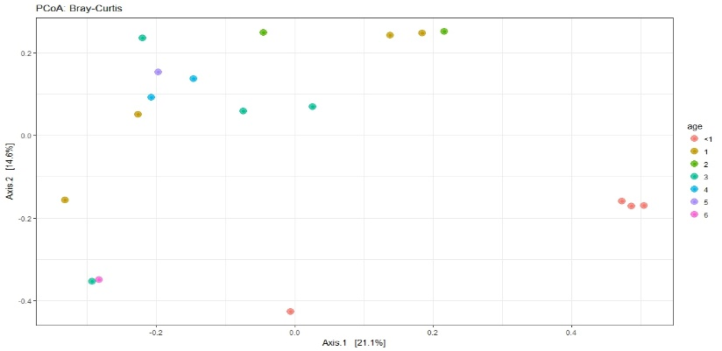
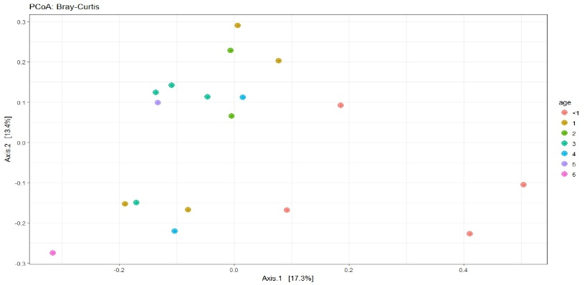
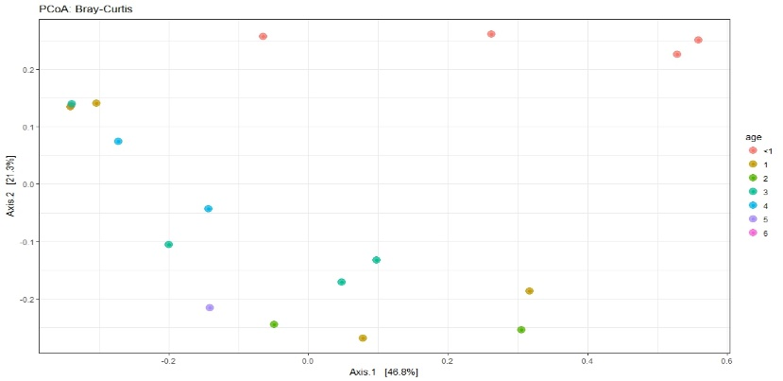
UNWEIGHTED UNIFRAC
BRAY-CURTIS
WEIGHTED UNIFRAC
A
B
C

Supplementary Figure 1. Beta-diversity analysis of AD group at T₀. The plots show the first two principal axes for PCoA using Bray-Curtis (A), unweighted UniFrac (B) and weighted UniFrac (C) algorithms. Patients under 1 year of age are indicated with a red circle. P-values obtained by PERMANOVA analyses are reported.

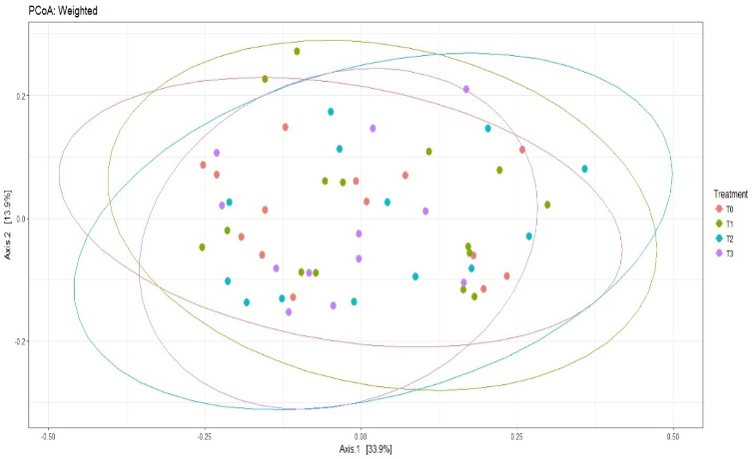
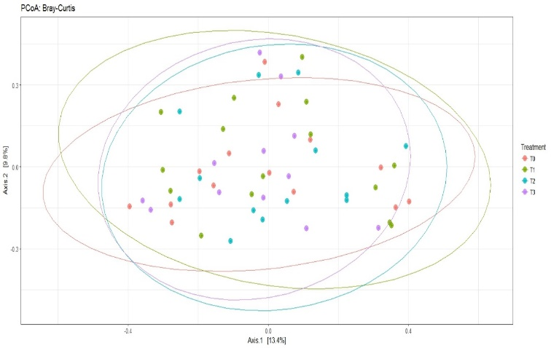
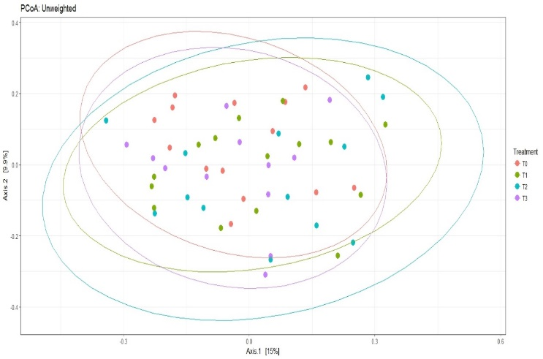
BRAY-CURTIS
UNWEIGHTED UNIFRAC
WEIGHTED UNIFRAC
p= 0.977
p= 0.91
p= 0.991
A
B
C

Supplementary Figure 2. Beta-diversity analysis applied for all the time points of AD group. The plots show the first two principal axes for PCoA using Bray-Curtis (A), unweighted UniFrac (B) and weighted UniFrac (C) algorithms. P-values obtained by PERMANOVA analyses are reported.

Supplementary Figure 3. Linear discriminative analysis (LDA) effect size (LEfSe) analyses of statistically significant Operational Taxonomic Units (OTUs) for AD and CTRL T₀ point. In green (positive LDA scores) and red (negative LDA scores) are reported OTUs associated with group T0 AD and CTRL, respectively.
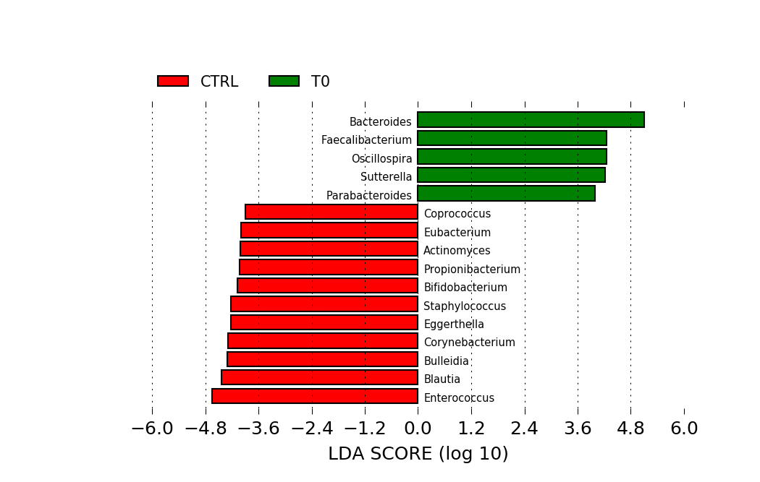

Supplementary Table 1. Primers and probes designed for B. breve and L. salivarius for the Real Time assay.

Species specificity | Primer or probe | Sequence | Product size
B. breve | Fw_Bbreve | 5'-GATGGGGTCGCGTCCTAT-3' | 242 bp
B. breve | Rv_Bbreve | 5'-CTCAACACAAAGTGCCTTGCT-3' | 242 bp
B. breve | P_Bbreve | 5'-FAM CAGCGACGCCGCGTGAGGGATGGAGGCC BHQ-3' | 242 bp
L. salivarius | Fw_Lsalivarius | 5'-AGGTGATGATACGTAGCCGAA-3' | 204 bp
L. salivarius | Rv_Lsalivarius | 5'-GAATGAACAGTTACTCTCACTCGTG-3' | 204 bp
L. salivarius | P_Lsalivarius | 5'- HEX CGCCGCGTGAGTGAAGAAGGTCTTCGGATCG BHQ-3' | 204 bp

Supplementary Table 2. Permanova test results on beta diversity analyses performed including and excluding infants.
 | including infants |  |  | excluding infants
 | Bray Curtis | Weighted UniFrac | Unweighted UniFrac | Bray Curtis | Weighted UniFrac | Unweighted UniFrac
Variables | p-value | p-value | p-value | p-value | p-value | p-value
Age | 0.002 | 0.016 | 0.044 | 0.220 | 0.098 | 0.311
BMI | 0.35 | 0.35 | 0.889 | 0.297 | 0.315 | 0.900
Neonatal feeding | 0.32 | 0.38 | 0.191 | 0.400 | 0.100 | 0.200
Weaning time | 0.038 | 0.011 | 0.235 | 0.262 | 0.257 | 0.492
Delivery modality | 0.644 | 0.583 | 0.422 | 0.400 | 0.501 | 0.159
Values in bold are statistically significant.

Supplementary Table 3. Wilcoxon signed rank test with p-values corrected for Holm method.
Groups | Observed  p value | Chao1  p value | Shannon  p value
T₀ vs CTRL | 0.0027 | 0.0026 | 1.0000
T₁ vs CTRL | 0.0027 | 0.0019 | 0.5984
T₂ vs CTRL | 0.0013 | 0.0000 | 1.0000
T₃ vs CTRL | 0.0008 | 0.0002 | 1.0000
T₄ vs CTRL | 0.0134 | 0.0004 | 1.0000
T₁ vs T₀ | 1 | 1 | 1
T₂ vs T₀ | 1 | 1 | 1
T₃ vs T₀ | 1 | 1 | 1
T₄ vs T₀ | 1 | 1 | 1
T₂ vs T₁ | 1 | 1 | 1
T₃ vs T₁ | 1 | 1 | 1
T₄ vs T₁ | 1 | 1 | 1
T₃ vs T₂ | 1 | 1 | 1
T₄ vs T₂ | 1 | 1 | 1
T₄ vs T₃ | 1 | 1 | 1

Supplementary Table 4. U Mann-Whitney test at phylum level of the CTRL and T₀ AD groups. For each group relative abundances of phyla are reported.
Phylum | CTRL | T₀ | p value
Actinobacteria | 7.6463 | 0.4904 | 0.0001
Bacteroidetes | 5.8911 | 28.6427 | 0.0019
TM7 | 0.3810 | 0.0121 | 0.0022
Firmicutes | 71.3766 | 56.6330 | 0.1799
Verrucomicrobia | 0.0910 | 0.5835 | 0.7393
Fusobacteria | 0.0310 | 0.1134 | 0.9815
Synergistetes | 0.0000 | 0.0152 | 1
Cyanobacteria | 0.6310 | 0.0988 | 1
Proteobacteria | 13.9476 | 13.4109 | 1
Values in bold are statistically significant.
Supplementary Table 5. U Mann-Whitney test at family level of the CTRL and T₀ AD groups. For each group relative abundances of phyla are reported.

Phylum | Family | CTRL | T₀ | p value
Actinobacteria | Coriobacteriaceae | 6.6091 | 0.3906 | 0.0001
Actinobacteria | Actinomycetaceae | 0.1690 | 0.0061 | 0.0009
Actinobacteria | Corynebacteriaceae | 0.1338 | 0.0000 | 0.0048
Actinobacteria | Bifidobacteriaceae | 0.6570 | 0.0019 | 0.0053
Actinobacteria | Propionibacteriaceae | 0.1281 | 0.1091 | 0.0199
Bacteroidetes | Bacteroidaceae | 4.5471 | 23.9424 | 0.0012
Firmicutes | Erysipelotrichaceae | 14.6941 | 1.8436 | 0.0002
Firmicutes | Enterococcaceae | 7.2549 | 0.0740 | 0.0041
Firmicutes | Staphylococcaceae | 0.0598 | 0.0000 | 0.0105
Proteobacteria | Alcaligenaceae | 0.1168 | 2.6322 | 0.0072
Values in bold are statistically significant.

Supplementary Table 6. U Mann-Whitney test results at genus level of the CTRL and T₀ AD groups. For each group relative abundances of phyla are reported.
Phylum | Genus | CTRL | T0 | p value
Actinobacteria | Actinomyces | 0.18873 | 0.00643 | 0.0002032
Actinobacteria | Bifidobacterium | 0.74815 | 0.00195 | 0.000585688
Actinobacteria | Corynebacterium | 0.15837 | 0 | 0.000603291
Actinobacteria | Eggerthella | 0.98343 | 0.03048 | 0.001548945
Actinobacteria | Propionibacterium | 0.15146 | 0.00496 | 0.000507574
Bacteroidetes | Bacteroides | 5.06 | 23.657 | 0.000406236
Bacteroidetes | Parabacteroides | 0.38068 | 1.50348 | 0.033776008
Firmicutes | Blautia | 3.06713 | 0.40691 | 0.000377935
Firmicutes | Bulleidia | 0.0874 | 0 | 0.000264829
Firmicutes | Coprococcus | 0.22915 | 0.00914 | 0.003943051
Firmicutes | Enterococcus | 4.83965 | 0.03558 | 0.002974127
Firmicutes | Eubacterium | 0.76044 | 0.09386 | 0.002826059
Firmicutes | Faecalibacterium | 0.0981 | 1.97224 | 9.08586E-05
Firmicutes | Oscillospira | 0.2153 | 2.16519 | 0.000212178
Firmicutes | Staphylococcus | 0.06544 | 0 | 0.001316072
Proteobacteria | Sutterella | 0.12753 | 2.77603 | 0.000800181
Values in bold are statistically significant.

Supplementary Table 7. AUROC values for the OTUs selected for the T₀ DA and CTRL groups.
 | T0 | CTRL
Variables | Area
Actinomyces | 0.135 | 0.865
Propionibacterium | 0.169 | 0.831
Bifidobacterium | 0.179 | 0.821
Eggerthella | 0.179 | 0.821
Bacteroides | 0.853 | 0.147
Staphylococcus | 0.222 | 0.778
Enterococcus | 0.228 | 0.772
Blautia | 0.127 | 0.873
Coprococcus | 0.216 | 0.784
Faecalibacterium | 0.909 | 0.091
Oscillospira | 0.889 | 0.111
Bulleidia | 0.167 | 0.833
Eubacterium | 0.188 | 0.812
Sutterella | 0.837 | 0.163
Corynebacterium | 0.194 | 0.806
Parabacteroides | 0.714 | 0.286
Values in bold are statistically significant.

Supplementary Table 8. Discriminant analysis based on the 16 selected OTUs at T₀ for AD and CTRL groups.
 |  | Groups | Predicted Group Membership |  | Total
 |  | Groups | CTRL | T₀
Originalª | % | CTRL | 100 | 0 | 100
Originalª | % | T₀ | 7.1 | 92.9 | 100
Cross-validated^{b} | % | CTRL | 83.3 | 16.7 | 100
Cross-validated^{b} | % | T₀ | 14.3 | 85.7 | 100
ª 96,9% of original grouped cases correctly classified.
^{b} 84,4% of cross-validated grouped cases correctly classified.

Supplementary Table 9. Wilcoxon Signed Ranks Test applied for the time-points comparisons of B. breve and L. salivarius values.
B. breve |  | L. salivarius
Groups | p value | Groups | p value
T0-T1 | 0.001 | T0-T1 | 0.003
T0-T2 | 0.001 | T1-T3 | 0.011
T0-T3 | 0.003 | T1-T2 | 0.023
T1-T3 | 0.057 | T0-T2 | 0.109
T2-T3 | 0.248 | T0-T3 | 0.180
T1-T2 | 0.445 | T2-T3 | 0.180
Values in bold are statistically significant.

Supplementary Table 10. Spearman’s correlation between B. breve and L. salivarius amounts at T₁ sample size (N), Spearman rank probability (Rho) and correlation (R) are shown in the table.
 | B. breve vs L. salivarius
Rho | 0.683
p value | 0.005
N | 15
Values in bold are statistically significant.

