Title page

Elovl4a participates in LC-PUFA biosynthesis and is regulated by PPARαβ in golden pompano Trachinotus ovatus (Linnaeus 1758)
Ke-Cheng Zhu ^{1,2,3}, Ling Song ¹, Hua-Yang Guo ^{1,2}, Liang Guo ^{1,2,3}, Nan Zhang ^{1,2,3}, Bao-Suo Liu ^{1,2,3}, Shi-Gui Jiang ^{1,2,4} & Dian-Chang Zhang ^{1,2,3 *}
¹Key Laboratory of South China Sea Fishery Resources Exploitation and Utilization, Ministry of Agriculture, South China Sea Fisheries Research Institute, Chinese Academy of Fishery Sciences, 231 Xingang Road West, Haizhu District, Guangzhou 510300, China;
²Engineer Technology Research Center of Marine Biological Seed of Guangdong Province, Guangzhou, Guangdong Province, The People’s Republic of China;
³Key Laboratory of Fishery Ecology & Environment, Guangdong Province;
⁴South China Sea Bio-Resource Exploitation and Utilization Collaborative Innovation Center.
*Corresponding author:
Dr. Dian C. Zhang
231 Xingang Road West, Haizhu District, Guangzhou City, Guangdong 510300, PR China.
E-mail address: zhangdch@scsfri.ac.cn
Tel.: +86 02089108316; fax: +86 02089022702

SUPPLEMENTARY INFORMATION includes:
Supplementary Figures S1-S3
Supplementary Tables S1-S3

Supplementary Figure S1. Sequence of cDNA and deduced protein of ToElovl4a.
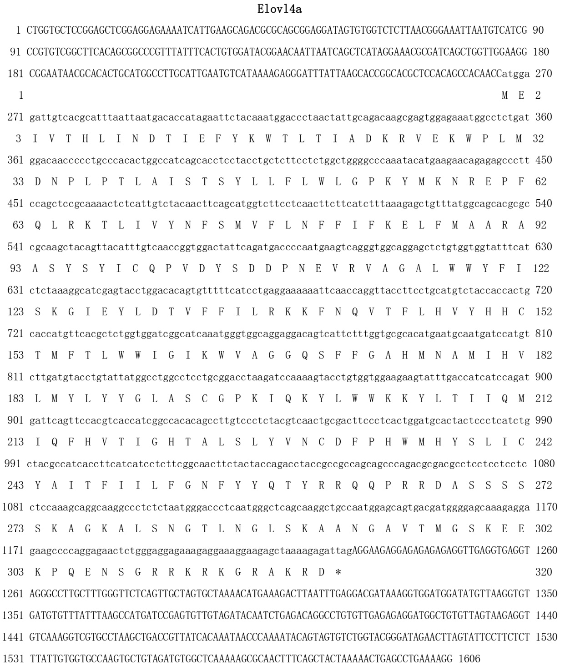

Supplementary Figure S2. Western blot analysis of Elovl4a proteins in livers (A and B) and brains (C and D) after eight dietary treatment in T. ovatus. Arrows indicates target bands of Elovl4a.

Supplementary Figure S3. Western blot analysis is used to detect the expression of ToPPARαb (A) and ToElovl4a (B) after the transfection of either control RNA (Control) or siRNA (RNAi), respectively. Arrows indicates target bands.

Supplementary Table 1. Ingredients and proximate composition of the experimental diets.
Ingredient (dry weight, %) | Diets
Ingredient (dry weight, %) | FO | KO | SO | CO | 1:1FO-SO | 1:1FO-CO | 1:1KO-SO | 1:1KO-CO
Fish meal | 25 | 25 | 25 | 25 | 25 | 25 | 25 | 25
Chicken meal | 10 | 10 | 10 | 10 | 10 | 10 | 10 | 10
Pork meal | 5 | 5 | 5 | 5 | 5 | 5 | 5 | 5
Soybean meal | 20 | 20 | 20 | 20 | 20 | 20 | 20 | 20
Corn protein flour | 7 | 7 | 7 | 7 | 7 | 7 | 7 | 7
Low-gluten flour | 20 | 20 | 20 | 20 | 20 | 20 | 20 | 20
Calcium dihydrogen  phosphate | 1.6 | 1.6 | 1.6 | 1.6 | 1.6 | 1.6 | 1.6 | 1.6
Choline chloride | 0.2 | 0.2 | 0.2 | 0.2 | 0.2 | 0.2 | 0.2 | 0.2
Lutein | 0.2 | 0.2 | 0.2 | 0.2 | 0.2 | 0.2 | 0.2 | 0.2
Compound premixª | 3 | 3 | 3 | 3 | 3 | 3 | 3 | 3
FO^{b} | 8 | 0 | 0 | 0 | 0 | 0 | 0 | 0
KO^{c} | 0 | 8 | 0 | 0 | 0 | 0 | 0 | 0
SO^{d} | 0 | 0 | 8 | 0 | 0 | 0 | 0 | 0
CO^{e} | 0 | 0 | 0 | 8 | 0 | 0 | 0 | 0
1:1 FO-SO | 0 | 0 | 0 | 0 | 8 | 0 | 0 | 0
1:1 FO-CO | 0 | 0 | 0 | 0 | 0 | 8 | 0 | 0
1:1 KO-SO | 0 | 0 | 0 | 0 | 0 | 0 | 8 | 0
1:1 KO-CO | 0 | 0 | 0 | 0 | 0 | 0 | 0 | 8
Proximate analysis
(dry matter, g/100g)
Crude protein | 42.9 | 43.2 | 44.6 | 44.3 | 45.1 | 44.6 | 46.3 | 46.3
Crude lipid | 12.5 | 11.0 | 11.7 | 12.0 | 11.6 | 12.0 | 11.2 | 10.8
Ash | 10.5 | 10.4 | 10.1 | 10.6 | 9.9 | 9.6 | 9.4 | 10.5
Moisture | 5.0 | 8.3 | 7.3 | 5.7 | 7.2 | 7.5 | 5.5 | 5.1
C18:3n-3 | 5.6 | 9.0 | 30.3 | 6.1 | 17.4 | 6.3 | 17.4 | 7.5
C18:2n-6 | 46.7 | 62.4 | 262.3 | 267.3 | 153.5 | 161 | 148.2 | 165.4
n-3/n-6^{f} | 2.14 | 2.14 | 0.22 | 0.14 | 0.49 | 0.43 | 0.60 | 0.49
Total PUFA^{g} | 184.7 | 224.9 | 324 | 307.7 | 238.9 | 240.5 | 246.6 | 255.9
ªCompound premix are provided by Guangzhou Nutriera Biotechnology Co., Ltd.
Compound premix provides the following (mg kg⁻¹ diet): vitamin A (375000 IU) 119.81 mg, vitamin D₃ (77000IU) 1.925 mg, vitamin E 3000 mg, vitamin K₃ 930 mg, vitamin B₁ 600 mg, vitamin B₂ 600 mg, vitamin B₆ 600 mg, vitamin B₁₂ 4.0 mg, vitamin C 10500 mg, D-calcium 400 mg, nicotinamide 4500 mg, folic acid 185mg, D-Biotin 7.5 mg, inositol 4500 mg, Zn 1750 mg, Mn 1100 mg, Cu 410 mg, Fe 1300, Co 60 mg, I₂ 50 mg, Se 15 mg.
^{b}FO, fish oil.
^{c}KO, krill oil.
^{d}SO, soybean oil.
^{e}CO, corn oil.
^{f}n3/n6 PUFA, omega 3 polyunsaturated fatty acids: n-6 polyunsaturated fatty acids.
^{g}Total PUFA, the sum omega 3 polyunsaturated fatty acids and omega 6 polyunsaturated fatty acids.

Supplementary Table 2. Primers used for sequence cloning, deletion mutant construction, mRNA construction and qRT-PCR.
Subject and Primers | Nucleotide sequence
Primers for sequence cloning
PPARαb-ORF-F | CTAGCTAGCATGGTCGACATGGAGAGCCAC
PPARαb-ORF-R | CCCAAGCTTTCAGTACATGTCTCTGTA
Elovl4a-ORF-F | CGGGGTACCATGGAGATTGTCACGCA
Elovl4a-ORF-R | CCGCTCGAGCTAATCTCTTTTAGCTCTTC
Deletion mutant construction
Elovl4a-pF1 | CGGGGTACCCAAAAATCTGCTGACACATG
Elovl4a-pF1 | CCGCTCGAGATAATAATTTCATTTAA
Elovl4a-pF2 | CGGGGTACCAGCCAATAAATATACAG
Elovl4a-pF2 | CCGCTCGAGATAATAATTTCATTTAA
Elovl4a-pF3 | CGGGGTACCATCATTGAAGCAGACGC
Elovl4a-pF3 | CCGCTCGAGATAATAATTTCATTTAA
Elovl4a-pF4 | CGGGGTACCCAAAAATCTGCTGACACA
Elovl4a-pF4 | CCGCTCGAGTTCAACTGATTCCACTG
Elovl4a-pF5 | CGGGGTACCCAAAAATCTGCTGACACA
Elovl4a-pF5 | CCGCTCGAGTAATTAAATGCGTGACAATC
Primers for qRT-PCR
qRT-E4a-F | ACTGCGACTTCCCTCAC
qRT-E4a-R | CCATCGTCACTGCTCCA
EF1α-F | AAGCCAGGTATGGTTGTCAACTTT
EF1α-R | CGTGGTGCATCTCCACAGACT
siRNA
PPARαb-si | GCGAATGCAGGAGAGCATT
PPARαb-NC | ACGUGACACGUUCGGAGAATT

Supplementary Table 3.
Elovls proteins used in multiple alignment.
Speices | Gene | Ensembl (Accession) No. | Speices | Gene | Ensembl (Accession) No.
Trachinotus ovatus | Elovl4a | MG674424 | Bos taurus | Elovl4 | ENSBTAG00000015498
Takifugu rubripes | Elovl4a | ENSTRUG00000004612 | Trachinotus ovatus | Elovl4b | MG674425
Xiphophorus maculatus | Elovl4a | ENSXMAP00000006115.1 | Gasterosteus aculeatus | Elovl4b | ENSGACT00000017607.1
Astyanax mexicanus | Elovl4a | ENSAMXP00000017270.1 | Takifugu rubripes | Elovl4b | ENSTRUG00000014717
Danio rerio | Elovl4a | ENSDARG00000006773 | Astyanax mexicanus | Elovl4b | ENSAMXP00000006663.1
Gadus morhua | Elovl4a | ENSGMOT00000002680.1 | Oreochromis niloticus | Elovl4b | ENSONIP00000000842.1
Poecilia formosa | Elovl4a | ENSPFOP00000018605.2 | Tetraodon nigroviridis | Elovl4b | ENSTNIG00000010936
Oreochromis niloticus | Elovl4a | ENSONIP00000009094.1 | Xiphophorus maculatus | Elovl4b | ENSXMAG00000025824
Loxodonta africana | Elovl4 | ENSLAFG00000003948 | Kryptolebias marmoratus | Elovl4b | ENSKMAG00000018217
Mus musculus | Elovl4 | ENSMUSG00000032262 | Monopterus albus | Elovl4b | ENSMALG00000021572
Gallus gallus | Elovl4 | ENSGALG00000015876 | Homo sapiens | Elovl2 | ENSG00000197977
Homo sapiens | Elovl4 | ENSG00000118402 | Gallus gallus | Elovl2 | ENSGALG00000012748
Canis lupus familiaris | Elovl4 | ENSCAFG00000030132 | Danio rerio | Elovl2 | ENSDARG00000045414
Capra hircus | Elovl4 | ENSCHIG00000017259

