Fluorescent Biocompatible Platinum-Porphyrin–Doped Polymeric Hybrid Particles for Oxygen and Glucose Biosensing
Gaurav Pandey ^{1 , ζ}, Rashmi Chaudhari ^{2, ζ}, Bhavana Joshi ^{1, ζ}, Sandeep Choudhary¹ , Jaspreet Kaur¹, Abhijeet Joshi ^{1, *}
Supplementary Information
A)
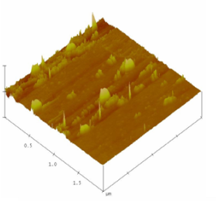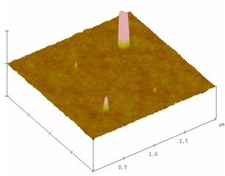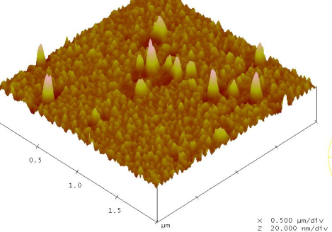
B)
Figure S1: AFM images of PLGA nanoparticles, PEI-PLGA nanoparticles and PLA nanoparticles and CLSM images of PEI-PLGA nanoparticles embedded in alginate microspheres (A) and CLSM images of PLGA nanoparticles embedded alginate microspheres (B)
a)
b)
Fig S2: a) Calibration curve for Pt-Porphyrin for quantifying the encapsulation efficiency. b) Reversibility of response of Pt-Porphyrin when exposed to different concentrations of oxygen ranging from 0-10 mM

Fig S3. Response time curves for Glucose sensing using GPP-AM using a concentration of 6 mM Glucose, (Y error bars represent standard deviation of intensities of triplicate measurement

Table S1. Effect of Pressure and flow rate of droplet generator for production of PP-AM and GPP-AM carriers
Pressure  (mbar) | Flow rate  (ml/hr) | Concentration nanoparticles: alginate | Size of Hybrid microparticles (µm)
70 (5) | 20 (2) | - | 60 (10)
60 (5) | 10 (2) | 25 % w/v | 60 (10)
120 (5) | 10 (2) | 25% w/v | 25 (7)
300 (5) | 15 (2) | 75 % w/v | 15 (5)
400 (5) | 15 (2) | 75 % w/v | 8 (5)
The standard sample parameters used were concentration of alginate (2%w/v), Concentration of CaCl₂ (250 mM), Nozzle size (0.35 mm) and distance for crosslinking (10 cm). Values in parenthesis represent the standard deviation; All the experiments were conducted for triplicate

