The pentaglycine bridges of Staphylococcus aureus peptidoglycan are essential for cell integrity
João M. Monteiro¹, Gonçalo Covas^{1,3}, Daniela Rausch², Sérgio R. Filipe^{3,1}, Tanja Schneider², Hans-Georg Sahl² and Mariana G. Pinho^{1,*}
1- Instituto de Tecnologia Química e Biológica António Xavier, Universidade Nova de Lisboa, Oeiras, Portugal
2-Institute of Pharmaceutical Microbiology, University of Bonn, 53115 Bonn, Germany
3-UCIBIO-REQUIMTE, Departamento de Ciências da Vida, Faculdade de Ciências e Tecnologia, Universidade Nova de Lisboa, Caparica, Portugal
*Correspondence and requests for materials should be addressed to M.G.P. (email: mgpinho@itqb.unl.pt)

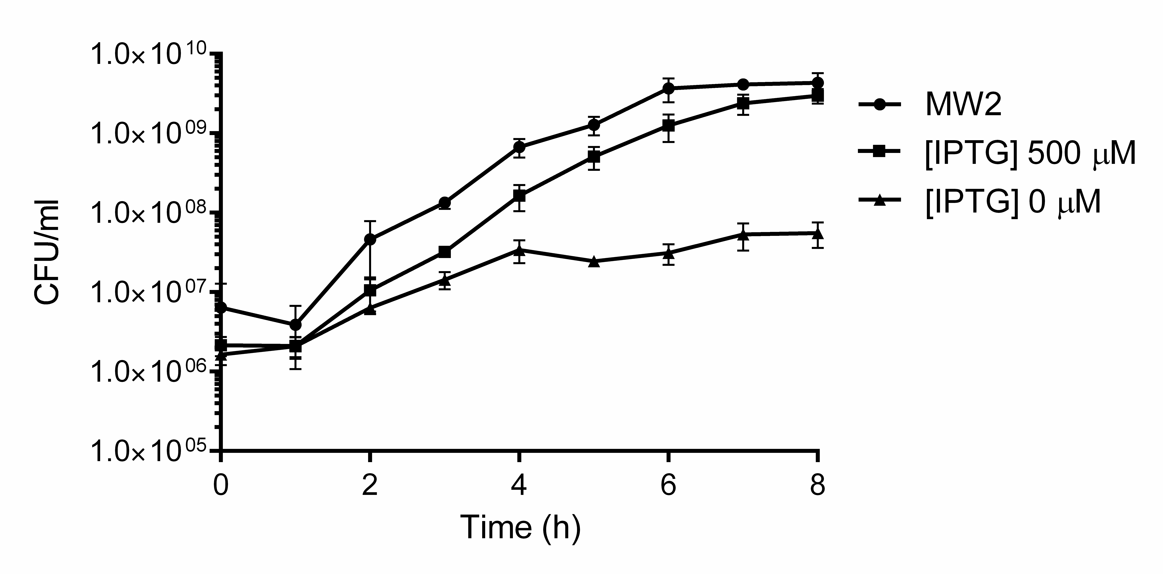
Supplementary Figure 1. FemAB is essential for the viability of MW2. Colony forming units (CFU) were counted in cultures of parental strain MW2 and of strain MW2-iFemAB grown in the presence ([IPTG] 500 µM) or absence ([IPTG] 0 µM) of femAB expression. Data shown are representative of three independent experiments. Symbols indicate means and error bars indicate standard deviation from six technical replicates.

Supplementary Fig. 2. Endogenous FemAB can be depleted in cells producing plasmid-encoded FemAB. Growth curves of strain MW2-iFemAB grown in the presence (MW2-iFemAB + IPTG) or absence (MW2-iFemAB – IPTG) of endogenous femAB expression; and of MW2-iFemAB depleted of endogenous femAB expression and either carrying wild-type femAB in a multicopy plasmid under the control of Pcad (MW2pFemAB^{wt} –IPTG +CdCl₂), or empty vector (MW2pCNX –IPTG +CdCl₂). Symbols indicate means and error bars indicate standard deviation from three biological replicates.
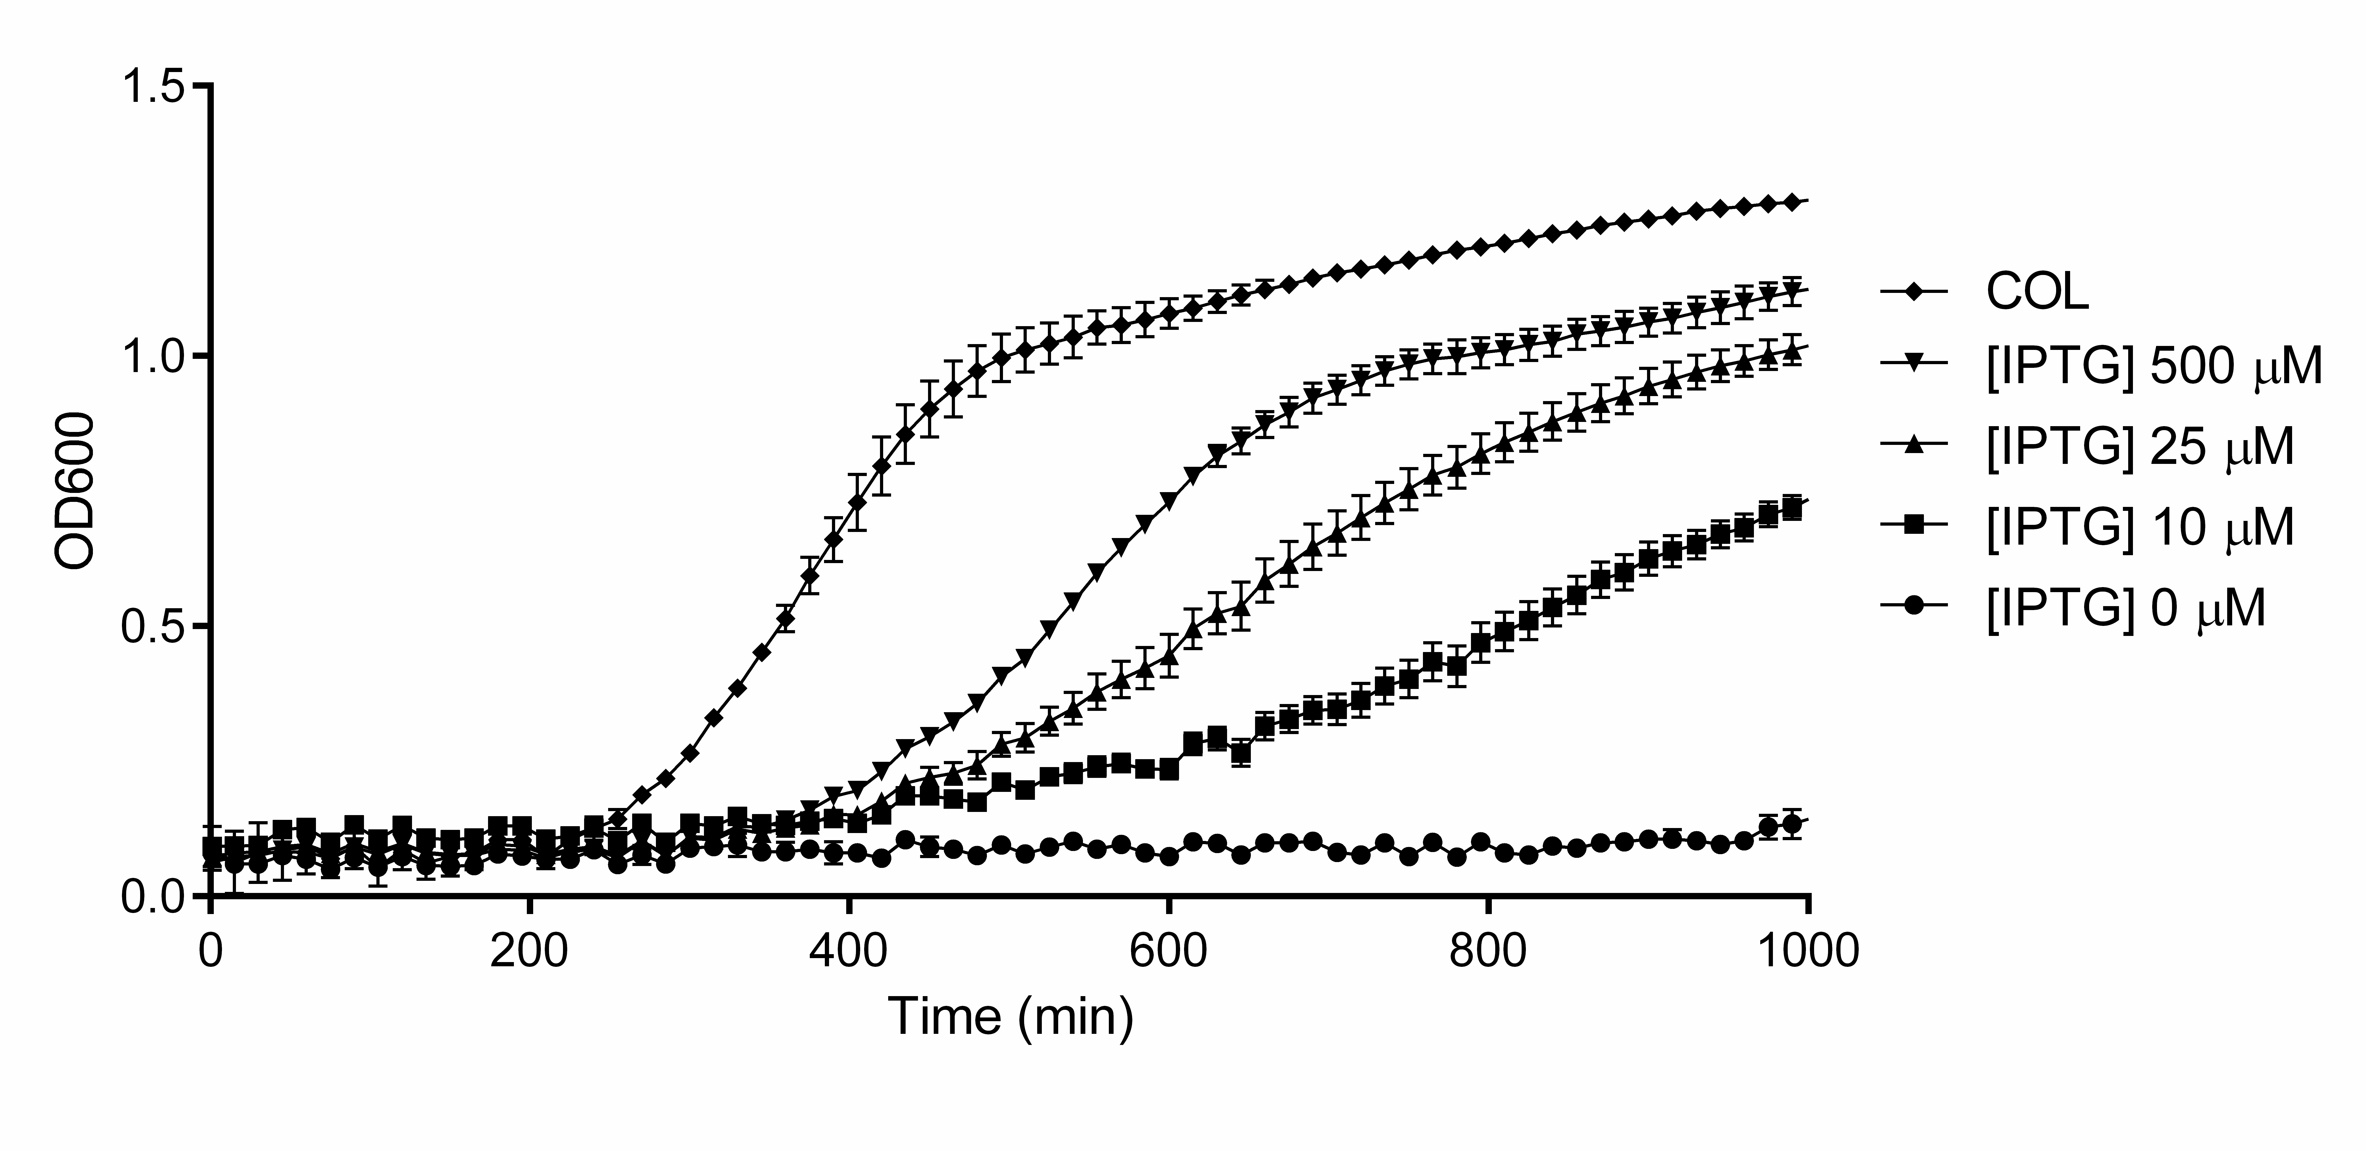Supplementary Figure 3. femAB is essential in COL. Growth curves of COL-iFemAB with IPTG-inducible femAB operon. In the absence of IPTG ([IPTG] 0 µM), no growth was detected. Growth was rescued with increasing concentrations of IPTG. Symbols indicate means and error bars indicate standard deviation from three biological replicates.

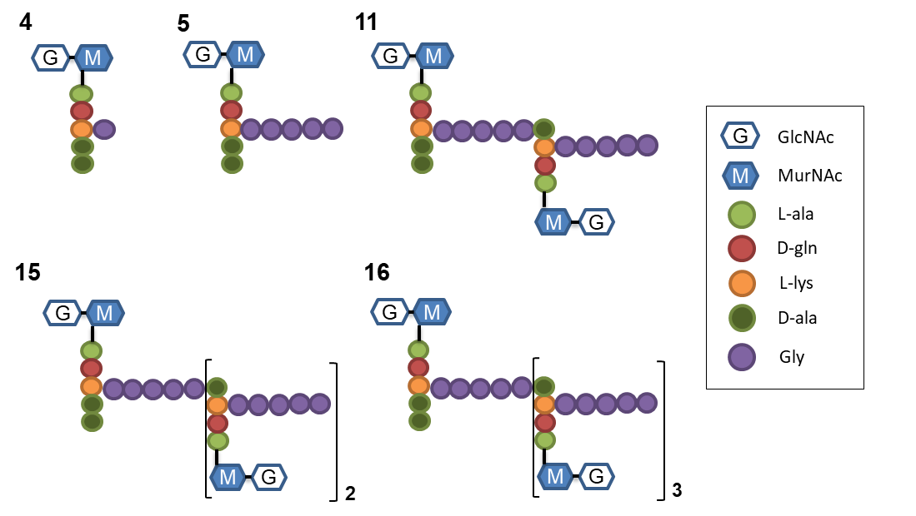
Supplementary Figure 4. Chemical structures of muropeptide species. Proposed structures of the peaks present in muropeptide chromatograms, according to de Jonge and Tomasz¹. Muropeptides are numbered according to increasing retention times. GlcNAc – N-acetylglucosamine, MurNAc – N-acetylmuramic acid.
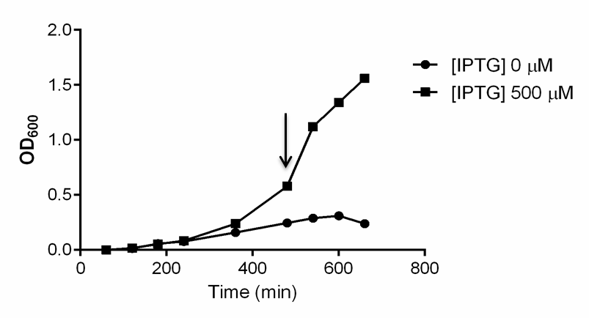
Supplementary Figure 5. Depletion of FemAB led to growth arrest. Growth curves of MW2-iFemAB in the presence ([IPTG] 500 µM) or absence ([IPTG] 0 µM) of IPTG, to determine the timing of growth arrest in the non-induced condition (see Methods). Cells were collected for microscopy at the indicated time point (black arrow).

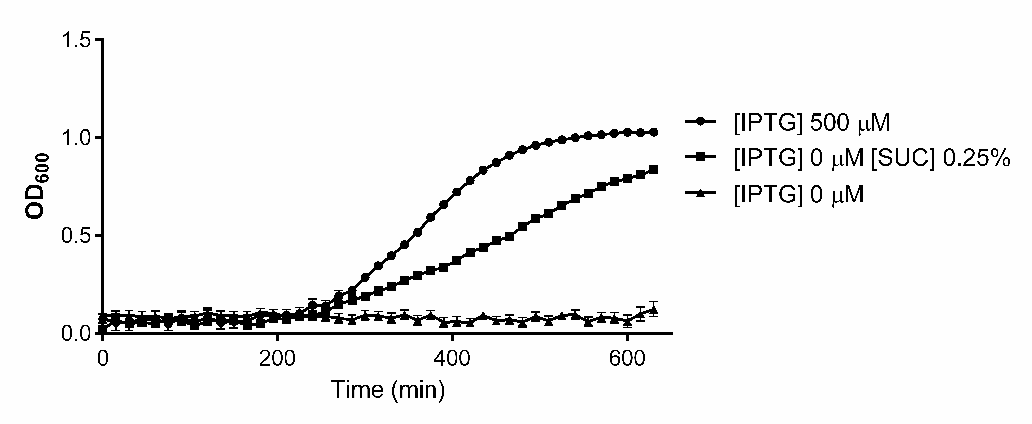
Supplementary Fig. 6. Sucrose can compensate for a FemAB deficit. Growth rates of MW2-iFemAB incubated in the presence ([IPTG] 500 µM) or absence ([IPTG] 0 µM) of IPTG, or in the absence of IPTG with 0.25% of sucrose ([IPTG] 0 µM [SUC] 0.25%). Adding sucrose to the medium allowed for cell growth in the absence of FemAB expression. Symbols indicate means and error bars indicate standard deviation from three biological replicates.

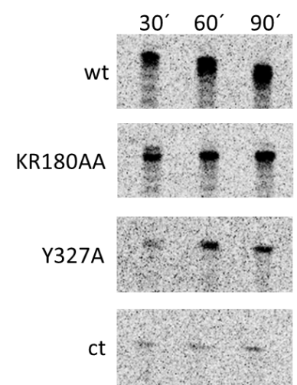
Supplementary Fig. 7. Selected mutations reduce FemA activity in vitro. Recombinant FemA^{wt}, FemA^{KR180AA} and FemA^{Y327A} were incubated with lipid II-Gly₁ in the presence of [U-¹⁴C]-glycine charged tRNA, for either 30, 60 or 90 minutes and reaction products were separated by TLC. No FemA was added to control row (ct). Figure shows representative bands that were excised for radioactivity measurements (see Methods).

Supplementary Table 1 – Strains and plasmids used in this study.
Strains | Description | Source or reference
E. coli
DC10B | Δdcm in the DH10B background; Dam methylation only | 2
BL21 (DE3)  BL21-FemX | B F⁻ dcm ompT hsdS(r_{B}⁻ m_{B}⁻) gal λ(DE3)  BL21(DE3) expressing full length C-ter His-tagged FemX; Kan^{r} | Stratagene  This work
BL21-GlyS  BL21-FemA^{wt} | BL21(DE3) expressing full length C-ter His-tagged GlyS; Kan^{r}  BL21(DE3) expressing full length C-ter His-tagged FemA; Kan^{r} | This work  This work
BL21-FemA^{KR180AA} | BL21(DE3) expressing mutant C-ter His-tagged FemA^{KR180AA}; Kan^{r} | This work
BL21-FemA^{RF220AA} | BL21(DE3) expressing mutant C-ter His-tagged FemA^{RF220AA}; Kan^{r} | This work
BL21-FemA^{Y327A} | BL21(DE3) expressing mutant C-ter His-tagged FemA^{Y327A}; Kan^{r} | This work
S. aureus
RN4220 | Restriction-deficient derivative of NCTC8325-4 | 3
MW2 | CA-MRSA; SCCmec type IV, ST1, pbla⁺ | 4
MW2-iFemAB | MW2 femAB::pFemABi pMGPII; Ery^{r} Cm^{r} | This work
MW2pCNX | MW2 femAB::pFemABi pMGPII pCNX; Ery^{r} Cm^{r} Kan^{r} | This work
MW2pFemAB^{wt} | MW2 femAB::pFemABi pMGPII pFemAB^{wt}; Ery^{r} Cm^{r} Kan^{r} | This work
MW2pFemA^{KR180AA} | MW2 femAB::pFemABi pMGPII pFemA^{KR180AA}B; Ery^{r} Cm^{r} Kan^{r} | This work
MW2pFemA^{RF220AA} | MW2 femAB::pFemABi pMGPII pFemA^{RF220AA}B; Ery^{r} Cm^{r} Kan^{r} | This work
MW2pFemA^{Y327A} | MW2 femAB::pFemABi pMGPII pFemA^{Y327A}B; Ery^{r} Cm^{r} Kan^{r} | This work
COL | HA-MRSA | 5
COL-iFemAB | COL femAB::pFemABi pMGPII; Ery^{r} Cm^{r} | This work

Plasmids | Description | Source or reference
pMUTIN4 | S. aureus integrative vector containing an IPTG-inducible Pspac promoter; Amp^{r} Ery^{r} | 6
pMGPII | S. aureus replicative plasmid containing lacI; Amp^{r} Cm^{r} | 7
pCNX | Replicative vector containing a cadmium inducible Pcad promoter; Amp^{r} Kan^{r} | 8
pFemABi | pMUTIN4 derivative containing a femA DNA fragment under the control of Pspac; Amp^{r} Ery^{r} | This work
pMADfemAmch | Vector containing a femA-mCherry-STOP-femB DNA fragment; Amp^{r} Ery^{r} | 9
pFemAB^{wt} | pCNX derivative encoding a FemA-mCherry fusion and FemB, both under the control of Pcad; Amp^{r} Kan^{r} | This work
pFemA^{KR180AA}B | pCNX derivative encoding a mutant FemA(K180A, R181A)-mCherry fusion and FemB, both under the control of Pcad; Amp^{r} Kan^{r} | This work
pFemA^{RF220AA}B | pCNX derivative encoding a mutant FemA(R220A, F224A)-mCherry fusion and FemB, both under the control of Pcad; Amp^{r} Kan^{r} | This work
pFemA^{Y327A}B | pCNX derivative encoding a mutant FemA(Y327A)-mCherry fusion and FemB, both under the control of Pcad; Amp^{r} Kan^{r} | This work
pET-24b | E. coli replicative vector for the expression of proteins with a His₆ fusion at the C-terminus, under Pspac promoter; Kan^{r} | Novagen
pET-GlyS | pET-24b derivative encoding a GlyS-His₆ fusion; Kan^{r} | 10
pET-FemX | pET-24b derivative encoding a FemX-His₆ fusion; Kan^{r} | 10
pET-FemA^{wt} | pET-24b derivative encoding a FemA-His₆ fusion; Kan^{r} | This work
pET-FemA^{KR180AA} | pET-24b derivative encoding a mutant FemA(K180A, R181A)-His₆ fusion; Kan^{r} | This work
pET-FemA^{RF220AA} | pET-24b derivative encoding a mutant FemA(R220A, F224A)-His₆ fusion; Kan^{r} | This work
pET-FemA^{Y327A} | pET-24b derivative encoding a mutant FemA(Y327A)-His₆ fusion; Kan^{r} | This work
Amp, ampicillin; Kan, kanamycin; Ery, erythromycin; Cm, chloramphenicol

Supplementary Table 2. Oligonucleotides used in this study.
Primer Name | Sequence (5’-3’)
spacfemab_P1 EcoRI |  | GCGCGAATTCATGAAGTTTACAAATTTAACAGC
spacfemab_P2 BamHI |  | CGCGGGATCCTTATCAAAGAACCAATCATTACCAGCATTAC
pcnfemab_P1 BamHI |  | GCGCGCGGATCCGCAAATACGGAAATGAAATTAATTAACG
pcnfemab_P2 EcoRI |  | CGCGCGGAATTCCTATTTCTTTAATTTTTTACGTAATTTATC
fema_kr180aa_fw |  | ATGGACTTAGAGCAGCAAACACGAAAAAAGTTAAAAAGAATG
fema_kr180aa_rev |  | TTTTCGTGTTTGCTGCTCTAAGTCCATCCATATTTTTAATGATG
fema_rf220aa_fw |  | GCTGATGCTGATGACAAAGCTTACTACAATCGCTTAAAATATTAC
fema_rf220aa_rev |  | GTAGTAAGCTTTGTCATCAGCATCAGCAAAAGCTTTTGATTC
fema_Y327a_fw |  | GAAGTTGTTGCTTATGCTGGTGGTACATCAAATGCATTCC
fema_Y327a_rev |  | ACCAGCATAAGCAACAACTTCAAATGGATTGATAAAGAAG
femaexpress_P1 BamHI |  | CGCGCGGATCCATGAAGTTTACAAATTTAACAGCTAAAGAGTTTG
femaexpress_P2 EcoRI |  | CGCGCGAATTCCTAAAAAATTCTGTCTTTAACTTTTTTAAGTGC
Underlined sequences correspond to restriction sites

References
1 de Jonge, B. L., Chang, Y. S., Gage, D. & Tomasz, A. Peptidoglycan composition of a highly methicillin-resistant Staphylococcus aureus strain. The role of penicillin binding protein 2A. J Biol Chem 267, 11248-11254 (1992).
2 Monk, I. R., Shah, I. M., Xu, M., Tan, M. W. & Foster, T. J. Transforming the untransformable: application of direct transformation to manipulate genetically Staphylococcus aureus and Staphylococcus epidermidis. mBio 3, e00277-11 (2012).
3 Nair, D. et al. Whole-genome sequencing of Staphylococcus aureus strain RN4220, a key laboratory strain used in virulence research, identifies mutations that affect not only virulence factors but also the fitness of the strain. J Bacteriol 193, 2332-2335 (2011).
4 Baba, T. et al. Genome and virulence determinants of high virulence community-acquired MRSA. Lancet 359, 1819-1827 (2002).
5 Gill, S. R. et al. Insights on evolution of virulence and resistance from the complete genome analysis of an early methicillin-resistant Staphylococcus aureus strain and a biofilm-producing methicillin-resistant Staphylococcus epidermidis strain. J. Bacteriol. 187, 2426-2438 (2005).
6 Vagner, V., Dervyn, E. & Ehrlich, S. D. A vector for systematic gene inactivation in Bacillus subtilis. Microbiology 144, 3097-3104 (1998).
7 Pinho, M. G., Filipe, S. R., de Lencastre, H. & Tomasz, A. Complementation of the essential peptidoglycan transpeptidase function of penicillin-binding protein 2 (PBP2) by the drug resistance protein PBP2A in Staphylococcus aureus. J Bacteriol 183, 6525-6531 (2001).
8 Monteiro, J. M. et al. Cell shape dynamics during the staphylococcal cell cycle. Nat Commun 6, 8055 (2015).
9 Monteiro, J. M. et al. Peptidoglycan synthesis drives an FtsZ-treadmilling-independent step of cytokinesis. Nature, 554 528-532 (2018).
10 Schneider, T. et al. In vitro assembly of a complete, pentaglycine interpeptide bridge containing cell wall precursor (lipid II-Gly5) of Staphylococcus aureus. Mol Microbiol 53, 675-685 (2004).

