Supplementary Information

Differential Mobility Spectrometry of Ketones in Air at Extreme Levels of Moisture

Z. Safaei¹, M. Sillanpää¹, G.A. Eiceman², J. Puton³, J.A. Stone⁴, M. Nasirikheirabadi¹, O. Anttalainen⁵,

¹Department of Green Chemistry, LUT University, Sammonkatu 12, FI-50130 Mikkeli, Finland.
²Department of Chemistry and Biochemistry, 1175 North Horseshoe Drive, New Mexico State University, Las Cruces, NM 88003
³Institute of Chemistry, Military University of Technology, Kaliskiego 2, Warsaw, Poland
⁴Department of Chemistry, Queens University, Kingston, Ont. K7L 4J1, Canada
⁵Environics Oy, Sammonkatu 12, FI-50130 Mikkeli, Finland

Acetone at fixed concentration of 400 ppb and 3 moisture levels of 1.0 x 10², 4.1 x 10², and 1.10 x 10³ ppm
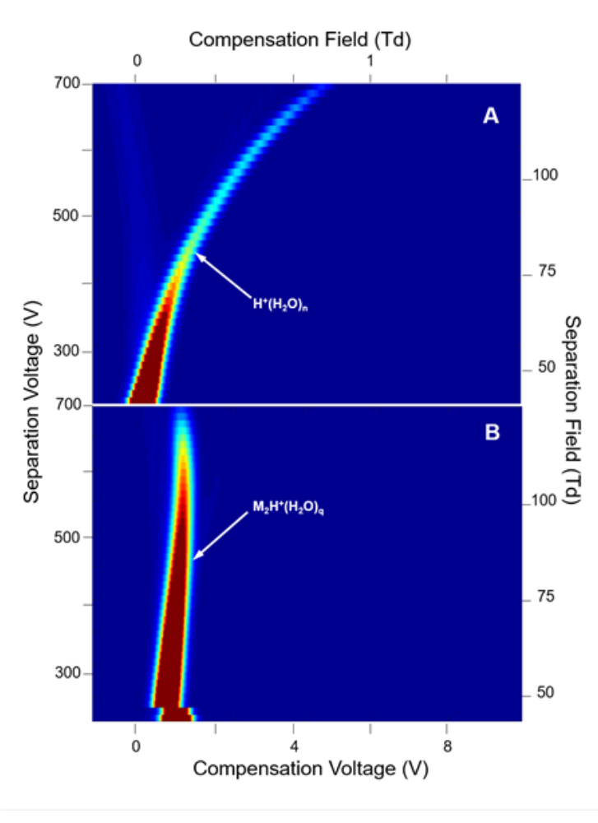
Figure 1S. Dispersion plots for acetone at 400 ppb vapor concentration and 1.0 x 10² ppm moisture (B) and for the reactant ion peak as a control measurement (A).

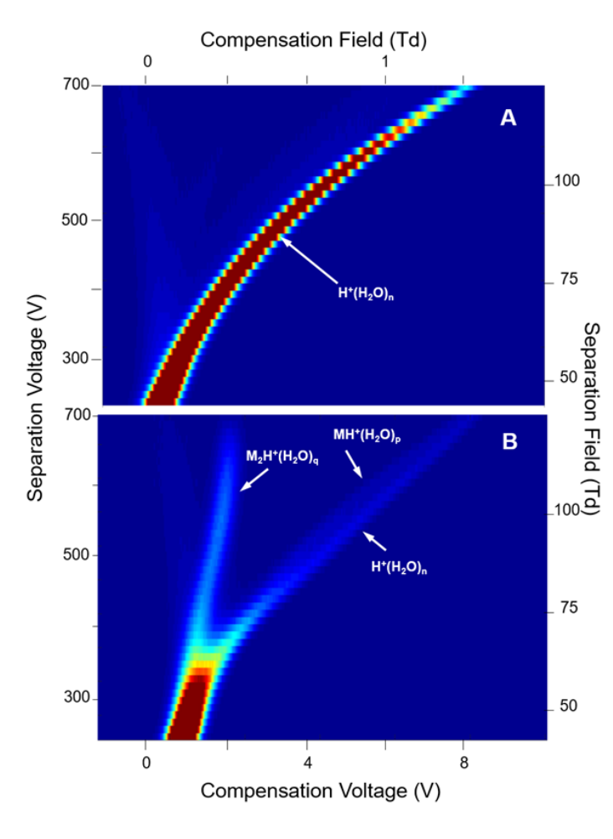
Figure 2S. Dispersion plots for acetone at 400 ppb vapor concentration and 4.1 x 10² ppm moisture (B) and for the reactant ion peak as a control measurement (A).

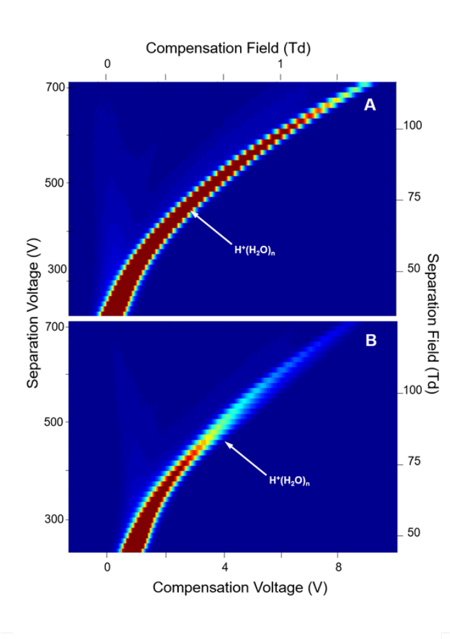
Figure 3S. Dispersion plots for acetone at 400 ppb vapor concentration and 1.10 x 10³ ppm moisture (B) and for the reactant ion peak as a control measurement (A).

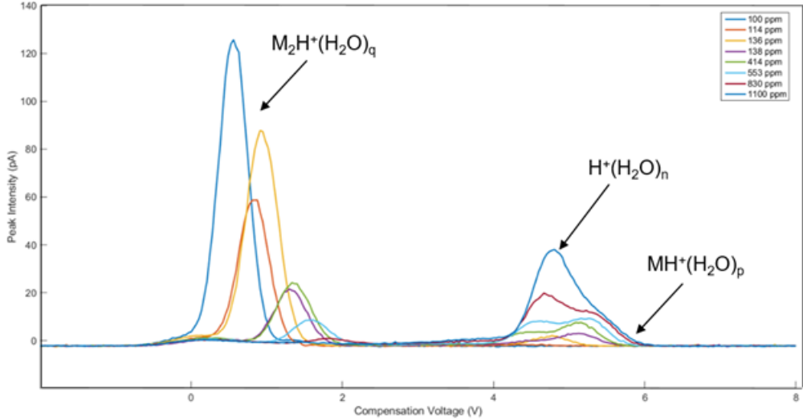

Figure 4S. Composition of DMS spectra obtained at 500 V separation voltage at 400 ppb acetone and several moisture levels (see inset).

2-Butanone at fix concentration of 20 ppb and 3 moisture levels: 1.0 x 10², 5.5 x 10², and 1.25 x 10³ ppm

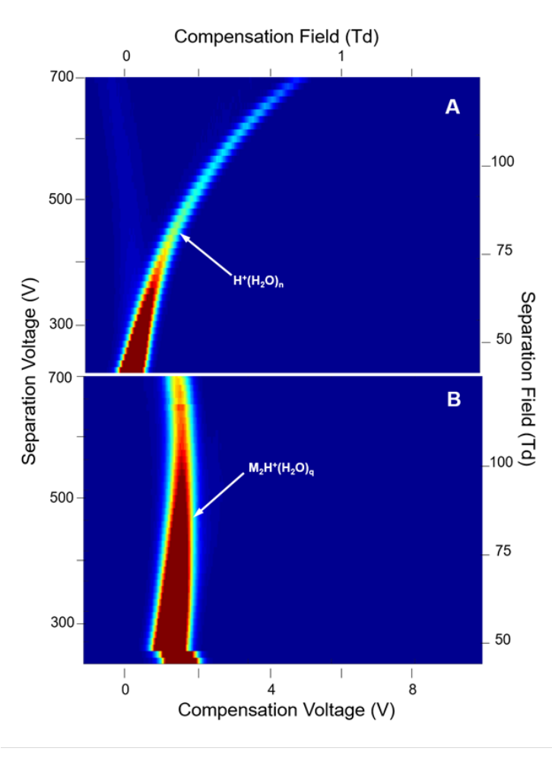
Figure 5S. Dispersion plots for 2-butanone at 20 ppb vapor concentration and 1.0 x 10² ppm moisture (B) and for the reactant ion peak as a control measurement (A).

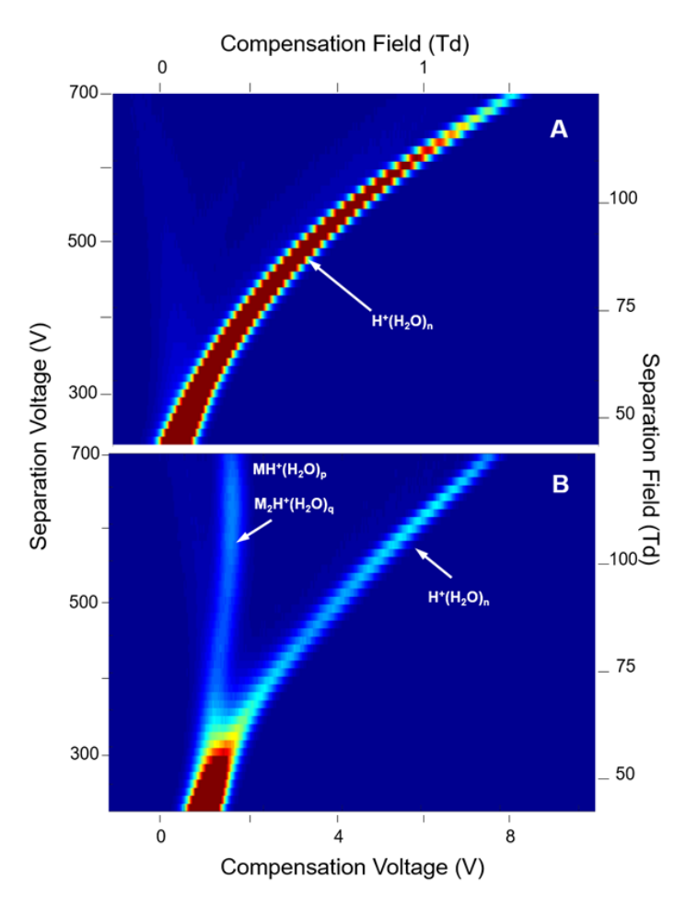
Figure 6S. Dispersion plots for 2-butanone at 20 ppb vapor concentration and 5.5 x 10² ppm moisture (B) and for the reactant ion peak as a control measurement (A).

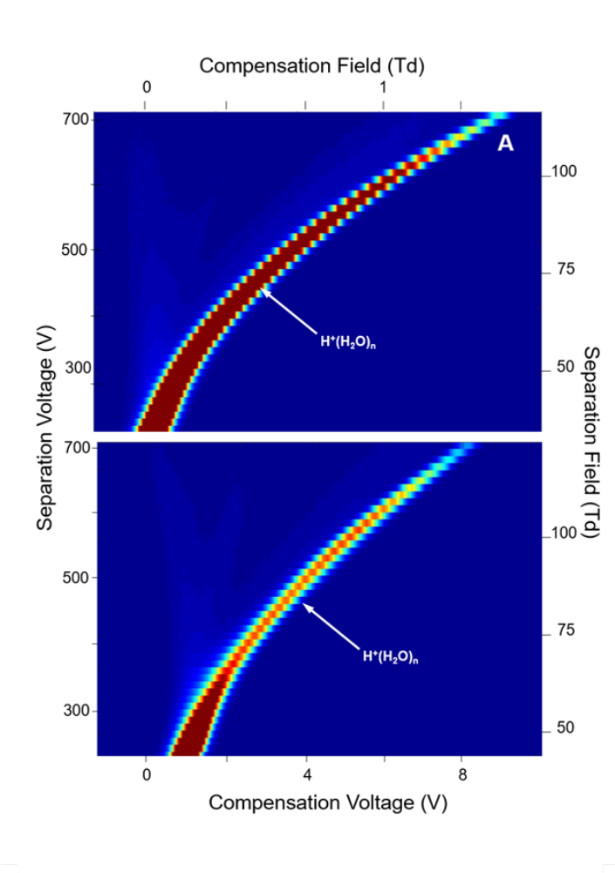
Figure 7S. Dispersion plots for 2-butanone at 20 ppb vapor concentration and 1.25 x 10³ ppm moisture (B) and for the reactant ion peak as a control measurement (A).

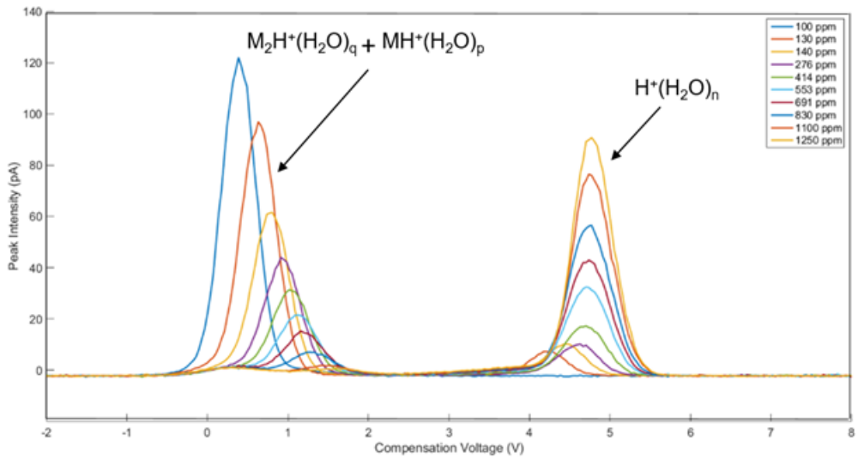
Figure 8. Composition of DMS spectra obtained at 500 V separation voltage at 400 ppb 2-butanone and several moisture levels (see inset).

