Upregulation of NDRG1 predicts poor outcome and facilitates disease progression by influencing the EMT process in bladder cancer.
Aiwei Li¹, Xi Zhu², Chanjuan Wang¹, Shuo Yang¹, Yan Qiao¹, Rui Qiao¹, Jie Zhang¹*
1 Department of Laboratory Medicine, Peking University Third Hospital, No.49 North Garden Road, Haidian District, Beijing 100191, China
2 Department of Urology, Friendship Hospital Affiliated to Capital Medical University, 95th Yong An Road, Xuan Wu District, Beijing 100050, China
*Correspondence:
Pro. Dr. Jie Zhang, Department of Laboratory Medicine, Peking University Third Hospital, E-mail: zhangjiebjmu@163.com, Phone: +86 10 82265719, Fax: +86 10 82265719

Table S1 The sequences of all primers listed in this study
Target gene | Forward primer (5′–3′) | Reverse primer (5′ –3′)
NDRG1 | CGCCAGCACATTGTGAATGAC | TTTGAGTTGCACTCCACCACG
SNAI1 | CCTCCCTGTCAGATGAGGAC | CCAGGCTGAGGTATTCCTTG
SNAI2 | GGGGAGAAGCCTTTTTCTTG | TCCTCATGTTTGTGCAGGAG
ZEB1 | AACCCAACTTGAACGTCACA | ATTACACCCAGACTGCGTCA
ZEB2 | CCAGAGGAAACAAGGATTTCAG | AGGCCTGACATGTAGTCTTGTG
TWIST1 | AGCTACGCCTTCTCCGTCT | TCCTTCTCTGGAAACAATGACA
TWIST2 | GAGCGACGAGATGGACAATAAGA | ATGCGCCACACGGAGAA
GAPDH | TGTTCCAATATGATTCCACCC | CTTCTCCATGGTGCGTGAAGA

Table S2 The antibody of all protein listed in this study
Target protein | Dilution | CAT. # | Manufacturer
NDRG1 | 1:1000 | 9485 | Cell Signaling Technology, US
E-cad | 1:500 | ab40772 | Abcam, US
N-cad | 1:500 | Ab76011 | Abcam, US
Cytokeratin 7 | 1:5000 | ab68459 | Abcam, US
Claudin-1 | 1:500 | 13255 | Cell Signaling Technology, US
β-catenin | 1:1000 | 8480 | Cell Signaling Technology, US
Slug | 1:250 | 9585 | Cell Signaling Technology, US
SMAD4 | 1:1000 | 38454 | Cell Signaling Technology, US
SMAD2/3 | 1:1000 | 8685 | Cell Signaling Technology, US
GAPDH | 3 µg/mL | M171-3 | MBL Co., Ltd, Japan

Table S3 Patients’ characteristics of 15 paired bladder cancer tissues
 | Patients
Total | n=15
Age (years)
<60 | 3
≥60 | 12
Gender
Male | 12
Female | 3
Smoking
No | 6
Yes | 9
Multicentricity
No | 10
Yes | 5
Size (cm)
<3cm | 5
≥3cm | 10
Lymph node metastasis
Negative | 13
Positive | 2
TNM Stage
NMIBC | 4
MIBC | 11
Pathological grade
G1 | 2
G2 | 7
G3 | 6
NMIBC: non-muscle-invasive bladder cancer;
MIBC: muscle-invasive bladder cancer

Fig. S1
Overall survival of patients with muscle invasive bladder cancer (MIBC) stratified by NDRG1 protein expression level; Kaplan-Meier method, log-rank test, p=0.612.

Fig. S2
Expression of NDRG1 in various bladder cancer cell lines. n=3, **p<0.01, ***p<0.0001.

Fig. S3
T24
siNC siNDRG1

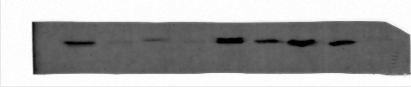

Expression of NDRG1 in T24 cells after transfection with NDRG1 siRNAs.

Figure 1C Original image
NDRG1
GAPDH
NDRG1
GAPDH
NDRG1 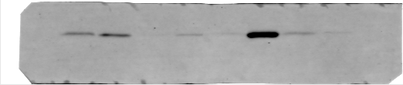
GAPDH
NDRG1 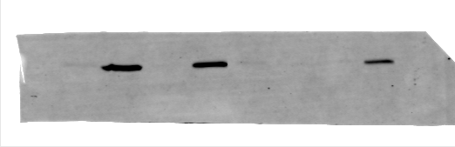
GAPDH 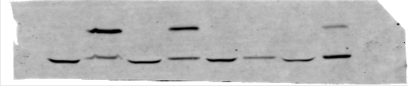

Figure 4A Original image
NDRG1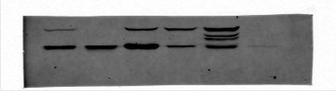
GAPDH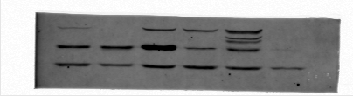

Figure 4B Original image
NDRG1 over
GAPDH 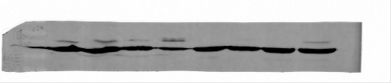
NDRG1 si
GAPDH 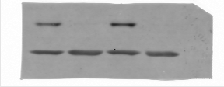

Figure 6C Original image

E-cad
GAPDH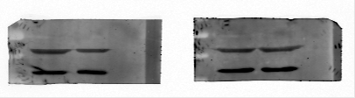
Cytokeratin 7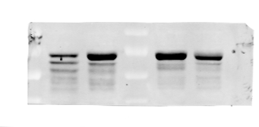
Claudin-1
GAPDH
N-cad 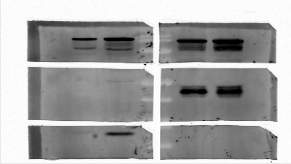

GAPDH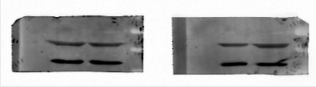
β-catenin 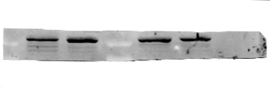
slug
SMAD4
GAPDH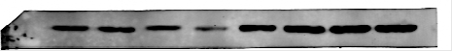
SMAD2/3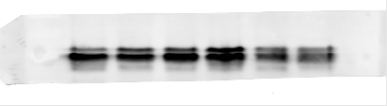
GAPDH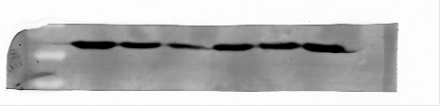

Figure 6D Original image
5637 cell
Cytokeratin 7
GAPDH
Claudin-1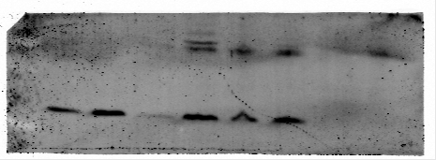
GAPDH 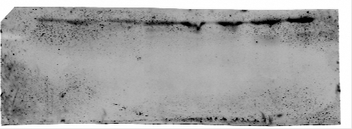
N-cad
slug
GAPDH
E-cad
β-catenin
GAPDH
SMAD4
GAPDH
SMAD2/3
GAPDH

T24 cell
E-cad 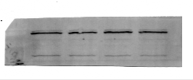
GAPDH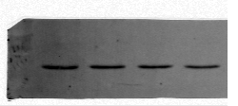
Cytokeratin 7
GAPDH
Claudin-1
slug
GAPDH
β-catenin 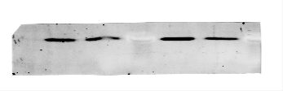
GAPDH 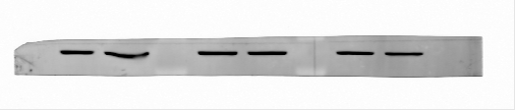

SMAD4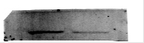
SMAD2/3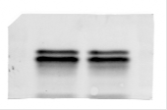
GAPDH