Supplementary Information for the manuscript:

Fabrication of inclined non-symmetrical periodic micro-structures using Direct Laser Interference Patterning

Sabri Alamri1,*, Mikhael El-Khoury1, Alfredo I. Aguilar-Morales1, Sebastian Storm1,2, Tim Kunze1, Andrés F. Lasagni1,2

¹ Fraunhofer-Institut für Werkstoff- und Strahltechnik IWS, Dresden, 01277, Germany
² Technische Universität Dresden, Institut für Fertigungstechnik, Dresden, 01062, Germany
*sabri.alamri@iws.fraunhofer.de

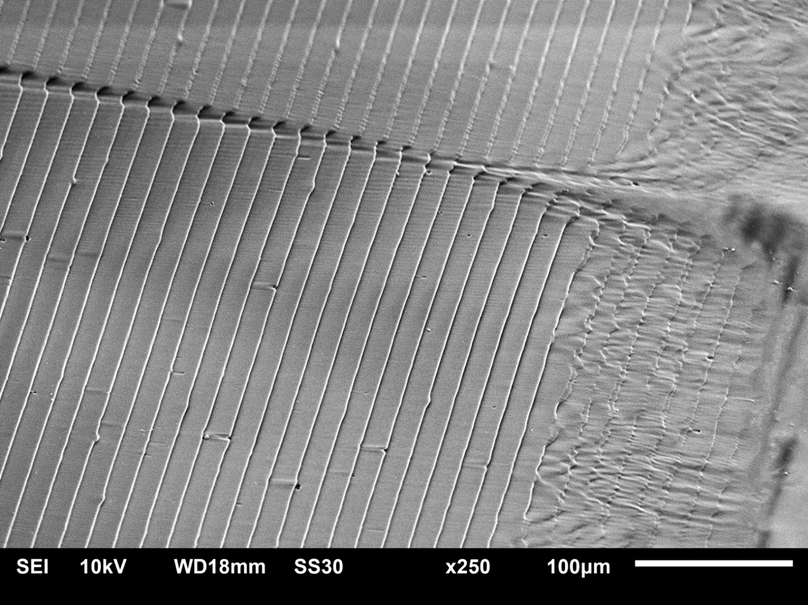
Figure S1: Particular of the irradiated area of two adjacent DLIP-pixels, showing irregularities at the pixel-border. The structuring was performed with a laser fluence of 1.32 J/cm², 20 pulses per area and an inclination of 75°.

