ELECTRONIC SUPPLEMENTARY MATERIAL
Effect of genotype and age on cerebral [¹⁸F]FDG uptake varies between transgenic
APP_{Swe}-PS1_{dE9} and Tg2576 mouse models of Alzheimer’s disease
Journal: Scientific Reports
Anniina Snellman*^{1,2}, Jatta S. Takkinen^{1,2,3}, Francisco R. Lopez-Picon^{1,2}, Olli Eskola⁴, Olof Solin^{4,5,6}, Juha O. Rinne^{7,8}, and Merja Haaparanta-Solin^{1,2}
¹MediCity Research Laboratory, University of Turku, Tykistökatu 6 A, FI-20520 Turku, Finland
²PET Preclinical Laboratory, Turku PET Centre, University of Turku, Tykistökatu 6 A, FI-20520 Turku, Finland
³Doctoral Programme in Clinical Research, University of Turku, Turku, Finland
⁴Radiopharmaceutical Chemistry Laboratory, Turku PET Centre, University of Turku, Kiinamyllynkatu 4-8, FI-20520 Turku, Finland
⁵Accelerator Laboratory, Turku PET Centre, Åbo Akademi University, Kiinamyllynkatu 4-8, FI-20520 Turku, Finland
⁶Department of Chemistry, University of Turku, Vatselankatu 2, FI-20500 Turku, Finland
⁷Turku PET Centre, Turku University Hospital, Kiinamyllynkatu 4-8, FI-20520 Turku, Finland
⁸Division of Clinical Neurosciences, Turku University Hospital, Kiinamyllynkatu 4-8, FI-20520 Turku, Finland
*Corresponding author: Anniina Snellman, PhD, Tykistökatu 6A, FI-20520 Turku, Finland, Tel: + 358 2 3337020, Fax: +358 29 450 5040, E-mail: aepakk@utu.fi

SUPPLEMENTARY METHODS
Animal models
Two transgenic animal mouse models, Tg2576 and APP_{Swe}-PS1_{dE9}, were used in this study. Briefly, Tg2576 mice carry the 695-isoform of the amyloid precursor protein (APP) gene with Swedish double mutation (APP_{Swe}, K670N/M671L) and start to exhibit Aβ deposition and associated reactive gliosis by 11-13 months of age, whereas the APP_{Swe}-PS1_{dE9} double TG strain expresses both APP_{Swe} and presenilin-1 with deletion of exon 9, resulting in earlier initiation of Aβ deposition typically at 6 months of age. All animals were housed at 21 ± 3°C in 55 ± 15% humidity with a light period from 6:00 a.m. to 6:00 p.m and free access to tap water and soya-free chow (RM3 (E) soya, 801710, Special Diets Service, Essex, UK). Mice were weighed before each experimental session and body temperature and blood glucose levels (Glu) measured before each PET scan using a microprobe rectal thermometer (Physitemp Instruments, Inc., USA) and Accu-Chek Aviva Nano (Roche Diagnostics, USA), respectively. All animals were fasted for 3 hours, taken to the laboratory 45 minutes and anesthesized 30 minutes prior to [¹⁸F]FDG injection.
Quantification of beta-amyloid deposition and microgliosis
A minimum of one slide containing 8-10 sections was stained for each mouse. Stained sections were scanned using the 3DHISTECH Slide Scanner 250 and evaluated by CaseViewer software version 1.3 (3DHISTECH, Budapest, Hungary). Six different brain regions (FC, TPC, HC, THA, STR, and CB) were analysed from each mouse to estimate the amount of regional Aβ and microgliosis. From each mouse, 2−3 sections (1−4 snapshots each) were captured for each region at 15x magnification using CaseViewer software. The snapshots were converted into 8-bit images and thresholded individually by comparing them to the original images. Finally, the percentage of 6E10 or anti-Iba-1-positive area out of the total image area was calculated using Image J (Wayne Rasband, National Institute of Health, MD, USA), and mean values for each region were used for correlation analysis.

SUPPLEMENTARY FIGURES

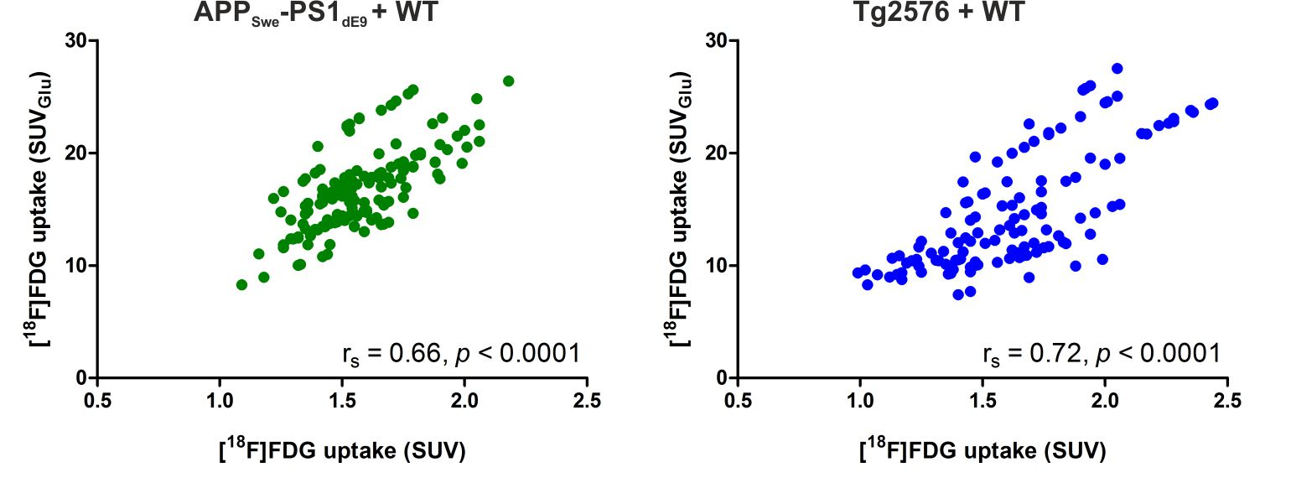

Supplementary Figure S1
Correlation between obtained standardized uptake values (SUV) and SUVs normalized for individual blood sugar levels (SUV_{Glu}) in APP_{Swe}-PS1_{dE9} and wild-type (WT) mice, and Tg2576 and WT mice. Significant positive correlation between SUV and SUV_{Glu} was found for both APP_{Swe}-PS1_{dE9} (r_{s} = 66, p < 0.0001) and Tg2576 (r_{s} = 0.72, p < 0.0001) models. For this figure, SUV and SUV_{Glu} values from both transgenic and WT mice, and data from all analysed brain regions was pooled for clarity (correlations calculated individually for each analysed brain region are reported in detail in Supplementary Table S1).

Supplementary Figure S2
Ex vivo tissue counting results from transgenic (TG) APP_{Swe}-PS1_{dE9}, Tg2576, and wild type (WT) mice quantified as standardized uptake values (SUV) or SUVs corrected for individual blood glucose levels (SUV_{Glu}). No statistically significant differences were detected in brain, heart, brown adipose tissue (BAT), liver and muscle between the evaluated age groups of 6 and 12 months or genotypes in APP_{Swe}-PS1_{dE9} and WT mice. In Tg2576 and WT mice, [¹⁸F]FDG uptake in BAT as SUV, and brain as SUV_{Glu} showed significant difference between groups (p = 0.04), however, significance was lost after correcting for multiple comparisons.

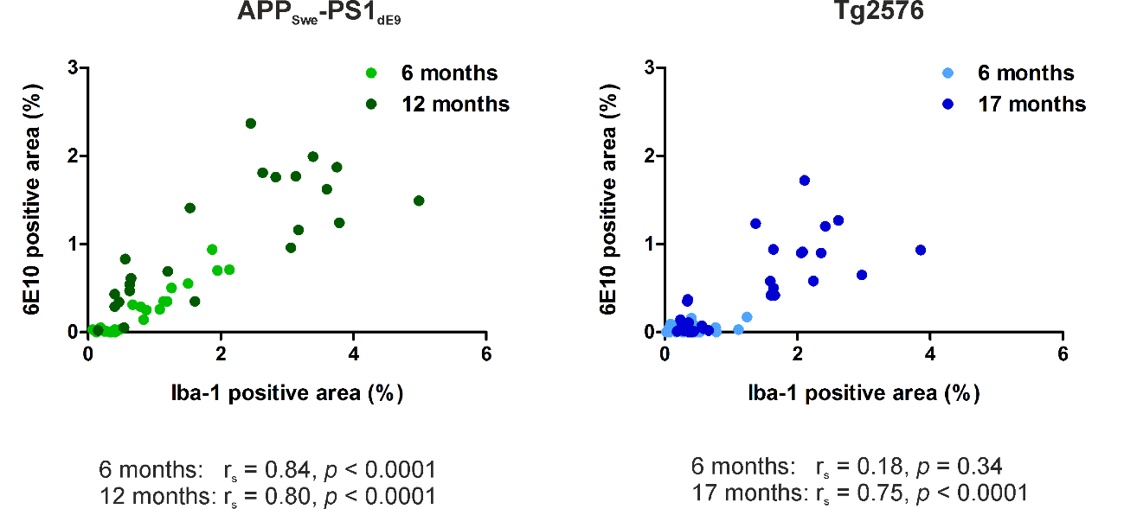

Supplementary Figure S3
Correlation between 6E10 positive beta-amyloid deposits and Iba-1 positive microgliosis in APP_{Swe}-PS1_{dE9} and Tg2576 transgenic mice. In APP_{Swe}-PS1_{dE9} mice, strong positive correlation between regional beta-amyloid deposition and microgliosis was detected both at 6 months (r_{s} = 0.84, p < 0.0001) and 12 months of age (r_{s} = 0.80, p < 0.0001). In Tg2576 mice, no correlation was observed yet at 6 months (r_{s} = 0.18, p = 0.34), whereas strong correlation (r_{s} = 0.75, p < 0.0001) was present at 17 months.
SUPPLEMENTARY TABLES

Supplementary Table S1
Regional ex vivo digital autoradiography results presented as [¹⁸F]FDG binding ratios (R), using whole brain (WB) estimate as a reference region. Data are presented as medians and interquartile ranges. Differences between groups are tested with non-parametric Kruskal-Wallis test (*p < 0.05), and if significance was found additional Dunn’s test for multiple comparisons was performed (#p < 0.05 after multiple comparisons). Abbreviations: CB = cerebellum; FC = frontal cortex; HC = hippocampus; ns = non-significant; R_{WB} = binding ratio-to-whole brain; STR = striatum; TG = transgenic; THA = thalamus; TPC = tempo-parietal cortex; WB = whole brain; WT = wild type.
 | APP_{Swe}-PS1_{dE9}
 | 6 months |  |  | 12 months
R_{WB} | TG | WT |  | TG | WT | p
FC | 1.00 (0.94–1.01) | 0.98 (0.94–1.07) |  | 1.02 (1.01–1.04) | 0.98 (0.95–1.02) | 0.34 | ns
PC | 0.96 (0.91–0.99) | 1.04 (0.97–1.05) |  | 1.01 (1.01–1.05) | 0.94 (0.91–1.00) | 0.04 | *
TC | 0.94 (0.92–0.95) | 0.96 (0.91–0.99) |  | 0.98 (0.97–1.00) | 0.97 (0.96–1.01) | 0.08 | ns
STR | 1.25 (1.21–1.29) | 1.19 (1.12–1.21) |  | 1.20 (1.11–1.30) | 1.26 (1.17–1.31) | 0.28 | ns
HC | 0.99 (0.98–1.02)# | 0.89 (0.88–0.92)# |  | 0.94 (0.91–0.97) | 0.92 (0.87–0.95) | 0.02 | *
THA | 1.06 (0.96–1.10) | 1.09 (1.07–1.18) |  | 1.09 (1.07–1.6) | 1.09 (1.07.1.19) | 0.61 | ns
CB | 0.94 (0.88–1.02) | 0.83 (0.80–0.95) |  | 0.87 (0.84–0.93) | 0.89 (0.86–0.94) | 0.31 | ns
 | Tg2576
 | 6 months |  |  | 17 months
R_{WB} | TG | WT |  | TG | WT | p
FC | 0.87 (0.8-0.97) | 0.91 (0.82–0.99) |  | 0.89 (0.86–0.92) | 0.88 (0.85–0.91) | 1.00 | ns
PC | 0.89 (0.84–0.93) | 0.88 (0.79–0.92) |  | 0.86 (0.84–0.89) | 0.87 (0.83–0.91) | 0.94 | ns
TC | 0.86 (0.80–0.96) | 0.86 (0.79–0.92) |  | 0.89 (0.86–0.94) | 0.90 (0.85–0.94) | 0.85 | ns
STR | 1.22 (1.19–1.26) | 1.29 (1.20–1.33) |  | 1.22 (1.13–1.30) | 1.20 (1.09–1.31) | 0.47 | ns
HC | 0.98 (0.91–0.99) | 1.05 (0.94–1.14) |  | 1.01 (1.00–1.03) | 0.94 (0.89–0.98) | 0.32 | ns
THA | 1.09 (1.02–1.17) | 1.15 (1.10–1.19) |  | 1.10 (1.02–1.27) | 1.20 (1.20–1.21) | 0.11 | ns
CB | 0.86 (0.77–0.93) | 0.87 (0.80–0.92) |  | 0.88 (0.86–0.92) | 1.04 (1.03–1.04) | 0.13 | ns
Supplementary Table S2
Correlation between regional standard uptake values without (SUV), and with normalization for blood glucose levels (SUV_{Glu}) evaluated using Spearman’s correlation. Strong and significant positive correlation was found in all brain regions in both models. Abbreviations: CB = cerebellum; FC = frontal cortex; HC = hippocampus; STR = striatum; THA = thalamus; TPC = tempo-parietal cortex.

 | APP_{swe}-PS1_{dE9} |  |  | Tg2576
 | SUV vs. SUV_{Glu} |  |  | SUV vs. SUV_{Glu}
 | Spearman r | p |  | Spearman r | p
FC | 0.60 | 0.0013 |  | 0.75 | 0.0001
TPC | 0.70 | <.0001 |  | 0.68 | 0.0007
HC | 0.57 | 0.0026 |  | 0.67 | 0.001
THA | 0.65 | 0.0003 |  | 0.67 | 0.0009
STR | 0.67 | 0.0002 |  | 0.68 | 0.0008
CB | 0.62 | 0.0007 |  | 0.72 | 0.0002

Supplementary Table S3
Details of the used protocols for beta-amyloid and Iba-1 immunohistochemistry (IHC). PFA = paraformaldehyde; BSA = bovine serum albumin; NGS = normal goat serum; PBS = phosphate buffered saline

 | Beta-amyloid IHC | anti-Iba-1 IHC
Sections | Fresh frozen | Fresh frozen
Post fixation | 4% PFA, 30 min | 4% PFA, 30 min
Peroxidase blocking | 0.3% H₂O₂ in 10% MeOH, 20 min | 0.3% H₂O₂ in 10% MeOH, 30 min
Antigen retrieval | > 95% Formic acid, 10 min | NA
Blocking | 0.3% Triton X-100, 2% BSA, 2% NGS in PBS (pH 7.4), 60 min | 0.3% Triton X-100, 2% BSA, 2% NGS in PBS (pH 7.4), 120 min
Primary antibody | 6E10, anti-Abeta₁₋₁₆ (SIG-39320) | Anti-Iba-1 (CAT# 019-19741)
Manufacturer | Covance Inc. | Wako Pure Chemical Industries, Ltd
Dilution | 1:500 | 1:1000
Incubation time | O/N, + 8C | O/N, + 8C
Wash | PBSt, 3 x 5 min | PBSt, 3 x 5 min
Secondary antibody | Biotin-SP-conjugate AffiniPure Goat Anti-mouse IgG | Biotin-Goat-anti-rabbit IgG
Manufacturer | Jackson Immuno Research Laboratories | Invitrogen
Dilution | 1:500 | 1:500
Incubation time | 30min, RT | 60 min, RT
Wash | PBSt, 3x10 min | PBSt, 3x10 min
Avidin-Peroxidase conjugate | 30 min | 60 min
Substrate | 3,3'-Diaminobenzidine | 3,3'-Diaminobenzidine

