Electronic Supporting Information (ESI) for:

Electrical percolation threshold of carbon black in a polymer matrix and its application to antistatic fibre

Hyun-Jung Choi¹, Moo Sung Kim¹, Damiro Ahn¹, Sang Young Yeo^{1,*}, So Hee Lee²

¹Technical Textile and Materials R&D Group, Korea Institute of Industrial Technology, 143 Hanggaulro, Sangnok-gu, Ansan-si, Gyeonggi- do, 15588, Republic of Korea
²Department of Clothing and Textiles, Gyeongsang National University, 501 Jinju-daero, Jinju-si, South Gyeongsang Province, 52828, Republic of Korea

*Corresponding authors
Sang Young Yeo, Technical Textile and Materials R&D Group, Korea Institute of Industrial Technology, Gyeonggi-do, Korea.
Phone number: +82-31-8040-6068; Fax number: +82-31-8040-6080. E-mail: miracle@kitech.re.kr

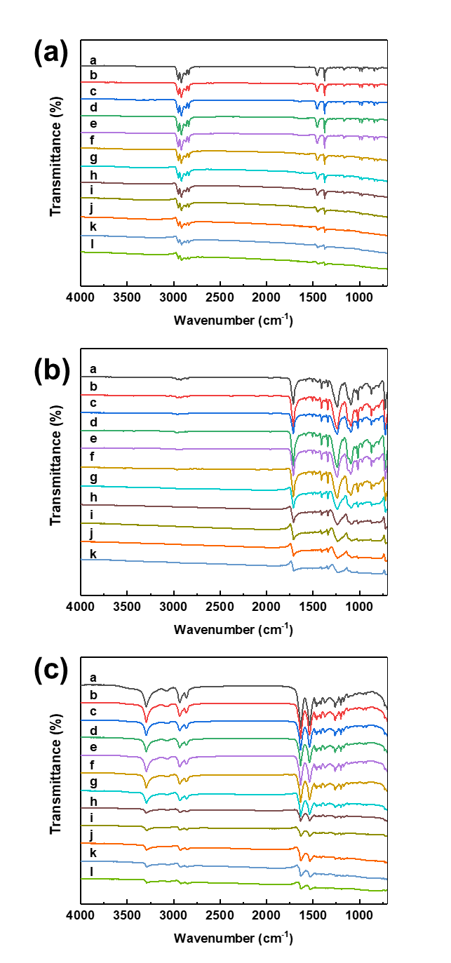
Fig. S1. FT-IR spectra of (a) CB/PP, (b) CB/PET and (c) CB/Nylon composites. (a: neat polymer, b-l is amount of CB content; b: 0.1wt% , c: 0.5wt%, d: 0.7wt%, e:1.0 wt%, f: 3.0 wt%, g:5.0 wt%, h: 7.0 wt%, i: 10.0 wt%, j; 12.0 wt%, k; 15.0 wt%, l: 18.0 wt%)

