In accordance to Nature Publishing Groups Authorship Policy we agree to change the authors of the manuscript as indicated below.

NAME OF JOURNAL: Scientific Reports

TITLE OF MANUSCRIPT: Visual short-term memory for coherent motion in video game players: evidence from a memory-masking paradigm

MANUSCRIPT NUMBER: SREP-18-07078B

CORRESPONDING AUTHORS NAME: Andrea Pavan

PREVIOUS AUTHOR NAMES:
Andrea Pavan, Martine Hobaek, Steven P. Blurton, Filippo Ghin, Mark W. Greenlee

UPDATED AUTHOR NAMES:
Andrea Pavan, Martine Hobaek, Steven P. Blurton, Adriano Contillo, Filippo Ghin, Mark W. Greenlee

CHANGE TO AUTHOR LIST: Adriano contillo has been added to the previous author list given his contribution with elaborated power function implementation, fitting procedure and model comparisons.

Print Name | Signature | Date
Andrea Pavan |  | 14/02/2019
Martine Hobaek | 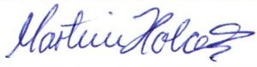 | 14/02/2019
Steven P. Blurton |  | 14/02/2019
Adriano Contillo |  | 14/02/2019
Filippo Ghin | 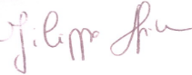 | 14/02/2019
Mark W. Greenlee | 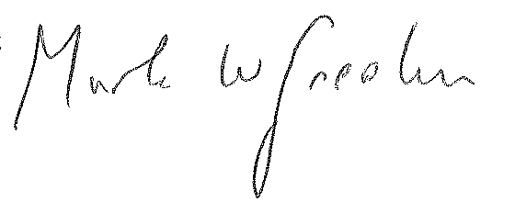 | 14/02/2019

