Improved methods for the detection of histone interactions with peptide microarrays

Christopher J. Petell^{1,2}, Andrea T. Pham¹, Jessica Skela¹, and Brian D. Strahl^{1,2}*

¹Department of Biochemistry and Biophysics, 120 Mason Farm Rd, University of North Carolina at Chapel Hill, NC, USA 27599; USA
²UNC Lineberger Comprehensive Cancer Center, 450 West Drive, University of North Carolina at Chapel Hill, NC, USA 27599; USA

*Corresponding Author: (brian_strahl@med.unc.edu)

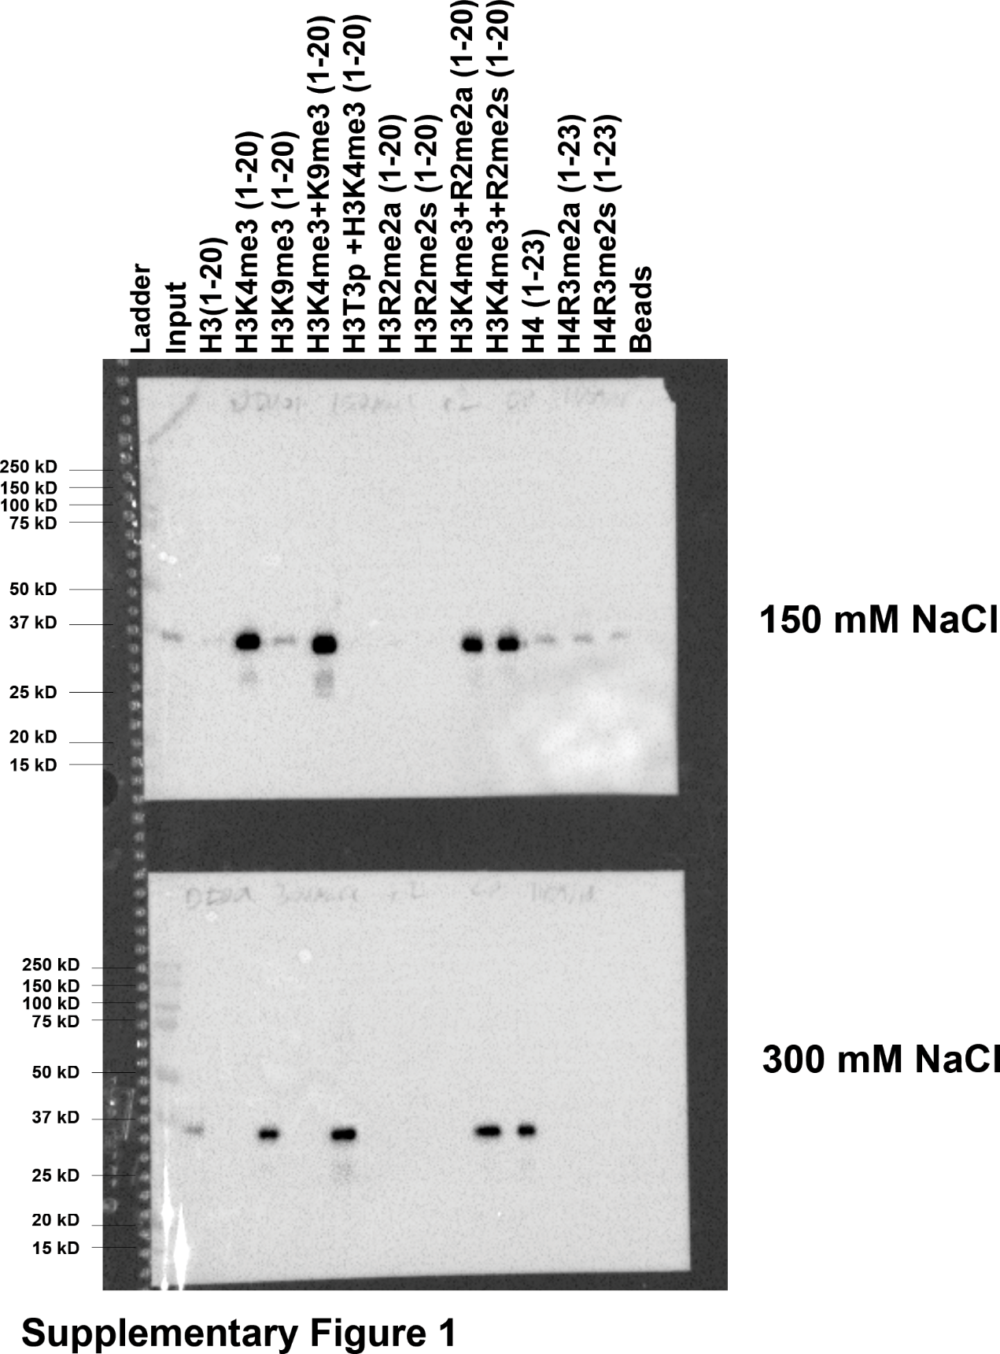

Supplementary Figure S1: Full images of representative Western blots.
Uncropped images of the Western blots used in Figure 1c, representative of triplicate experiments.
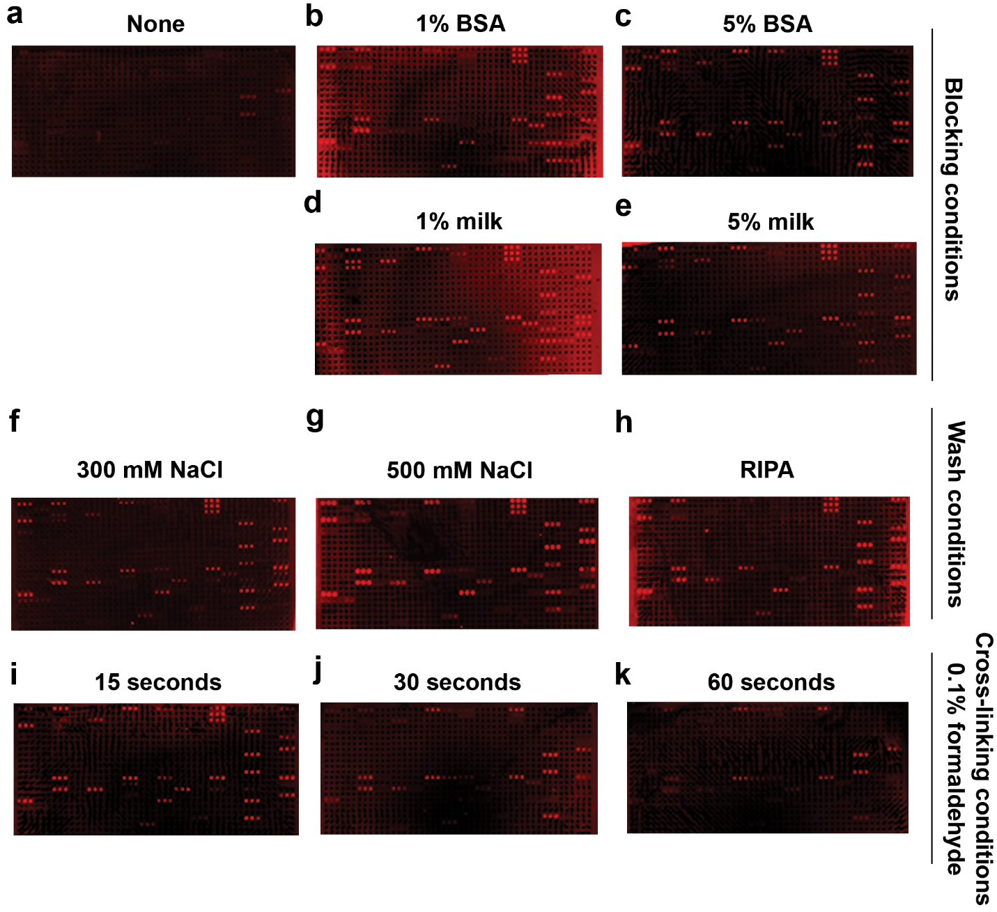
Supplementary Figure S2: Additional representative images for DIDO1 PHD array experiments.
a-e) Additional representative images of the arrays presented in Figures 1-2, with panels a-e corresponding to Figure 1b, Figure 2a-d, Figure 3a, and Figure 5b. f-h) Second set of representative images of the arrays presented in Figure 3, where panels f-h correspond to Figure 3b-d and Figure 4a. i-k) Additional set of representative images for arrays shown in Figure 4, with panels i-j corresponding to Figure 4b-d and Figure 5c. Images are representative of array results for greater or equal to four experiments (i.e., n ≥ 4 subarrays).
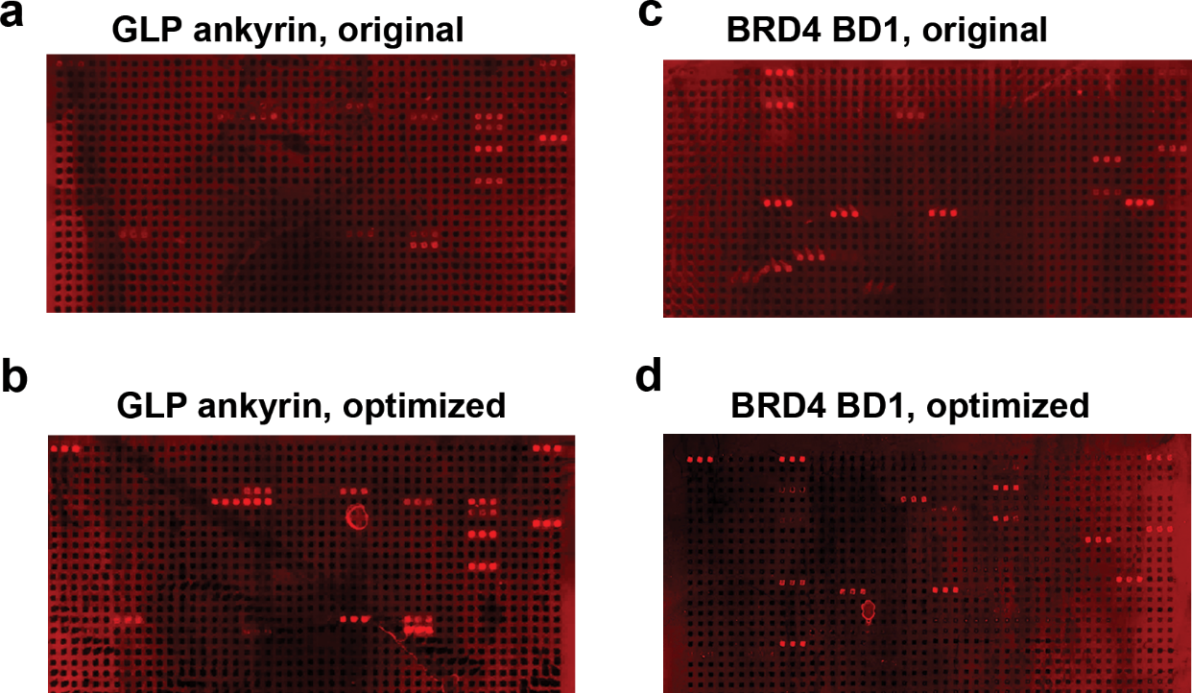

Supplementary Figure S3: Additional representative images for GLPA ankyrin and BRD4 bromodomain 1 arrays.
a-d) Additional representative images of the arrays presented in Figure 6 for the GLP ankyrin domain using the original (a) and optimized (b) method and for the BRD4 bromodomain 1 (BD1) using the original c) and optimized (d) method. Images are representative of array results for greater or equal to four experiments (i.e., n ≥ 4 subarrays).

