Supplementary information

Egocentrically-stable discriminative stimulus-based spatial navigation in mice: implementation and comparison with allocentric cues

Jinsung Chun, Youngsoo Kim, Jin Woo Choi, Daesoo Kim and Sungho Jo

- Supplementary figure 1
- Supplementary figure 2
- Supplementary figure 3
- Supplementary figure 4
- Supplementary figure 5
- Supplementary figure 6
- Supplementary figure 7
- Supplementary figure 8

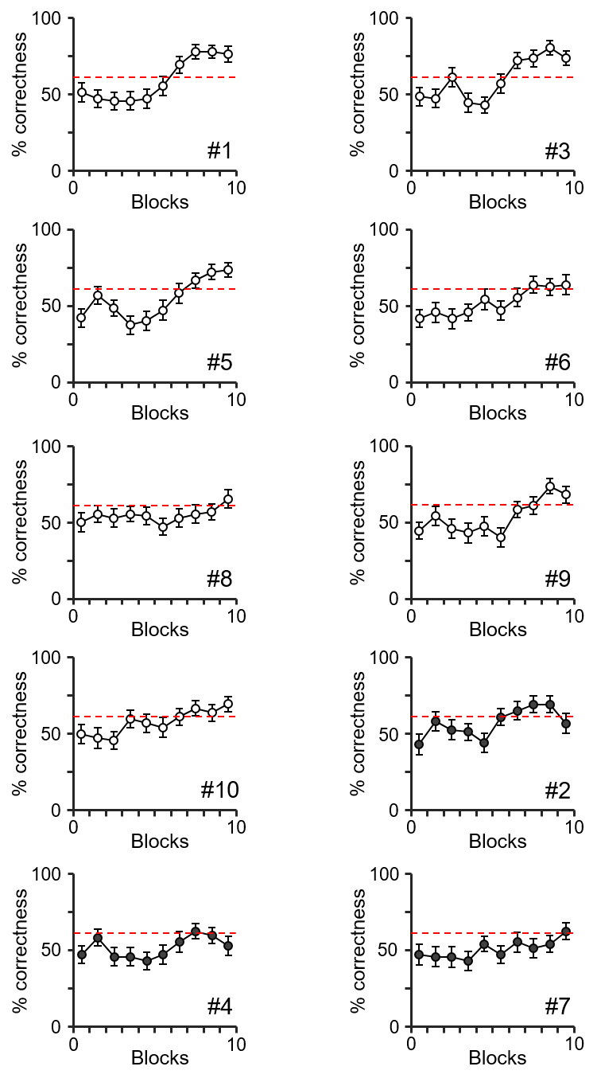

Figure S1. The progress of egocentric stimulus-based learning in an individual mouse.
The percentage of correctness during the training period of egocentric stimulus-based learning for each mouse (unfilled points, trained group; filled points, untrained group). The red dashed line indicates the lowest possible percentage that would signify a statistically significant amount of correct choices.
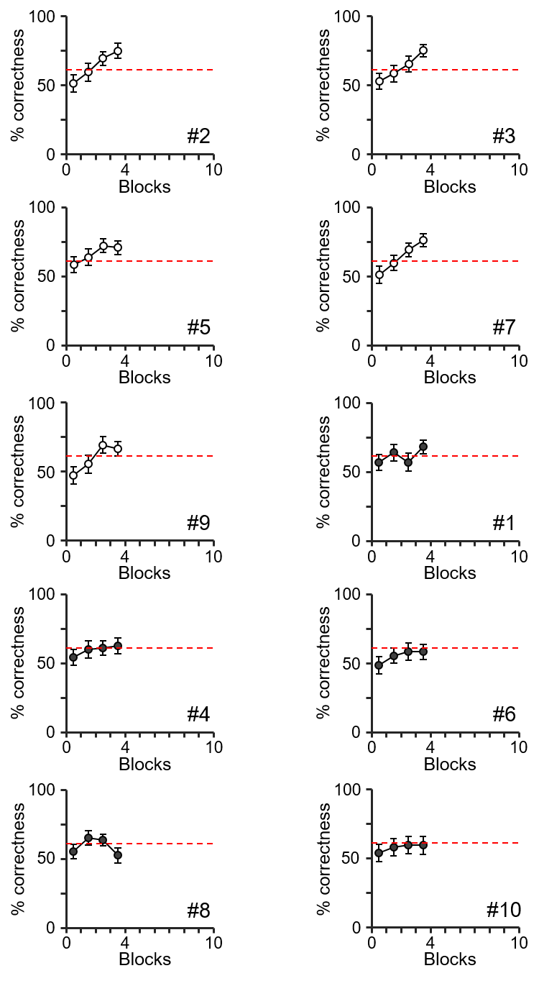

Figure S2. The progress of external route mark-based learning for each mouse.
The percentage of correctness during the training period of external route mark-based learning for each mouse (unfilled points, trained group; filled points, untrained group). The red dashed line indicates the lowest possible percentage that would signify a statistically significant amount of correct choices.
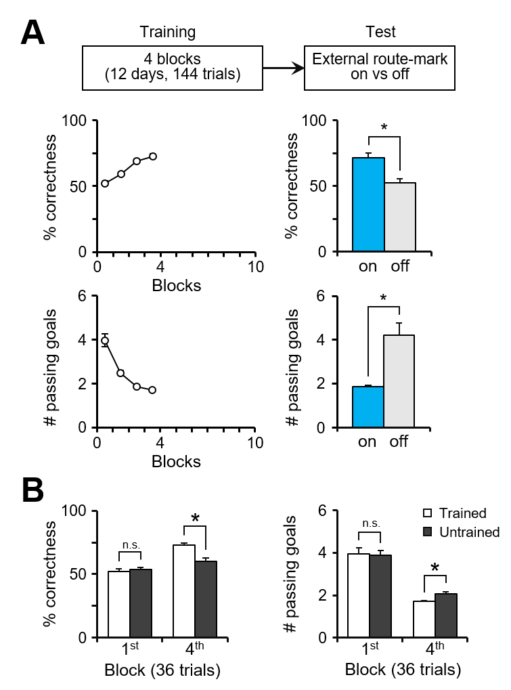

Figure S3. Mice successfully facilitate external route mark-based based learning for spatial navigation.
(A) The percentage of correctness (upper) and the total number of visited goal points until finding the correct goal (lower) for each block within the training period (4 blocks; 36 trials in a block). Data from the trained group of mice (n = 5/10) was used for analysis. The bar graphs show that behavioral performance significantly declines when lacking external route-marks (blue bar, with external route-mark; gray bar, without external route-mark; n = 5, two-tailed paired t-test, p = 0.016 in upper, p = 0.044 in lower). (B) A comparison of the percentage of correctness and the number of passing goal points between trained (n = 5/10, unfilled bar) and untrained mice (n = 5/10, filled bar). There was no significant difference between the two groups in the first block (two-tailed t-test, n = 5 vs. 5, p = 0.607 in left, p = 0.841 in right), in contrast to the significant difference in the fourth block (two-tailed t-test, n = 5 vs. 5, p = 0.015 in left, p = 0.010 in right).
*p < 0.05; n.s., no significant differences; Error bars are represented as mean ± SEM.

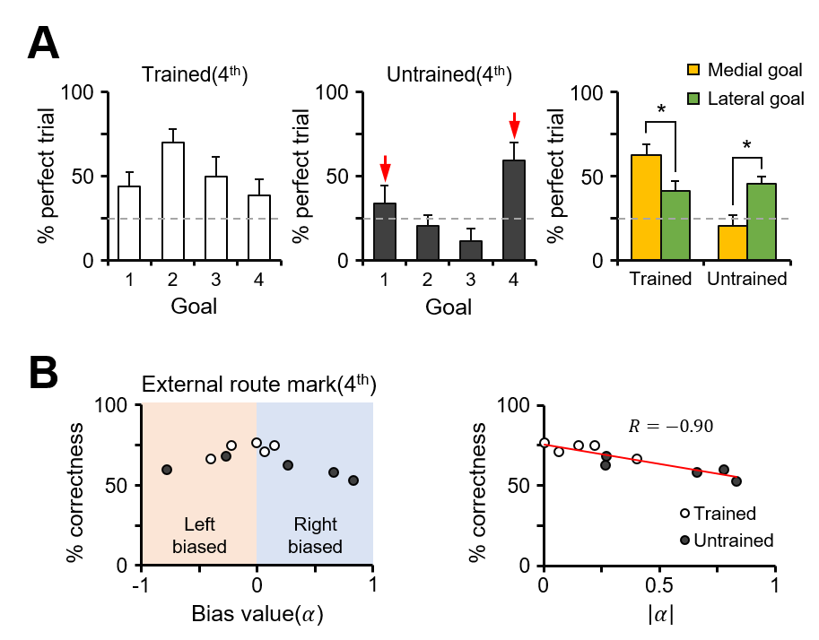

Figure S4. Biased selection strategy is negatively correlated with external route mark-based learning.
(A) The proportion of perfect trials among the trials with the same correct goal point for both the trained (unfilled, n = 5/10) and untrained (filled, n = 5/10) mice in the external route mark-based learning group. The gray dashed line indicates the probability of randomly choosing the correct goal point (1 out of 4 or 25%). The red arrows indicate the two goals that are lateral. The proportions of perfect trials for the trials with a medial goal point as the assigned destination (area 2 and 3, yellow) and those with a lateral goal point as the assigned destination (area 1 and 4, green) were compared. The trained mice show a significantly higher percentage of correctness for the medial trials compared to the lateral ones (n = 5, two-tailed paired t-test, p = 0.035), whereas the untrained mice show a significantly lower value for the medial trials compared to the lateral ones (n = 5, two-tailed paired t-test, p = 0.007). (B) Left: The scatterplot shows the percentage of correctness versus the bias value for both the trained (unfilled) and untrained (filled) groups (orange shadow, the case with left biased selection; blue shadow, the case with right biased selection). Right: The percentage of correctness versus the absolute value of the bias value. The red line is the best fit line resulting from linear regression, and the R-value indicates Pearson’s correlation coefficient.
*p < 0.05; n.s., no significant differences; Error bars are represented as mean ± SEM.

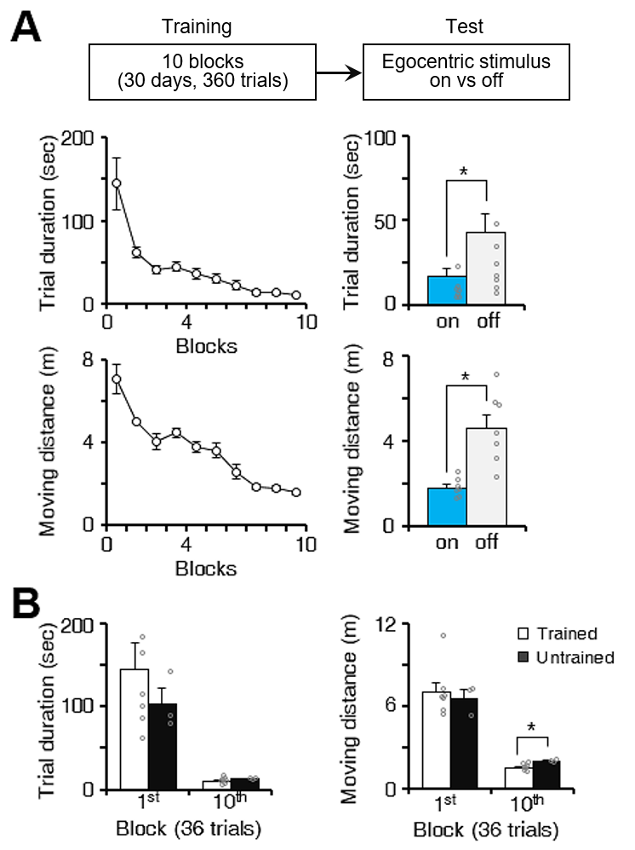

Figure S5, related to Figure 1. Latency to reach the goal and total path length of mice during egocentric stimulus-based learning.
(A) The bar graphs show that behavioral performance declined when egocentric stimuli were not provided (blue bar, with egocentric stimuli; gray bar, without egocentric stimuli; n = 7, two-tailed paired t-test, p = 0.013 in upper, p = 0.004 in lower). (B) The trial duration and the moving distance in a trial were compared between the trained (n = 7/10, unfilled bar) and untrained mice (n = 3/10, filled bar). There was no significant difference between the two groups in the first training block (two-tailed t-test, n = 7 vs. 3, p = 0.289 in left, p = 0.636 in right), whereas in the tenth block, there was a significant difference in the moving distances between the untrained and trained groups, but not in trial duration (two-tailed t-test, n = 7 vs. 3, p = 0.197 in left, p = 0.002 in right). *p < 0.05; n.s., no significant differences; Error bars represent the mean ± SEM.

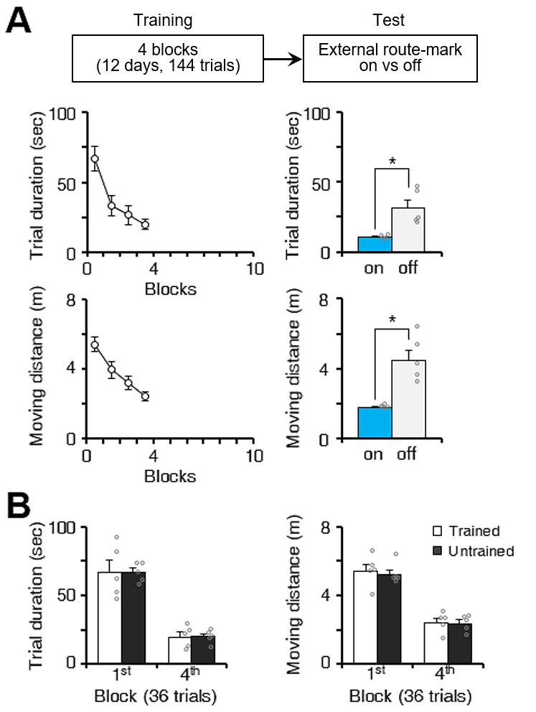

Figure S6, related to Figure 3. Latency to reach the goal and total path length of mice during external route mark-based learning.
(A) The bar graphs show that behavioral performance declined without landmarks (blue bar, with external route-mark; gray bar, without external route-mark; n = 5, two-tailed paired t-test, p = 0.022 in upper, p = 0.010 in lower). (B) The trial duration and the moving distance in a trial were compared between the trained (n = 5/10, unfilled bar) and untrained mice (n = 5/10, filled bar). There were no significant differences between the two groups both in the first training block (two-tailed t-test, n = 5 vs. 5, p = 0.956 in left, p = 0.731 in right) and fourth block (two-tailed t-test, n = 5 vs. 5, p = 0.972 in left, p = 0.863 in right). *p < 0.05; n.s., no significant differences; Error bars represent the mean ± SEM.

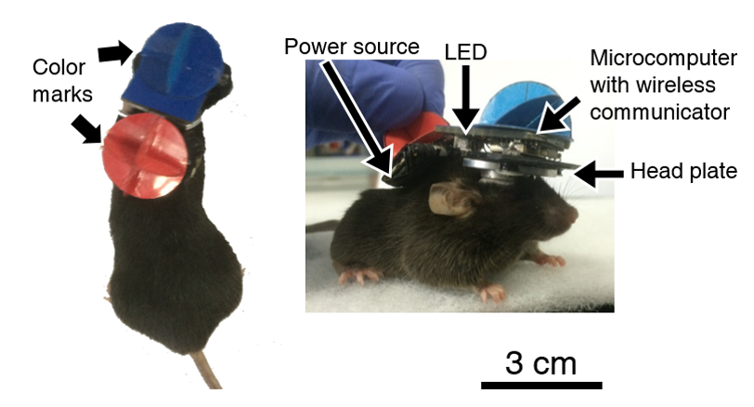

Figure S7. A snapshot of a mouse with the head-mounted device.
A snapshot of the head-mounted LED device on a mouse.

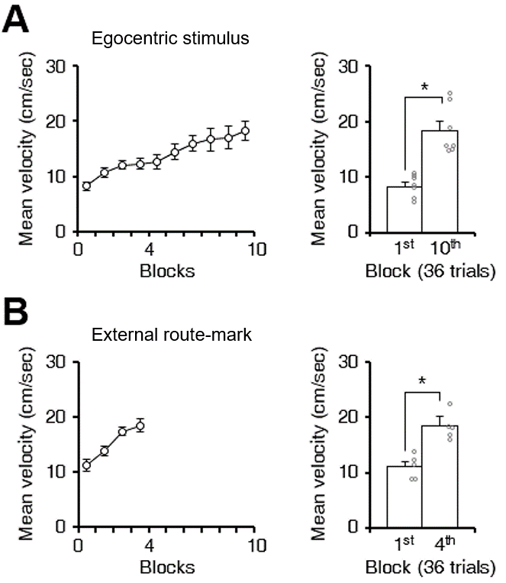

Figure S8, related to Figure 1 and 3. Mean velocity in a trial during external route mark-based learning of mice. (A) The mean velocity for each block within the training period for egocentric stimulus-based learning (10 blocks; 36 trials in each block). Data from the trained group (n = 7/10) was used for analysis. The bar graph shows that the mean velocity significantly increased from the first block to the tenth block. (1st vs. 10th; n = 7, two-tailed paired t-test, p < 0.001). (B) The mean velocity for each block within the training period for external route mark-based learning (4 blocks; 36 trials in each block). Data from the trained group (n = 5/10) was used for analysis. The bar graph shows that the mean velocity significantly increased from the first block to the fourth block. (1st vs. 4th; n = 5, two-tailed paired t-test, p = 0.004). *p < 0.05; n.s., no significant differences; Error bars represent the mean ± SEM. Gray dots represent individual data point.

