Supplementary data
Biogeographical origin and timing of the founder ichthyosis TGM1 c.1187G>A mutation in an isolated Ecuadorian population

Uxia Saraiva Esperón-Moldes^{1,2}, Jacobo Pardo-Seco^{2,3}, Martha Montalván-Suárez⁴, Laura Fachal¹, Manuel Ginarte⁵, Laura Rodríguez-Pazos⁶, Alberto Gómez-Carballa³, María Fernanda Moscoso⁷, Nora Ugalde-Noritz⁸, Andrés Ordóñez-Ugalde^{1,7,8}, Daniel Tettamanti-Miranda⁹, Juan Carlos Ruiz¹⁰, Antonio Salas^{2,3,#,}*, Ana Vega^{1,#,}*

This file is composed of 7 figures and 3 tables attached as a separate XLSX file

Figure S1. Pedigree of family 1E.
Figure S2. Pedigree of family 5E.
Figure S3. Pedigree of family 11E.
Figure S4. Pedigree of family 17E.
Figure S5. Pedigree of family 24E.
Figure S6. Pedigree of family 25E.
Figure S7. Pedigree of family 27E.
Table S1. TMRCA and mutation age estimations. Detailed information of each marker including: distance to the mutation in Mb, estimated recombination fraction, founder allele in cases and controls. TMRCA calculations in generations for each marker and Labuda´s correction also in generations. The botton row shows the median of the TMRCA age estimation for each estimator and the interquartile range (IQR), Gamma method and DMLE results are given in number of generations with a confidence interval of 95%. θ: recombination fraction according to Haldane mapping function, PD: frequency of the founder allele in the normal population, PN: frequency of the founder allele in the disease population.
Table S2. Markers used for the ancestral study, including their chromosomal location, the number of markers before and after LD (Linkage disequilibrium) filtering.
Table S3. Phased haplotypes of the control population (Ecuador and Galicia) for the 10 STR markers.
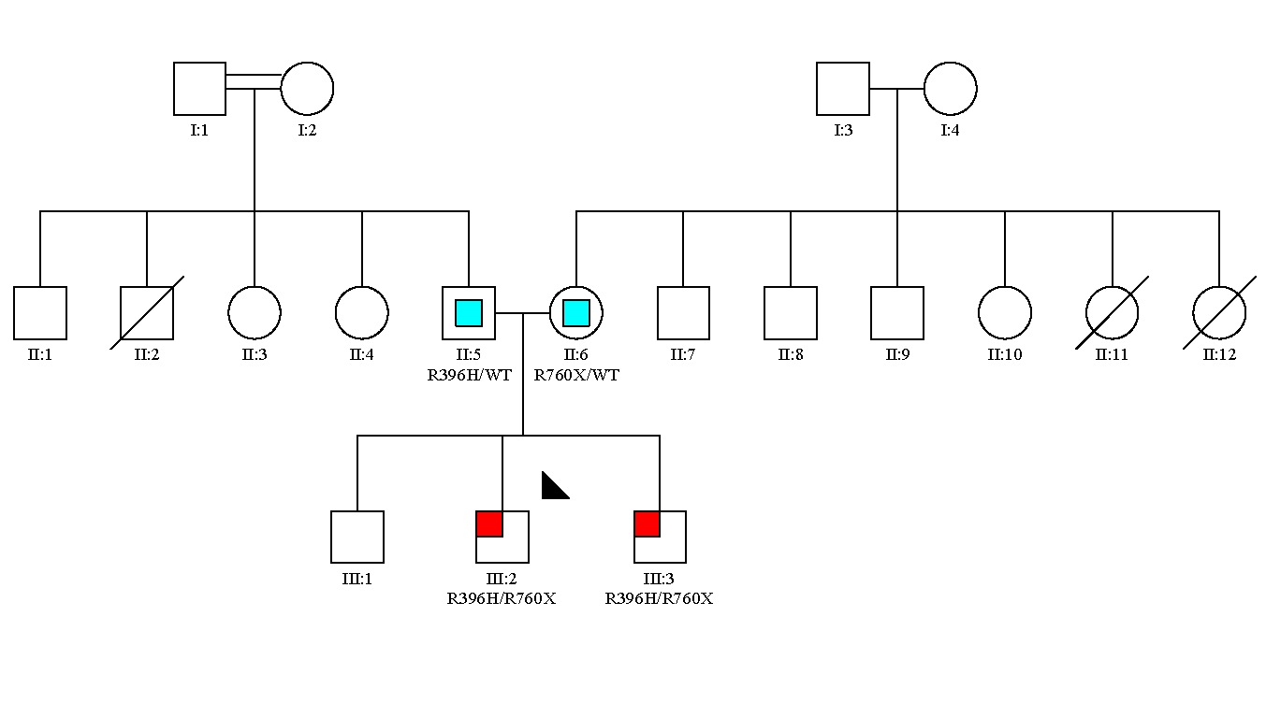
Figure S1. Pedigree of family 1E. Affected subjects and carriers are denoted with red and blue squares, respectively. The proband is marked with an upper left arrow.

Figure S2. Pedigree of family 5E. Affected subjects and carriers are denoted with red and blue squares, respectively. The proband is marked with an upper left arrow.
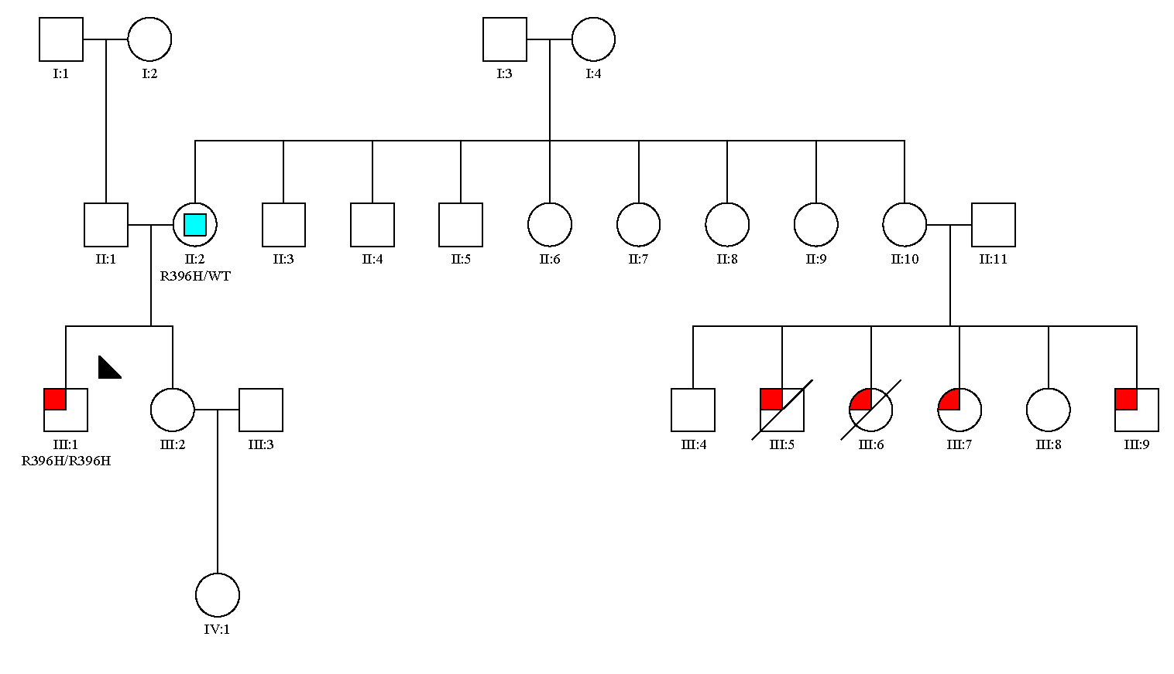

Figure S3. Pedigree of family 11E. Affected subjects and carriers are denoted with red and blue squares, respectively. The proband is marked with an upper left arrow.
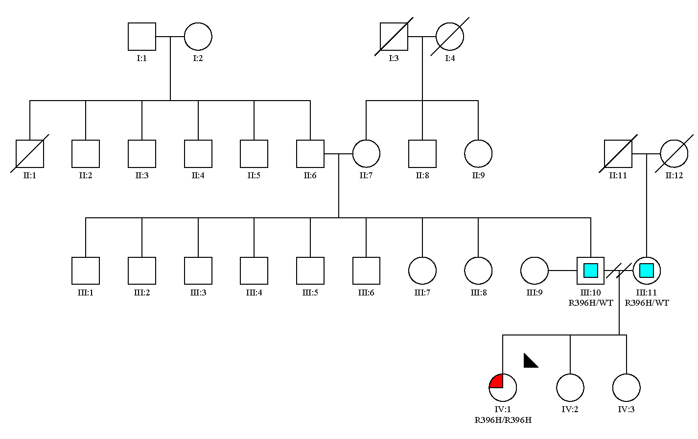

Figure S4. Pedigree of family 17E. Affected subjects and carriers are denoted with red and blue squares, respectively. The proband is marked with an upper left arrow.

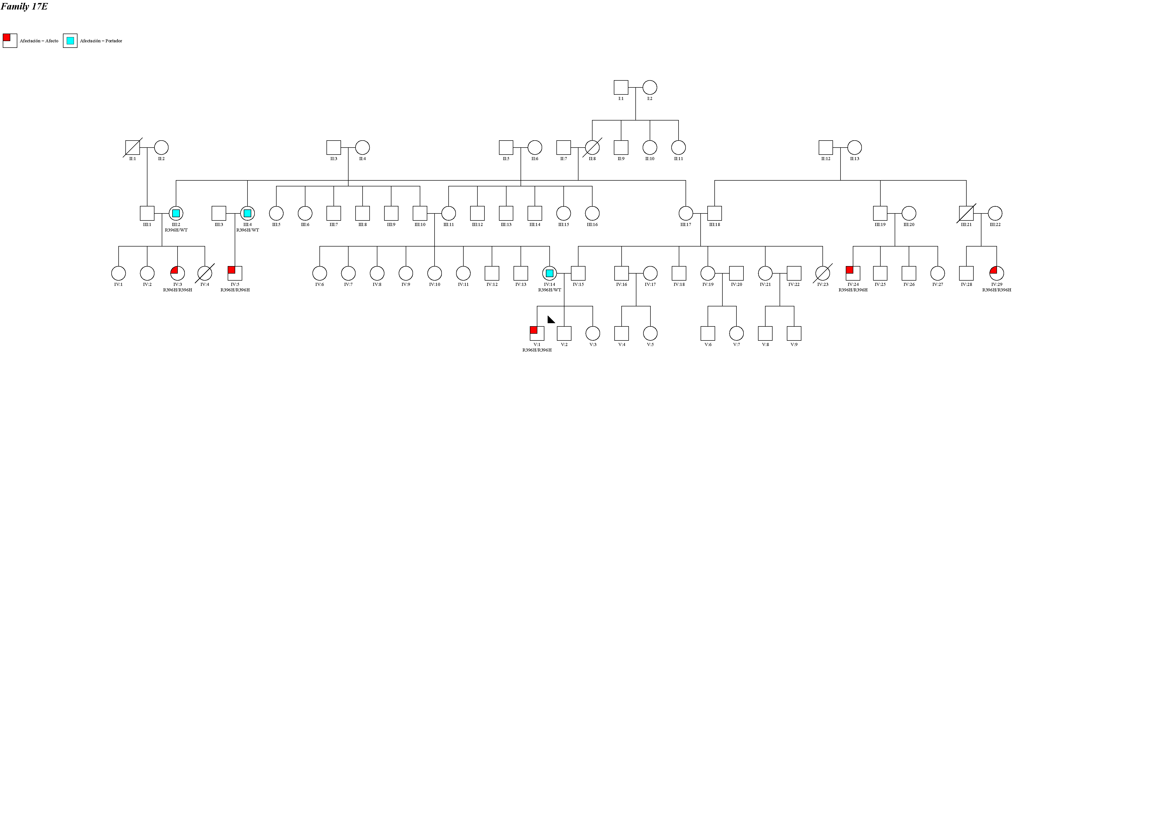

Figure S5. Pedigree of family 24E. Affected subjects and carriers are denoted with red and blue squares, respectively. The proband is marked with an upper left arrow.

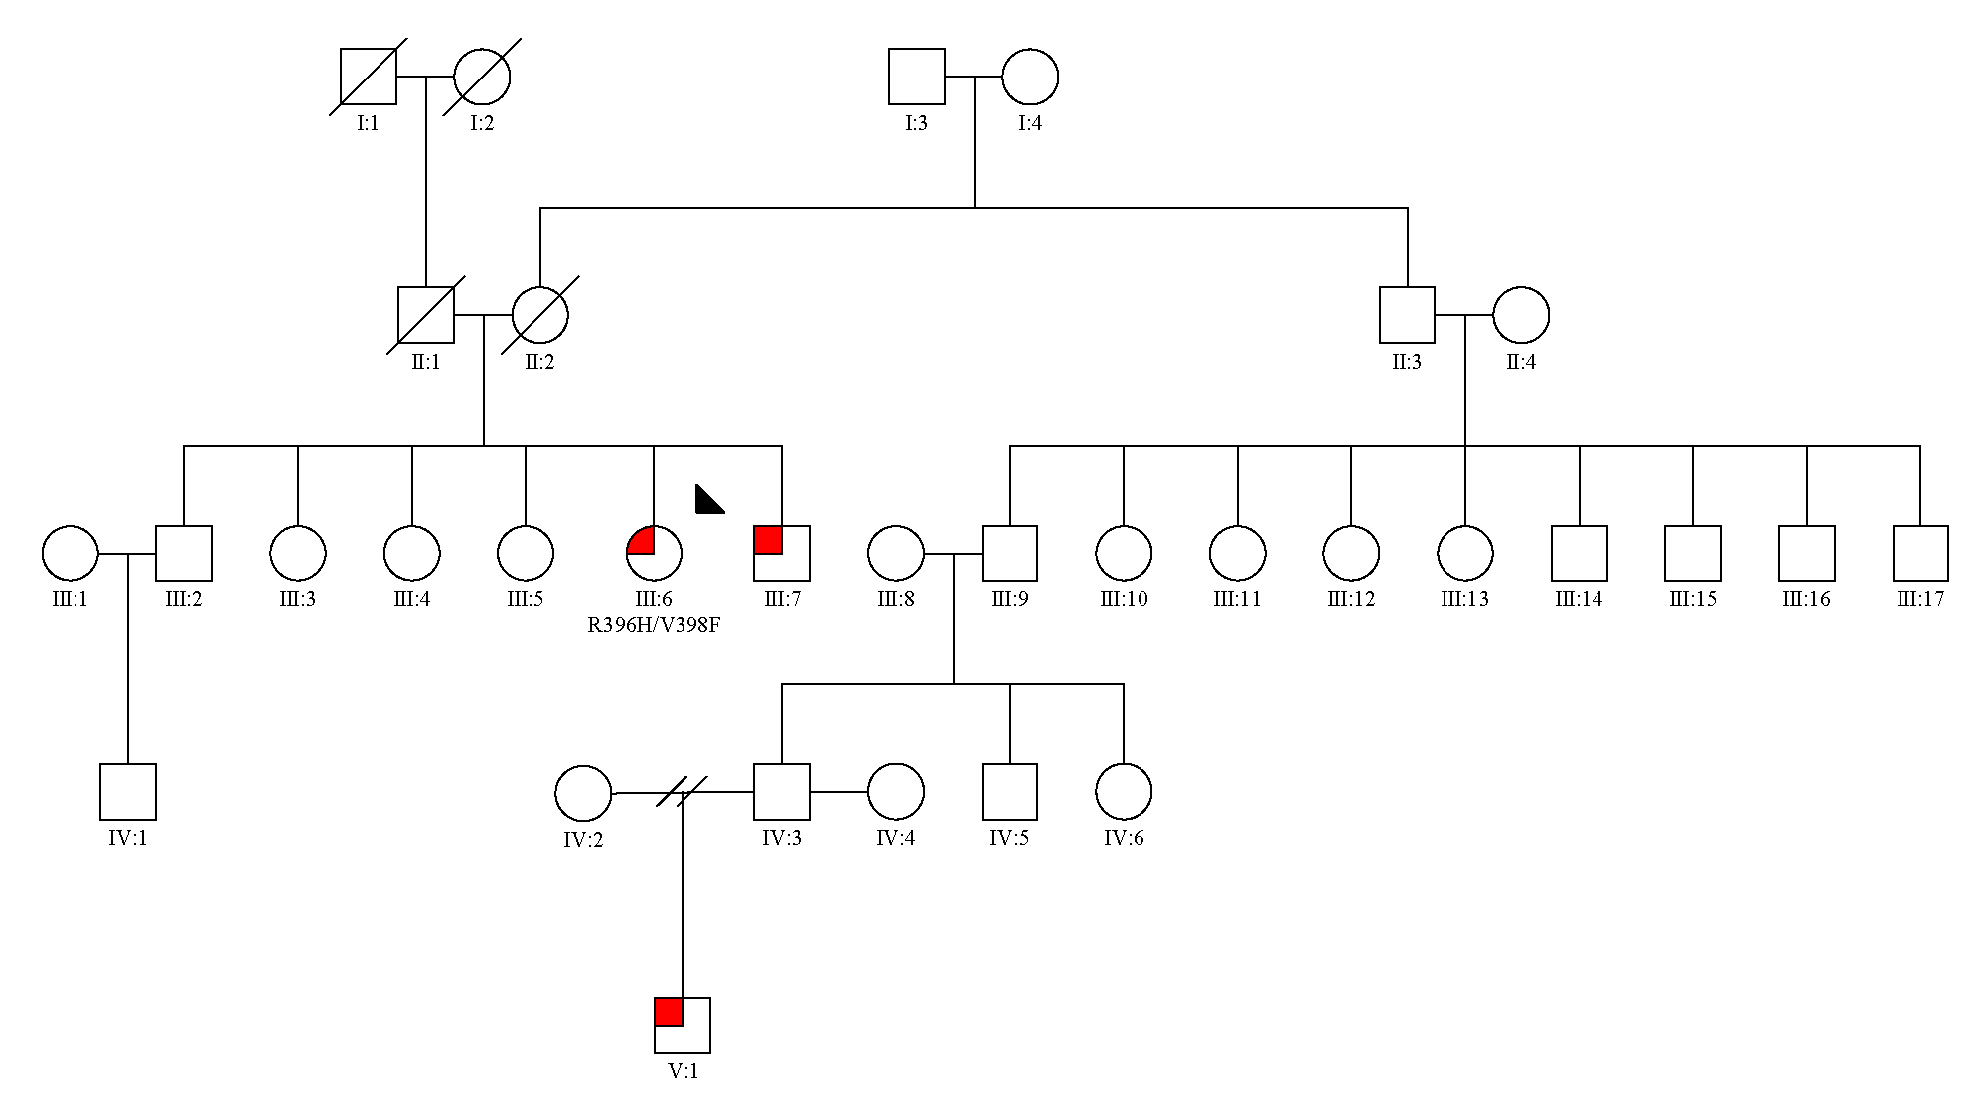

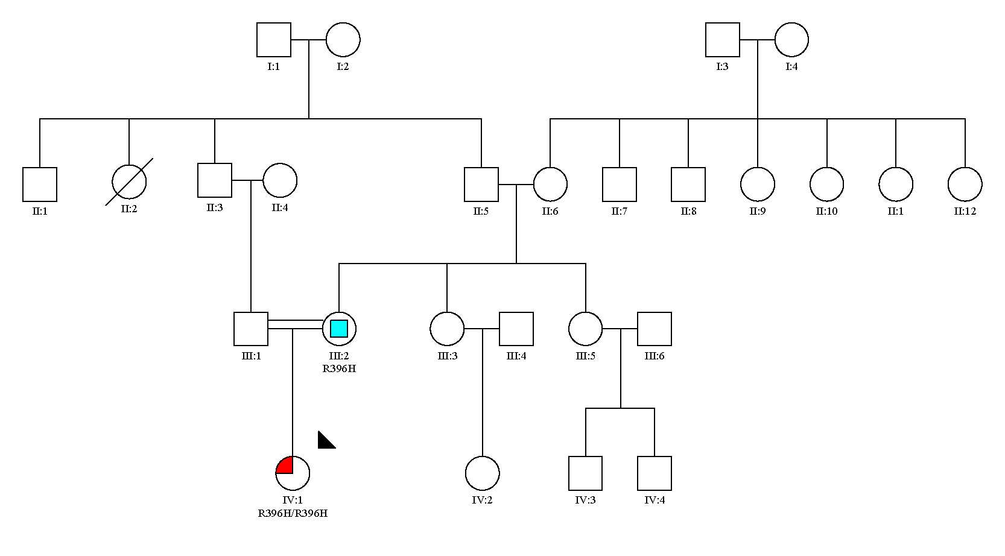
Figure S6. Pedigree of family 25E. Affected subjects and carriers are denoted with red and blue squares, respectively. The proband is marked with an upper left arrow.

Figure S7. Pedigree of family 27E. Affected subjects and carriers are denoted with red and blue squares, respectively. The proband is marked with an upper left arrow.

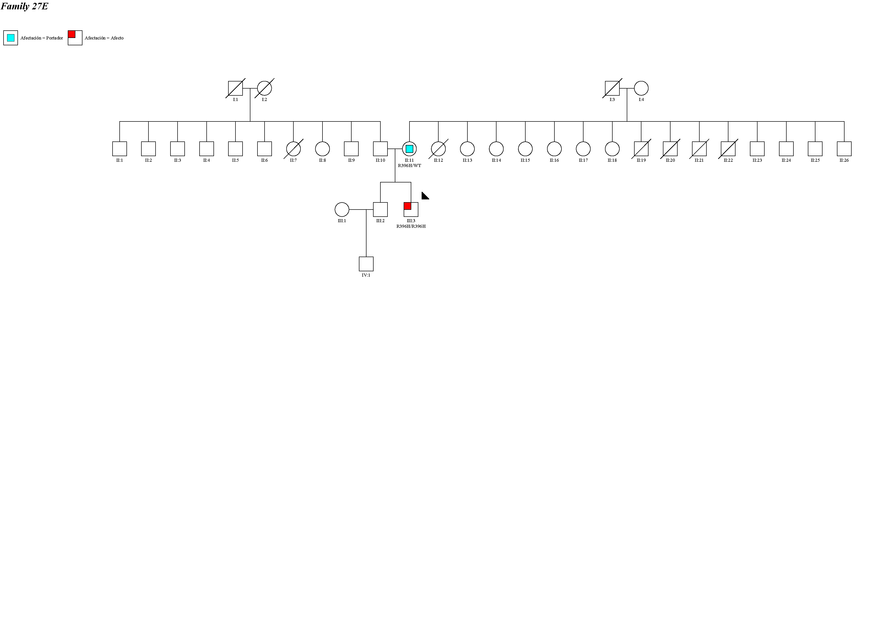

Table S1. TMRCA and mutation age estimations. Detailed information of each marker including: distance to the mutation in Mb, estimated recombination fraction, founder allele in cases and controls.

MICROSATELLITES |  |  |  |  |  | TMRCA ESTIMATIONS |  |  |  |  |  |  |  | MUTATION AGE ESTIMATION
Markers | Distance to mutation | Haldane (θ) | Founder allele | PD | PN | Labuda correction | Bergman | Bergman corrected | Labuda | Labuda corrected | Risch | Lander | Gamma method | DMLE
D14S72 | 3,36 | 0,069 | 1 | 0,3 | 0,22 | 5 | 32 | 39 | 17 | 22 | 10176 | 8 | * | *
D14S1043 | 3,35 | 0,069 | 5 | 0,6 | 0,83 | 8 | * | * | 13 | 21 | 5 | 17 | * | *
D14S742 | 2,52 | 0,053 | 3 | 0,85 | 0,4 | 10 | 5 | 14 | 5 | 15 | 57 | 43 | * | *
D14S581 | 0,43 | 0,009 | 3 | 0,45 | 0,29 | 20 | 155 | 173 | 150 | 170 | * | 81 | * | *
D14S64 | 0,17 | 0,004 | 8 | 0,5 | 0,03 | 26 | 196 | 218 | 331 | 357 | * | 225 | * | *
D14S264 | 0,55 | 0,005 | 8 | 1 | 0,27 | 19 | * | * | * | * | * | * | * | *
D14S1032 | 1,48 | 0,032 | 8 | 0,75 | 0,12 | 13 | 10 | 22 | 16 | 29 | 16 | 56 | * | *
D14S275 | 1,97 | 0,042 | 3 | 0,75 | 0,31 | 11 | 10 | 21 | 12 | 23 | 20 | 38 | * | *
D14S1042 | 4,53 | 0,091 | 4 | 0,9 | 0,35 | 6 | 2 | 8 | 2 | 8 | * | 30 | * | *
D14S1060 | 8,69 | 0,16 | 5 | 0,8 | 0,57 | 3 | 4 | 7 | 2 | 5 | 8 | 13 | * | *
 |  |  |  |  |  | Generations | 10 (5-10) | 22 (11-22) | 13 (5-13) | 22 (15-22) | 18 (8-18) | 38 (17-38) | 27(20-37) | 41(32-58)

TMRCA calculations in generations for each marker and Labuda´s correction also in generations.
The botton row shows the median of the TMRCA age estimation for each estimator and the interquartile range (IQR)
Gamma method and DMLE results are given in number of generations with a confidence interval of 95%
θ: recombination fraction according to Haldane mapping function
PD: frequency of the founder allele in the normal population
PN: frequency of the founder allele in the disease population

Table S2. Markers used for the ancestral study.
Chromosome | Start | End | Nº of markers | Nº of markers after LD filtering | Genes
chr1 | 35225291 | 35225439 | 8 | 3 | GJB4
chr1 | 35226483 | 35229375 | 156 | 48 | GJB4
chr1 | 35246739 | 35247429 | 13 | 4 | GJB3
chr1 | 35247828 | 35248093 | 10 | 4 | GJB3
chr1 | 35250288 | 35252020 | 74 | 25 | GJB3
chr1 | 152274600 | 152287273 | 1068 | 235 | FLG
chr1 | 152287744 | 152288003 | 6 | 0 | FLG
chr1 | 152297614 | 152297729 | 2 | 1 | FLG
chr1 | 153232125 | 153232259 | 3 | 0 | LOR
chr1 | 153233351 | 153234650 | 30 | 14 | LOR
chr1 | 155204188 | 155205685 | 41 | 14 | GBA
chr1 | 155205922 | 155206310 | 15 | 8 | GBA
chr1 | 155207081 | 155207419 | 5 | 0 | GBA
chr1 | 155207672 | 155208147 | 14 | 2 | GBA
chr1 | 155208257 | 155208732 | 10 | 4 | GBA
chr1 | 155209126 | 155209603 | 15 | 4 | GBA
chr1 | 155209626 | 155210140 | 16 | 4 | GBA
chr1 | 155210370 | 155210558 | 5 | 0 | GBA
chr1 | 155210826 | 155211119 | 9 | 3 | GBA
chr1 | 155213835 | 155214074 | 8 | 2 | GBA
chr1 | 155214246 | 155214703 | 18 | 7 | GBA
chr2 | 128014815 | 128015353 | 17 | 5 | ERCC3
chr2 | 128016821 | 128020508 | 104 | 36 | ERCC3
chr2 | 128028861 | 128029079 | 1 | 0 | ERCC3
chr2 | 128030390 | 128030587 | 4 | 1 | ERCC3
chr2 | 128036698 | 128037003 | 5 | 1 | ERCC3
chr2 | 128037972 | 128038257 | 11 | 2 | ERCC3
chr2 | 128044228 | 128044643 | 10 | 2 | ERCC3
chr2 | 128046185 | 128046490 | 11 | 3 | ERCC3
chr2 | 128046862 | 128048215 | 35 | 7 | ERCC3
chr2 | 128049960 | 128050472 | 14 | 6 | ERCC3
chr2 | 128051038 | 128051802 | 36 | 10 | ERCC3
chr2 | 159813999 | 159963000 | 4049 | 578 | INTERGENIC
chr2 | 215796215 | 215797515 | 35 | 7 | ABCA12
chr2 | 215798751 | 215798989 | 6 | 2 | ABCA12
chr2 | 215802183 | 215802389 | 7 | 1 | ABCA12
chr2 | 215807598 | 215807791 | 5 | 2 | ABCA12
chr2 | 215809674 | 215809878 | 5 | 1 | ABCA12
chr2 | 215812095 | 215812330 | 1 | 1 | ABCA12
chr2 | 215813269 | 215813511 | 5 | 1 | ABCA12
chr2 | 215813713 | 215813923 | 7 | 3 | ABCA12
chr2 | 215815552 | 215815857 | 8 | 4 | ABCA12
chr2 | 215818527 | 215818881 | 10 | 3 | ABCA12
chr2 | 215819875 | 215820135 | 15 | 3 | ABCA12
chr2 | 215821336 | 215821552 | 5 | 1 | ABCA12
chr2 | 215822950 | 215823228 | 7 | 2 | ABCA12
chr2 | 215823697 | 215823852 | 7 | 1 | ABCA12
chr2 | 215831521 | 215831727 | 7 | 1 | ABCA12
chr2 | 215833393 | 215833581 | 5 | 1 | ABCA12
chr2 | 215834946 | 215835174 | 12 | 2 | ABCA12
chr2 | 215838622 | 215838816 | 3 | 1 | ABCA12
chr2 | 215839451 | 215839638 | 5 | 2 | ABCA12
chr2 | 215840458 | 215840811 | 12 | 0 | ABCA12
chr2 | 215842989 | 215843240 | 4 | 0 | ABCA12
chr2 | 215843477 | 215843814 | 15 | 2 | ABCA12
chr2 | 215845156 | 215845417 | 11 | 1 | ABCA12
chr2 | 215846860 | 215847157 | 6 | 2 | ABCA12
chr2 | 215848320 | 215848639 | 8 | 5 | ABCA12
chr2 | 215851215 | 215851502 | 8 | 3 | ABCA12
chr2 | 215852320 | 215852567 | 4 | 0 | ABCA12
chr2 | 215854002 | 215854395 | 6 | 3 | ABCA12
chr2 | 215855375 | 215855805 | 9 | 2 | ABCA12
chr2 | 215862368 | 215862583 | 10 | 3 | ABCA12
chr2 | 215865378 | 215865794 | 11 | 1 | ABCA12
chr2 | 215866231 | 215866511 | 6 | 1 | ABCA12
chr2 | 215868882 | 215869073 | 6 | 1 | ABCA12
chr2 | 215872400 | 215872620 | 3 | 0 | ABCA12
chr2 | 215875004 | 215875244 | 2 | 1 | ABCA12
chr2 | 215876112 | 215876423 | 10 | 5 | ABCA12
chr2 | 215876644 | 215876909 | 11 | 2 | ABCA12
chr2 | 215880163 | 215880437 | 9 | 2 | ABCA12
chr2 | 215882681 | 215882906 | 5 | 2 | ABCA12
chr2 | 215884009 | 215884570 | 17 | 3 | ABCA12
chr2 | 215890346 | 215890553 | 5 | 1 | ABCA12
chr2 | 215891493 | 215891712 | 6 | 1 | ABCA12
chr2 | 215896494 | 215896860 | 6 | 2 | ABCA12
chr2 | 215901626 | 215901839 | 8 | 3 | ABCA12
chr2 | 215910510 | 215910789 | 10 | 1 | ABCA12
chr2 | 215914299 | 215914585 | 8 | 1 | ABCA12
chr2 | 215917160 | 215917358 | 7 | 0 | ABCA12
chr2 | 215919246 | 215919438 | 3 | 0 | ABCA12
chr2 | 215928738 | 215928992 | 6 | 2 | ABCA12
chr2 | 215940164 | 215940390 | 5 | 3 | ABCA12
chr2 | 215976269 | 215976463 | 6 | 0 | ABCA12
chr2 | 216002812 | 216003201 | 7 | 2 | ABCA12
chr3 | 3742447 | 3744195 | 75 | 22 | INTERGENIC
chr3 | 3819358 | 3819537 | 7 | 2 | INTERGENIC
chr3 | 3820874 | 3821056 | 3 | 0 | INTERGENIC
chr3 | 3822985 | 3824435 | 65 | 26 | INTERGENIC
chr3 | 3830547 | 3830808 | 10 | 5 | INTERGENIC
chr3 | 3836872 | 3837162 | 11 | 4 | INTERGENIC
chr3 | 3839534 | 3839948 | 12 | 3 | INTERGENIC
chr3 | 3841345 | 3841630 | 5 | 3 | LRRN1
chr3 | 3842334 | 3842609 | 7 | 4 | LRRN1
chr3 | 3864367 | 3864631 | 11 | 1 | LRRN1
chr3 | 3868875 | 3869243 | 9 | 2 | LRRN1
chr3 | 4046822 | 4046930 | 3 | 1 | INTERGENIC
chr3 | 4110202 | 4110479 | 9 | 5 | INTERGENIC
chr3 | 4270943 | 4271082 | 7 | 3 | INTERGENIC
chr3 | 4402778 | 4403988 | 62 | 28 | SUMF1
chr3 | 4417963 | 4418123 | 6 | 3 | SUMF1
chr3 | 4452498 | 4452712 | 7 | 1 | SUMF1
chr3 | 4458761 | 4458976 | 2 | 1 | SUMF1
chr3 | 4459643 | 4459866 | 10 | 2 | SUMF1
chr3 | 4461697 | 4461880 | 10 | 3 | SUMF1
chr3 | 4490899 | 4491074 | 6 | 2 | SUMF1
chr3 | 4494509 | 4494783 | 8 | 1 | SUMF1
chr3 | 4508609 | 4509016 | 19 | 8 | SUMF1
chr3 | 43731554 | 43731744 | 3 | 1 | ABHD5
chr3 | 43731822 | 43732252 | 18 | 3 | ABHD5
chr3 | 43732311 | 43732581 | 21 | 9 | ABHD5
chr3 | 43732698 | 43733051 | 8 | 4 | ABHD5
chr3 | 43740717 | 43741287 | 13 | 4 | ABHD5
chr3 | 43743353 | 43743550 | 4 | 1 | ABHD5
chr3 | 43743656 | 43744129 | 16 | 2 | ABHD5
chr3 | 43753148 | 43753406 | 8 | 1 | ABHD5
chr3 | 43756388 | 43756600 | 4 | 1 | ABHD5
chr3 | 43759109 | 43759399 | 5 | 0 | ABHD5
chr3 | 43759884 | 43764267 | 115 | 21 | ABHD5
chr3 | 43775491 | 43775913 | 19 | 2 | ABHD5
chr3 | 190023439 | 190026278 | 85 | 28 | CLDN1
chr3 | 190027907 | 190028092 | 5 | 1 | CLDN1
chr3 | 190030610 | 190031057 | 21 | 4 | CLDN1
chr3 | 190039722 | 190040314 | 22 | 10 | CLDN1
chr5 | 147405195 | 147405399 | 6 | 2 | SPINK5
chr5 | 147443375 | 147443712 | 14 | 4 | SPINK5
chr5 | 147444859 | 147445088 | 9 | 1 | SPINK5
chr5 | 147449835 | 147450063 | 6 | 2 | SPINK5
chr5 | 147451660 | 147451833 | 4 | 1 | SPINK5
chr5 | 147465917 | 147466145 | 7 | 0 | SPINK5
chr5 | 147468054 | 147468218 | 3 | 0 | SPINK5
chr5 | 147468531 | 147468706 | 3 | 1 | SPINK5
chr5 | 147468729 | 147468885 | 2 | 0 | SPINK5
chr5 | 147469006 | 147469234 | 8 | 4 | SPINK5
chr5 | 147470165 | 147470313 | 4 | 0 | SPINK5
chr5 | 147470440 | 147470658 | 6 | 2 | SPINK5
chr5 | 147470677 | 147470841 | 5 | 1 | SPINK5
chr5 | 147473866 | 147474094 | 10 | 5 | SPINK5
chr5 | 147475330 | 147475518 | 5 | 0 | SPINK5
chr5 | 147477379 | 147477616 | 6 | 2 | SPINK5
chr5 | 147478746 | 147478928 | 5 | 0 | SPINK5
chr5 | 147479966 | 147480194 | 10 | 2 | SPINK5
chr5 | 147480867 | 147481049 | 9 | 1 | SPINK5
chr5 | 147481293 | 147481521 | 11 | 4 | SPINK5
chr5 | 147484464 | 147484613 | 7 | 4 | SPINK5
chr5 | 147486549 | 147486777 | 12 | 3 | SPINK5
chr5 | 147488265 | 147488450 | 3 | 1 | SPINK5
chr5 | 147491280 | 147491508 | 8 | 3 | SPINK5
chr5 | 147492380 | 147492547 | 6 | 1 | SPINK5
chr5 | 147493874 | 147494102 | 8 | 0 | SPINK5
chr5 | 147495882 | 147496079 | 8 | 3 | SPINK5
chr5 | 147497949 | 147498177 | 6 | 2 | SPINK5
chr5 | 147498498 | 147498671 | 8 | 4 | SPINK5
chr5 | 147499521 | 147499749 | 9 | 3 | SPINK5
chr5 | 147499807 | 147500004 | 6 | 0 | SPINK5
chr5 | 147503345 | 147503573 | 6 | 2 | SPINK5
chr5 | 147504277 | 147504553 | 11 | 5 | SPINK5
chr5 | 147505036 | 147505226 | 7 | 1 | SPINK5
chr5 | 147505235 | 147505463 | 7 | 2 | SPINK5
chr5 | 147506495 | 147506692 | 5 | 1 | SPINK5
chr5 | 147510771 | 147511002 | 7 | 0 | SPINK5
chr5 | 147513309 | 147513500 | 6 | 3 | SPINK5
chr5 | 147516495 | 147516975 | 14 | 4 | SPINK5
chr5 | 156886976 | 156887637 | 23 | 9 | NIPAL4
chr5 | 156890051 | 156890391 | 15 | 4 | NIPAL4
chr5 | 156894006 | 156894163 | 5 | 3 | NIPAL4
chr5 | 156894214 | 156895026 | 22 | 9 | NIPAL4
chr5 | 156895679 | 156895870 | 10 | 3 | NIPAL4
chr5 | 156898614 | 156898875 | 8 | 1 | NIPAL4
chr5 | 156899289 | 156901780 | 65 | 17 | NIPAL4
chr6 | 36210894 | 36211088 | 4 | 2 | PNPLA1
chr6 | 36238186 | 36238491 | 13 | 1 | PNPLA1
chr6 | 36259046 | 36259382 | 19 | 10 | PNPLA1
chr6 | 36260787 | 36260953 | 11 | 3 | PNPLA1
chr6 | 36261889 | 36262226 | 11 | 3 | PNPLA1
chr6 | 36263090 | 36263251 | 6 | 4 | PNPLA1
chr6 | 36269587 | 36270296 | 33 | 8 | PNPLA1
chr6 | 36274018 | 36274203 | 7 | 3 | PNPLA1
chr6 | 36275313 | 36276422 | 37 | 19 | PNPLA1
chr6 | 137143651 | 137143983 | 10 | 6 | PEX7
chr6 | 137146301 | 137146459 | 2 | 1 | PEX7
chr6 | 137147406 | 137147657 | 8 | 2 | PEX7
chr6 | 137151094 | 137151448 | 6 | 4 | PEX7
chr6 | 137166702 | 137166880 | 3 | 2 | PEX7
chr6 | 137167160 | 137167369 | 4 | 1 | PEX7
chr6 | 137187714 | 137187921 | 4 | 1 | PEX7
chr6 | 137190977 | 137191191 | 5 | 2 | PEX7
chr6 | 137191819 | 137192027 | 3 | 1 | PEX7
chr6 | 137193285 | 137193441 | 2 | 2 | PEX7
chr6 | 137219229 | 137219429 | 5 | 2 | PEX7
chr6 | 137234545 | 137235122 | 17 | 6 | PEX7
chr6 | 158589328 | 158589477 | 15 | 3 | GTF2H5
chr6 | 158591451 | 158591620 | 5 | 1 | GTF2H5
chr6 | 158612958 | 158620426 | 228 | 63 | GTF2H5
chr7 | 40172291 | 40172908 | 13 | 4 | MPLKIP
chr7 | 40173777 | 40174308 | 15 | 4 | MPLKIP
chr7 | 100797627 | 100797983 | 21 | 9 | AP1S1
chr7 | 100799824 | 100800103 | 6 | 3 | AP1S1
chr7 | 100800607 | 100800816 | 7 | 2 | AP1S1
chr7 | 100802289 | 100802527 | 9 | 3 | AP1S1
chr7 | 100803749 | 100804608 | 27 | 8 | AP1S1
chr7 | 100804722 | 100804927 | 5 | 3 | AP1S1
chr9 | 131102788 | 131103167 | 13 | 5 | SLC27A4
chr9 | 131105355 | 131105622 | 8 | 1 | SLC27A4
chr9 | 131107383 | 131107878 | 19 | 8 | SLC27A4
chr9 | 131110773 | 131111032 | 6 | 3 | SLC27A4
chr9 | 131112540 | 131112710 | 7 | 3 | SLC27A4
chr9 | 131112712 | 131112904 | 6 | 1 | SLC27A4
chr9 | 131114866 | 131115076 | 4 | 1 | SLC27A4
chr9 | 131115253 | 131115563 | 9 | 7 | SLC27A4
chr9 | 131115643 | 131115870 | 6 | 0 | SLC27A4
chr9 | 131117281 | 131117519 | 3 | 1 | SLC27A4
chr9 | 131117626 | 131118125 | 19 | 5 | SLC27A4
chr9 | 131122562 | 131123799 | 36 | 14 | SLC27A4
chr10 | 13319745 | 13320404 | 17 | 5 | PHYH
chr10 | 13322925 | 13323160 | 8 | 1 | PHYH
chr10 | 13325639 | 13325889 | 7 | 2 | PHYH
chr10 | 13330309 | 13330591 | 13 | 3 | PHYH
chr10 | 13333410 | 13333962 | 18 | 10 | PHYH
chr10 | 13336377 | 13337037 | 27 | 8 | PHYH
chr10 | 13337177 | 13337656 | 15 | 4 | PHYH
chr10 | 13340136 | 13340295 | 8 | 4 | PHYH
chr10 | 13341369 | 13341813 | 21 | 8 | PHYH
chr10 | 13341917 | 13342180 | 6 | 3 | PHYH
chr10 | 13343935 | 13344462 | 13 | 5 | PHYH
chr10 | 90519901 | 90520057 | 5 | 2 | LIPN
chr10 | 90521104 | 90521320 | 1 | 0 | LIPN
chr10 | 90521894 | 90522112 | 5 | 1 | LIPN
chr10 | 90524116 | 90524415 | 8 | 3 | LIPN
chr10 | 90525975 | 90526185 | 3 | 1 | LIPN
chr10 | 90528498 | 90528735 | 11 | 5 | LIPN
chr10 | 90530551 | 90530798 | 9 | 4 | LIPN
chr10 | 90534179 | 90534351 | 2 | 2 | LIPN
chr10 | 90534798 | 90534970 | 7 | 4 | LIPN
chr10 | 90537715 | 90538049 | 14 | 7 | LIPN
chr11 | 130029406 | 130030139 | 18 | 7 | ST14
chr11 | 130057958 | 130058218 | 11 | 4 | ST14
chr11 | 130058374 | 130058602 | 9 | 8 | ST14
chr11 | 130058713 | 130058884 | 7 | 2 | ST14
chr11 | 130059169 | 130059841 | 27 | 12 | ST14
chr11 | 130059885 | 130060639 | 32 | 11 | ST14
chr11 | 130063993 | 130064233 | 10 | 3 | ST14
chr11 | 130064484 | 130064682 | 10 | 4 | ST14
chr11 | 130066183 | 130066393 | 11 | 3 | ST14
chr11 | 130066414 | 130066739 | 12 | 3 | ST14
chr11 | 130067685 | 130067890 | 12 | 5 | ST14
chr11 | 130068152 | 130068566 | 24 | 9 | ST14
chr11 | 130068791 | 130069014 | 11 | 3 | ST14
chr11 | 130069795 | 130070082 | 8 | 2 | ST14
chr11 | 130078254 | 130078629 | 12 | 3 | ST14
chr11 | 130079286 | 130080406 | 35 | 13 | ST14
chr12 | 53038291 | 53039403 | 47 | 18 | KRT2
chr12 | 53040473 | 53040794 | 13 | 3 | KRT2
chr12 | 53041463 | 53041689 | 7 | 2 | KRT2
chr12 | 53041906 | 53042171 | 12 | 4 | KRT2
chr12 | 53042740 | 53042936 | 11 | 4 | KRT2
chr12 | 53043647 | 53043808 | 6 | 2 | KRT2
chr12 | 53044072 | 53044506 | 12 | 1 | KRT2
chr12 | 53045291 | 53046009 | 32 | 13 | KRT2
chr12 | 53068469 | 53069578 | 48 | 12 | KRT1
chr12 | 53070008 | 53070329 | 14 | 4 | KRT1
chr12 | 53070792 | 53071018 | 5 | 2 | KRT1
chr12 | 53071049 | 53071351 | 9 | 2 | KRT1
chr12 | 53071383 | 53071579 | 4 | 1 | KRT1
chr12 | 53071896 | 53072057 | 5 | 0 | KRT1
chr12 | 53072275 | 53072590 | 6 | 2 | KRT1
chr12 | 53073491 | 53074241 | 32 | 13 | KRT1
chr13 | 20761553 | 20763969 | 99 | 32 | GJB2
chr13 | 20766871 | 20767164 | 6 | 5 | GJB2
chr13 | 20796050 | 20797684 | 56 | 17 | GJB6
chr13 | 20803668 | 20803938 | 8 | 3 | GJB6
chr13 | 20804786 | 20805422 | 21 | 9 | GJB6
chr13 | 20805470 | 20805694 | 4 | 2 | GJB6
chr13 | 20806282 | 20806584 | 6 | 4 | GJB6
chr13 | 29233090 | 29233374 | 17 | 5 | POMP
chr13 | 29233908 | 29234106 | 6 | 3 | POMP
chr13 | 29236496 | 29236694 | 5 | 1 | POMP
chr13 | 29238595 | 29238756 | 1 | 0 | POMP
chr13 | 29242559 | 29242761 | 6 | 1 | POMP
chr13 | 29246425 | 29246619 | 5 | 0 | POMP
chr13 | 29252121 | 29253143 | 26 | 4 | POMP
chr14 | 24718269 | 24718797 | 13 | 7 | TGM1
chr14 | 24723278 | 24723544 | 11 | 3 | TGM1
chr14 | 24723819 | 24724080 | 9 | 6 | TGM1
chr14 | 24724127 | 24724509 | 13 | 3 | TGM1
chr14 | 24724519 | 24724773 | 12 | 5 | TGM1
chr14 | 24725144 | 24725333 | 4 | 0 | TGM1
chr14 | 24727440 | 24727644 | 4 | 1 | TGM1
chr14 | 24727690 | 24727929 | 9 | 4 | TGM1
chr14 | 24728230 | 24728505 | 12 | 5 | TGM1
chr14 | 24728859 | 24729067 | 10 | 3 | TGM1
chr14 | 24729095 | 24729414 | 13 | 7 | TGM1
chr14 | 24729605 | 24729954 | 18 | 1 | TGM1
chr14 | 24730850 | 24731139 | 21 | 10 | TGM1
chr14 | 24731189 | 24731610 | 28 | 12 | TGM1
chr14 | 24732244 | 24732796 | 24 | 10 | TGM1
chr14 | 24733089 | 24733688 | 15 | 6 | TGM1
chr15 | 91541595 | 91542334 | 27 | 8 | VPS33B
chr15 | 91542510 | 91543073 | 20 | 4 | VPS33B
chr15 | 91543079 | 91543255 | 3 | 2 | VPS33B
chr15 | 91543669 | 91544285 | 16 | 8 | VPS33B
chr15 | 91544568 | 91544742 | 1 | 1 | VPS33B
chr15 | 91545229 | 91545462 | 8 | 2 | VPS33B
chr15 | 91546264 | 91546411 | 3 | 1 | VPS33B
chr15 | 91548056 | 91548211 | 5 | 1 | VPS33B
chr15 | 91548234 | 91548399 | 6 | 0 | VPS33B
chr15 | 91548559 | 91548734 | 6 | 4 | VPS33B
chr15 | 91548873 | 91549064 | 7 | 2 | VPS33B
chr15 | 91549152 | 91549339 | 7 | 2 | VPS33B
chr15 | 91549551 | 91550326 | 28 | 10 | VPS33B
chr15 | 91550648 | 91550853 | 6 | 1 | VPS33B
chr15 | 91551049 | 91551244 | 6 | 0 | VPS33B
chr15 | 91552980 | 91553126 | 3 | 0 | VPS33B
chr15 | 91556951 | 91557151 | 9 | 3 | VPS33B
chr15 | 91557563 | 91557713 | 5 | 3 | VPS33B
chr15 | 91560142 | 91560344 | 7 | 3 | VPS33B
chr15 | 91560984 | 91561165 | 5 | 0 | VPS33B
chr15 | 91561197 | 91561316 | 2 | 1 | VPS33B
chr15 | 91565333 | 91565883 | 20 | 7 | VPS33B
chr15 | 100940549 | 100943120 | 93 | 29 | CERS3
chr15 | 100996047 | 100996301 | 11 | 7 | CERS3
chr15 | 101009532 | 101009739 | 7 | 2 | CERS3
chr15 | 101013078 | 101013307 | 11 | 5 | CERS3
chr15 | 101015991 | 101016433 | 12 | 3 | CERS3
chr15 | 101019582 | 101019751 | 4 | 1 | CERS3
chr15 | 101020143 | 101020301 | 0 | 0 | CERS3
chr15 | 101024704 | 101024923 | 10 | 2 | CERS3
chr15 | 101030926 | 101031186 | 8 | 5 | CERS3
chr15 | 101040402 | 101040759 | 10 | 3 | CERS3
chr15 | 101041831 | 101042105 | 16 | 4 | CERS3
chr15 | 101043864 | 101044103 | 10 | 4 | CERS3
chr15 | 101061821 | 101062011 | 2 | 1 | CERS3
chr15 | 101068967 | 101069520 | 15 | 10 | CERS3
chr15 | 101084278 | 101084668 | 15 | 8 | CERS3
chr15 | 101084805 | 101084975 | 7 | 2 | CERS3
chr15 | 101085057 | 101085250 | 11 | 3 | CERS3
chr17 | 7975903 | 7976318 | 8 | 5 | ALOX12B
chr17 | 7976415 | 7976686 | 5 | 1 | ALOX12B
chr17 | 7976924 | 7977125 | 6 | 3 | ALOX12B
chr17 | 7978862 | 7979084 | 7 | 5 | ALOX12B
chr17 | 7979442 | 7979712 | 11 | 3 | ALOX12B
chr17 | 7979924 | 7980111 | 1 | 0 | ALOX12B
chr17 | 7980257 | 7980561 | 13 | 6 | ALOX12B
chr17 | 7982663 | 7982907 | 6 | 3 | ALOX12B
chr17 | 7983036 | 7983463 | 10 | 5 | ALOX12B
chr17 | 7983502 | 7983706 | 9 | 1 | ALOX12B
chr17 | 7983925 | 7984148 | 5 | 2 | ALOX12B
chr17 | 7984151 | 7984344 | 12 | 3 | ALOX12B
chr17 | 7984373 | 7984555 | 5 | 2 | ALOX12B
chr17 | 7989283 | 7989588 | 13 | 6 | ALOX12B
chr17 | 7990563 | 7991072 | 20 | 8 | ALOX12B
chr17 | 7999167 | 8000174 | 40 | 14 | ALOXE3
chr17 | 8006590 | 8006883 | 10 | 2 | ALOXE3
chr17 | 8007382 | 8007583 | 4 | 2 | ALOXE3
chr17 | 8011735 | 8011957 | 7 | 0 | ALOXE3
chr17 | 8012441 | 8012711 | 9 | 4 | ALOXE3
chr17 | 8013183 | 8013896 | 23 | 4 | ALOXE3
chr17 | 8014626 | 8014899 | 8 | 1 | ALOXE3
chr17 | 8015360 | 8015564 | 4 | 1 | ALOXE3
chr17 | 8017751 | 8017977 | 15 | 3 | ALOXE3
chr17 | 8018205 | 8018425 | 7 | 3 | ALOXE3
chr17 | 8018874 | 8019056 | 3 | 3 | ALOXE3
chr17 | 8020043 | 8020348 | 13 | 3 | ALOXE3
chr17 | 8021111 | 8021910 | 17 | 9 | ALOXE3
chr17 | 8021963 | 8022415 | 19 | 7 | ALOXE3
chr17 | 19551398 | 19551628 | 5 | 3 | ALDH3A2
chr17 | 19551788 | 19552487 | 28 | 10 | ALDH3A2
chr17 | 19554809 | 19555141 | 8 | 0 | ALDH3A2
chr17 | 19555809 | 19556060 | 8 | 1 | ALDH3A2
chr17 | 19558543 | 19558750 | 3 | 1 | ALDH3A2
chr17 | 19559407 | 19559937 | 17 | 4 | ALDH3A2
chr17 | 19560983 | 19561225 | 4 | 1 | ALDH3A2
chr17 | 19562835 | 19563062 | 8 | 6 | ALDH3A2
chr17 | 19564389 | 19564805 | 10 | 2 | ALDH3A2
chr17 | 19566595 | 19566865 | 5 | 2 | ALDH3A2
chr17 | 19568210 | 19568410 | 8 | 2 | ALDH3A2
chr17 | 19574983 | 19575319 | 6 | 1 | ALDH3A2
chr17 | 19575614 | 19575794 | 3 | 3 | ALDH3A2
chr17 | 19576413 | 19576638 | 6 | 0 | ALDH3A2
chr17 | 19577346 | 19580961 | 81 | 20 | ALDH3A2
chr17 | 38974318 | 38974784 | 14 | 6 | KRT10
chr17 | 38974988 | 38975463 | 15 | 6 | KRT10
chr17 | 38975718 | 38976093 | 6 | 2 | KRT10
chr17 | 38976250 | 38976969 | 15 | 3 | KRT10
chr17 | 38977236 | 38977419 | 4 | 0 | KRT10
chr17 | 38978160 | 38978913 | 28 | 9 | KRT10
chr19 | 15619285 | 15619444 | 4 | 3 | CYP4F22
chr19 | 15634453 | 15634660 | 4 | 2 | CYP4F22
chr19 | 15636093 | 15636419 | 19 | 9 | CYP4F22
chr19 | 15640469 | 15640714 | 9 | 2 | CYP4F22
chr19 | 15648121 | 15648275 | 7 | 3 | CYP4F22
chr19 | 15648295 | 15648523 | 8 | 4 | CYP4F22
chr19 | 15648632 | 15648854 | 11 | 4 | CYP4F22
chr19 | 15651210 | 15651578 | 24 | 8 | CYP4F22
chr19 | 15654731 | 15654898 | 5 | 1 | CYP4F22
chr19 | 15654910 | 15655140 | 2 | 0 | CYP4F22
chr19 | 15658868 | 15659102 | 10 | 3 | CYP4F22
chr19 | 15659898 | 15660063 | 5 | 2 | CYP4F22
chr19 | 15661434 | 15661617 | 2 | 2 | CYP4F22
chr19 | 15662054 | 15663178 | 33 | 15 | CYP4F22
chr19 | 45854195 | 45855029 | 64 | 21 | ERCC2
chr19 | 45855416 | 45855660 | 19 | 5 | ERCC2
chr19 | 45855713 | 45856124 | 24 | 4 | ERCC2
chr19 | 45856290 | 45856642 | 20 | 6 | ERCC2
chr19 | 45857937 | 45858159 | 10 | 2 | ERCC2
chr19 | 45858872 | 45859036 | 5 | 1 | ERCC2
chr19 | 45860477 | 45860679 | 8 | 1 | ERCC2
chr19 | 45860681 | 45861007 | 11 | 2 | ERCC2
chr19 | 45861972 | 45862220 | 16 | 5 | ERCC2
chr19 | 45864731 | 45864950 | 9 | 3 | ERCC2
chr19 | 45866950 | 45867427 | 19 | 4 | ERCC2
chr19 | 45867442 | 45867855 | 19 | 7 | ERCC2
chr19 | 45868045 | 45868466 | 14 | 5 | ERCC2
chr19 | 45871837 | 45872051 | 9 | 1 | ERCC2
chr19 | 45872137 | 45872455 | 8 | 2 | ERCC2
chr19 | 45873340 | 45873926 | 20 | 5 | ERCC2
chr22 | 21213220 | 21213685 | 26 | 7 | SNAP29
chr22 | 21213720 | 21213978 | 6 | 2 | SNAP29
chr22 | 21224574 | 21225379 | 21 | 7 | SNAP29
chr22 | 21235286 | 21235472 | 5 | 2 | SNAP29
chr22 | 21237708 | 21237907 | 3 | 0 | SNAP29
chr22 | 21241916 | 21245552 | 132 | 38 | SNAP29

