Comparison of Once-Daily Administration of Edoxaban and Rivaroxaban in Asian Patients with Atrial Fibrillation

So-Ryoung Lee,ª Eue-Keun Choi,ª* Kyung-Do Han,^{b} Jin-Hyung Jung,^{b} Seil Oh,ª Gregory Y H Lip^{c,d}

ªDivision of Cardiology, Department of Internal Medicine, Seoul National University Hospital, Seoul, Republic of Korea
^{b}Department of Medical Statistics, College of Medicine, Catholic University of Korea, Seoul, Republic of Korea
^{c} Liverpool Centre for Cardiovascular Science, University of Liverpool and Liverpool Chest & Heart Hospital, Liverpool, United Kingdom; and ^{d} Department of Clinical Medicine, Aalborg University, Aalborg, Denmark

Online Data Supplements
Contents of the Supplementary Materials
I. Supplementary Tables
II. Supplementary Figures

I. Supplementary Tables
Table S1. Definition of comorbidities and clinical outcomes
Diagnosis | ICD-10-CM code and definition | Diagnostic definition
Atrial fibrillation | I480-484, I489 | Admission or outpatient department≥1
Valvular atrial fibrillation | I050, I052, I059, Z952-Z954
Pulmonary embolism | I26 | Admission≥1
Deep vein thrombosis | I802 | Admission≥1
Received joint replacement operation | N0711, N1711, N1721, N2070, N3710, N3721, N3717, N3720, N2072, N2077, N3722, N3727 | Admission≥1
End stage renal disease | N185, Z49 | Dialysis≥2
Ischemic stroke | I63, I64 | Admission≥1 and brain imaging (CT or MRI) ≥1
Intracranial hemorrhage | I60-62 | Admission≥1 or RBC transfusion≥1
Hospitalization for GI bleeding | K22.6, K25.0, K25.2, K25.4, K25.6, K26.0, K26.2, K26.4, K26.6, K27.0, K27.2, K27.4, K27.6, K28.0, K28.2, K28.4, K28.6, K29.0, K62.5, K92.0, K92.1, K92.2 | Admission≥1 and RBC transfusion≥1
Hospitalization for major bleeding | Intracranial bleeding or gastrointestinal bleeding | ICH, admission≥1 or RBC transfusion≥1  GI bleeding, admission≥1 and RBC transfusion≥1
Hypertension | I10-I13, I15; and minimum 1 prescription of anti-hypertensive drug (thiazide, loop diuretics, aldosterone antagonist, alpha-/beta-blocker, calcium-channel blocker, angiotensin-converting enzyme inhibitor, angiotensin II receptor blocker). | Admission≥1 or outpatient department≥2
Diabetes mellitus | E11-E14; and minimum 1 prescription of anti-diabetic drugs (sulfonylureas, metformin, meglitinides, thiazolidinediones, dipeptidyl peptidase-4 inhibitors, α-glucosidase inhibitors and insulin). | Admission≥1 or outpatient department≥2
Dyslipidemia | E78 | Admission or outpatient department≥1
Heart failure | I50 | Admission or outpatient department≥1
Vascular disease
Prior MI | I21, I22 | Admission or outpatient department≥1
PAD | I70, I73 | Admission or outpatient department≥2
COPD | J41-44 | Admission or outpatient department≥1
Abbreviation: COPD, chronic obstructive pulmonary disease; GI, gastrointestinal; MI, myocardial infarction; PAD, peripheral artery disease.

Table S2. The logistic regression model used to calculate the propensity score
 | Coefficient | SE | OR (95% CI) | P value
Reduced dose matching
Age (per year) | 0.009 | 0.003 | 1.009 (1.003-1.016) | 0.004
Sex (male) | -0.142 | 0.027 | 0.753 (0.678-0.835) | <0.001
CHA₂DS₂-VASc score (per point) | -0.124 | 0.027 | 0.883 (0.839-0.931) | <0.001
Diabetes mellitus | 0.029 | 0.031 | 1.060 (0.939-1.196) | 0.3484
Hypertension | 0.104 | 0.027 | 1.232 (1.110-1.367) | <0.001
Dyslipidemia | 0.019 | 0.024 | 1.039 (0.944-1.143) | 0.434
Congestive heart failure | 0.098 | 0.031 | 1.218 (1.080-1.373) | 0.001
Prior MI | 0.044 | 0.072 | 1.092 (0.824-1.448) | 0.538
COPD | 0.001 | 0.028 | 1.002 (0.897-1.120) | 0.969
PAD | -0.088 | 0.033 | 0.838 (0.736-0.955) | 0.008
Standard dose matching
Age (per year) | -0.003 | 0.003 | 0.997 (0.990-1.003) | 0.328
Sex (male) | 0.004 | 0.031 | 1.008 (0.892-1.140) | 0.895
CHA₂DS₂-VASc score (per point) | -0.218 | 0.031 | 0.804 (0.756-0.855) | <0.001
Diabetes mellitus | 0.020 | 0.034 | 1.040 (0.910-1.189) | 0.565
Hypertension | -0.053 | 0.031 | 0.900 (0.798-1.016) | 0.089
Dyslipidemia | -0.059 | 0.027 | 0.888 (0.799-0.987) | 0.028
Congestive heart failure | 0.157 | 0.037 | 1.369 (1.186-1.581) | <0.001
Prior MI | 0.046 | 0.090 | 1.097 (0.771-1.561) | 0.606
COPD | 0.055 | 0.037 | 1.116 (0.967-1.288) | 0.134
PAD | -0.103 | 0.039 | 0.815 (0.698-0.951) | 0.009
Abbreviation: CI, confidence interval; COPD, chronic obstructive pulmonary disease; MI, myocardial infarction; OR, odds ratio; PAD, peripheral artery disease; SE, standard error of coefficient.
Table S3. Difference in baseline characteristics between regular and reduced dose in each NOAC
 | Rivaroxaban |  |  |  | Edoxaban
 | Standard  (20mg)  (n=11,200) | Reduced  (15/10mg)  (n=11,749) | ASD |  | Standard  (60mg)  (n=1,815) | Reduced  (30mg)  (n=2,385) | ASD
Age, years
Mean ± SD | 68.9±10.0 | 73.9±9.2 | 0.522 |  | 66.7±9.6 | 74.0±9.2 | 0.773
Median (IQR) | 70 (63-76) | 75 (69-80) |  |  | 68 (61-74) | 75 (69-80)
<65 | 3,258 (29.1) | 1,641 (14.0) |  |  | 675 (37.2) | 317 (13.3)
65-74 | 4,570 (40.8) | 4,014 (34.2) |  |  | 772 (42.5) | 834 (35.0)
≥75 | 3,372 (30.1) | 6,094 (51.9) |  |  | 368 (20.3) | 1,234 (51.7)
Men | 6,576 (58.7) | 5,695 (48.5) | 0.206 |  | 1,194 (65.8) | 1,077 (45.2) | 0.424
CHA₂DS₂-VASc score
Mean ± SD | 3.36±1.67 | 3.86±1.65 | 0.302 |  | 2.75±1.53 | 3.61±1.59 | 0.546
Median (IQR) | 3 (2-4) | 4 (3-5) |  |  | 3 (2-4) | 4 (3-5)
0-1 | 1,315 (11.7) | 788 (6.7) |  |  | 358 (19.7) | 203 (8.5)
2-3 | 4,980 (44.5) | 4,191 (35.7) |  |  | 935 (51.5) | 950 (39.8)
≥4 | 4,905 (43.8) | 6,770 (57.6) |  |  | 522 (28.8) | 1,232 (51.7)
CHADS₂ score
Mean ± SD | 1.81±1.20 | 2.04±1.22 | 0.189 |  | 1.42±1.08 | 1.79±1.19 | 0.324
Median (IQR) | 2 (1-2) | 2 (1-3) |  |  | 1 (1-2) | 2 (1-2)
Hypertension | 8,112 (72.4) | 8,628 (73.4) | 0.022 |  | 1,250 (68.9) | 1,574 (66) | 0.061
Diabetes mellitus | 2,683 (24.0) | 2,732 (23.3) | 0.210 |  | 379 (20.9) | 466 (19.5) | 0.033
Dyslipidemia | 4,802 (42.9) | 4,809 (40.9) | 0.039 |  | 777 (42.8) | 883 (37.0) | 0.118
Heart failure | 3,501 (31.3) | 3,819 (32.5) | 0.026 |  | 358 (19.7) | 590 (24.7) | 0.120
Prior MI | 354 (3.2) | 421 (3.6) | 0.023 |  | 37 (2.0) | 60 (2.5) | 0.032
PAD | 1,954 (17.5) | 2,155 (18.3) | 0.023 |  | 281 (15.5) | 429 (18.0) | 0.067
COPD | 2,064 (18.4) | 2,554 (21.7) | 0.082 |  | 262 (14.4) | 486 (20.4) | 0.157
Categorical variables, n (%)
Abbreviation: ASD, absolute standardized difference; COPD, chronic obstructive pulmonary disease; IQR, interquartile range; MI, myocardial infarction; PAD, peripheral artery disease; SD, standard deviation.

Table S4. Baseline characteristics of propensity matched population by each dose regimens
 | Standard dose |  |  |  | Reduced dose
 | Rivaroxaban  (n=5,445) | Edoxaban  (n=1,815) | ASD |  | Rivaroxaban  (n=6,924) | Edoxaban  (n=2,308) | ASD
Age, years
Mean ± SD | 67.2±9.8 | 66.7±9.6 | 0.047 |  | 74.3±8.9 | 74.0±9.1 | 0.034
Median (IQR) | 68 (61-74) | 68 (61-74) |  |  | 75 (69-80) | 75 (69-80)
<65 | 1,975 (36.3) | 675 (37.2) |  |  | 875 (12.6) | 302 (13.1)
65-74 | 2,267 (41.6) | 772 (42.5) |  |  | 2,355 (34.0) | 798 (34.6)
≥75 | 1,203 (22.1) | 368 (20.3) |  |  | 3,694 (53.4) | 1,208 (52.3)
Men | 3,565 (65.5) | 1,194 (65.8) |  |  | 3,205 (46.3) | 1,076 (46.6)
CHA₂DS₂-VASc score
Mean ± SD | 2.75±1.50 | 2.75±1.53 | 0.003 |  | 3.67±1.59 | 3.65±1.60 | 0.014
Median (IQR) | 3 (2-4) | 3 (2-4) |  |  | 4 (3-5) | 4 (3-5)
0-1 | 1,044 (19.2) | 358 (19.7) |  |  | 557 (8.0) | 191 (8.3)
2-3 | 2,866 (52.6) | 935 (51.5) |  |  | 2,602 (37.6) | 891 (38.6)
≥4 | 1,535 (28.2) | 522 (28.8) |  |  | 3,765 (54.4) | 1,226 (53.1)
CHADS₂ score
Mean ± SD | 1.48±1.08 | 1.42±1.08 | 0.052 |  | 1.86±1.17 | 1.84±1.18 | 0.023
Median (IQR) | 1 (1-2) | 1 (1-2) |  |  | 2 (1-3) | 2 (1-3)
Hypertension | 3,861 (70.9) | 1,250 (68.9) | 0.044 |  | 4,771 (68.9) | 1574 (68.2) | 0.015
Diabetes mellitus | 1,092 (20.1) | 379 (20.9) | 0.020 |  | 1,385 (20) | 466 (20.2) | 0.005
Dyslipidemia | 2,244 (41.2) | 777 (42.8) | 0.032 |  | 2,435 (35.2) | 877 (38.0) | 0.059
Heart failure | 1,054 (19.4) | 358 (19.7) | 0.009 |  | 1,792 (25.9) | 590 (25.6) | 0.007
Prior MI | 86 (1.6) | 37 (2.0) | 0.034 |  | 165 (2.4) | 60 (2.6) | 0.014
PAD | 728 (13.4) | 281 (15.5) | 0.060 |  | 1,212 (17.5) | 416 (18.0) | 0.014
COPD | 688 (12.6) | 262 (14.4) | 0.053 |  | 1,324 (19.1) | 476 (20.6) | 0.038
Categorical variables, n (%)
Abbreviation: ASD, absolute standardized difference; COPD, chronic obstructive pulmonary disease; IQR, interquartile range; MI, myocardial infarction; PAD, peripheral artery disease; SD, standard deviation.

Table S5. Number of events, crude event rates according to subgroups
Subgroup category | Treatment group | Total number | Ischemic stroke |  | ICH |  | Hospitalization for GI bleeding |  | Hospitalization for major bleeding |  | All-cause death |  | Ischemic stroke + ICH + all-cause death
Subgroup category | Treatment group | Total number | Events | IR* | Events | IR* | Events | IR* | Events | IR* | Events | IR* | Events | IR*
Age (years)
<65 | Rivaroxaban | 2850 | 22 | 1.17 | 9 | 0.48 | 7 | 0.37 | 16 | 0.85 | 36 | 1.91 | 62 | 3.31
<65 | Edoxaban | 977 | 5 | 1.69 | 2 | 0.68 | 1 | 0.34 | 3 | 1.01 | 5 | 1.69 | 10 | 3.38
65-74 | Rivaroxaban | 4622 | 75 | 2.37 | 29 | 0.91 | 50 | 1.57 | 79 | 2.49 | 120 | 3.75 | 203 | 6.42
65-74 | Edoxaban | 1570 | 9 | 1.93 | 4 | 0.86 | 3 | 0.64 | 7 | 1.50 | 17 | 3.64 | 29 | 6.24
≥75 | Rivaroxaban | 4897 | 129 | 4.12 | 42 | 1.33 | 95 | 3.03 | 133 | 4.26 | 334 | 10.5 | 457 | 14.7
≥75 | Edoxaban | 1576 | 24 | 5.19 | 4 | 0.86 | 16 | 3.45 | 20 | 4.32 | 53 | 11.4 | 76 | 16.4
Sex
Male | Rivaroxaban | 6770 | 106 | 2.39 | 46 | 1.03 | 63 | 1.41 | 108 | 2.43 | 269 | 6.00 | 389 | 8.78
Male | Edoxaban | 2270 | 19 | 2.87 | 4 | 0.60 | 13 | 1.96 | 17 | 2.56 | 40 | 6.01 | 60 | 9.06
Female | Rivaroxaban | 5599 | 120 | 3.21 | 34 | 0.90 | 89 | 2.38 | 120 | 3.22 | 221 | 5.85 | 333 | 8.94
 | Edoxaban | 1853 | 19 | 3.38 | 6 | 1.07 | 7 | 1.24 | 13 | 2.32 | 35 | 6.20 | 55 | 9.82
CHA₂DS₂-VASc score
0-2 | Rivaroxaban | 4128 | 36 | 1.39 | 15 | 0.58 | 20 | 0.77 | 35 | 1.35 | 91 | 3.50 | 131 | 5.07
0-2 | Edoxaban | 1397 | 8 | 2.03 | 4 | 1.01 | 5 | 1.27 | 9 | 2.28 | 14 | 3.54 | 25 | 6.34
≥3 | Rivaroxaban | 8241 | 190 | 3.40 | 65 | 1.15 | 132 | 2.35 | 193 | 3.45 | 399 | 7.05 | 591 | 10.6
≥3 | Edoxaban | 2726 | 30 | 3.62 | 6 | 0.72 | 15 | 1.80 | 21 | 2.53 | 61 | 7.31 | 90 | 10.9
Renal function (CrCl, mL/min)
≤50 | Rivaroxaban | 506 | 16 | 4.66 | 5 | 1.44 | 9 | 2.60 | 14 | 4.07 | 31 | 8.88 | 47 | 13.7
≤50 | Edoxaban | 148 | 2 | 4.95 | 0 | 0 | 2 | 5.02 | 2 | 5.02 | 4 | 9.85 | 5 | 12.4
>50 | Rivaroxaban | 9241 | 148 | 2.42 | 54 | 0.88 | 96 | 1.56 | 148 | 2.42 | 270 | 4.37 | 430 | 7.04
>50 | Edoxaban | 3140 | 23 | 2.46 | 8 | 0.85 | 8 | 0.85 | 16 | 1.71 | 36 | 3.84 | 65 | 6.97
Body weight (kg)
≤60 | Rivaroxaban | 3767 | 84 | 3.36 | 31. | 1.23 | 59 | 2.36 | 89 | 3.57 | 169 | 6.69 | 252 | 10.1
 | Edoxaban | 1255 | 16 | 4.34 | 5 | 135 | 5 | 1.35 | 10 | 2.71 | 26 | 7.01 | 44 | 11.9
>60 | Rivaroxaban | 5980 | 80 | 2.01 | 28 | 0.70 | 46 | 1.15 | 73 | 1.84 | 132 | 3.29 | 225 | 5.68
 | Edoxaban | 2033 | 9 | 1.48 | 3 | 0.49 | 5 | 0.82 | 8 | 1.32 | 14 | 2.30 | 26 | 4.29
*IR, per 100 person-years.
Abbreviation: CrCl, creatinine clearance; GI, gastrointestinal; ICH, intracranial hemorrhage; IR, incidence rate.

II. Supplementary Figures
Figure S1. Distribution of propensity scores in rivaroxaban and edoxaban group before and after matching
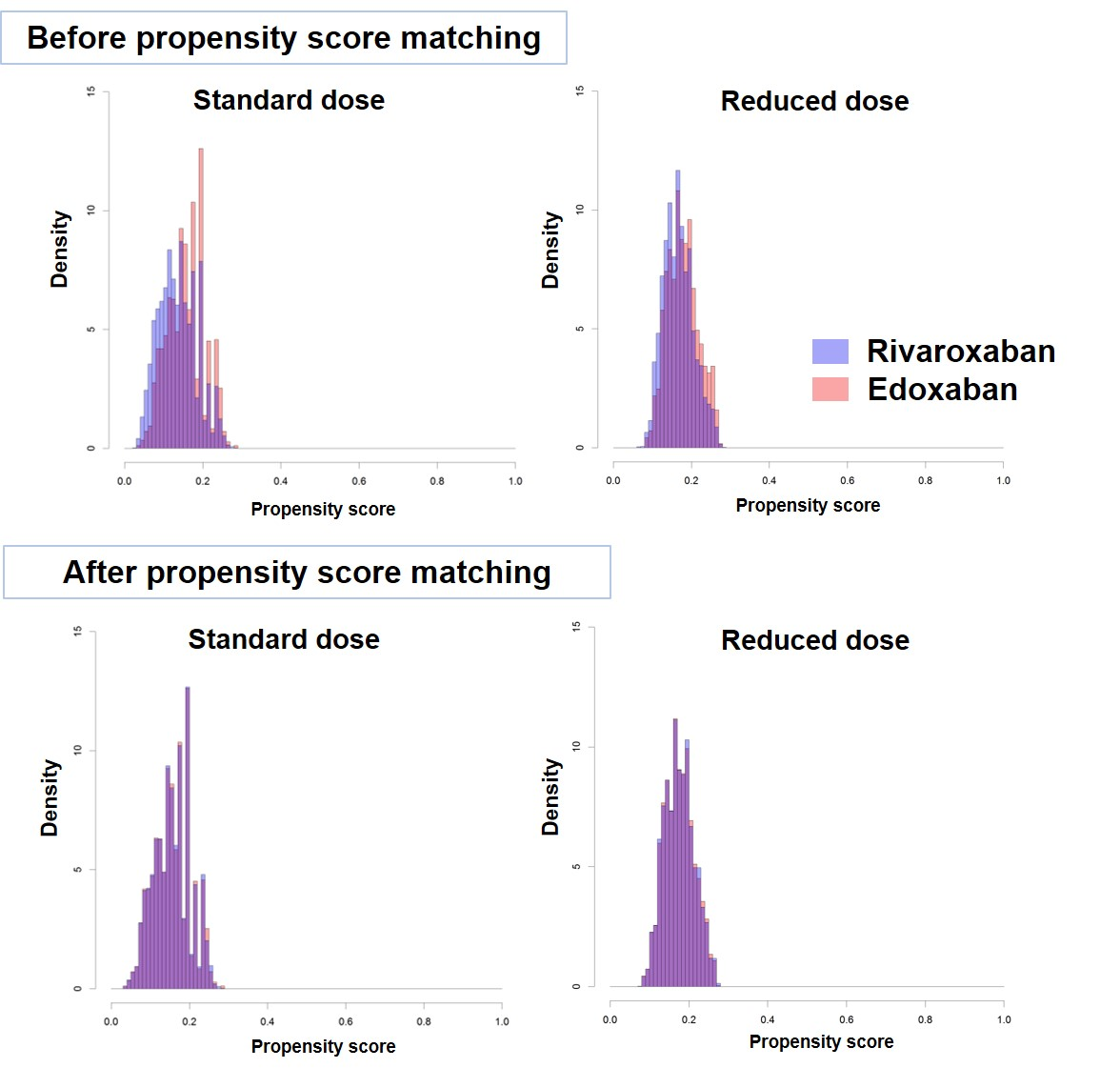
Figure S2. Cumulative incidence of six clinical outcomes in rivaroxaban 20 mg and edoxaban 60 mg groups
Figure S3. Cumulative incidence of six clinical outcomes in rivaroxaban 15/10 mg and edoxaban 30 mg groups

