Supplementary Information
Title: Deep learning-based survival prediction of oral cancer patients.
Authors: Dong Wook Kim1, Sanghoon Lee1, Sunmo Kwon1, Woong Nam1, 2, In-Ho Cha1, 2, Hyung Jun Kim1, 2*

Affiliations:
1 Department of Oral & Maxillofacial Surgery, Yonsei University College of Dentistry, 50-1 Yonsei-ro, Seodaemun-gu, Seoul, 03722, Republic of Korea
2 Oral Cancer Research Institute, Yonsei University College of Dentistry, 50-1 Yonsei-ro, Seodaemun-gu, Seoul, 03722, Republic of Korea

Supplementary Figure S1. Average of c-index among additional splits. The variance among different splits S2-S4 implies the prediction error, which indicates ‘what performance one may get from a different dataset,’ in addition to the variance of model performance itself. The variance of performance is shown in Figure 3 as 95% confidence interval, which is obtained from the bootstraps of the training set.
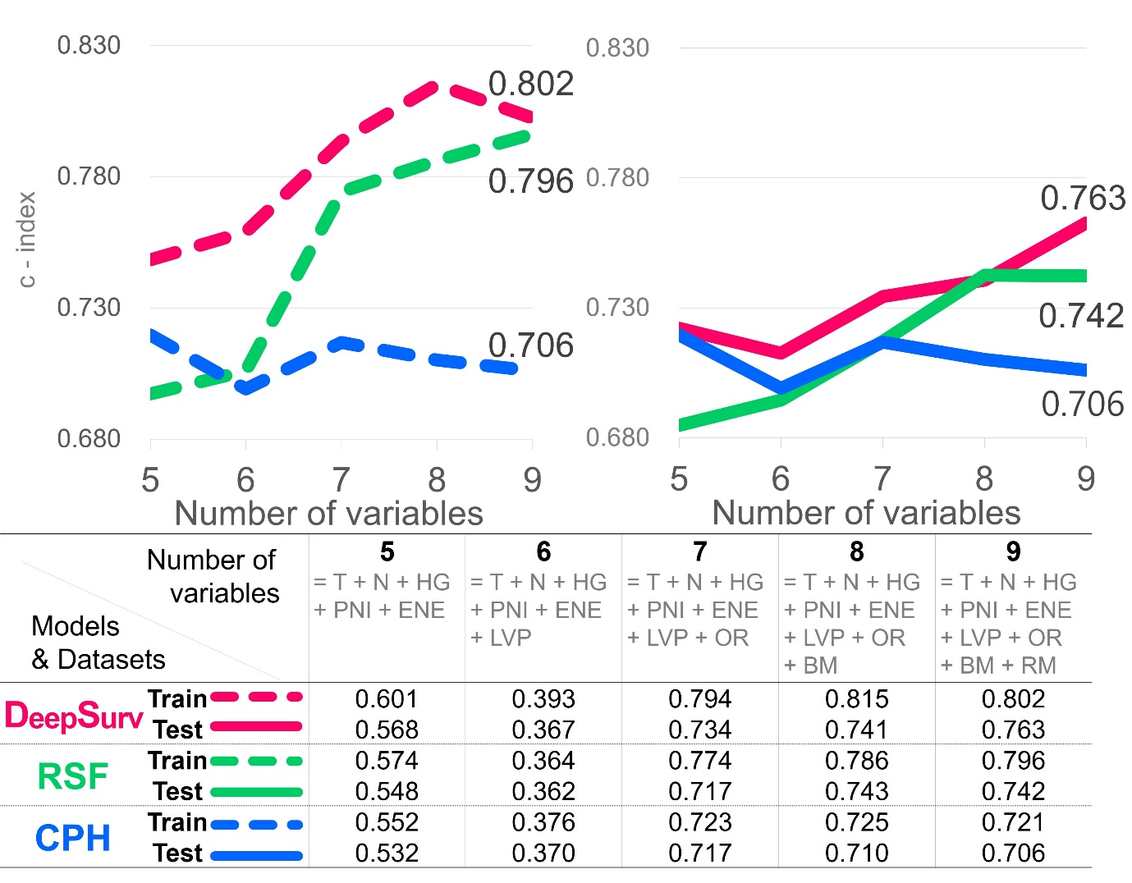
Supplementary Figure S2. C-index of additional split #1
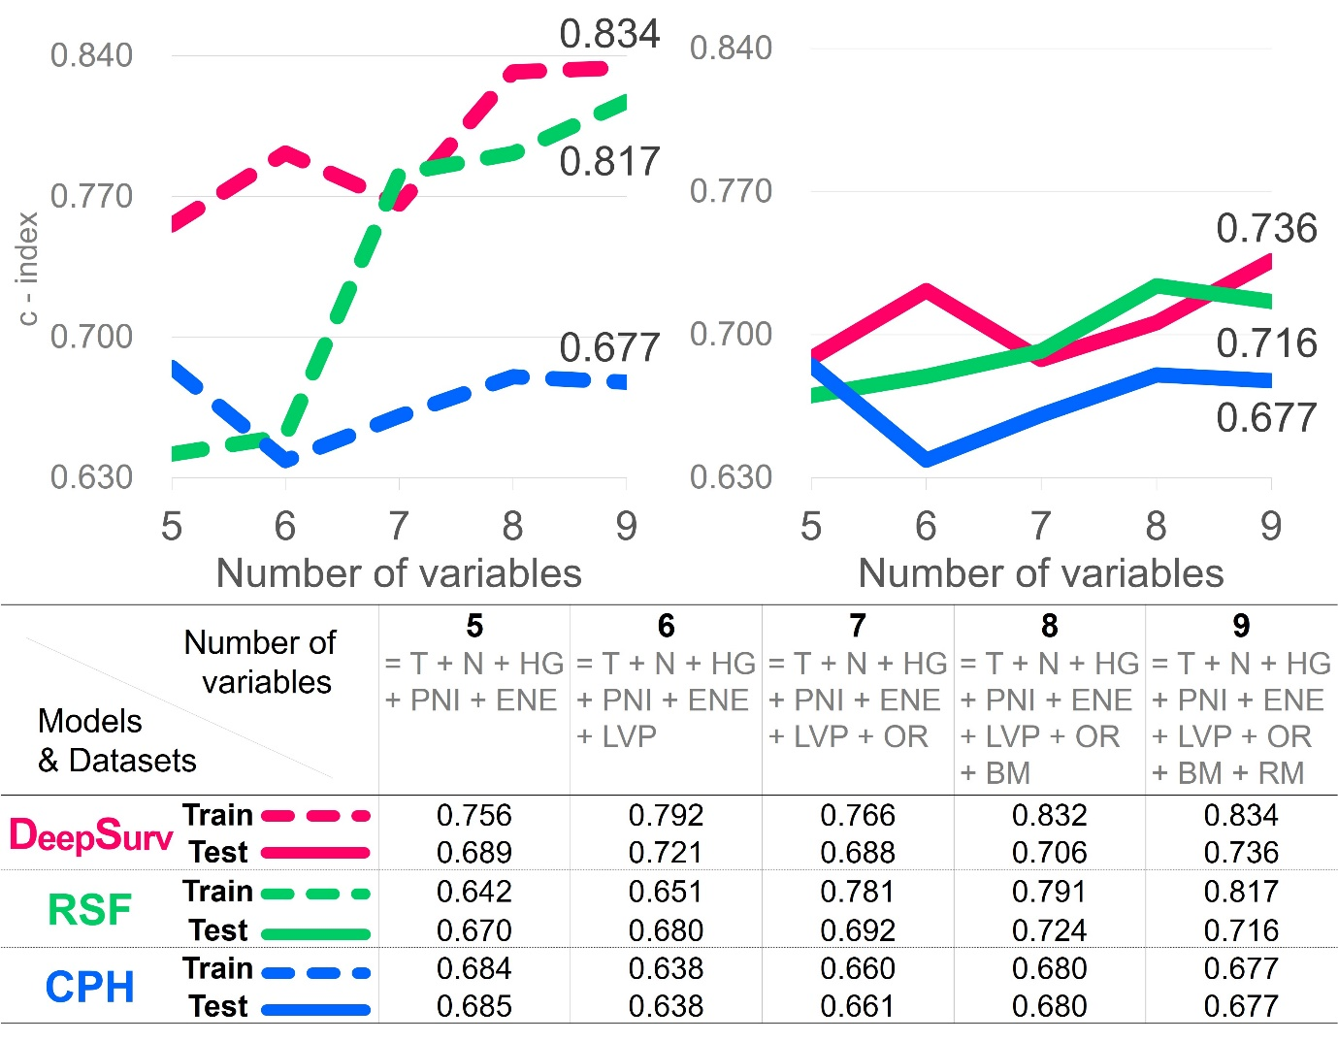

Supplementary Figure S3. C-index of additional split #2
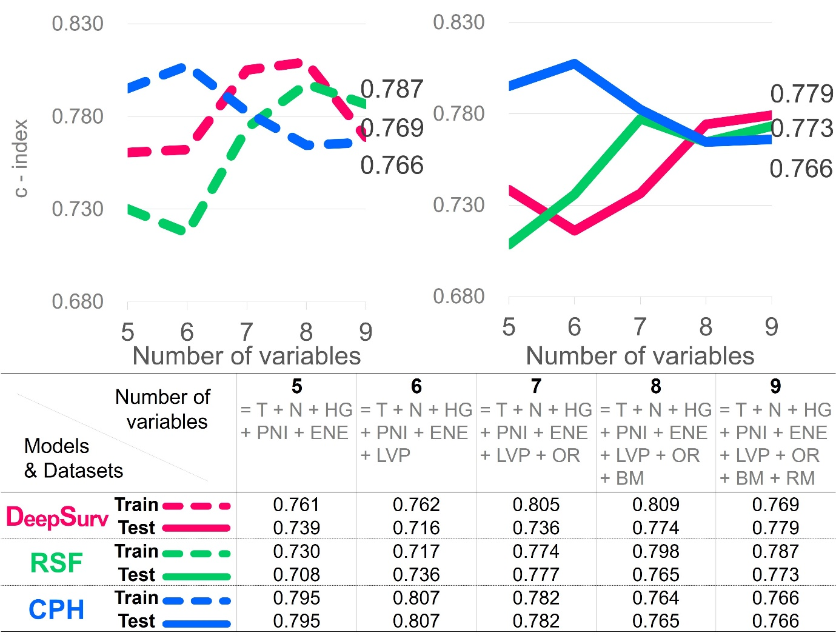

Supplementary Figure S4. C-index of additional split #3
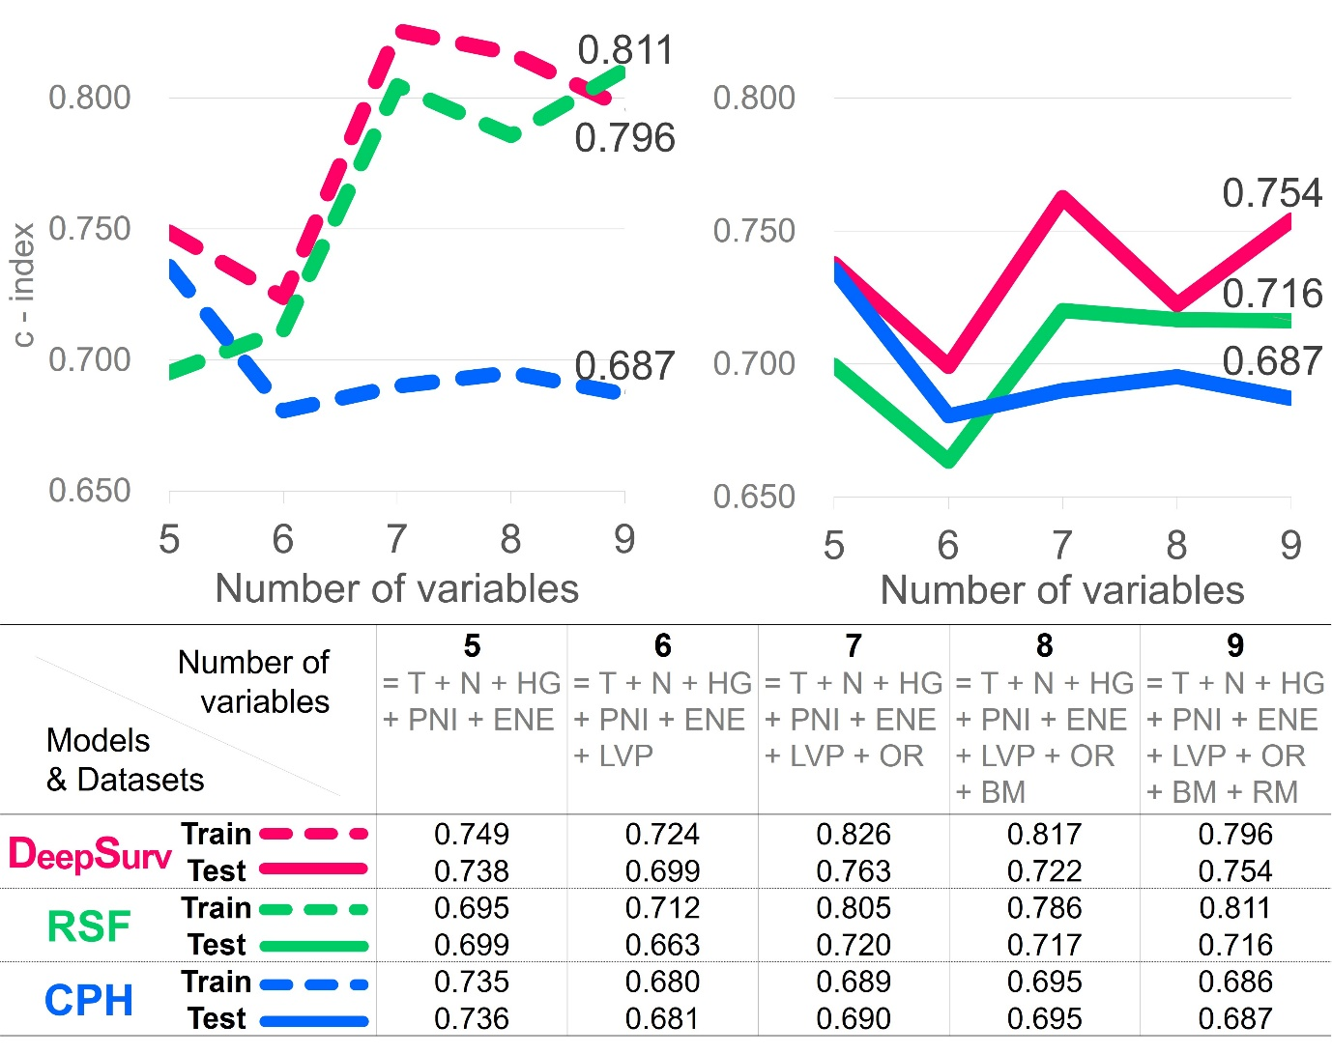

Supplementary Table S5. Pairwise minimal depth interactions among variables in random survival forest.
 | N stage | T stage | OR | HG | BM | RM | PNI | ENE | LVP
N stage | 0.176 | 0.389 | 0.542 | 0.379 | 0.480 | 0.435 | 0.682 | 0.820 | 0.653
T stage | 0.418 | 0.183 | 0.588 | 0.420 | 0.544 | 0.526 | 0.711 | 0.731 | 0.705
OR | 0.372 | 0.379 | 0.221 | 0.382 | 0.535 | 0.453 | 0.691 | 0.727 | 0.682
HG | 0.398 | 0.378 | 0.627 | 0.230 | 0.563 | 0.495 | 0.711 | 0.748 | 0.713
BM | 0.450 | 0.592 | 0.710 | 0.483 | 0.317 | 0.556 | 0.781 | 0.803 | 0.782
RM | 0.596 | 0.617 | 0.794 | 0.559 | 0.758 | 0.388 | 0.851 | 0.904 | 0.879
PNI | 0.617 | 0.652 | 0.778 | 0.651 | 0.758 | 0.709 | 0.407 | 0.868 | 0.861
ENE | 0.641 | 0.709 | 0.783 | 0.683 | 0.755 | 0.716 | 0.834 | 0.483 | 0.857
LVP | 0.759 | 0.766 | 0.857 | 0.776 | 0.848 | 0.827 | 0.925 | 0.930 | 0.497
OR = Overall recurrence, HG = Histologic grade, PNI = Perineural invasion, ENE = Extranodal extension , LVP = Lymphovascular permeation, OR = Overall recurrence, BM = Bone marrow invasion, RM = Resection margin

