Supplementary information

Mathematical expertise modulates the architecture of dorsal and cortico-thalamic white matter tracts

Hyeon-Ae Jeon^{1,2,+,*}, Ulrike Kuhl^{3,+}, Angela D. Friederici³

¹Department of Brain and Cognitive Sciences, Daegu Gyeongbuk Institute of Science and Technology (DGIST), Daegu 42988, Korea
²Partner Group of the Max Planck Institute for Human Cognitive and Brain Sciences at the
Department for Brain and Cognitive Sciences, DGIST, Daegu 42988, Korea
³Department of Neuropsychology, Max Planck Institute for Human Cognitive and Brain Sciences, Leipzig, 04103, Germany

Supplementary Figure S1. Separate correlations for mathematicians and non-mathematicians.
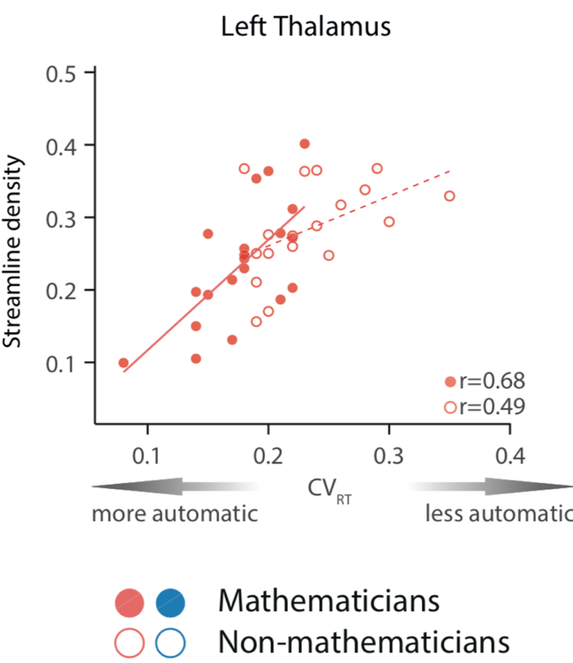
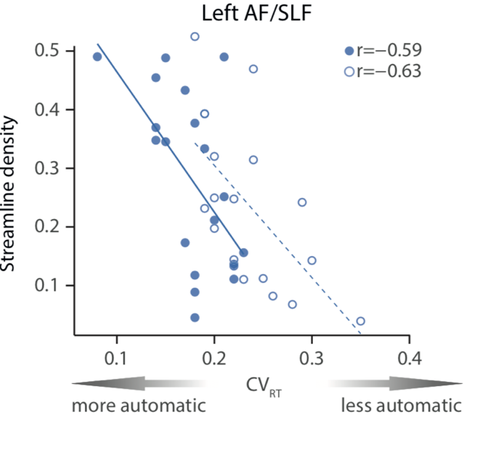

(a) For streamline density within the left AF/SFL cluster, a significant negative correlation was found with CV_{RT} scores for mathematicians (r = -0.59, p = 0.0063) and non-mathematicians (r = -0.63, p = 0.0053), respectively. (b) The positive association between streamline density within the left thalamus cluster and CV_{RT} scores were also significant for both groups (mathematicians: r = 0.68, p = 0.0009; non-mathematicians: r = 0.49, p = 0.0391). An additional statistical comparison of both sets of correlations using Fisher’s z revealed no significant differences between the strength of associations between both groups (AF/SLF cluster: z = -0.1800, p = 0.8572; left Thalamus cluster: z = -0.8273, p = 0.4081).

