Supporting information:

Visualization of unstained DNA nanostructures with advanced in-focus phase contrast TEM techniques

Yoones Kabiri ¹, Raimond B. G. Ravelli ², Tibor Lehnert ³, Haoyuan Qi ³, Allard J. Katan ¹, Natascha Roest ², Ute Kaiser ³, Cees Dekker ¹, Peter J. Peters ^{2*}, and Henny Zandbergen ^{1*}

- Kavli institute of nanoscience Delft, Delft 2629HZ, The Netherlands

- The Maastricht Multimodal Molecular Imaging Institute, Universiteitssingel 50, Maastricht 6229 ER, The Netherlands

- Materialwissenschaftliche Elektronenmikroskopie, Universität Ulm, Albert-Einstein-Allee 11, 89081 Ulm, Germany

* Corresponding authors: peter.peters@maastrichtuniversity.nl, h.w.zandbergen@tudelft.nl

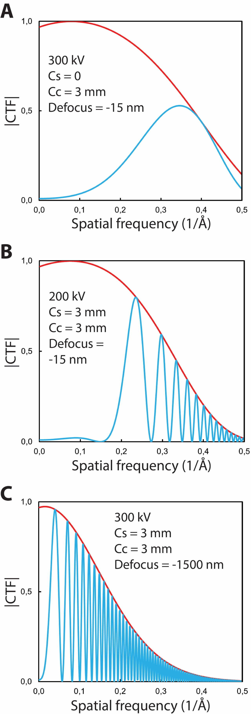

Figure S1. CTFs (blue curves) for (A) a Cs corrected Titan microscope operating at 300 kV (B) a non-corrected Arctica microscope operating at 200 kV (C) a non-corrected Titan microscope at 300 kV under strong defocus illumination. The red curves are the total envelope function (temporal and spatial).

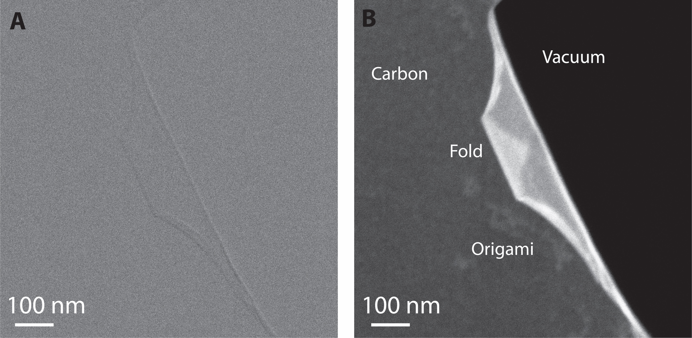

Figure S2. DF imaging performance in conjugation with DE-16 camera. (A) Bright-field and (B) DF image of a same area on the sample. Remarkable contrast enhancement is see after inserting DF aperture.

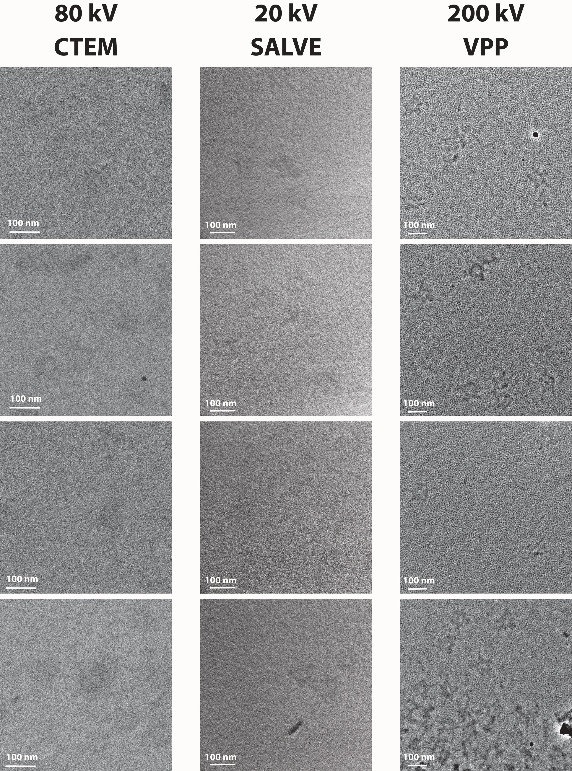

Figure S3. Additional exemplary micrographs. More data will be deposited in the Electron Microscopy Public Image Archive (EMPIAR).

